Supplementary materials - Uncropped Western blots

Fig. 1g

ACSL4 LOX15
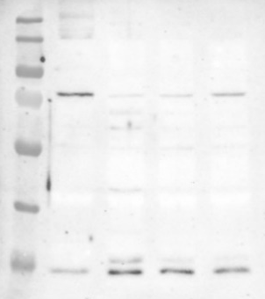

β-actin for ACSL4 β-actin for LOX15
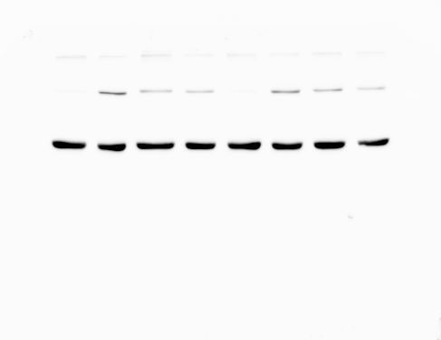

Fig. 1h

GPX4 β-actin for GPX4

FSP1 β-actin for FSP1
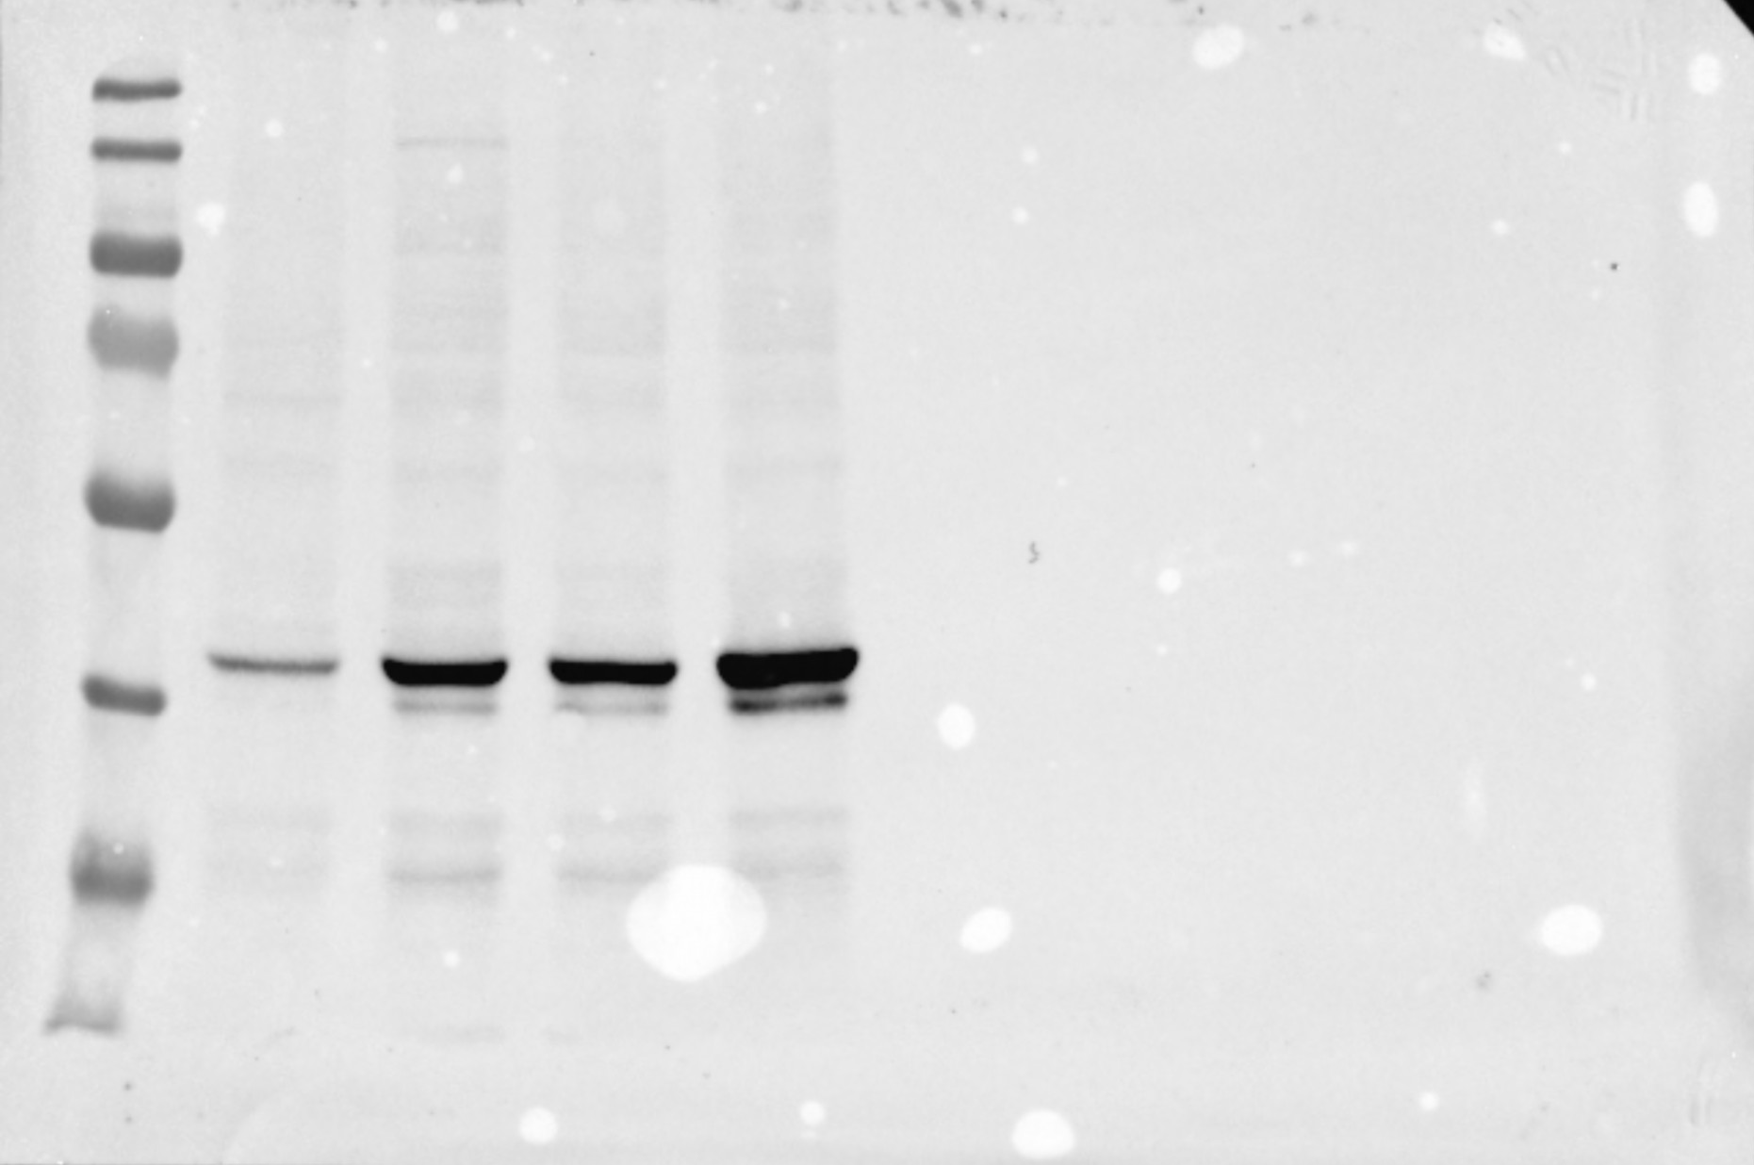

Fig.3e

Perforin β-actin

Suppl. Fig. 1g

GPX4 FSP1
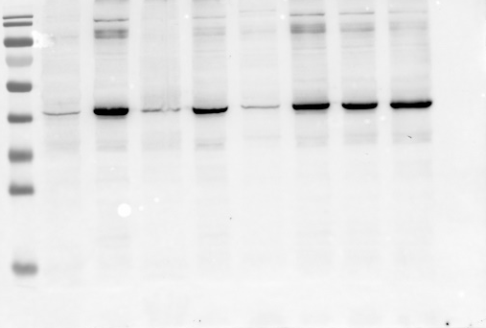

β-actin for GPX4 & FSP1

Suppl. Fig. 2g

LC3 β-actin
