Table 1S. Preliminary study by thin layer chromatography for selection of Mobile phase composition for simultaneous estimation of Berberine and Conessine
Sr. no | Mobile phase | Composition | Derivatizing agent | Remarks
1 | Ethyl acetate: Methanol: Diethyl  amine: Water | 2:2:0.5:0.5 | Anisaldehyde(sulfuric  acid) reagent | Conessine didn t run
2 | Toluene: Ethanol | 5:5 | Anisaldehyde(sulfuric  acid) reagent | Conessine didn t run
3 | Chloroform: Methanol | 5:5 | Dragendorff reagent | Conessine didn t run
4 | Toluene: Ethyl acetate: Formic acid | 7:2:1 | Anisaldehyde(sulfuric acid) reagent | No separation drugs | of | both
5 | Methanol : Water | 8:2 | Dragendorff reagent
6 | Ethyl acetate : Methanol: Diethyl amine | 6.5:1:0.3 | Anisaldehyde(sulfuric acid) reagent | Good resolution was observed in two  biomarkers
7 | Toluene : ethyl acetate : diethylamine | 6.5:2.5:1 | Anisaldehyde(sulfuric  acid) reagent | Tailing in berberine
8 | Ethylacetate : hexane : diethylamine | 7.5:2.5:5 | Anisaldehyde(sulfuric  acid) reagent | Tailing in conessine
9 | Toluene : ethylacetate : diethylamine | 6:3:1 | Anisaldehyde(sulfuric  acid) reagent | Tailing in berberine
10 | Toluene : ethylacetate | 9:3 | Anisaldehyde(sulfuric acid) reagent | No separation drugs | of | both
11 | Toluene : ethylacetate : formic acid | 9.7:2.7:0.3 | Anisaldehyde(sulfuric acid) reagent | No separation drugs | of | both
12 | Benzene : methanol | 8:2 | Dragendorff reagent | Both drugs didn t run
13 | Benzene : diethylether | 7:3 | Dragendorff reagent | Both drugs didn t run
14 | Petroleum ether : diethyl ether | 5:5 | Dragendorff reagent
15 | Toluene : ethylacetate : diethylamine | 6.5:2.5:1 | Anisaldehyde(sulfuric acid) reagent | No separation drugs | of | both
16 | Benzene : ethylacetate : diethylamine | 6:3:1 | Anisaldehyde(sulfuric  acid) reagent | Tailing in berberine
17 | Benzene : ethylacetate : diethylamine | 1:2:1 | Dragendorff reagent | Tailing in berberine
18 | Toluene: ethylacetate : diethylamine | 7.5:2:0.5 | Dragendorff reagent | Berberine didn t run
19 | Benzene : chloroform | 7:25 | Anisaldehyde(sulfuric | Both drugs didn t run

Sr no | Tlc plates | Mobile phase and Composition v/v | Rf of berberine | Rf of conessine | Remark
1 | 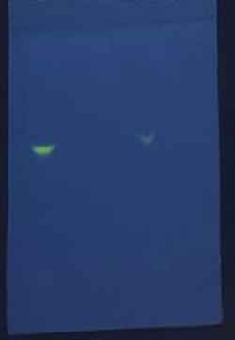 | Ethyl acetate: Methanol: Diethyl amine: Water  (2:2:0.5:0.5) v/ v | 0.4 | 0.4 | The spots were not separated properly and both had the same Rf value.
2 | 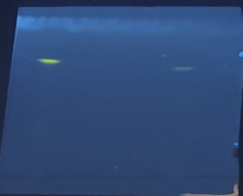 | Toluene: Ethanol  (5:5) v/v | 0.7 | 0.7 | No separation of both drugs
3 | 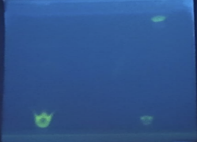 | Chloroform: Methanol  (5:5) v/v | - | - | Both drugs didn’t run
4 | 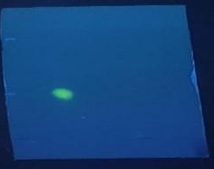 | Toluene: Ethyl acetate: Formic acid  (7:2:1) v/v | 0.4 | - | Conessine didn’t run
5 | 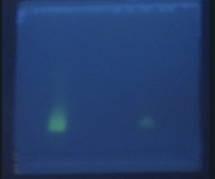 | Methanol: Water  (8:2) v/v | 0.3 | 0.3 | No separation was observed
6 | 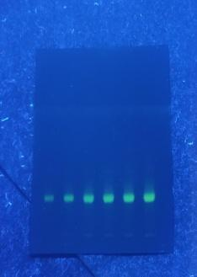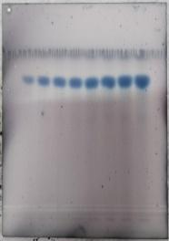 | Ethyl acetate:  Methanol: Diethyl amine (6.5:1:0.3) v/v | 0.22 | 0.85 | Good resolution was observed in two biomarkers

Table 2S: Translation of coding in actual units for the 27 experimental trials as per box–behnken design matrix
Coding | Mobile phase (ml) | Saturation time (mins) | Distance travelled (cm) | Derivatizing agent Concentration of anisaldehyde solution (%)
-1 | 2 | 15 | 7 | 0.5
0 | 2.5 | 20 | 8 | 1
1 | 3 | 25 | 9 | 1.5

Table 3S: linearity study for simultaneous estimation of berberine and conessine
Name of biomarker | Conc. Of stock solution (µg/ml) | Volume injected µl | Conc. (ng/band) | Area of set1 | Area of set2 | Area of set3
Berberine | 50 | 2 | 100 | 6423 | 6503 | 6931
Berberine |  | 4 | 200 | 10701 | 10295 | 10708
Berberine |  | 8 | 400 | 17024 | 16421 | 14844
Berberine |  | 10 | 500 | 19306 | 19294 | 17163
Berberine |  | 12 | 600 | 21407 | 20908 | 19095
Berberine |  | 16 | 800 | 24472 | 24039 | 21983
Conessine | 1000 | 2 | 2000 | 3325 | 3265 | 3308
Conessine |  | 4 | 4000 | 7530 | 7601 | 7593
Conessine |  | 8 | 8000 | 7530 | 13619 | 13558
Conessine |  | 10 | 10000 | 13585 | 15841 | 15754
Conessine |  | 12 | 12000 | 15790 | 18517 | 18763
Conessine |  | 16 | 16000 | 21834 | 21847 | 21756

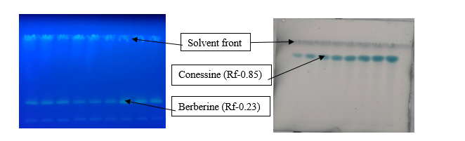
Fig 1S: (a) TLC showing berberine at R.f (0.23) visualization under UV light at 350nm
(b) TLC showing conessine at R.f (0.8) after derivatizing and visualization under visible light with Anisaldehyde 1% solution
TLC of simultaneous estimation of Berberine and Conessine(after derivatization) using mobile phase ethyl acetate: methanol: diethyl amine in the ratio (6.5:1:0.3v/v)

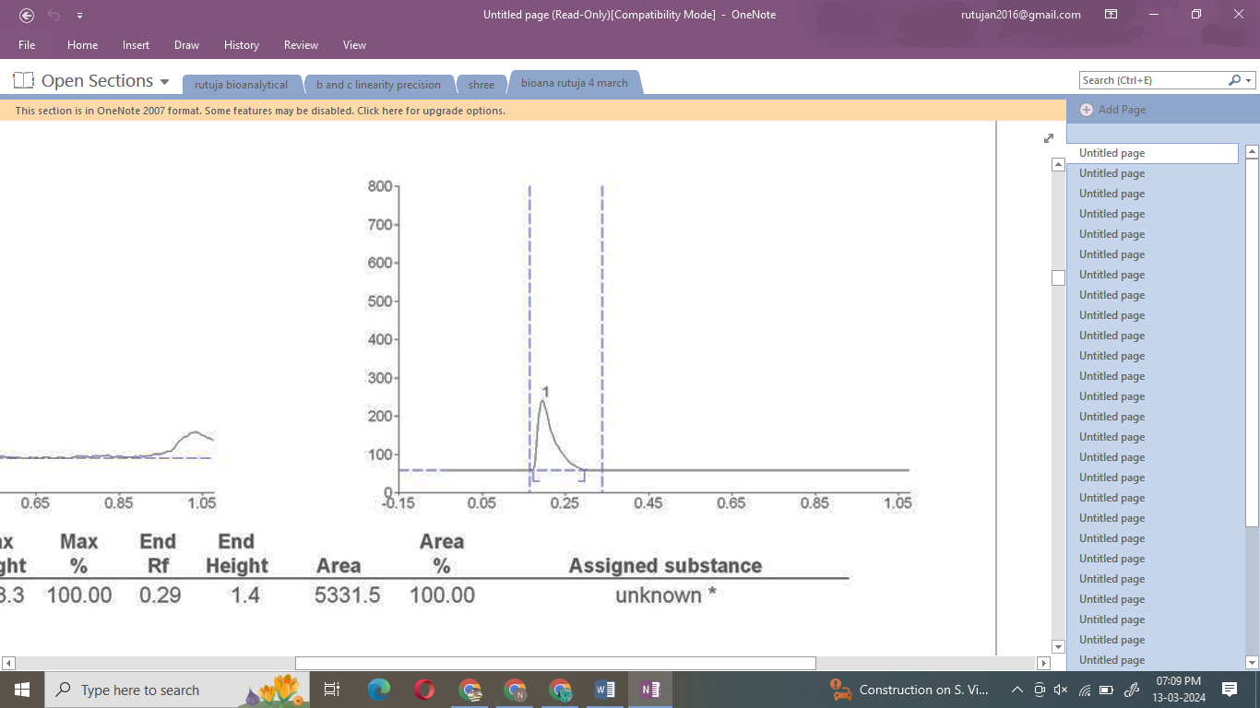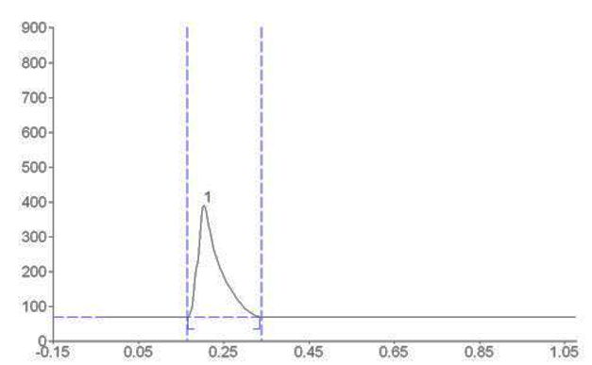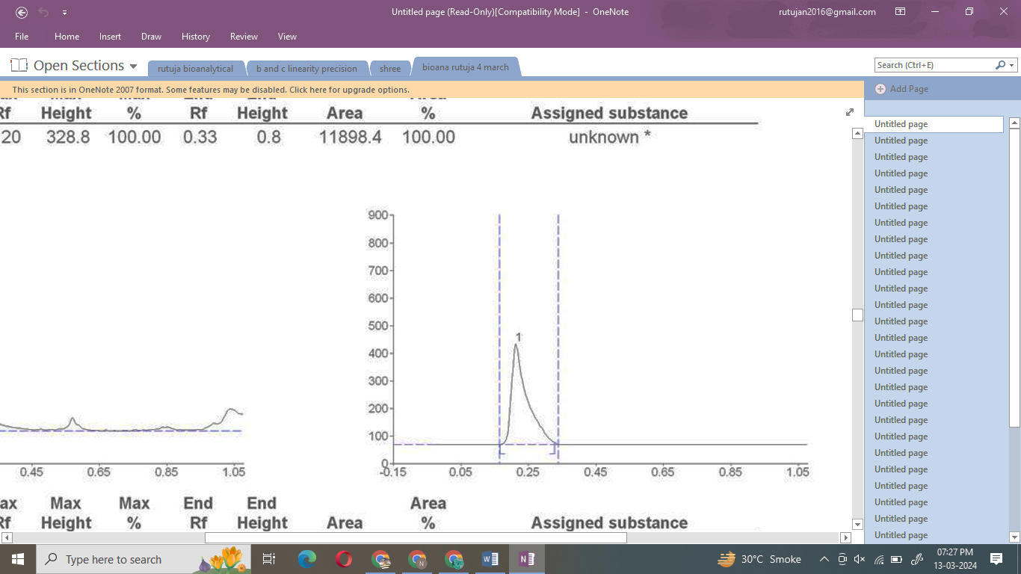

Figure 2S: Representative Chromatogram of Berberine at LQC, MQC and HQC level at 350nm for intraday precision
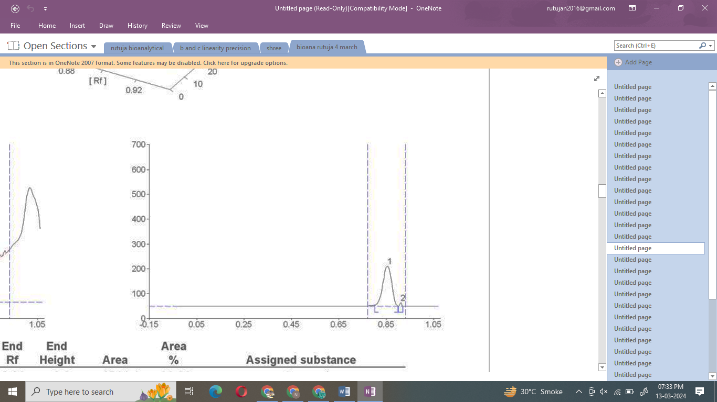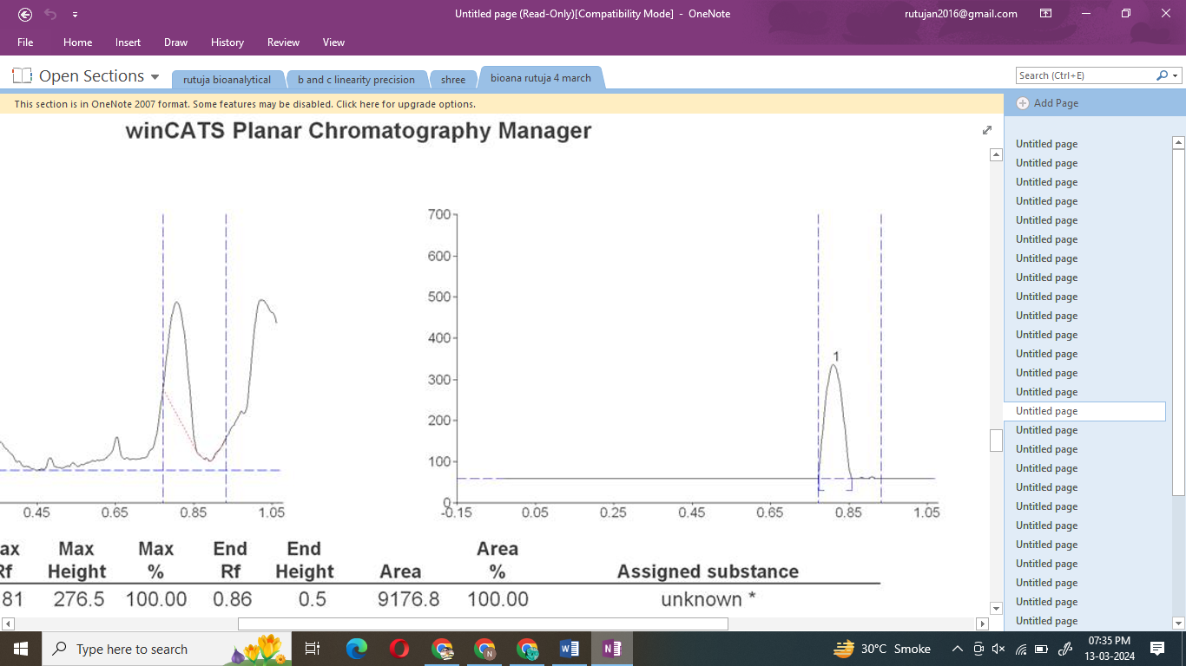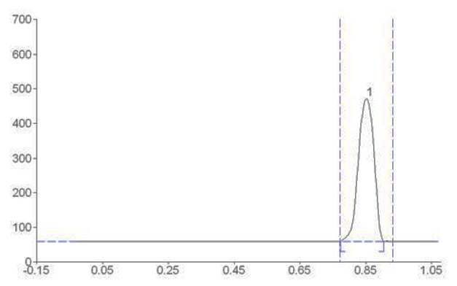

Figure 3S: Representative Chromatogram of Berberine at LQC, MQC and HQC level at 350nm for intraday precision

