Supplementary information of

Bioactive electrospun nanofibers with VEGF for wound healing
Xunxun Lin¹, Haibo Liu¹, Xixi Li¹, Yu Ling², Yanlin Wei², Xiazi Huang^{3#}, Hongmian Li^{2#}
1 Department of Plastic Surgery, Sun Yat-sen University 1st affiliated hospital, NO 58 Zhongshan 2 Road, 510080, Guangzhou, China.
2 Department of Emergency, The People’s Hospital of Guangxi Zhuang Autonomous Region, Nanning, 530021, China.
3 Department of Biomedical Engineering, The Hong Kong Polytechnic University, Hong Kong, 000000, China

#Corresponding author(s): Hongmian Li, E-mail: hmli@gxams.org.cn; Xiazi Huang, E-mail: sharon.huang@connect.polyu.hk.

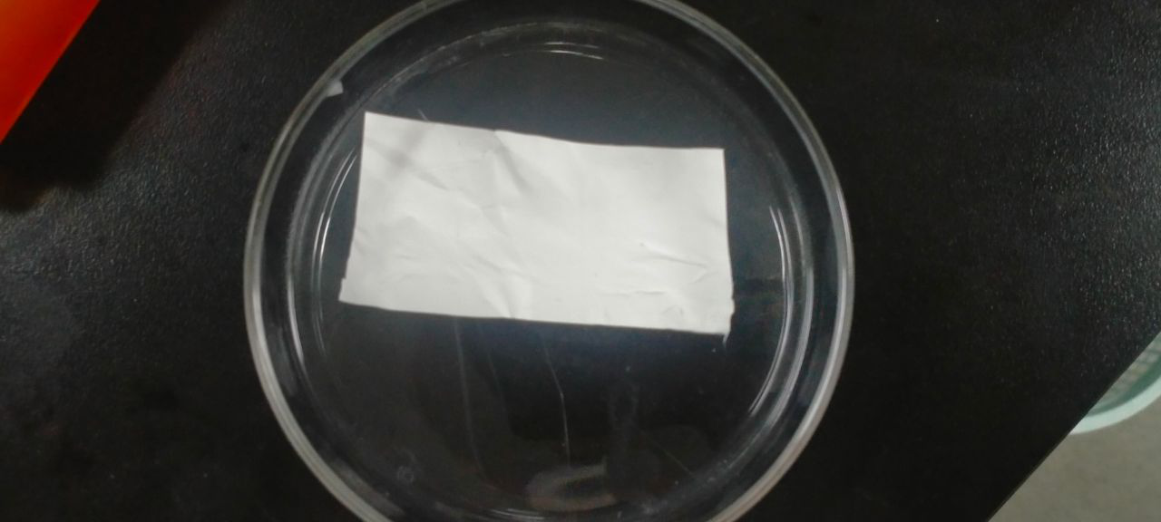
Figure S1. The picture of electrospinning fiber membrane.

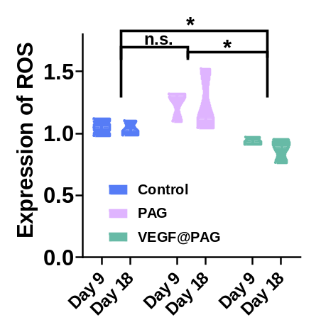
Figure S2. Changes in the expression of ROS in the wound on the day 9 and 18 of treatment.

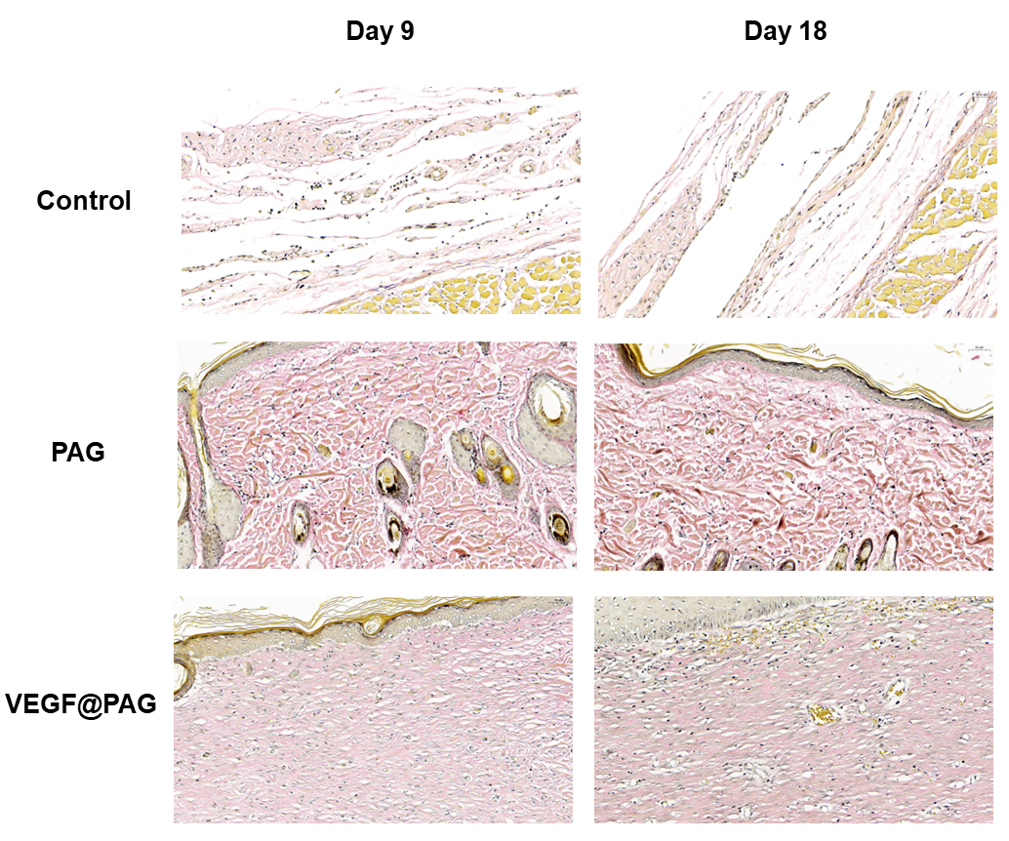
Figure S3. Representative images of EVG staining of the infected site after postoperative days 9 and 18.
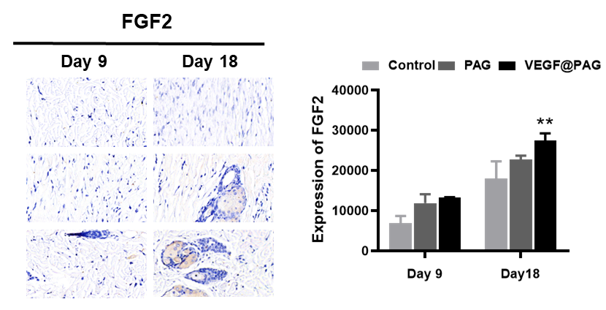
Figure S4. FGF2 were increased in wound areas with the VEGF@PAG treatment after 9 and 18 days and quantitative analysis.

