Supplementary Material:
Arsenic and Heavy metals levels into edible fresh meat (chicken, goat, and beef) and associated health risks
Syed Ali Musstjab Akber Shah Eqani¹, Ismat Nawaz^{1*}, Syed Sayyam Abbas¹, Nadeem Ali², Nisreen Rajah³, Iqra Rasheed⁴, Syeda Maria Ali⁴, Mohammed I. Orif ², Heqing Shen⁵

1-Department of Biosciences, COMSATS University, Islamabad, Pakistan
2- Center of Excellence in Environmental sciences, Kind Abdul Aziz University, Jeddah-21589, Saudia Arabia Department of Environmental Sciences,
3-Clinical Anatomy, Faculty of Medicine, King Abdul Aziz University, Jeddah-21589, Saudi Arabia
4- Department of Environmental Sciences, International Islamic University Islamabad, Pakistan
5- Institute of Urban Environment, Chinese Academy of Sciences, China

List of Tables: Table S1: Comparison of arsenic and heavy metals levels (ppm) measured in present and worldwide reported data.

List of Figures:
Figure S1 Comparison of metals (µg/Kg, dry weight) varying significantly between different animals in (a) liver (b)muscle.
Figure S2 Comparison of metals (µg/Kg, dry weight) varying significantly between different cities in beef (a) liver (b) muscle.
Figure S3 Correlation of metals in different liver and muscle of Chicken, Mutton and Beef.
Figure S4 PCA analysis for studied elements measured on liver and muscle of different animals.
Figure S5 PCA analysis for studied elements measured in the studied different animals at different cities of Pakistan.

Table S1: Comparison of arsenic and heavy metals levels (ppm) measured in present and worldwide reported data.
 | Cr |  | Mn |  | Ni |  | Cu |  | Zn |  | As |  | Cd |  | Pb |  | Reference
Location | liver | muscle | Liver | muscle | liver | muscle | liver | muscle | liver | muscle | liver | muscle | liver | muscle | liver | muscle
Chicken
Pakistan | 0.6 | 1.8 | 7.3 | 1.0 | 0.2 | 1.2 | 13.3 | 3.7 | 105.5 | 58.1 | 0.02 | 0.041 | 0.06 | 0.005 | 0.2 | 0.2 | Present study
Pakistan | 0.1 | 0.1 | 0.5 | 0.4 |  |  |  |  | 110.2 | 107.4 |  |  | 0.7 | 0.6 | 0.3 | 0.2 | Khan et al., 2016
China |  |  |  |  |  |  | 2.3 | 1.4 | 190.0 | 42.0 |  |  | 9.4 | 0.1 | 0.7 | 0.5 | Zhaung et al., 2014
Egypt |  |  |  |  |  |  |  |  |  |  |  |  |  | 0.1 |  | 0.3 | Khallafalla et al., 2016
Coimbatore. | 1.2 | 0.8 |  |  |  |  | 2.0 | 3.5 | 5.5 | 5.3 | 0.0 | 0.0 |  | 0.0 | 0.0 | 0.0 | Thirulogachandar et al 2014
Iraq |  | 0.1 |  | 0.0 |  | 0.0 |  | 0.2 |  | 2.0 |  |  |  | 0.1 |  | 1.2 | Hamasalim et al., 2013
Pakistan | 0.8 | 0.8 | 0.4 | 0.4 | 3.9 | 2.8 | 2.8 | 2.4 | 31.9 | 30.9 | 0.3 | 0.6 | 0.5 | 0.4 | 2.3 | 2.4 | Imran et al., 2015
Nigeria | 0.2 | 0.5 |  |  |  |  |  |  |  |  | 0.0 | 0.1 | 0.0 | 0.0 |  |  | Mohammad et al., 2013
Nigeria |  |  | 4.1 |  | 1.1 |  | 1.4 |  | 3.1 |  | 0.0 |  | 0.3 |  | 0.2 |  | Akan et al., 2010
Canada |  |  |  |  |  |  |  |  |  |  |  | 3.1 |  |  |  |  | Liu et al., 2016
Mutton
Pakistan | 0.4 | 0.6 | 8.8 | 0.9 | 0.4 | 0.3 | 209.6 | 3.6 | 200.9 | 313.2 | 0.13 | 0.19 | 0.1 | 0.009 | 0.4 | 0.2 | Present study
Nigeria |  |  |  |  |  |  | 2.0 |  | 4.0 |  |  |  | 0.0 |  | 0.2 |  | Milam et al., 2015
Zambia | 14.9 |  |  |  | 23.2 |  | 159.0 |  | 63.9 |  | 0.0 |  | 0.1 |  | 0.1 |  | yabe et al., 2012
Slovak Republic |  |  |  |  | 0.2 | 0.4 | 84.1 | 6.3 | 79.9 | 81.2 |  |  | 0.5 | 0.1 | 1.1 | 0.7 | Koréneková etal., 2002
Ghana |  | 1.0 |  |  |  |  |  |  |  |  |  | 0.0 |  | 0.0 |  |  | Nkansah et al., 2014
Nigeria | 0.8 |  | 2.8 |  | 0.1 |  | 0.5 |  | 2.3 |  | 0.3 |  | 0.8 |  | 0.2 |  | Akan et al., 2010
South India |  | 9.5 |  |  |  | 22.1 |  |  |  |  |  | 3.7 |  | 6.6 |  | 4.6 | Sathiyamoorthy et al., 2016
Beef
Pakistan | 0.5 | 0.5 | 12.5 | 1.2 | 0.2 | 1.2 | 192.8 | 4.9 | 127.6 | 414.2 | 0.18 | 0.32 | 0.3 | 0.01 | 0.9 | 0.3 | Present study
Egypt |  |  |  |  |  |  |  |  |  |  |  |  |  | 0.1 |  | 0.2 | Khallafala et al., 2016
Romania |  |  |  |  |  |  |  | 1.0 |  | 42.1 |  |  |  | 0.1 |  | 0.6 | Hoha et al., 2014
Nigeria | 17.1 | 5.4 |  |  | 0.8 | 1.1 | 77.4 | 2.6 | 529.4 | 527.0 |  |  | 0.2 | 0.4 | 0.3 | 0.1 | Ngozi et al., 2010
Iraq |  | 0.2 |  | 0.0 |  | 0.0 |  | 0.1 |  | 2.4 |  |  |  | 0.1 |  | 0.5 | Hamasalim et al., 2013
Pakistan |  |  |  |  |  |  |  |  |  |  |  |  |  | 0.1 |  | 2.0 | Nawaz et al., 2015
Ghana |  | 0.3 |  |  |  |  |  |  |  |  |  | 0.0 |  | 0.1 |  |  | Nkansah et al., 2014
Egypt | 21.9 | 11.2 |  |  | 14.6 | 21.2 |  |  |  |  | 4.6 | 5.1 | 14.2 | 1.4 | 42.7 | 8.8 | Khalafalla et al., 2011
Nigeria | 0.4 |  | 1.3 |  | 0.3 |  | 0.9 |  | 4.2 |  | 0.1 |  | 0.2 |  | 0.3 |  | Akan et al., 2010
Thailand |  | 0.0 |  |  |  |  |  |  |  |  |  |  |  | 0.0 |  | 0.0 | Jankeaw et al., 2015
North Spain |  |  |  |  |  |  |  |  |  |  |  |  |  | 30.7 | 2.0 |  | Miranda et al., 2001
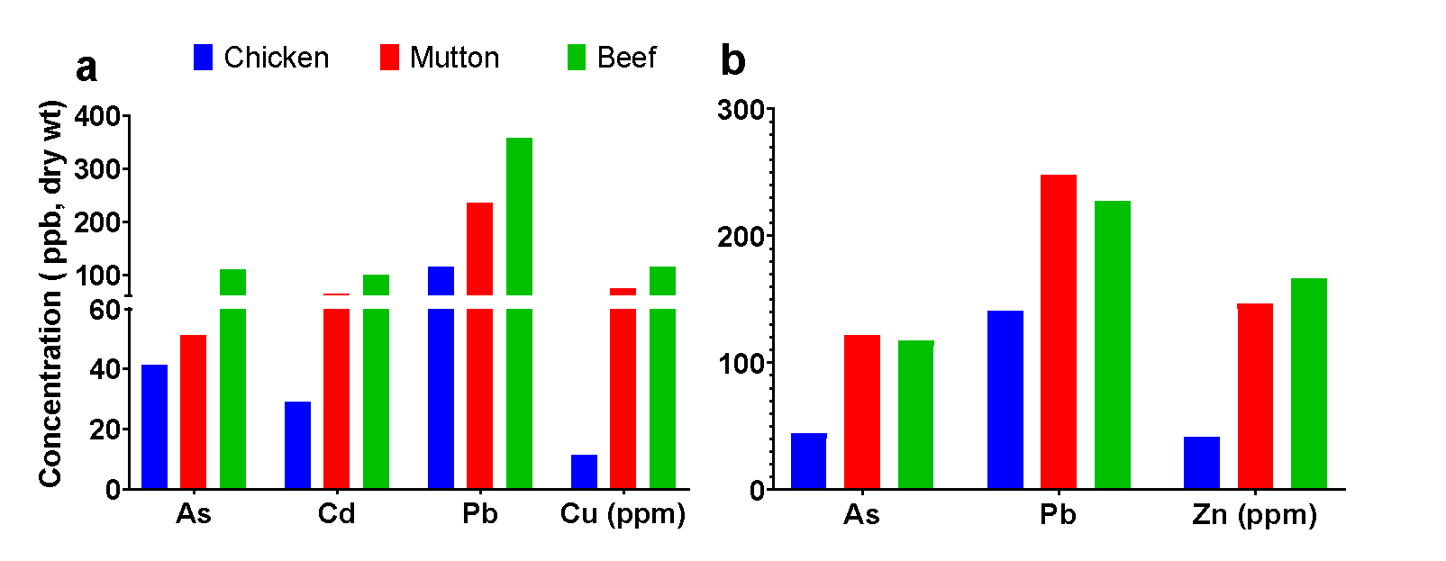

Figure S1 Comparison of metals (µg/Kg, dry weight) varying significantly between different animals in (a) liver (b)muscle.

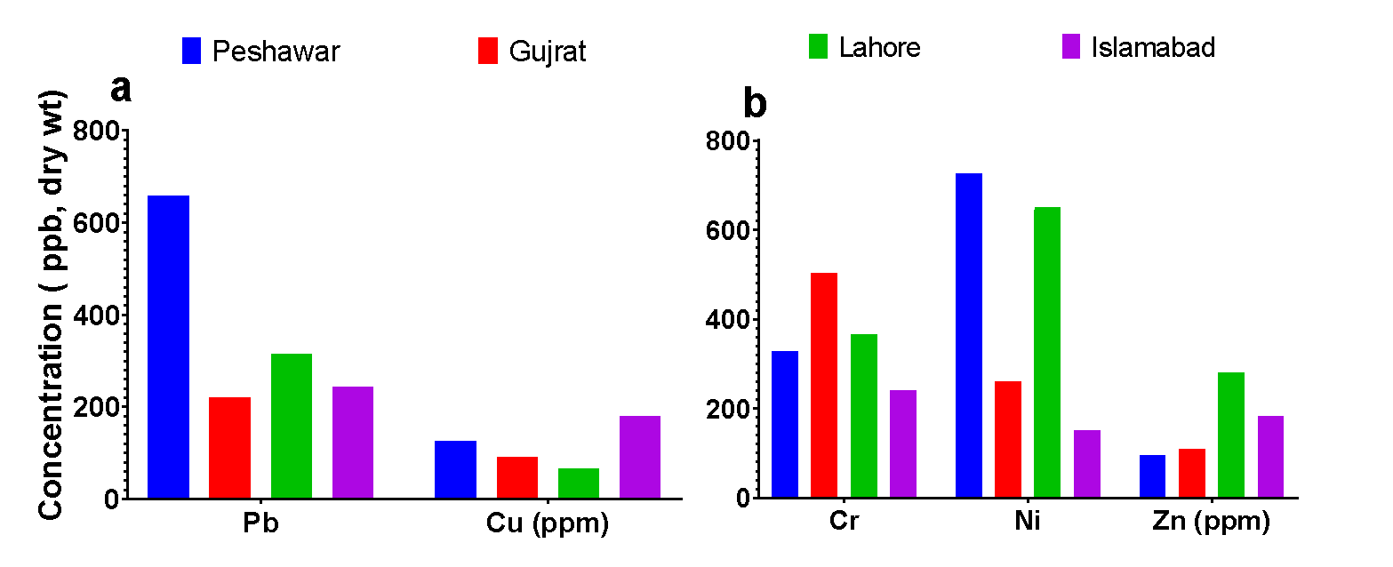

Figure S2 Comparison of metals (µg/Kg, dry weight) varying significantly between different cities in beef (a) liver (b) muscle.

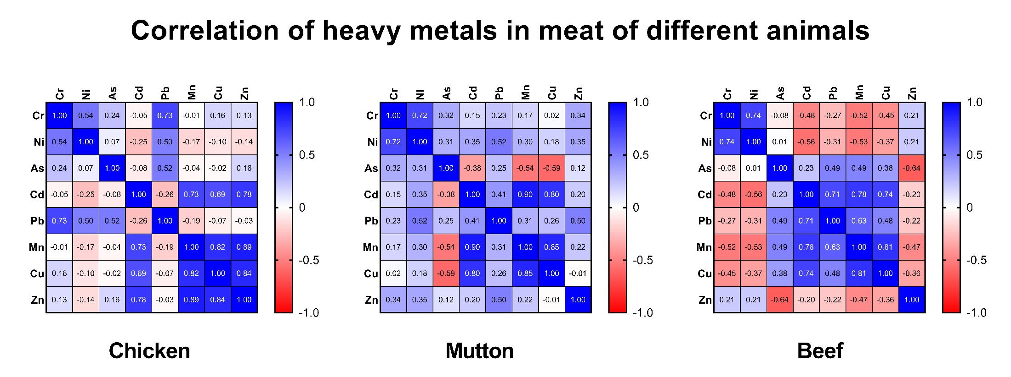
Figure S3 Correlation of metals in different liver and muscle of Chicken, Mutton and Beef.

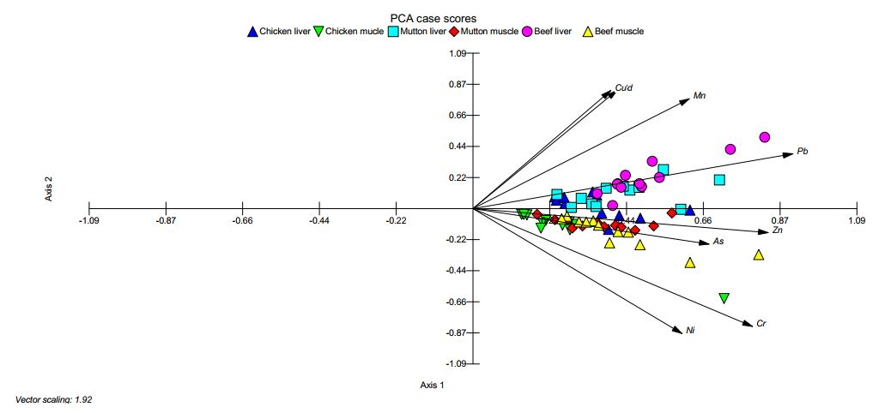

Figure S4 PCA analysis for studied elements measured on liver and muscle of different animals.

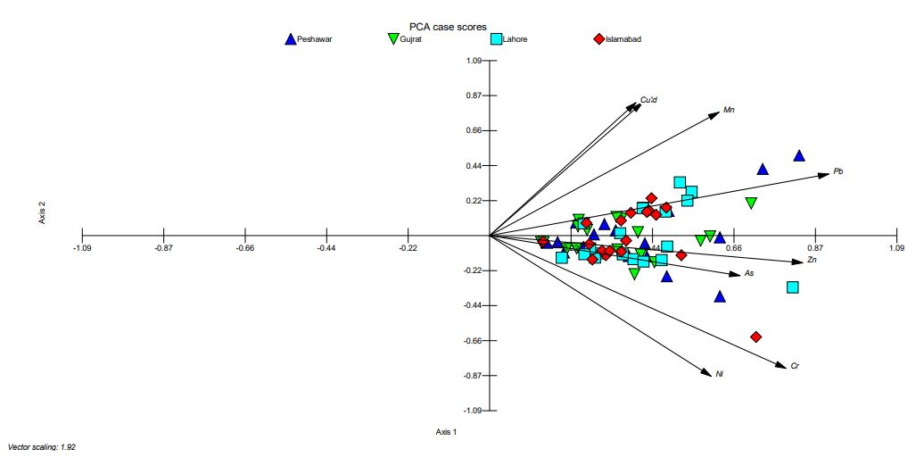
Figure S5 PCA analysis for studied elements measured in the studied different animals at different cities of Pakistan.

