Supplementary I

Selected events daily intensity of precipitation from 1964 to 2020

Time in (Min) | IDF La Niña year 1983 | IDF Neutral ENSO year 2000 | IDF El Niño Niña year 2014 | IDF EL Niña year 2015 | IDF Strong EL Niña year 2015 | IDF La Niña year 2020
5 | 233 | 299 | 926 | 123 | 403 | 219
10 | 147 | 188 | 582 | 77 | 253 | 138
15 | 112 | 143 | 443 | 59 | 193 | 105
30 | 70 | 90 | 279 | 37 | 121 | 66
45 | 54 | 69 | 212 | 28 | 92 | 50
60 | 44 | 57 | 175 | 23 | 76 | 41
75 | 38 | 49 | 151 | 20 | 66 | 36
105 | 32 | 41 | 127 | 17 | 56 | 30
120 | 29 | 37 | 114 | 15 | 50 | 27
135 | 26 | 34 | 104 | 14 | 45 | 25
150 | 24 | 31 | 97 | 13 | 42 | 23
165 | 23 | 29 | 90 | 12 | 39 | 21
180 | 21 | 27 | 85 | 11 | 37 | 20
195 | 20 | 26 | 81 | 11 | 35 | 19
210 | 20 | 25 | 77 | 10 | 34 | 18
225 | 19 | 24 | 75 | 10 | 32 | 18
240 | 18 | 23 | 72 | 10 | 31 | 17
255 | 18 | 23 | 70 | 9 | 31 | 17
360 | 13 | 17 | 52 | 7 | 23 | 12
480 | 11 | 14 | 43 | 6 | 19 | 10
600 | 9 | 12 | 37 | 5 | 16 | 9
720 | 8 | 11 | 33 | 4 | 14 | 8
960 | 7 | 9 | 27 | 4 | 12 | 6
1080 | 6 | 8 | 25 | 3 | 11 | 6
1200 | 6 | 8 | 24 | 3 | 10 | 6
1440 | 5 | 7 | 21 | 3 | 9 | 5

Supplementary II

Major lowest and highest ENSO Events hourly intensity of precipitation from 1983 to 2020

Time in Hour | IDF La Niña Event 1983 | IDF Neutral ENSO Event 2000 | IDF El Niño Niña Event 2014 | IDF EL Niña Average of 2015 | IDF Strong EL Niña Event 2015 | IDF La Niña Event 2020
0.5 | 252.0 | 89.9 | 278.6 | 79.2 | 121.3 | 65.9
1.0 | 126.0 | 56.5 | 175.1 | 49.8 | 76.2 | 41.4
2.0 | 63.0 | 36.9 | 114.5 | 32.5 | 49.8 | 27.1
3.0 | 42.0 | 27.5 | 85.1 | 24.2 | 37.0 | 20.1
6.0 | 21.0 | 16.7 | 51.9 | 14.7 | 22.6 | 12.3
12.0 | 12.0 | 12.0 | 12.0 | 12.0 | 12.0 | 12.0
24.0 | 5.3 | 6.7 | 20.8 | 5.9 | 9.1 | 4.9

Supplementary IIIa

Daily to hourly precipitation after the break

Time in Hour | IDF La Niña Event 1983 | IDF Neutral ENSO Event 2000 | IDF El Niño Niña Event 2014 | IDF EL Niña Average of 2015 | IDF Strong EL Niña Event 2015 | IDF La Niña Event 2020
0.5 | 252.0 | 89.9 | 278.6 | 79.2 | 121.3 | 65.9
1.0 | 126.0 | 56.5 | 175.1 | 49.8 | 76.2 | 41.4
2.0 | 63.0 | 36.9 | 114.5 | 32.5 | 49.8 | 27.1
3.0 | 42.0 | 27.5 | 85.1 | 24.2 | 37.0 | 20.1
6.0 | 21.0 | 16.7 | 51.9 | 14.7 | 22.6 | 12.3
12.0 | 12.0 | 12.0 | 12.0 | 12.0 | 12.0 | 12.0
24.0 | 5.3 | 6.7 | 20.8 | 5.9 | 9.1 | 4.9

Supplementary IIIb

Station 280 event calibration observed and model discharge

Date | Observed Daily Discharge (m³/s) | Calibration Mod Daily Discharge (m³/s)
8/20/2015 | 2968 | 2718
8/21/2015 | 1345 | 1344
8/22/2015 | 3354 | 3354
8/23/2015 | 3242 | 2823
8/24/2015 | 2964 | 3220
8/25/2015 | 2631 | 3368
8/26/2015 | 2483 | 3092
8/27/2015 | 2668 | 2823
8/28/2015 | 2526 | 3220
Average | 2687 | 2885
Maximum | 3354 | 3368
Minimum | 1344.5 | 1344

Supplementary IV
Correlation with precipitation and discharge

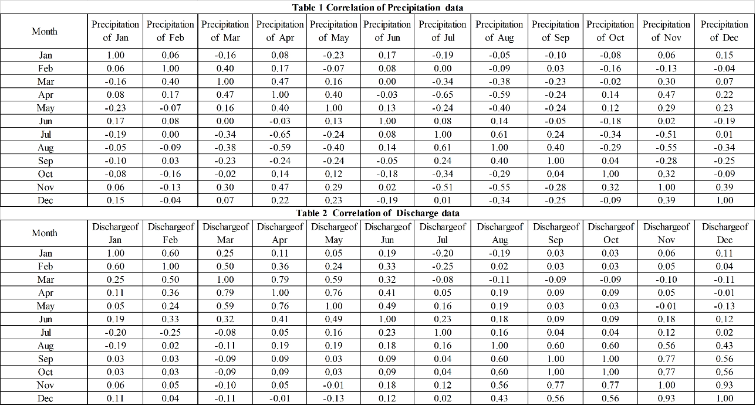

Supplementary V
Multi - regressions with running data

Correlation matrix: | SST Mean (X₁) | Pressure Mean (X₂) | Basin Mean Temp. (X₃) | Basin Mean Precipitation (mm) (X₄) | Mean Discharge (Y)
Running SST Annual Mean (X₁) | 1.000 | 1.000 | 0.999 | 0.182 | 0.408
Pre-Annual Mean (X₂) | 1.000 | 1.000 | 0.999 | 0.182 | 0.398
Basin Average (Mean) Temp X₃ | 0.999 | 0.999 | 1.000 | 0.184 | 0.400
Basin Mean Precipitation (mm) X₄ | 0.182 | 0.182 | 0.184 | 1.000 | 0.222
Running Discharge (Y) | 0.398 | 0.398 | 0.400 | 0.222 | 1.000

