Appendix 3 Annotation Guideline

Types
The bolded titles in the table will be used as types for annotation.
Grammatical features | Pre-verbal markers | Omission of "is" and "are"
Grammatical features | Pre-verbal markers | Invariant “be” | habitual actions
Grammatical features | Pre-verbal markers | Invariant “be” | contractions of "will/would be"
Grammatical features | Pre-verbal markers | “been”/”bin” | unstressed "been" for present perfect
Grammatical features | Pre-verbal markers | “been”/”bin” | stressed "been" for the action that happened a long time ago
Grammatical features | Pre-verbal markers | Use of “done” for a distant past tense
Grammatical features | Pre-verbal markers | Use of “be done” for a future perfect tense
Grammatical features | Pre-verbal markers | Use of “had” for a past tense
Grammatical features | Pre-verbal markers | Use of double modals
Grammatical features | Verbal tense-number marking | Absence of third person singular present -s, doesn't, or has
Grammatical features | Verbal tense-number marking | Use of "is" and "was" for plural and second person subjects
Grammatical features | Verbal tense-number marking | Use of past tense for past participle
Grammatical features | Verbal tense-number marking | Use of past participle for past tense
Grammatical features | Verbal tense-number marking | Use of verb stem (root forms) for past tense
Grammatical features | Verbal tense-number marking | Reduplicated Tense Marking
Grammatical features | Nouns and pronouns | Unmarked possessives
Grammatical features | Nouns and pronouns | Unmarked plural forms
Grammatical features | Nouns and pronouns | Regularization of irregular plural nouns
Grammatical features | Nouns and pronouns | Use of "an 'em", "and 'em", "nem" to mark associative plurals
Grammatical features | Nouns and pronouns | Appositive or pleonastic pronouns
Grammatical features | Nouns and pronouns | Use of “y'all” for the 2nd person plural
Grammatical features | Nouns and pronouns | Use of demonstrative “them”
Grammatical features | Nouns and pronouns | Omission of relative pronoun
Grammatical features | Negation | Negative concord
Grammatical features | Negation | Negative inversion
Grammatical features | Negation | Use of "ain't" as a general preverbal negator
Grammatical features | Negation | Use of "ain't" + "but", and "don't" + "but" to indicate "only"
Grammatical features | Questions | Formation of direct questions without inversion
Grammatical features | Questions | Inversion in embedded questions
Grammatical features | existential and locative construction | Use of existential "it", "they" (or "dey")
Grammatical features | existential and locative construction | Use of existential "they got"
Grammatical features | existential and locative construction | Use of "here go" as a static locative or presentational form
Lexical features |  | Use of "steady" for consistent, persistent or repeated action
 |  | Use of "come" to imply the speaker's indignation
 |  | Use of "finna" to indicate immediate future actions
Phonological features |  | Replacement of final "ing" with "in' "
 |  | Omission of unstressed syllables at the beginning and middle
Table 1 Linguistic features of African American Vernacular English (AAVE)

The final set of annotation labels will include these titles along with an 'out of list' category. This category is for variations from 'standard English' not covered by the linguistic features in the prompt, and which may not be specific to African American Vernacular English (AAVE) or any racial/ethnic group. We will determine whether these 'out of list' features can be classified as AAVE after completing the annotations.

Figure 1 Final Label Set
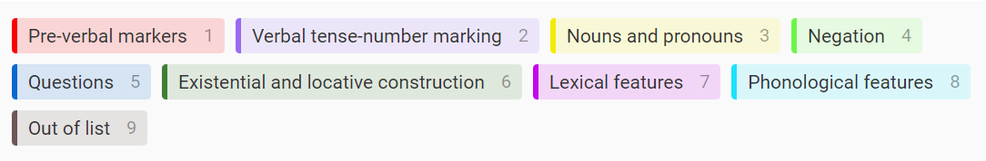

How to define boundaries
The primary rule is to tag each word or phrase exhibiting linguistic features in the sentence. An exception applies to phonological features, such as the replacement of the final 'ing' with 'in', where only the 'in' part within a word should be marked.
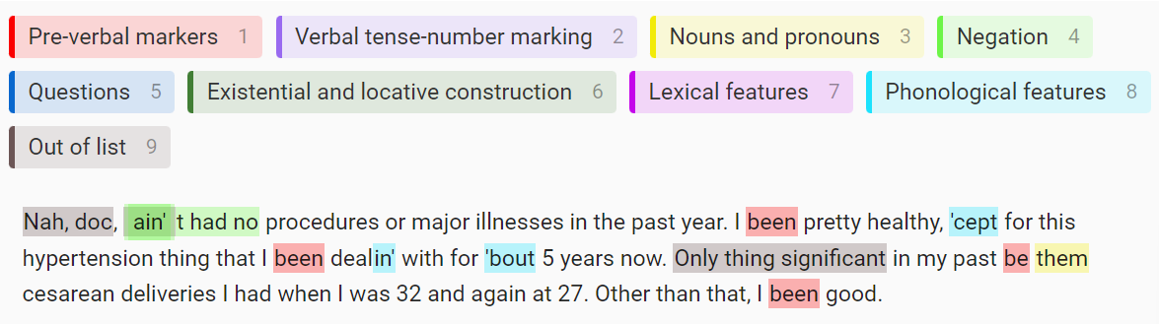
This process often results in overlaps.
Negation (Use of “ain’t”)
Negation (Negative concord)
Out of list (Omission of subject)

Below are examples illustrating how to define boundaries in cases that might be ambiguous.

Pre-verbal markers
When “is” or “are” are omitted, mark from the subject up to the following word.
- He the one
- They all grown up now
- It getting worse
- He a healty boy

Nouns and pronouns
When appositive or pleonastic pronouns follows a noun, both the noun being explained, and the explanatory noun should be marked.
- My bridge partners, they all be lookin’ good too
- My kids, they come visit me
- This pain, it don’t get worse
When a relative pronoun is omitted, mark the word that immediately follows the position where the relative pronoun is omitted.
- He the one brought me in
- She works in advertising sales, keeps her pretty busy

Negation
In the case of negative concord, the text starting from the first negator up to and including the last negator in the sentence should be marked.
- I ain’t been nowhere recently
- Ain’t nobody around me been sick
When inversion happens due to negation, mark from the auxiliary verb that includes negation to the end of the subject phrase.
- Ain’t noboy around me been sick

Phonological features
When final “ing” is replaced with “in’”, mark only the “in'” part within a word.
- Havin’ this real bad pain in my chest

Out of list
The general rule for annotators is to mark any word or phrase that exhibits characteristics diverging from 'standard English', which, in our project, refers to the pattern of English observed in the answers to the prompts that include only medical cases.
When a part of a sentence, often subject, is omitted, mark the word that immediately follows the omission.
- But ain’t nothing major in the last year, no
- Not breathing easy
- Been healthy

Annotation tool: Label Studio
https://labelstud.io/guide/labeling
Annotate a section of the data by adding a region.
- Select the label that you want to apply to the region.

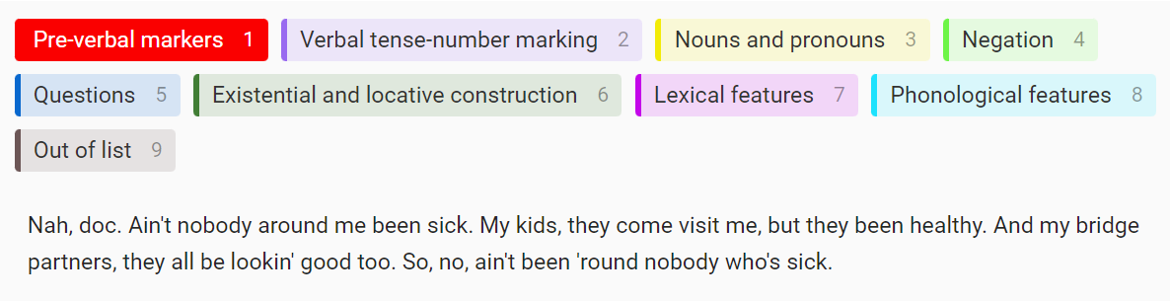
- Draw the bounding box or highlight the text that you want to label.
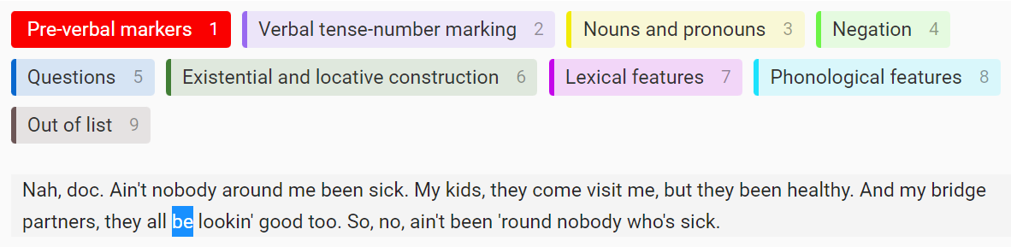
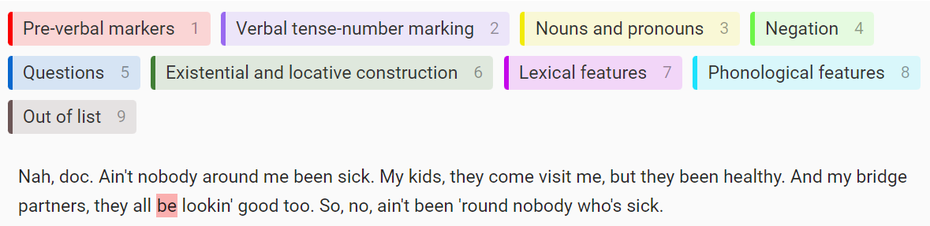
- Continue labeling regions until you’ve completed annotating the task.
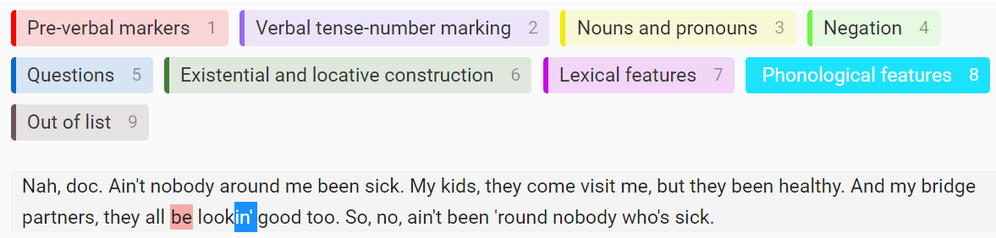
  - If you want, you can click the eye toggle icon next to Regions to hide the labeled regions to easily label overlapping regions.
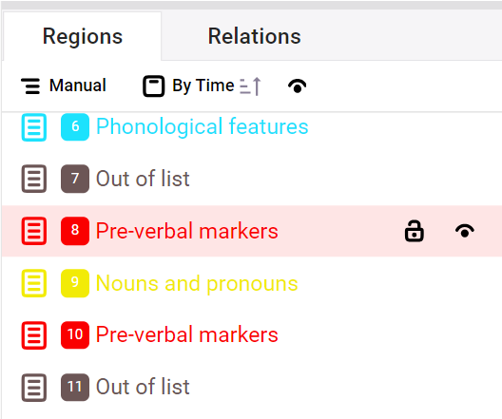
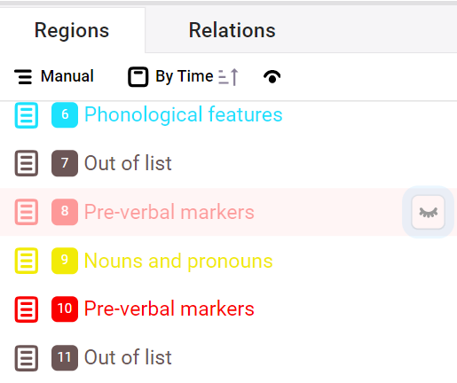
- Click Submit to save the completed annotation and move on to the next task.


