Performance on the treatment of octogen wastewater by Fe-C micro-electrolysis
Guodong Chai ^{1,2,3a}, Haoting Xiong ^{3a}, Yishi Qian⁴, Lin Xie ³, Yi Xiao ³,
Dongqi Wang ^{2,3,5}, Yishan Lin ^{6,*}
¹ CCTEG Xi’an Research Institute (Group) Co., Ltd., Xi'an, Shaanxi 710077, China
²State Key Laboratory of Eco-hydraulics in Northwest Arid Region, Xi'an University of Technology, Xi'an, Shaanxi 710048, China;
³Department of Municipal and Environmental Engineering, School of Water Resources and Hydro-Electric Engineering, Xi'an University of Technology, Xi'an, Shaanxi 710048, China
⁴ Xi'an Modern Chemistry Research Institute, Xi'an, Shaanxi 710065, China;
⁵Shaanxi Key Laboratory of Water Resources and Environment, Xi'an University of Technology, Xi'an, Shaanxi 710048, China;
⁶ Shaanxi Key Laboratory of Earth Surface System and Environmental Carrying Capacity, College of Urban and Environmental Sciences, Northwest University, Xi'an 710127, China;

1. Materials and methods
Before the experiment, the strains were taken from the ultra-low temperature refrigerator and inoculated into 96-well plates. For 96-well plates, 120μl LB medium was added to each well, and then 20μl of thawed bacterial solution was added. The inoculated 96-well plates were cultured overnight at 37 °C (16-22h). A 1x M9 medium was used to dilute the bacterial solution at a ratio of 1:5, and the bacterial solution in the 96-well plate was transferred to the 384-well plate (with a certain arrangement order) by using the automatic pipetting workstation (German, Eppendorf AG, epMotion5075t). For the 384-well plate, 55 μl 1x M9 medium was added to each well, and then 5 μl bacterial solution was added and cultured at 37 °C for 5 h-6 h to make the optical density (OD) reach the early exponential growth stage (OD~0.2); after culture, 10 μl of different doses of disinfection by-products diluted with 1 x M9 medium were added to each well of the 384-well plate. To determine the effect of HMX-induced gene transcription level, the 384-well plate was placed in a microplate cell imaging system for simultaneous measurement of optical density (OD600, cell growth) and fluorescence readings (GFP level, Ex: 45 nm, Em: 528 nm). To develop a relatively rapid toxicity assessment method, the exposure time was selected as 2 h, and the reading was measured every 5 min. All tests were conducted in the dark and repeated three times.
All data were corrected by blank medium and promoterless bacterial controls (with and without toxicants), respectively. The gene expression alteration was called induction factor I (I=P_{e}/P_{c}), where Pe = (GFP/OD) _{experiment} and Pc = (GFP/OD) _{control}. Then, the natural log of the I value (ln(I)) at every time point is compiled for further analysis(Gou and Gu, 2011). The toxicity values of chemicals were quantified by the TELI, and TELI values represent the magnitude of altered gene expression for each gene response to toxicant exposure for 2h (a test chemical is defined as toxic when the TELI value is >1.5) (Gou et al., 2014). The calculation method uses the following equation (Gou and Gu, 2011):
${\text{TELI}}_{\text{gene}}\text{=}\frac{\int_{\text{t=0}}^{\text{t}}{\left({\text{e}}^{\left|\text{lnI}\right|}\text{-}{\text{e}}^{\left|\text{ln1}\right|}\right)\text{dt}}}{\text{Exposure Time}}$ （1）
${\text{TELI}}_{\text{stress}}\text{=}\frac{\sum_{\text{i=1}}^{\text{n}}{\text{wi×(}{\text{TELI}}_{\text{genei}}\text{)}}}{\text{n}}$ （2）
${\text{TELI}}_{\text{total}}\text{=}\frac{\sum_{\text{j=1}}^{\text{n}}{\text{wj×(}{\text{TELI}}_{\text{pathwayj}}\text{)}}}{\text{n}}$ （3）
where t (h) is the exposure time; i and j are the number of genes/stress pathway in the assay library; wi and wj are the weighting factors for the gene (i) and pathway (j); and in this study, all weighting factors were assigned a value of 1.

2. Figures
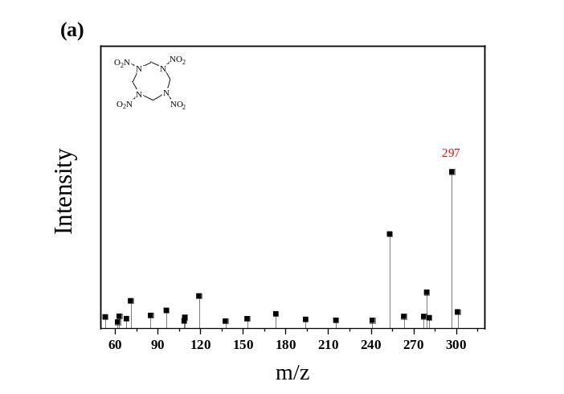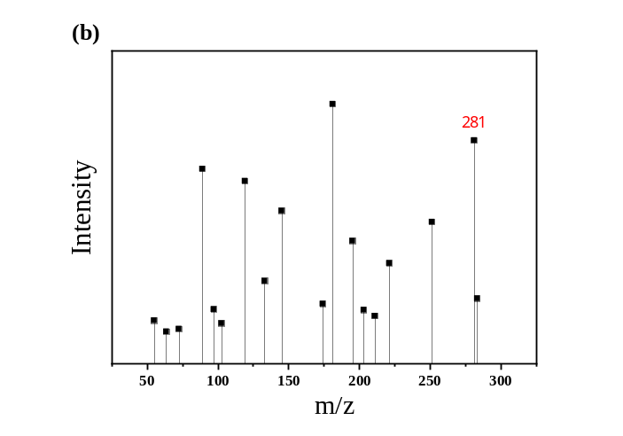
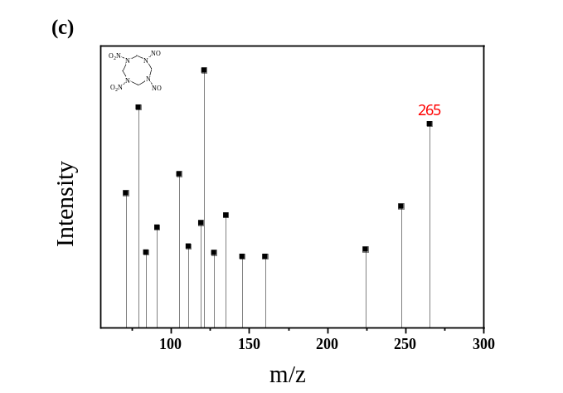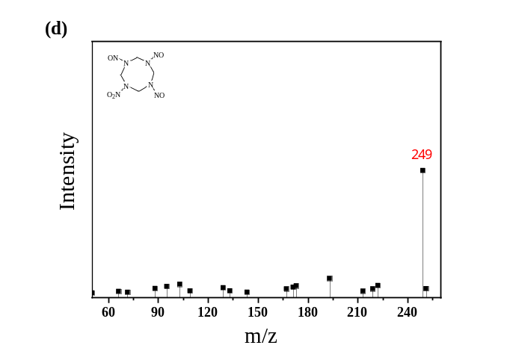
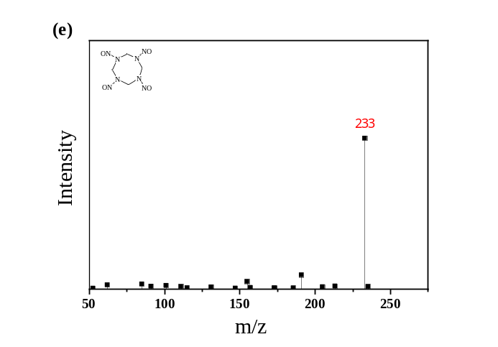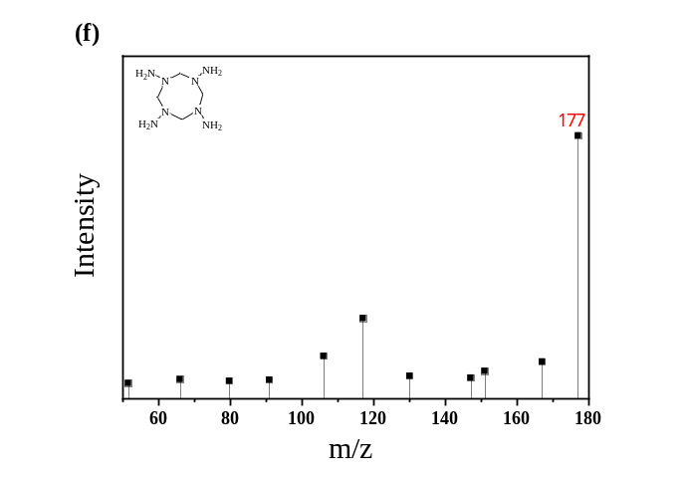
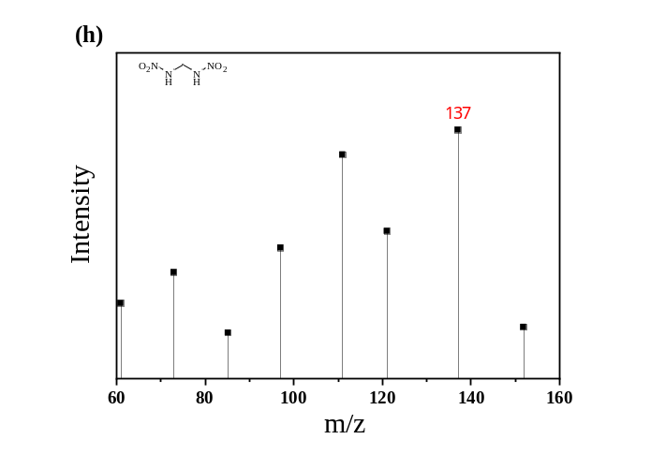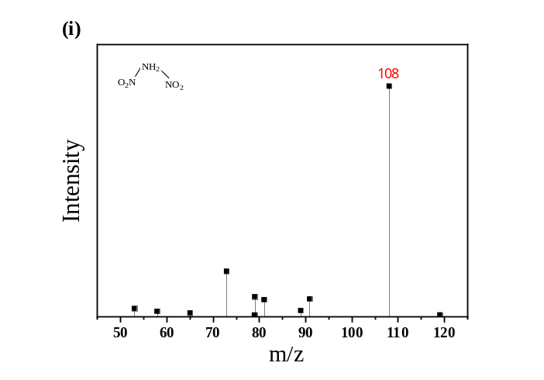
Figure.S1 Ion spectrum of HMX degradation intermediate products in positive ion mode

3. Tables
Table S1. Single-factor experimental design.
No. | Fe²⁺ dosage (g/L) | Activated carbon（g/L） | Initial pH | Fe/C mass ratio
1 | 30.0 | 30.0 | 2.0
2 | 30.0 | 30.0 | 3.0
3 | 30.0 | 30.0 | 4.0
4 | 30.0 | 30.0 | 5.0
5 | 30.0 | 30.0 | 6.0
6 | 30.0 | 30.0 | 7.0
7 | 10.0 | 30.0 | 4.0
8 | 20.0 | 30.0 | 4.0
9 | 30.0 | 30.0 | 4.0
10 | 40.0 | 30.0 | 4.0
11 | 50.0 | 30.0 | 4.0
12 | 60.0 | 30.0 | 4.0
13 | 70.0 | 30.0 | 4.0
14 |  |  | 4.0 | 0.5
15 |  |  | 4.0 | 0.6
16 |  |  | 4.0 | 0.8
17 |  |  | 4.0 | 0.9
18 |  |  | 4.0 | 1.0
19 |  |  | 4.0 | 1.1
20 |  |  | 4.0 | 1.2
21 |  |  | 4.0 | 1.3
22 |  |  | 4.0 | 1.4

Table S2. Stress gene library and its main functions。
Category |  |  | Gene selected | Known functions
Genotoxic Stress |  |  | uvrA, recE, clpB, rnt, recX, ada, dinB, mutT, nfo, ding, ftsk, recN, sbmC, ybfE, dnaQ, mutH, mutM, mutS, mutY, yjiW, mug, yebG, sulA, lexA, polB, recA, ssb, umuD, uvrD, ruvA, uvrC, uvrY, polA | DNA strand breaks and cross-linking, alter superhelicity, oxidative DNA damage, base alkylation, inhibition of DNA synthesis and replication
Redox Stress | Oxidation |  | soxS, soxR, oxyR, inaA, dps, ahpF, katG, sodA, ahpC, katE, ytfE, katE, sodB, sodC, trxA | Increased levels of superoxides, increased levels of peroxides, any other conditions, which alter the redox potential of the cell. Genes response to oxidative stress
Redox Stress | Detoxification |  | norR, fpr, tam, yeiG, yafN, yeaE, grxA, gst
Protein Stress |  |  | clpB, ycgE, cueR, entC, grpE, dnaK, fepB, dnaJ, rpoD, lon,ybgl | Denaturation, misfolding, cross-linking and alkylation of proteins, oxidation of individual amino acids and protein damage.
Membrane Stress |  | Energy stress | sdhC, cyoA | Perturbations of electron transport and exposure to uncoupling agents, which affect ATP levels in the cell.
 |  | Drug resistance | yedW, dacA, dacB, marR, sbmA, bacA, yhjX, emrE, sanA, emrA, marC, mdtK, yajR, fsr, cmr, mrcB, pbpG, ssrA, ompC | Related to compound /chemical  induced stress, most product located or functioned at inner or outer membrane
 |  | Metabolism | flgM、motA、cyoA
 |  | Cell Membrane | amiC, clsA, | Related to cell membrane and phospholipid synthesis
General Stress |  | Cold shock | cspA, cspB | Temperature downshift
 |  | Cell killing | dinJ,、slyA、yeeV、 yfjG
 |  | General stress | uspA, otsB, ydgL, bolA, rpoE, | Disturbance of the biochemical and biophysical homeostasis of the cell.

Table S3 Main degradation intermediates of HMX
Mid product | M+[H] | Possible  molecular  formulas | Molecular Structure | CAS
Original sample | 297 | C₄H₈N₈O₈ | 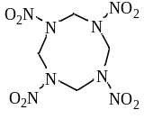 | 2691-41-0
Ⅱ | 281 | C₄H₈N₈O₇ | 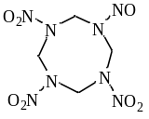 | —
Ⅲ | 265 | C₄H₈N₈O₆ | 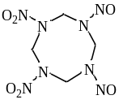
Ⅳ | 249 | C₄H₈N₈O₅ | 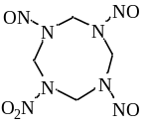
Ⅴ | 233 | C₄H₈N₈O₄ | 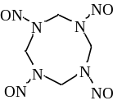
Ⅵ | 177 | C₄H₁₆N₈ | 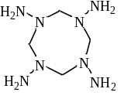
Ⅶ | 137 | CH₄N₄O₄ | 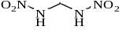 | 14168-44-6
Ⅷ | 108 | HN₃O₄ | 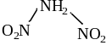

Reference

Gou, N., Gu, A.Z., 2011. A new transcriptional effect level index (TELI) for toxicogenomics-based toxicity assessment. Environmental science & technology 45, 5410-5417.
Gou, N., Yuan, S., Lan, J., Gao, C., Alshawabkeh, A.N., Gu, A.Z., 2014. A quantitative toxicogenomics assay reveals the evolution and nature of toxicity during the transformation of environmental pollutants. Environmental science & technology 48, 8855-8863.

ª Contributed equally to this study. Corresponding author. E-mail address: wangdq@xaut.edu.cn (D. Wang); yshanlisa@hotemail.com (Y. Lin)

