Empirical Evidence for a Meta-Theoretical Process-Based Model of Health-Related Quality of Life Using Network Analysis
  - Supplemental Materials

Table S1: Raw Centrality Indices 1
Figure S1: Results from edge weight accuracy 2
Figure S2: Results from node centrality stability tests 2
Figure S3: Item Stability Statistics 3

Table S1: Raw Centrality Indices
Node | Strength | Betweenness | Closeness
EUROIA - Social Affiliation | -0.12 | 1.10 | 0.61
EUROIA - Self Affirmation | -0.13 | -0.54 | -0.86
EUROIA - Roles/Responsibilities | -0.85 | -0.97 | -1.22
EUROIA - Eudaimonic Well-being | 0.67 | 0.12 | -0.28
ENRICHD Social Support | 0.33 | 1.42 | 1.29
Leisure Activities | -2.08 | -0.75 | -1.13
UCLA Loneliness Scale | 0.97 | 1.75 | 1.72
Flourishing Scale | -1.04 | -0.97 | -0.76
MCS - Role Limitation | -0.44 | -0.97 | -0.32
MCS - Emotional Well-being | 1.64 | 1.10 | 1.42
MCS - Vitality | 0.54 | -0.21 | 0.44
MCS - Social Functioning | 0.98 | -0.21 | -0.19
Self-efficacy Managing Chronic Disease | -0.46 | -0.86 | -0.71

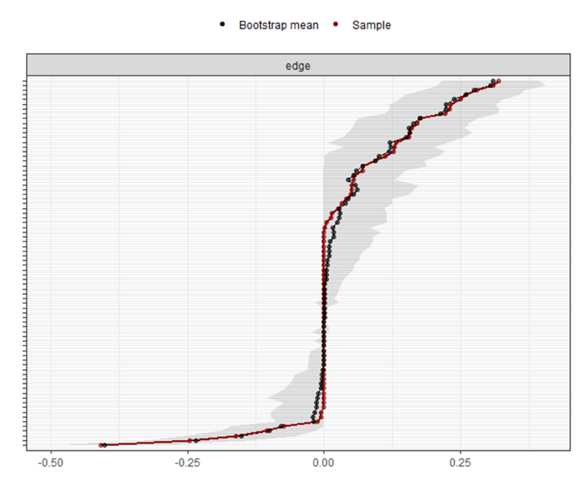
Figure S1: Results from edge weight accuracy

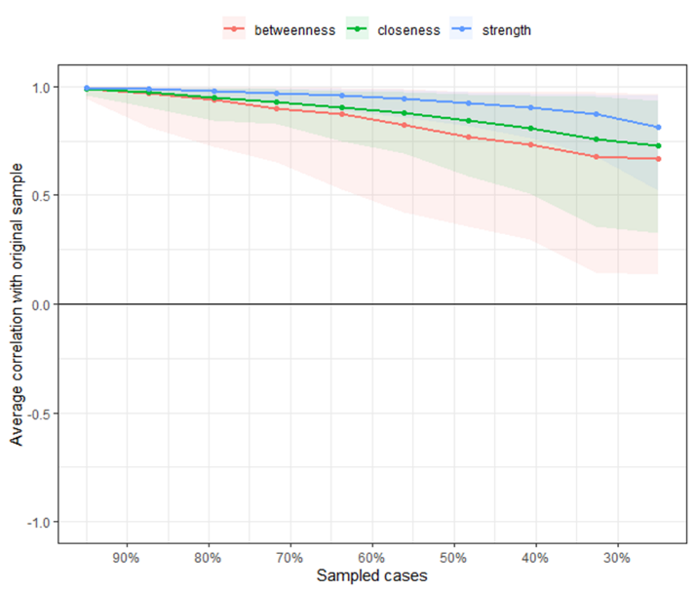
Figure S2: Results from node centrality stability tests

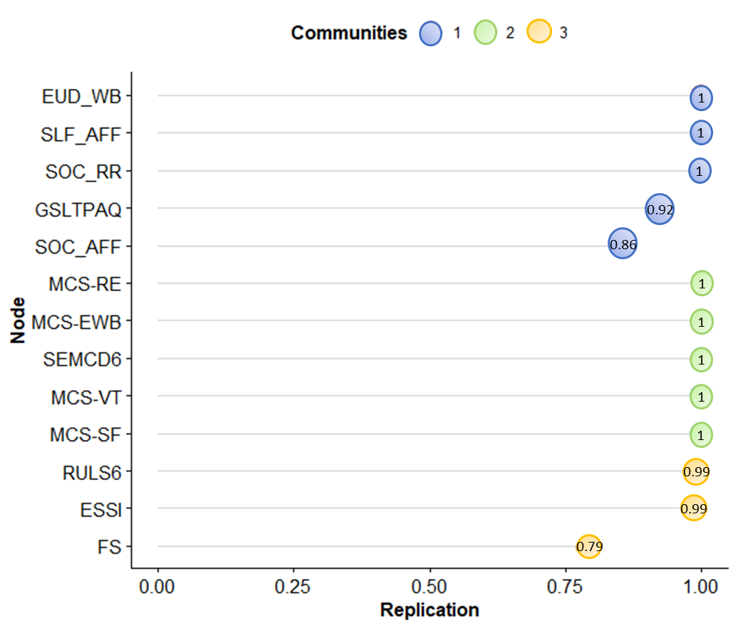
Figure S3: Item stability statistics

