Appendix A. Supplementary material

Cellular response in the resilience of Microcystis aeruginosa under polyaluminum chloride exposure

Eun-jeong Kim^{1,†}, Yeon-jeong Park^{2,†}, Jae Hak Lee³, Heesuk Lee², Jihye Yang¹, Han Soon Kim⁴, Seong-il Eyun^{1,*}

¹Department of Life Science, Chung-Ang University, Seoul 06974, Korea
²Water environmental Management Department, Korea Water Resources Corporation, Daejeon 34350, Korea
³Freshwater Bioresources Culture Collection (FBCC), Nakdonggang National Institute of Biological Resources, Sangju 37242, Korea
⁴Department of Life Science, Kyungpook National University, Daegu 41566, Korea

† These authors contributed equally to this work.
* Corresponding author: S. Eyun (eyun@cau.ac.kr)
SUPPLEMENTARY FIGURES AND TABLES
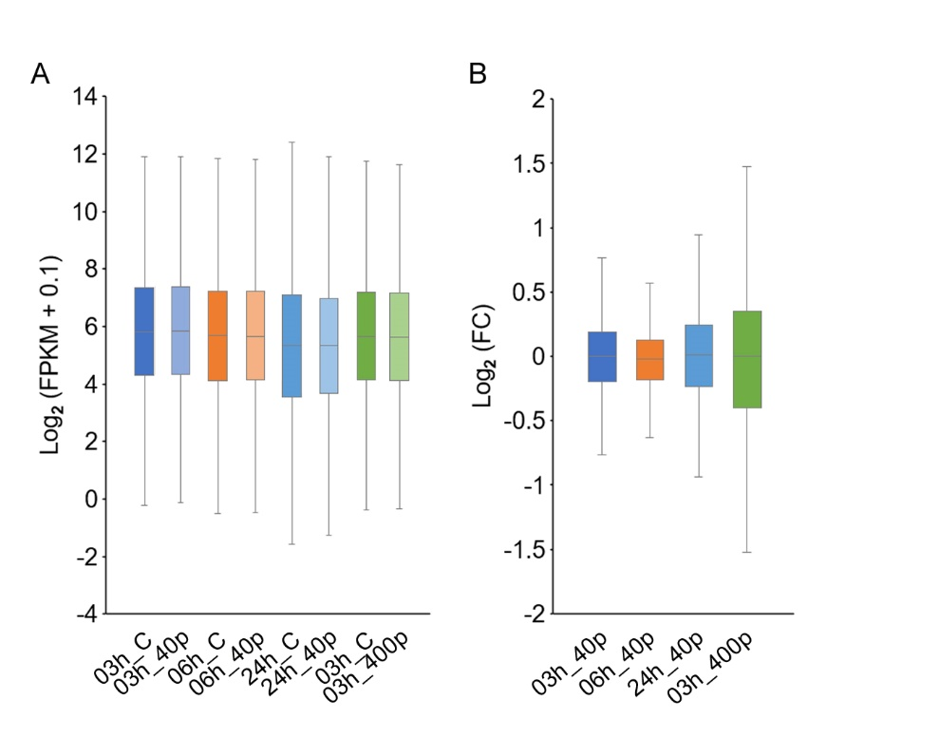
Fig. S1. The bar plot of DEG.
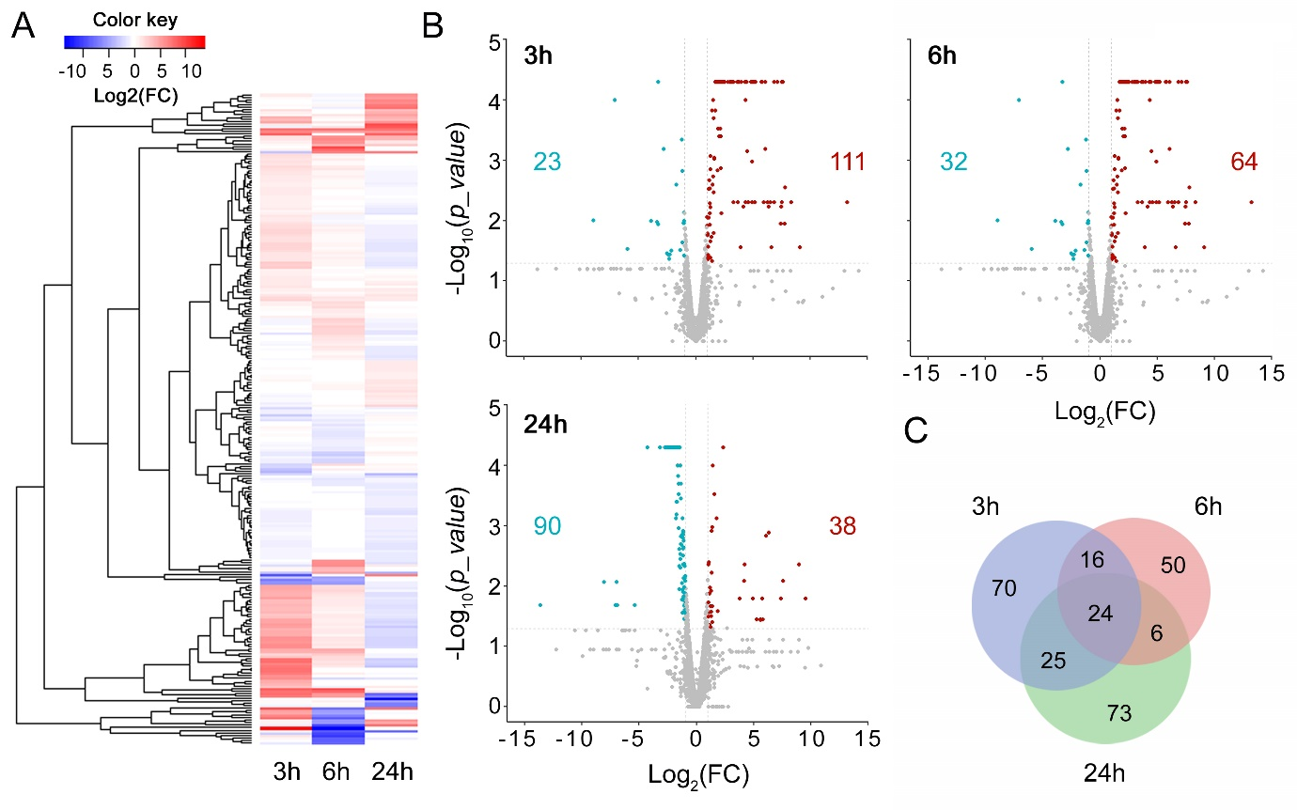
Fig. S2. The differential expression of genes in response to low PAC exposure in Microcystis aeruginosa. A) Heatmap displays the expression patterns of 358 DEGs at each time point. B) Volcano plots showing differentially expressed up-regulated (in red) and down-regulated (in sky blue) genes. The numbers in each color represent only DEGs with a p-value > 0.05 and absolute value Log₂ (fold change) ≥ 1. Each volcano plot corresponds to the time points of 3, 6, and 24 hours, and the numbers of genes are 134, 96, and 128, respectively. C) Venn diagram showing the unique and overlapping genes between DEGs identified at each time point.
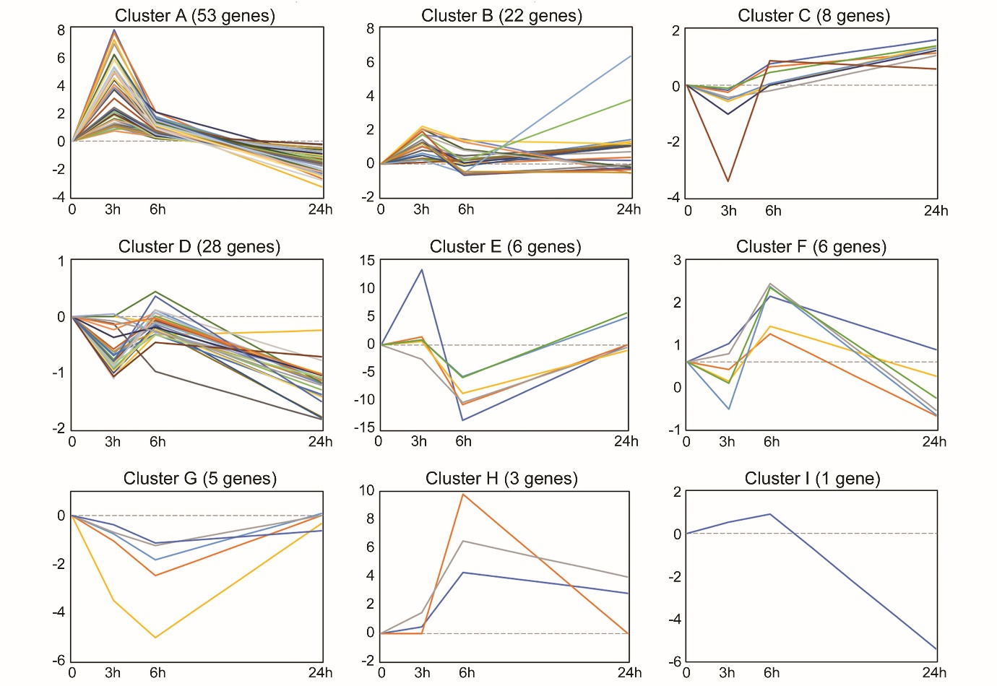
Fig. S3. Cluster analysis in DEGs at low PAC exposure.
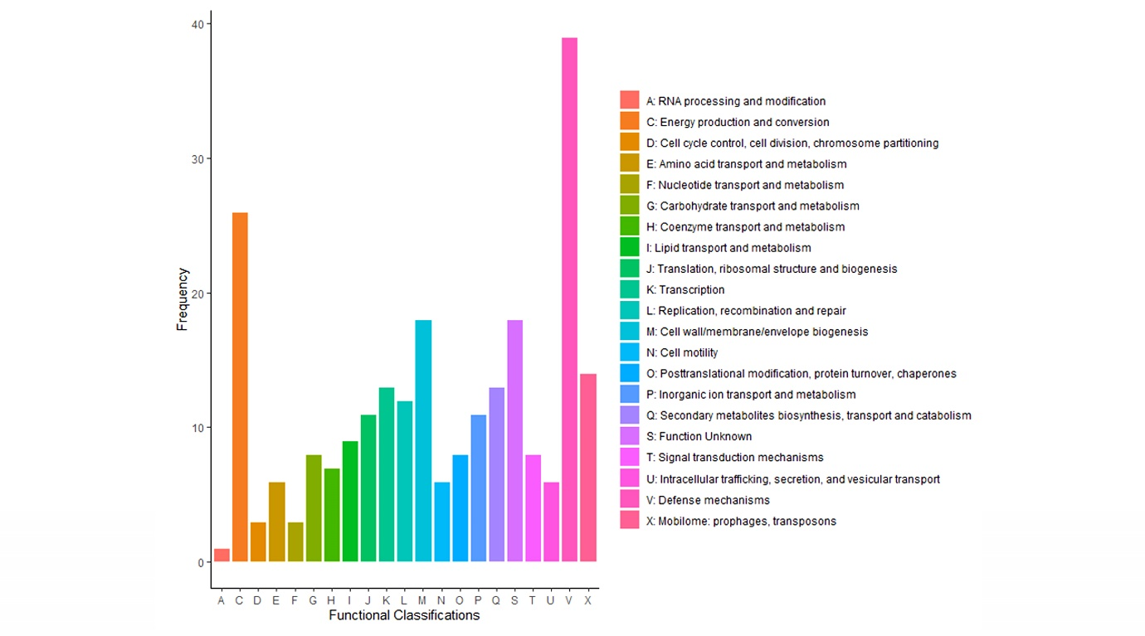
Fig. S4. 264 DEGs classifications of low PAC exposure including 3 hours, 6 hours, and 24 hours using the COG database. Functional classes are described in the right panel. COG: Clusters of Orthologous Genes.
Table S1. Cell numbers for the control, low, and high PAC exposure and doubling time between the control and low PAC exposure.
Time (hours) | No treatment | 40 ppm | 400 ppm
3  6  24  48  72  96  120  144  168  192  216  240  264  288  312  336  360  384  408  432  456  480  504  528  552 | 688,000  806,000  923,333  1,185,333  1,199,333  1,604,000  2,008,667  2,413,333  2,818,000  3,222,667  5,852,267  8,481,867  11,111,467  13,741,067  16,370,667  19,000,267  21,629,867  24,259,467  26,889,067  29,518,667  32,148,267  34,777,867  37,407,467  40,037,067  42,666,667 | 676,667  772,000  768,667  836,667  951,333  1,271,333  1,591,333  1,911,333  2,231,333  2,551,333  3,792,356  5,033,378  6,274,400  7,515,422  8,756,444  9,997,467  11,238,489  12,479,511  13,720,533  14,961,556  16,202,578  17,443,600  18,684,622  19,925,644  21,166,667 | 694,000  729,333  523,333  502,000  516,000  429,467  342,933  256,400  169,867  83,333  77,778  72,222  66,667  61,111  55,556  50,000  44,444  38,889  33,333  27,778  22,222  16,667  11,111  5,556  0

 | In (2) | B | In (2) / B
No treatment | 0.6931472 | 0.0077 | 90 hours (3.75 days)
40ppm PAC treatment | 0.6931472 | 0.0068 | 101.9 hours (4.25 days)
The difference |  |  | 11.9 hours (0.5 days)
Table S2. Summary statistics of RNA-seq data from M. aeruginosa. It was sequenced by the Illumina Novaseq6000 platform with the read length of 101 bp.
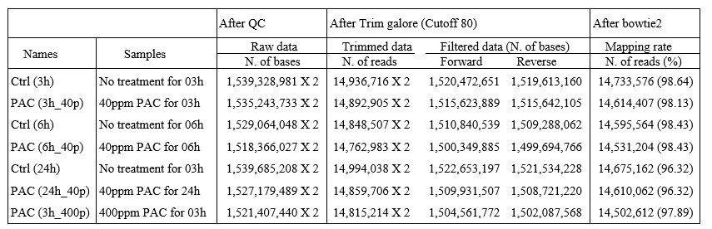
Table. S3. Type II toxin-antitoxin systems were significantly expressed in response to low and high PAC exposure. Upregulated genes are marked by green up-directed arrows, while downregulated genes are marked by red down-directed arrows.
