Supplementary Material
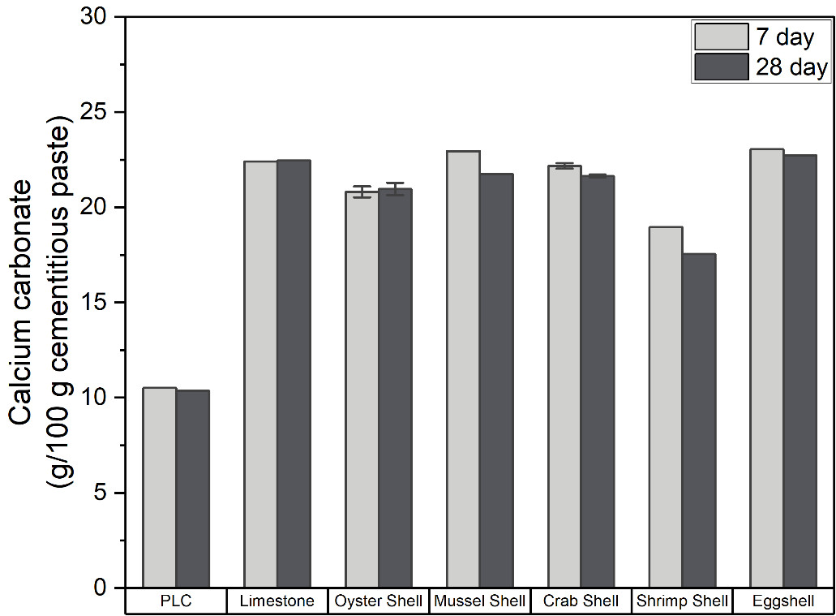
Fig S1. Amount of CaCO₃ in cement paste containing 20% limestone and waste shell powder at 20% cement replacement. Error bars indicate two standard deviations of the mean.

