Table 1. Parameters and impact values used for icing susceptibility mapping.
Parameters | Sub-parameters |  | Influence value | Weight percent | Total score
Aspect (°) | Flat (-1- -0,01) |  | 0 | 25 | 0
Aspect (°) | North (-0,01-22,5; 337,5-360)) |  | 9 | 25 | 225
Aspect (°) | Northeast (22,5-67,5) |  | 8 | 25 | 200
Aspect (°) | East (67,5-112,5) |  | 4 | 25 | 100
Aspect (°) | Southeast (112,5-157,5) |  | 2 | 25 | 50
Aspect (°) | South (157,5-202,5) |  | 1 | 25 | 25
Aspect (°) | Southwest (202,5-247,5) |  | 2 | 25 | 50
Aspect (°) | West (247,5-292,5) |  | 4 | 25 | 100
Aspect (°) | Northwest (295,5-337,5) |  | 8 | 25 | 200
Solar radiation (Watt/ m²) | December | <-500 | 8 | 25 | 160
Solar radiation (Watt/ m²) | December | 500-1000 | 7 | 25 | 140
Solar radiation (Watt/ m²) | December | 1000-2000 | 4 | 25 | 80
Solar radiation (Watt/ m²) | January | <-500 | 8 | 25 | 160
Solar radiation (Watt/ m²) | January | 500-1000 | 7 | 25 | 140
Solar radiation (Watt/ m²) | January | 1000-2000 | 4 | 25 | 80
Solar radiation (Watt/ m²) | January | 2000-3000 | 3 | 25 | 60
Solar radiation (Watt/ m²) | February | <-500 | 8 | 25 | 160
Solar radiation (Watt/ m²) | February | 500-1000 | 7 | 25 | 140
Solar radiation (Watt/ m²) | February | 1000-2000 | 4 | 25 | 80
Solar radiation (Watt/ m²) | February | 2000-3000 | 3 | 25 | 60
Solar radiation (Watt/ m²) | February | 3000-4000 | 2 | 25 | 40
Solar radiation (Watt/ m²) | March | <-500 | 8 | 25 | 160
Solar radiation (Watt/ m²) | March | 500-1000 | 7 | 25 | 140
Solar radiation (Watt/ m²) | March | 1000-2000 | 4 | 25 | 80
Solar radiation (Watt/ m²) | March | 2000-3000 | 3 | 25 | 60
Solar radiation (Watt/ m²) | March | 3000-4000 | 2 | 25 | 40
Solar radiation (Watt/ m²) | March | 4000-5000 | 1 | 25 | 20
Solar radiation (Watt/ m²) | April | <-500 | 8 | 25 | 160
Solar radiation (Watt/ m²) | April | 500-1000 | 7 | 25 | 140
Solar radiation (Watt/ m²) | April | 1000-2000 | 4 | 25 | 80
Solar radiation (Watt/ m²) | April | 2000-3000 | 3 | 25 | 60
Solar radiation (Watt/ m²) | April | 3000-4000 | 2 | 25 | 40
Solar radiation (Watt/ m²) | April | 4000-5000 | 1 | 25 | 20
Solar radiation (Watt/ m²) | April | 5000-6000 | 0 | 25 | 0
Slope (°) | 0-8 |  | 1 | 15 | 15
Slope (°) | 8-15 |  | 2 | 15 | 30
Slope (°) | 15-25 |  | 3 | 15 | 45
Slope (°) | 25-40 |  | 4 | 15 | 60
Precipitation (mm) | December | 46,9-47,5 | 1 | 15 | 15
Precipitation (mm) | December | 47,5-49,0 | 2 | 15 | 30
Precipitation (mm) | January | 38,9-39,4 | 1 | 15 | 15
Precipitation (mm) | January | 39,4 - 40,0 | 2 | 15 | 30
Precipitation (mm) | February | 0,6-7,9 | 1 | 15 | 15
Precipitation (mm) | February | 7,9-14,3 | 2 | 15 | 30
Precipitation (mm) | March | 0,6-7,9 | 1 | 15 | 15
Precipitation (mm) | March | 7,9-14,3 | 2 | 15 | 30
Precipitation (mm) | April | 54,757,6 | 1 | 15 | 15
Precipitation (mm) | April | 57,6-61,6 | 2 | 15 | 30
Temperature (C°) | December | -0,2 – 0,7 | 2 | 10 | 20
Temperature (C°) | December | 0,7 - 1,3 | 1 | 10 | 10
Temperature (C°) | January | -2,5--1,5 | 2 | 10 | 20
Temperature (C°) | January | -1,5--0,9 | 1 | 10 | 10
Temperature (C°) | February | -1,0-0,0 | 2 | 10 | 20
Temperature (C°) | February | 0.0-0.7 | 1 | 10 | 10
Temperature (C°) | March | 3,0-4,0 | 2 | 10 | 20
Temperature (C°) | March | 4.0-4.8 | 1 | 10 | 10
Temperature (C°) | April | 8.7-9.6 | 2 | 10 | 20
Temperature (C°) | April | 9,6-10,2 | 3 | 10 | 10
Elevation (m) | <-1.200 |  | 1 | 10 | 10
Elevation (m) | 1.200-1.250 |  | 2 | 10 | 20
Elevation (m) | 1.250-1.300 |  | 3 | 10 | 30
Elevation (m) | 1.300-1.350 |  | 4 | 10 | 40
Elevation (m) | >-1.400 |  | 5 | 10 | 50

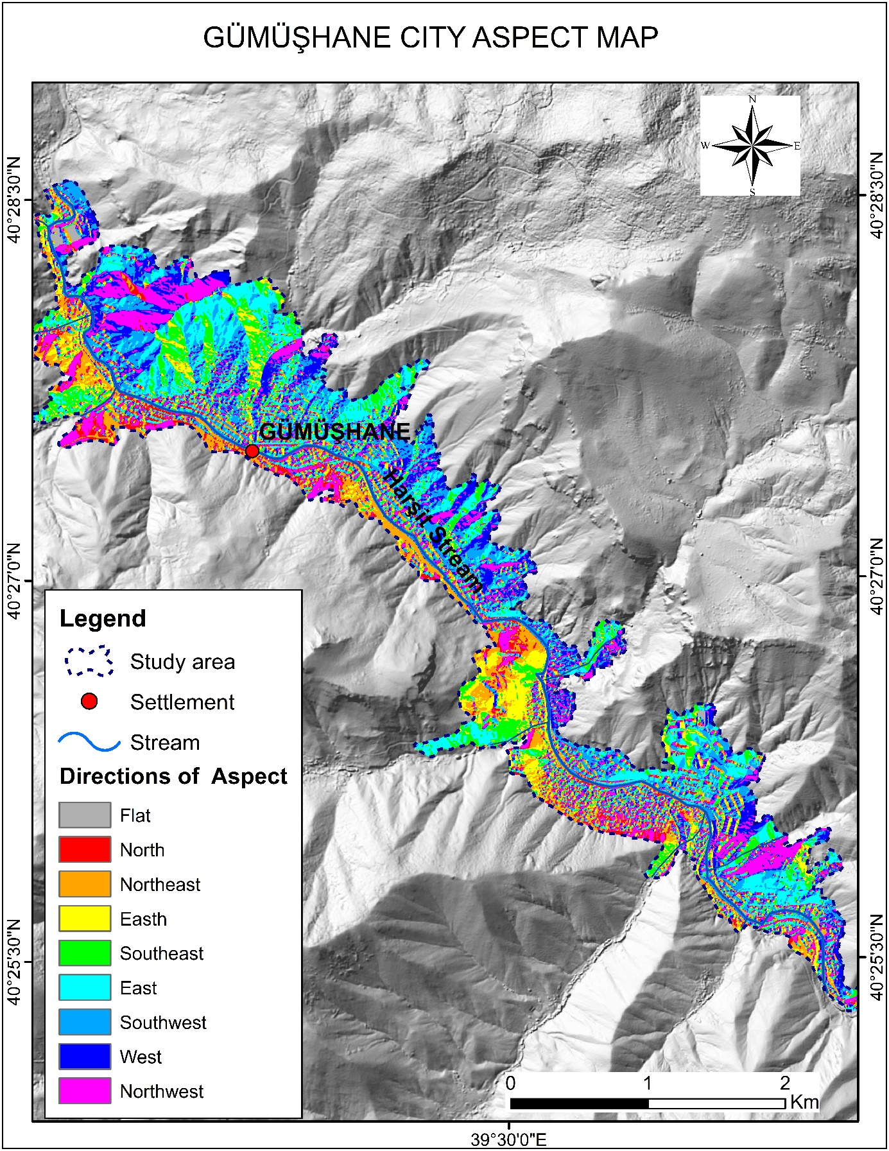
Figure 1. Gümüşhane city view map.

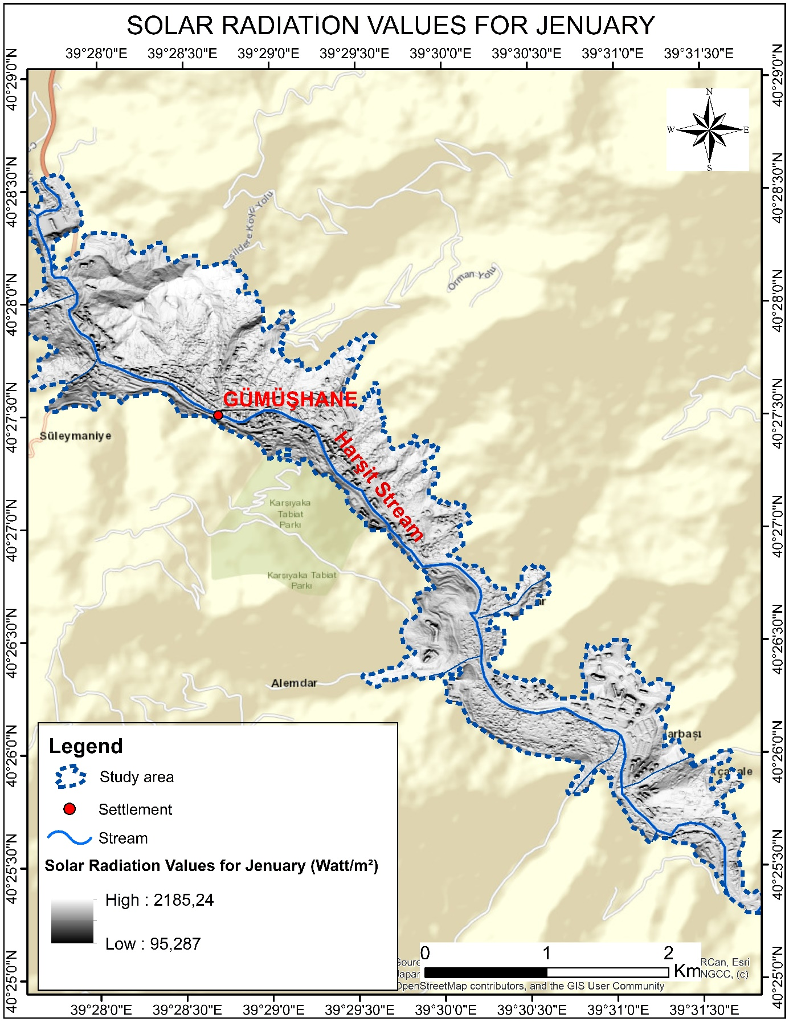
Figure 2. Solar radiation map of Gümüşhane city in January.

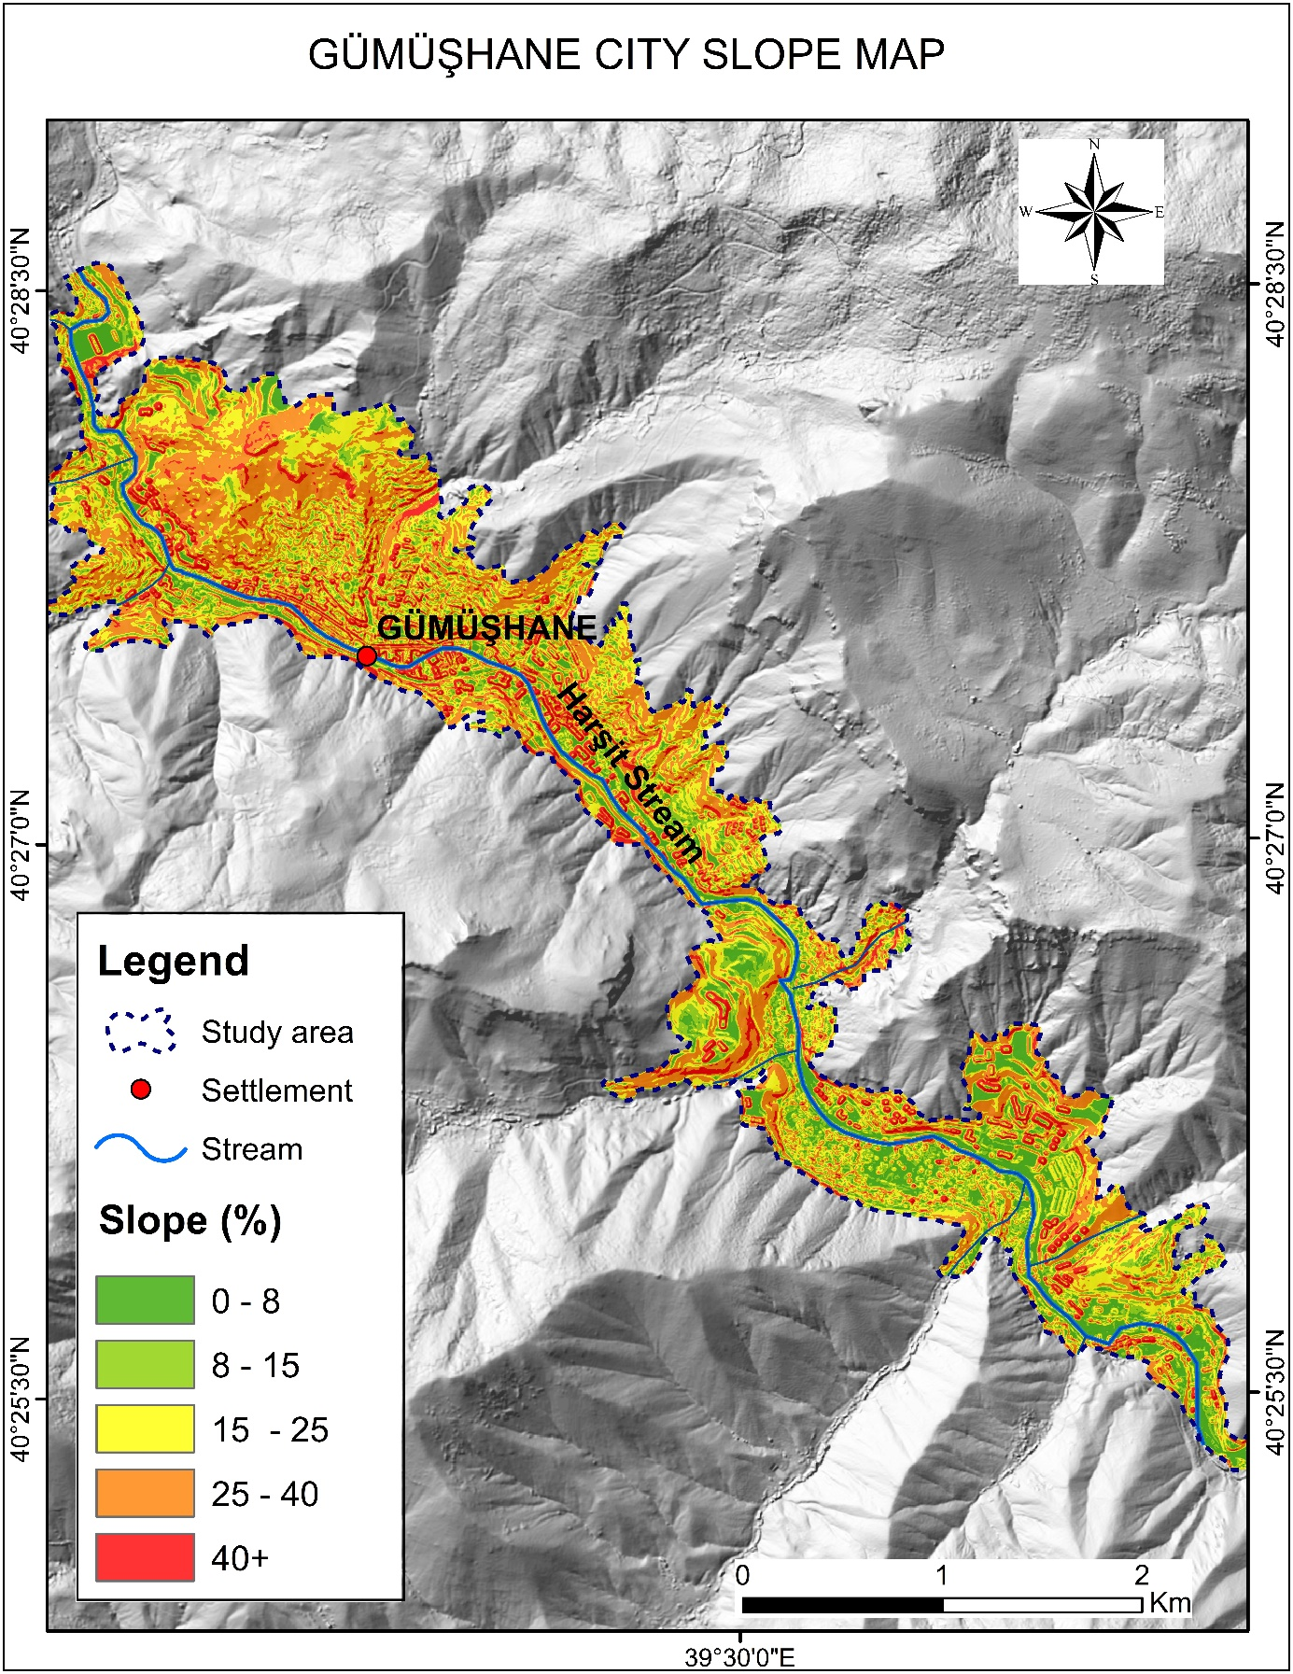
Figure 3. Gümüşhane city slope map.

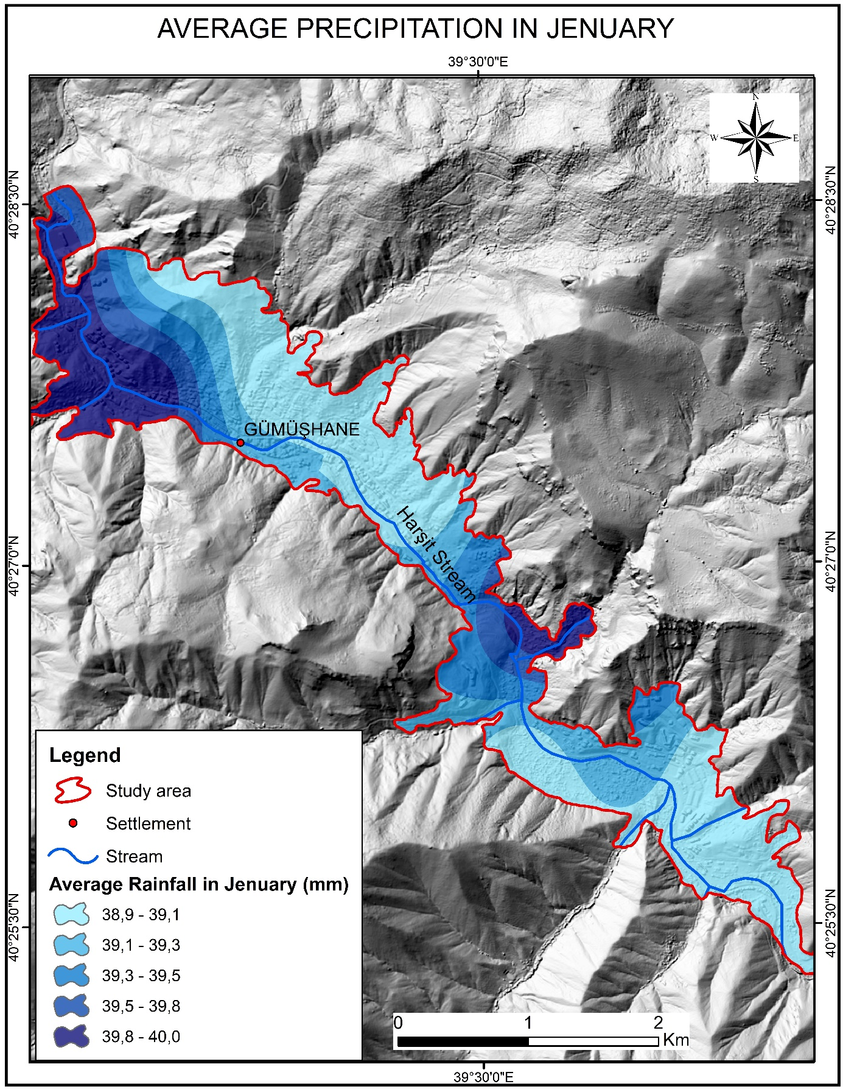
Figure 4. Map of total precipitation in January in Gümüşhane.

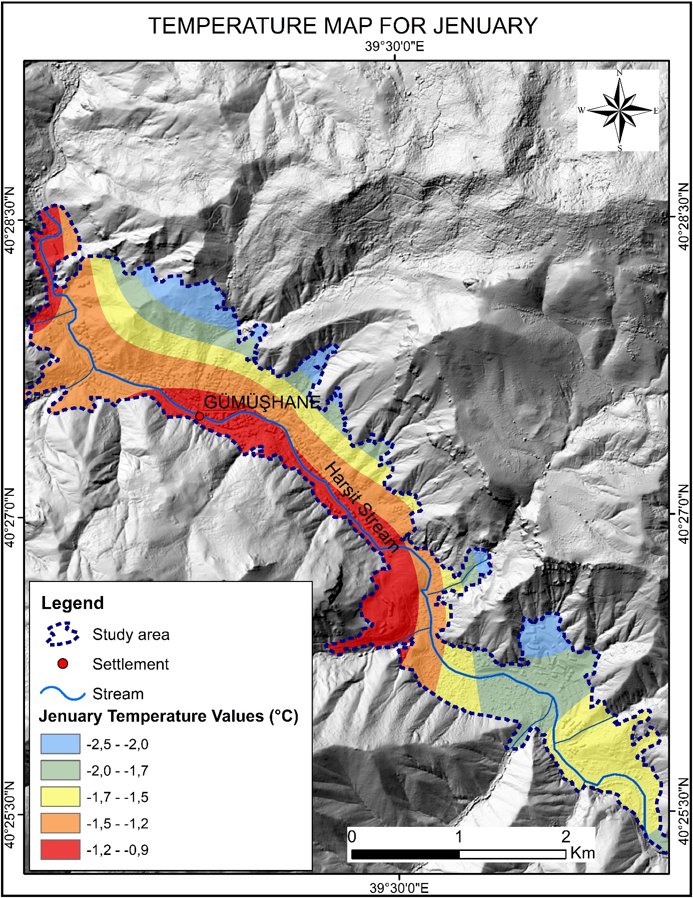
Figure 5. Gümüşhane city January temperature map.

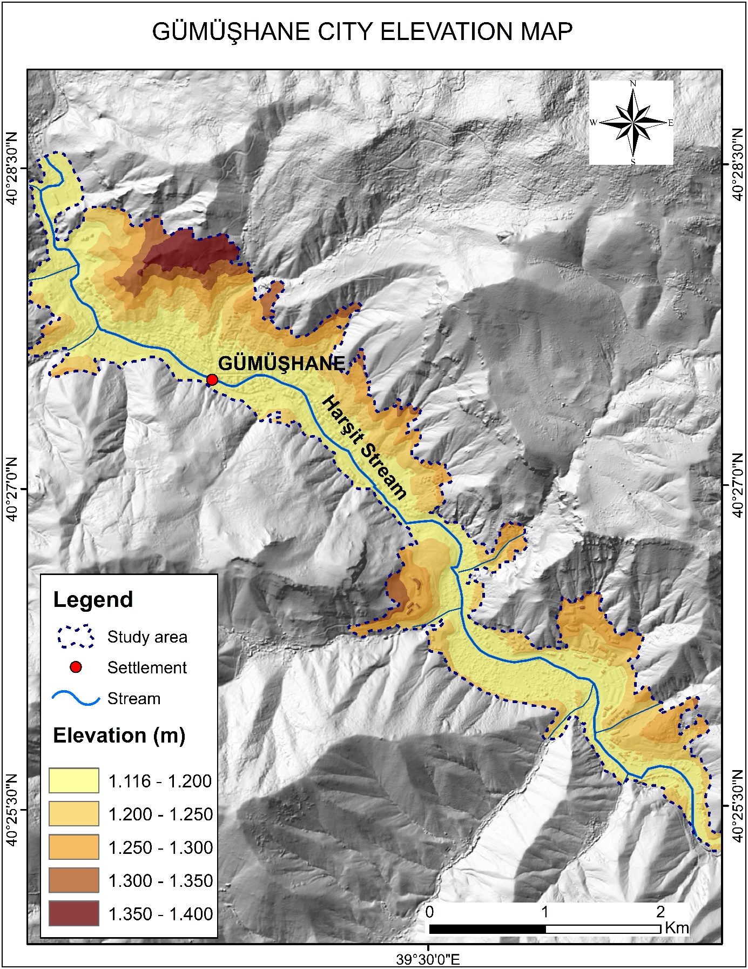
Figure 6. Gümüşhane city elevation map.

Table 2.Icing susceptibility groups, area and rate distributions.
Monthly | Icing Susceptibility Classes | Area (km²) | Rate (%)
December | Very Low | 1.55 | 24.39
December | Low | 1.81 | 28.57
December | Middle | 1.05 | 16.5
December | High | 0.92 | 14.46
December | Very High | 1.02 | 16.08
January | Very Low | 1.82 | 28.65
January | Low | 1.76 | 27.72
January | Middle | 0.92 | 14.55
January | High | 0.83 | 13.11
January | Very High | 1.02 | 15.97
February | Very Low | 0.83 | 12.99
February | Low | 1.96 | 30.84
February | Middle | 1.65 | 25.98
February | High | 0.84 | 13.26
February | Very High | 1.07 | 16.93
Mart | Very Low | 0.69 | 12.02
Mart | Low | 2.04 | 31.27
Mart | Middle | 1.64 | 26.66
Mart | High | 0.94 | 14.45
Mart | Very High | 1.04 | 15.6
April | Very Low | 1.51 | 23.75
April | Low | 1.97 | 31.02
April | Middle | 0.96 | 15.04
April | High | 0.93 | 14.65
April | Very High | 0.98 | 15.54
Total |  | 26.68

Table 3. Areas at Risk of Icing and Snowfall in Gümüşhane City Center During Winter Months
Month | Neighborhoods | Streets
December | Özcan Neighborhood | İnönü Avenue
December | Hasanbey Neighborhood | Muzaffer Demirbaş Street
December | İnönü Avenue | Bağlarbaşı Road
December | Muzaffer Demirbaş Street | Akçakale Road
December | Bağlarbaşı Road
January | Canca Neighborhood | İnönü Avenue
January | Özcan Neighborhood | Bahçeli Street
January | Güzel Avenue | Süleymaniye Road
January | Hasanbey Neighborhood
January | Karşıyaka Neighborhood
January | Bahçeli Street
January | Süleymaniye Road
February | Canca Neighborhood | Cumhuriyet Avenue
February | Özcan Neighborhood | İnönü Avenue
February | Şehit İlyas Boz Avenue | Atatürk Avenue
February | Güzel Avenue | Karşıyaka Neighborhood
February | Hasanbey Neighborhood | Muzaffer Demirhan Street
February | Süleymaniye Road | Kadirbeyli Street
February | Cumhuriyet Avenue | Bağlarbaşı Road
February | İnönü Avenue | Akçakale Neighborhood
February | Atatürk Avenue
February | Karşıyaka Neighborhood
February | Bahçeli Street
February | Muzaffer Demirhan Street
February | Kadirbeyli Street
February | Bağlarbaşı Road
February | Akçakale Neighborhood
March | Özcan Neighborhood | Yunus Emre Avenue
March | Süleymaniye Road | Bağlarbaşı Road
March | İnönü Avenue | Akçakale Neighborhood
March | Karşıyaka Neighborhood
March | Bahçeli Street
March | Muzaffer Demirhan Street
March | Kadirbeyli Street
March | Mevlâna Avenue
March | Yunus Emre Avenue
March | Bağlarbaşı Road
March | Akçakale Neighborhood
April | Özcan Neighborhood | Cumhuriyet Avenue
April | Şehit İlyas Boz Avenue | İnönü Avenue
April | Güzel Avenue | Atatürk Avenue
April | Hasanbey Neighborhood | Karşıyaka Neighborhood
April | Süleymaniye Road
April | İnönü Avenue
April | Cumhuriyet Avenue
April | Karşıyaka Neighborhood
April | Atatürk Avenue
April | Bahçeli Street (1 and 2)
April | Muzaffer Demirhan Street
April | 15 Şubat Avenue
April | Kazımkarabekir Avenue
April | Bağlarbaşı Road
April | Akçakale Neighborhood

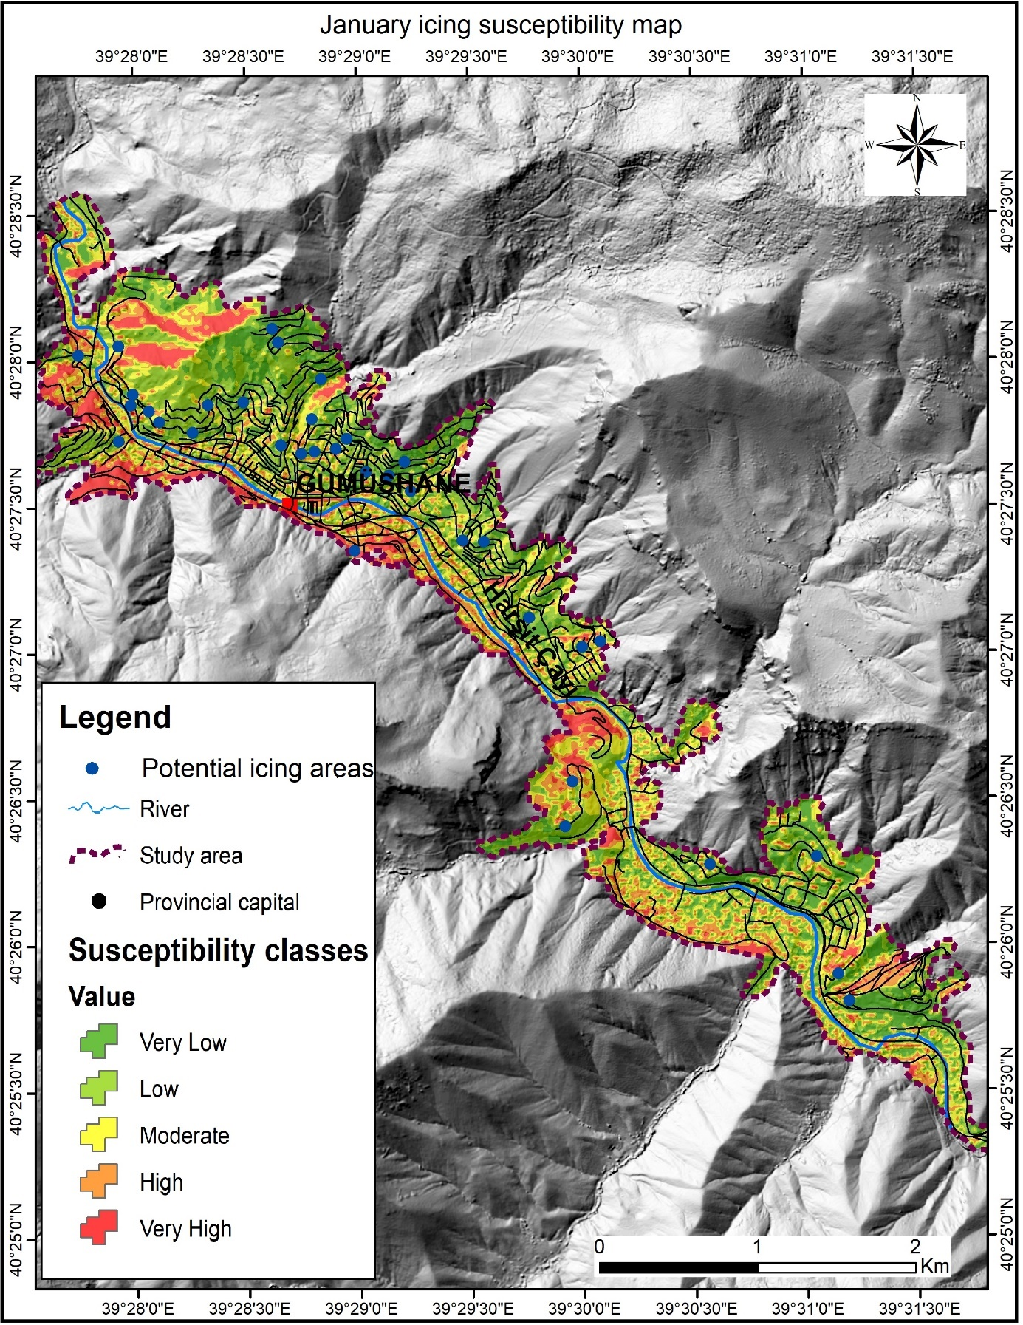
Figure 7. Gümüşhane city icing risk and potential icing map for January.

