Supplementary material
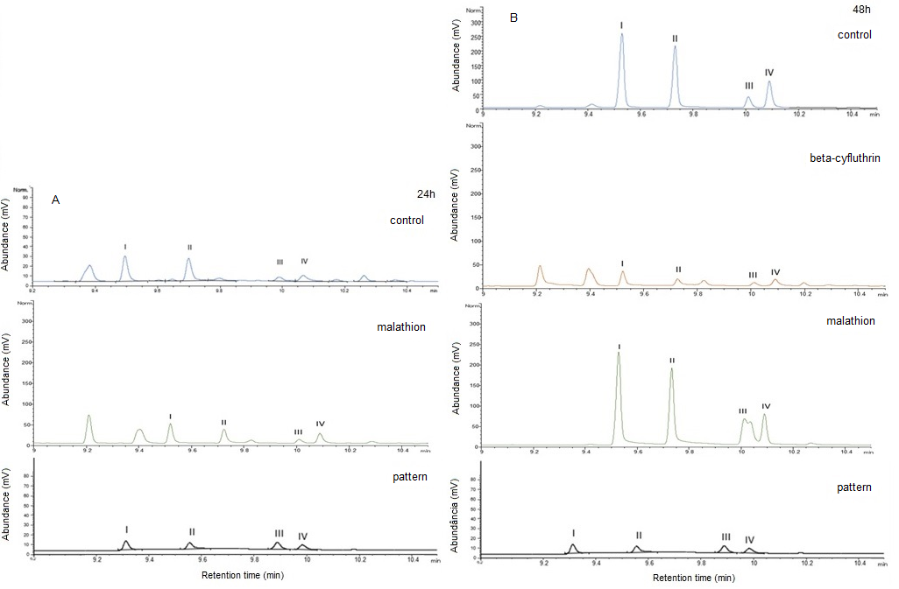
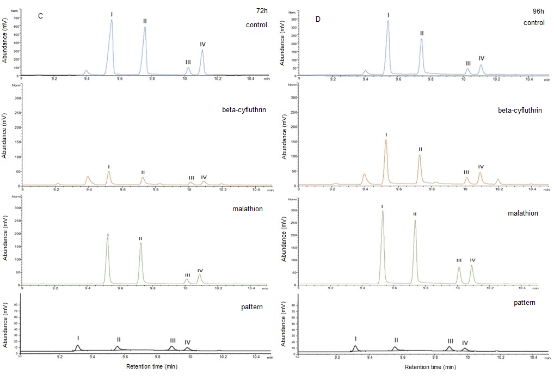
Table 1: Chromatographic profile (pA) of samples of collection of volatiles from males of Anthonomus grandis grandis Boh(Coleoptera: Curculionidae) in cotton plants on reproductive stage in different times after the begin of the treatments. A. control treatment (insects that were not exposed to insecticides), B insects preciously exposed with malathion and C. insects exposed with beta-cyfluthrin, and D. synthetic solution of 0.01 mg/mL of the four components of the aggregation pheromone: I. (+) - cis-2-isopropenyl-1-methylcyclobutane-ethanol; II. cis-2- (3,3-dimethyl) -cyclohexylidene-ethanol; III. cis-3,3-dimethylcyclohexylidene-acetaldehyde; IV. trans-3,3-dimethylcyclohexylideneacetaldehyde.

