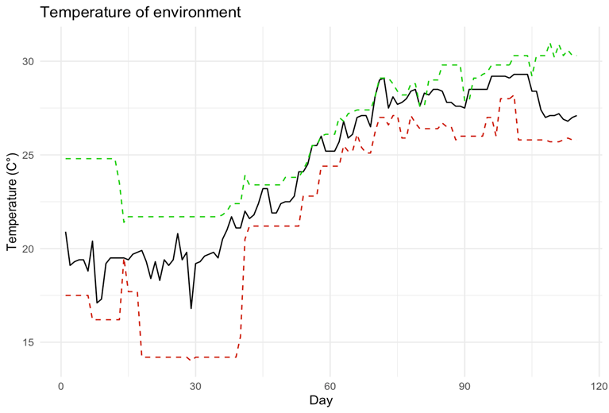
Figure S1. Ambient temperature (minimum and maximum temperature) during the study; Green: maximum, Red: minimum, and Black: average

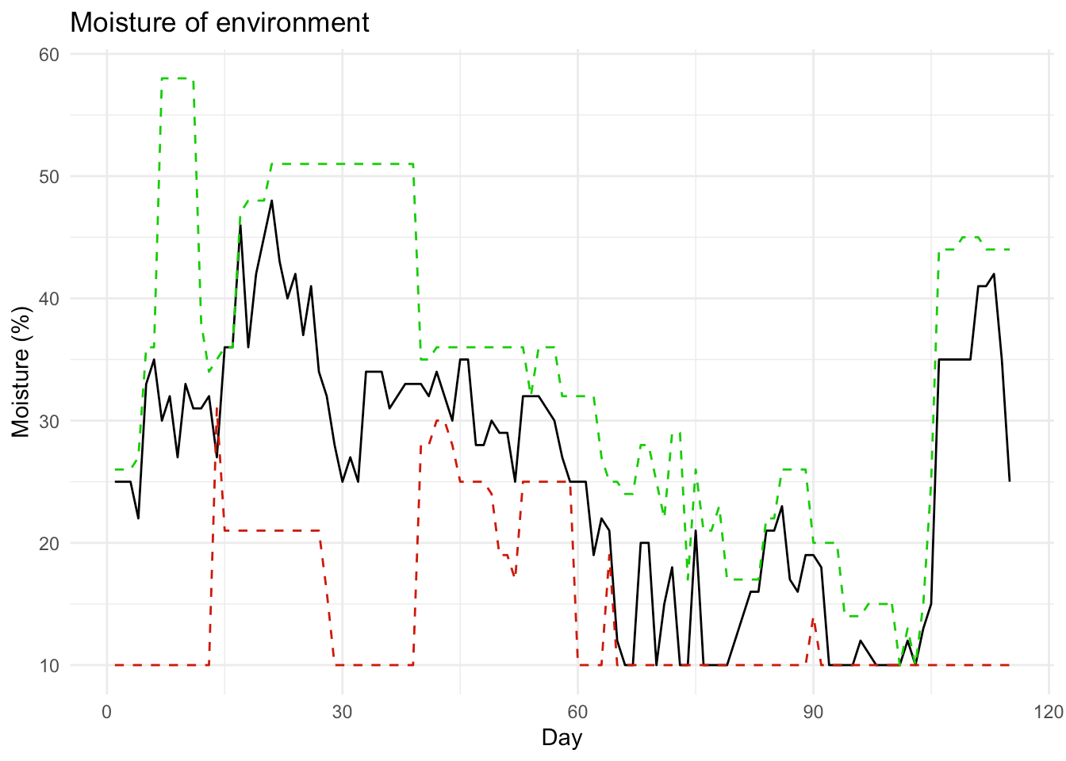
Figure S2. Humidity (minimum and maximum temperature) during the study; Green: maximum, Red: minimum, and Black: average

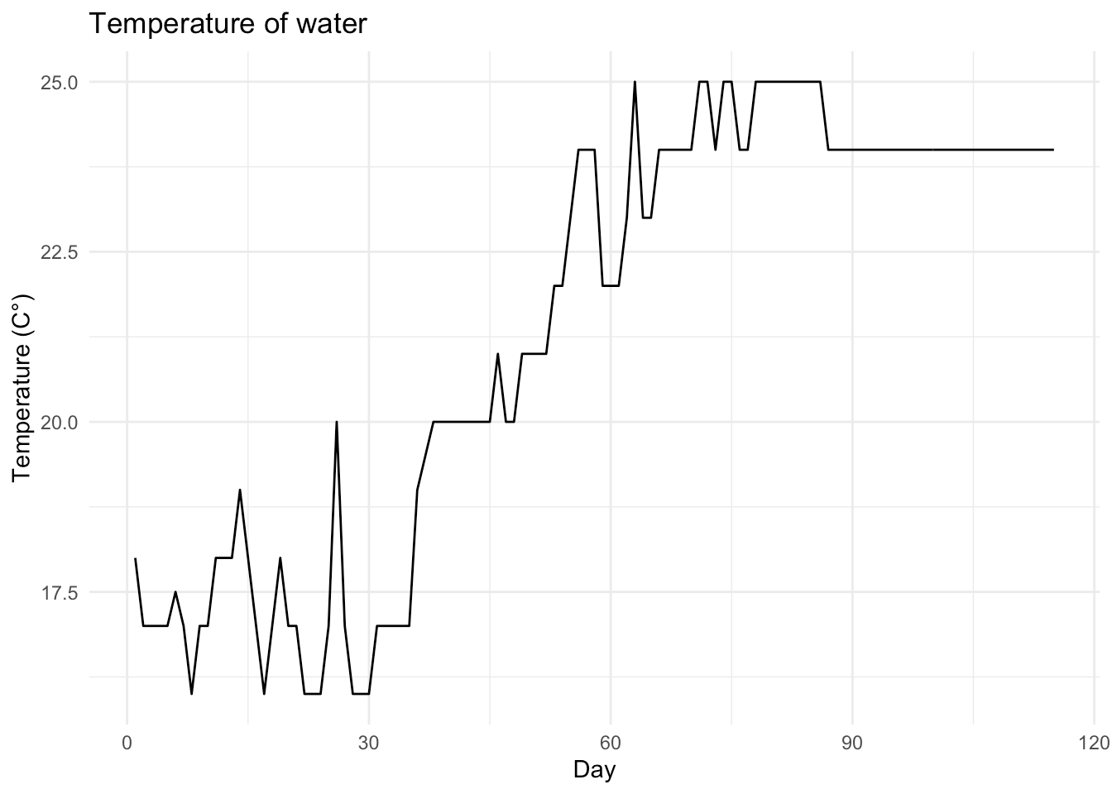
Figure S3. Fluctuations in water temperature in tubes during the entire incubation time

Table S1. The log-rank pairwise comparisons of survival of individuals between butachlor treatments (mg\L) and control groups
NO | Group 1 | Group 2 | Chisq | P- value
1 | BTC0.6 | BTC0.8 | 4.50 | 0.0338
2 | BTC0.1 | BTC0.4 | 7.13 | 0.0076
3 | BTC0.4 | BTC0.8 | 10.27 | 0.0013
4 | BTC0.4 | BTC0.6 | 20.89 | 0.0000
5 | BTC0.1 | BTC0.8 | 31.51 | 0.0000
6 | BTC0.1 | BTC0.6 | 47.45 | 0.0000
7 | control | BTC0.1 | 151.85 | 0.0000
8 | control | BTC0.4 | 231.07 | 0.0000
9 | BTC0.8 | BTC 1 | 316.81 | 0.0000
10 | control | BTC0.8 | 333.75 | 0.0000
11 | control | BTC 1 | 362.35 | 0.0000
12 | BTC0.6 | BTC0.6 | 375.01 | 0.0000
13 | BTC 1 | BTC 1.5 | 408.23 | 0.0000
14 | BTC0.4 | BTC 1 | 439.29 | 0.0000
15 | BTC0.8 | BTC 1.5 | 495.60 | 0.0000
16 | BTC0.1 | BTC 1 | 514.56 | 0.0000
17 | BTC0.4 | BTC 1.5 | 566.80 | 0.0000
18 | BTC0.1 | BTC 1.5 | 572.92 | 0.0000
19 | BTC0.6 | BTC 1.5 | 611.08 | 0.0000
20 | control | BTC 1 | 635.10 | 0.0000
21 | control | BTC 1.5 | 672.40 | 0.0000
Treatment | N | Observed | Expected | (O-E)²/E | (O-E)²/V
BTC | 500 | 500 | 227 | 330.05 | 439.58
BTC0.1 | 500 | 462 | 575 | 22.29 | 30.02
BTC0.4 | 500 | 481 | 528 | 4.14 | 5.49
BTC0.6 | 500 | 497 | 451 | 4.59 | 6.01
BTC0.8 | 500 | 497 | 475 | 1.00 | 1.31
BTC1.5 | 500 | 500 | 132 | 1030.31 | 1337.63
Control | 500 | 342 | 891 | 338.41 | 573.05
Table S2: The log-rank or Mantel-Haenszel test for multiple comparisons of BTC groups
Chi-Square Test: Chisq = 2399 on 6 degrees of freedom, p < 2e-16

Table S3: Multivariate analysis of variance
Source | Df | Pillai | Approx F | Num Df | Den Df | Pr(>F)
Group | 4 | 2.1281 | 2.0463 | 20 | 36 | 0.03003*
Residuals | 10
*Significant at the 0.05 level

Table S4: Effect size for ANOVA (Type I)
Parameter | Eta² (Partial) | 95% CI
Group | 0.53 | [0.05, 1.00]
One-sided CIs: upper bound fixed at [1.00].

Table S5: ANOVA and TukeyHSD Results for LBM (mm)
Analysis | Group Comparison | Diff | Lwr | Upr | p adj | Df | Sum Sq | Mean Sq | F value | Pr(>F)
ANOVA |  |  |  |  |  | 4 | 33.33 | 8.333 | 36.17 | 6.41e-06 ***
 | Residuals |  |  |  |  | 10 | 2.30 | 0.230
TukeyHSD | BTC0.1 - control | -2.0233333 | -3.313113 | -0.73355378 | 0.0030130
 | BTC0.4 - control | -2.8866667 | -4.176446 | -1.59688712 | 0.0001814
 | BTC0.6 - control | -3.3766667 | -4.666446 | -2.08688712 | 0.0000467
 | BTC0.8 - control | -4.4300000 | -5.719780 | -3.14022045 | 0.0000040
 | BTC0.4 - BTC0.1 | -0.8633333 | -2.153113 | 0.42644622 | 0.2534485
 | BTC0.6 - BTC0.1 | -1.3533333 | -2.643113 | -0.06355378 | 0.0388681
 | BTC0.8 - BTC0.1 | -2.4066667 | -3.696446 | -1.11688712 | 0.0008055
 | BTC0.6 - BTC0.4 | -0.4900000 | -1.779780 | 0.79977955 | 0.7246453
 | BTC0.8 - BTC0.4 | -1.5433333 | -2.833113 | -0.25355378 | 0.0183726
 | BTC0.8 - BTC0.6 | -1.0533333 | -2.343113 | 0.23644622 | 0.1260683
HSD Groups | control | 35.92000
 | BTC0.1 | 33.89667
 | BTC0.4 | 33.03333
 | BTC0.6 | 32.54333
 | BTC0.8 | 31.49000
Signif. codes: 0 ‘’ 0.001 '' 0.01 '' 0.05 '.' 0.1 ' ' 1

Table S6: ANOVA and TukeyHSD Results for LFF (mm)
Analysis | Group Comparison | Diff | Lwr | Upr | p adj | Df | Sum Sq | Mean Sq | F value | Pr(>F)
ANOVA |  |  |  |  |  | 4 | 9.647 | 2.4117 | 190.4 | 2.17e-09 ***
 | Residuals |  |  |  |  | 10 | 0.127 | 0.0127
TukeyHSD | BTC0.1 - control | -0.1000000 | -0.4024296 | 0.20242958 | 0.8087286
 | BTC0.4 - control | -0.5000000 | -0.8024296 | -0.19757042 | 0.0020458
 | BTC0.6 - control | -1.6000000 | -1.9024296 | -1.29757042 | 0.0000001
 | BTC0.8 - control | -1.9666667 | -2.2690962 | -1.66423708 | 0.0000000
 | BTC0.4 - BTC0.1 | -0.4000000 | -0.7024296 | -0.09757042 | 0.0097925
 | BTC0.6 - BTC0.1 | -1.5000000 | -1.8024296 | -1.19757042 | 0.0000001
 | BTC0.8 - BTC0.1 | -1.8666667 | -2.1690962 | -1.56423708 | 0.0000000
 | BTC0.6 - BTC0.4 | -1.1000000 | -1.4024296 | -0.79757042 | 0.0000023
 | BTC0.8 - BTC0.4 | -1.4666667 | -1.7690962 | -1.16423708 | 0.0000002
 | BTC0.8 - BTC0.6 | -0.3666667 | -0.6690962 | -0.06423708 | 0.0169648
HSD Groups | control | 30.00000
 | BTC0.1 | 29.90000
 | BTC0.4 | 29.50000
 | BTC0.6 | 28.40000
 | BTC0.8 | 28.03333

Table S7: ANOVA and TukeyHSD Results for LEM (mm)
Analysis | Group Comparison | Diff | Lwr | Upr | p adj | Df | Sum Sq | Mean Sq | F value | Pr(>F)
ANOVA |  |  |  |  |  | 4 | 25.126 | 6.282 | 9.922 | 0.00165 **
 | Residuals |  |  |  |  | 10 | 6.331 | 0.633
TukeyHSD | BTC0.1 - control | -0.6333333 | -2.771439 | 1.5047728 | 0.8605061
 | BTC0.4 - control | -0.8733333 | -3.011439 | 1.2647728 | 0.6725570
 | BTC0.6 - control | -2.5800000 | -4.718106 | -0.4418939 | 0.0174613
 | BTC0.8 - control | -3.4533333 | -5.591439 | -1.3152272 | 0.0024334
 | BTC0.4 - BTC0.1 | -0.2400000 | -2.378106 | 1.8981061 | 0.9953626
 | BTC0.6 - BTC0.1 | -1.9466667 | -4.084773 | 0.1914395 | 0.0788614
 | BTC0.8 - BTC0.1 | -2.8200000 | -4.958106 | -0.6818939 | 0.0099728
 | BTC0.6 - BTC0.4 | -1.7066667 | -3.844773 | 0.4314395 | 0.1380336
 | BTC0.8 - BTC0.4 | -2.5800000 | -4.718106 | -0.4418939 | 0.0174613
 | BTC0.8 - BTC0.6 | -0.8733333 | -3.011439 | 1.2647728 | 0.6725570
HSD Groups | control | 17.36000
 | BTC0.1 | 16.72667
 | BTC0.4 | 16.48667
 | BTC0.6 | 14.78000
 | BTC0.8 | 13.90667
Signif. codes: 0 ‘’ 0.001 '' 0.01 '' 0.05 '.' 0.1 ' ' 1

Table S8: ANOVA and TukeyHSD Results for WBM (gr)
Analysis | Group Comparison | Diff | Lwr | Upr | p adj | Df | Sum Sq | Mean Sq | F value | Pr(>F)
ANOVA |  |  |  |  |  | 4 | 0.1288 | 0.03219 | 3.225 | 0.0606 .
 | Residuals |  |  |  |  | 10 | 0.0998 | 0.00998
TukeyHSD | BTC0.1 - control | -0.10666667 | -0.3751136 | 0.1617802 | 0.6930144
 | BTC0.4 - control | -0.18000000 | -0.4484469 | 0.0884469 | 0.2521304
 | BTC0.6 - control | -0.19000000 | -0.4584469 | 0.0784469 | 0.2126272
 | BTC0.8 - control | -0.27666667 | -0.5451136 | -0.0082198 | 0.0427571
 | BTC0.4 - BTC0.1 | -0.07333333 | -0.3417802 | 0.1951136 | 0.8908945
 | BTC0.6 - BTC0.1 | -0.08333333 | -0.3517802 | 0.1851136 | 0.8399898
 | BTC0.8 - BTC0.1 | -0.17000000 | -0.4384469 | 0.0984469 | 0.2972860
 | BTC0.6 - BTC0.4 | -0.01000000 | -0.2784469 | 0.2584469 | 0.9999392
 | BTC0.8 - BTC0.4 | -0.09666667 | -0.3651136 | 0.1717802 | 0.7595899
 | BTC0.8 - BTC0.6 | -0.08666667 | -0.3551136 | 0.1817802 | 0.8210693
HSD Groups | control | 0.7166667
 | BTC0.1 | 0.6100000
 | BTC0.4 | 0.5366667
 | BTC0.6 | 0.5266667
 | BTC0.8 | 0.4400000
Signif. codes: 0 ‘’ 0.001 '' 0.01 '' 0.05 '.' 0.1 ' ' 1
Table S9: ANOVA and TukeyHSD Results for WEM (gr)
Analysis | Group Comparison | Diff | Lwr | Upr | p adj | Df | Sum Sq | Mean Sq | F value | Pr(>F)
ANOVA |  |  |  |  |  | 4 | 0.0998 | 0.02495 | 4.655 | 0.0222 *
 | Residuals |  |  |  |  | 10 | 0.0536 | 0.00536
TukeyHSD | BTC0.1 - control | -0.05333333 | -0.2500656 | 0.1433989 | 0.8934538
 | BTC0.4 - control | -0.11333333 | -0.3100656 | 0.0833989 | 0.3778245
 | BTC0.6 - control | -0.17000000 | -0.3667322 | 0.0267322 | 0.0995867
 | BTC0.8 - control | -0.23000000 | -0.4267322 | -0.0332678 | 0.0211116
 | BTC0.4 - BTC0.1 | -0.06000000 | -0.2567322 | 0.1367322 | 0.8479977
 | BTC0.6 - BTC0.1 | -0.11666667 | -0.3133989 | 0.0800656 | 0.3525696
 | BTC0.8 - BTC0.1 | -0.17666667 | -0.3733989 | 0.0200656 | 0.0839856
 | BTC0.6 - BTC0.4 | -0.05666667 | -0.2533989 | 0.1400656 | 0.8717073
 | BTC0.8 - BTC0.4 | -0.11666667 | -0.3133989 | 0.0800656 | 0.3525696
 | BTC0.8 - BTC0.6 | -0.06000000 | -0.2567322 | 0.1367322 | 0.8479977
HSD Groups | control | 0.5033333
 | BTC0.1 | 0.4500000
 | BTC0.4 | 0.3900000
 | BTC0.6 | 0.3333333
 | BTC0.8 | 0.2733333

