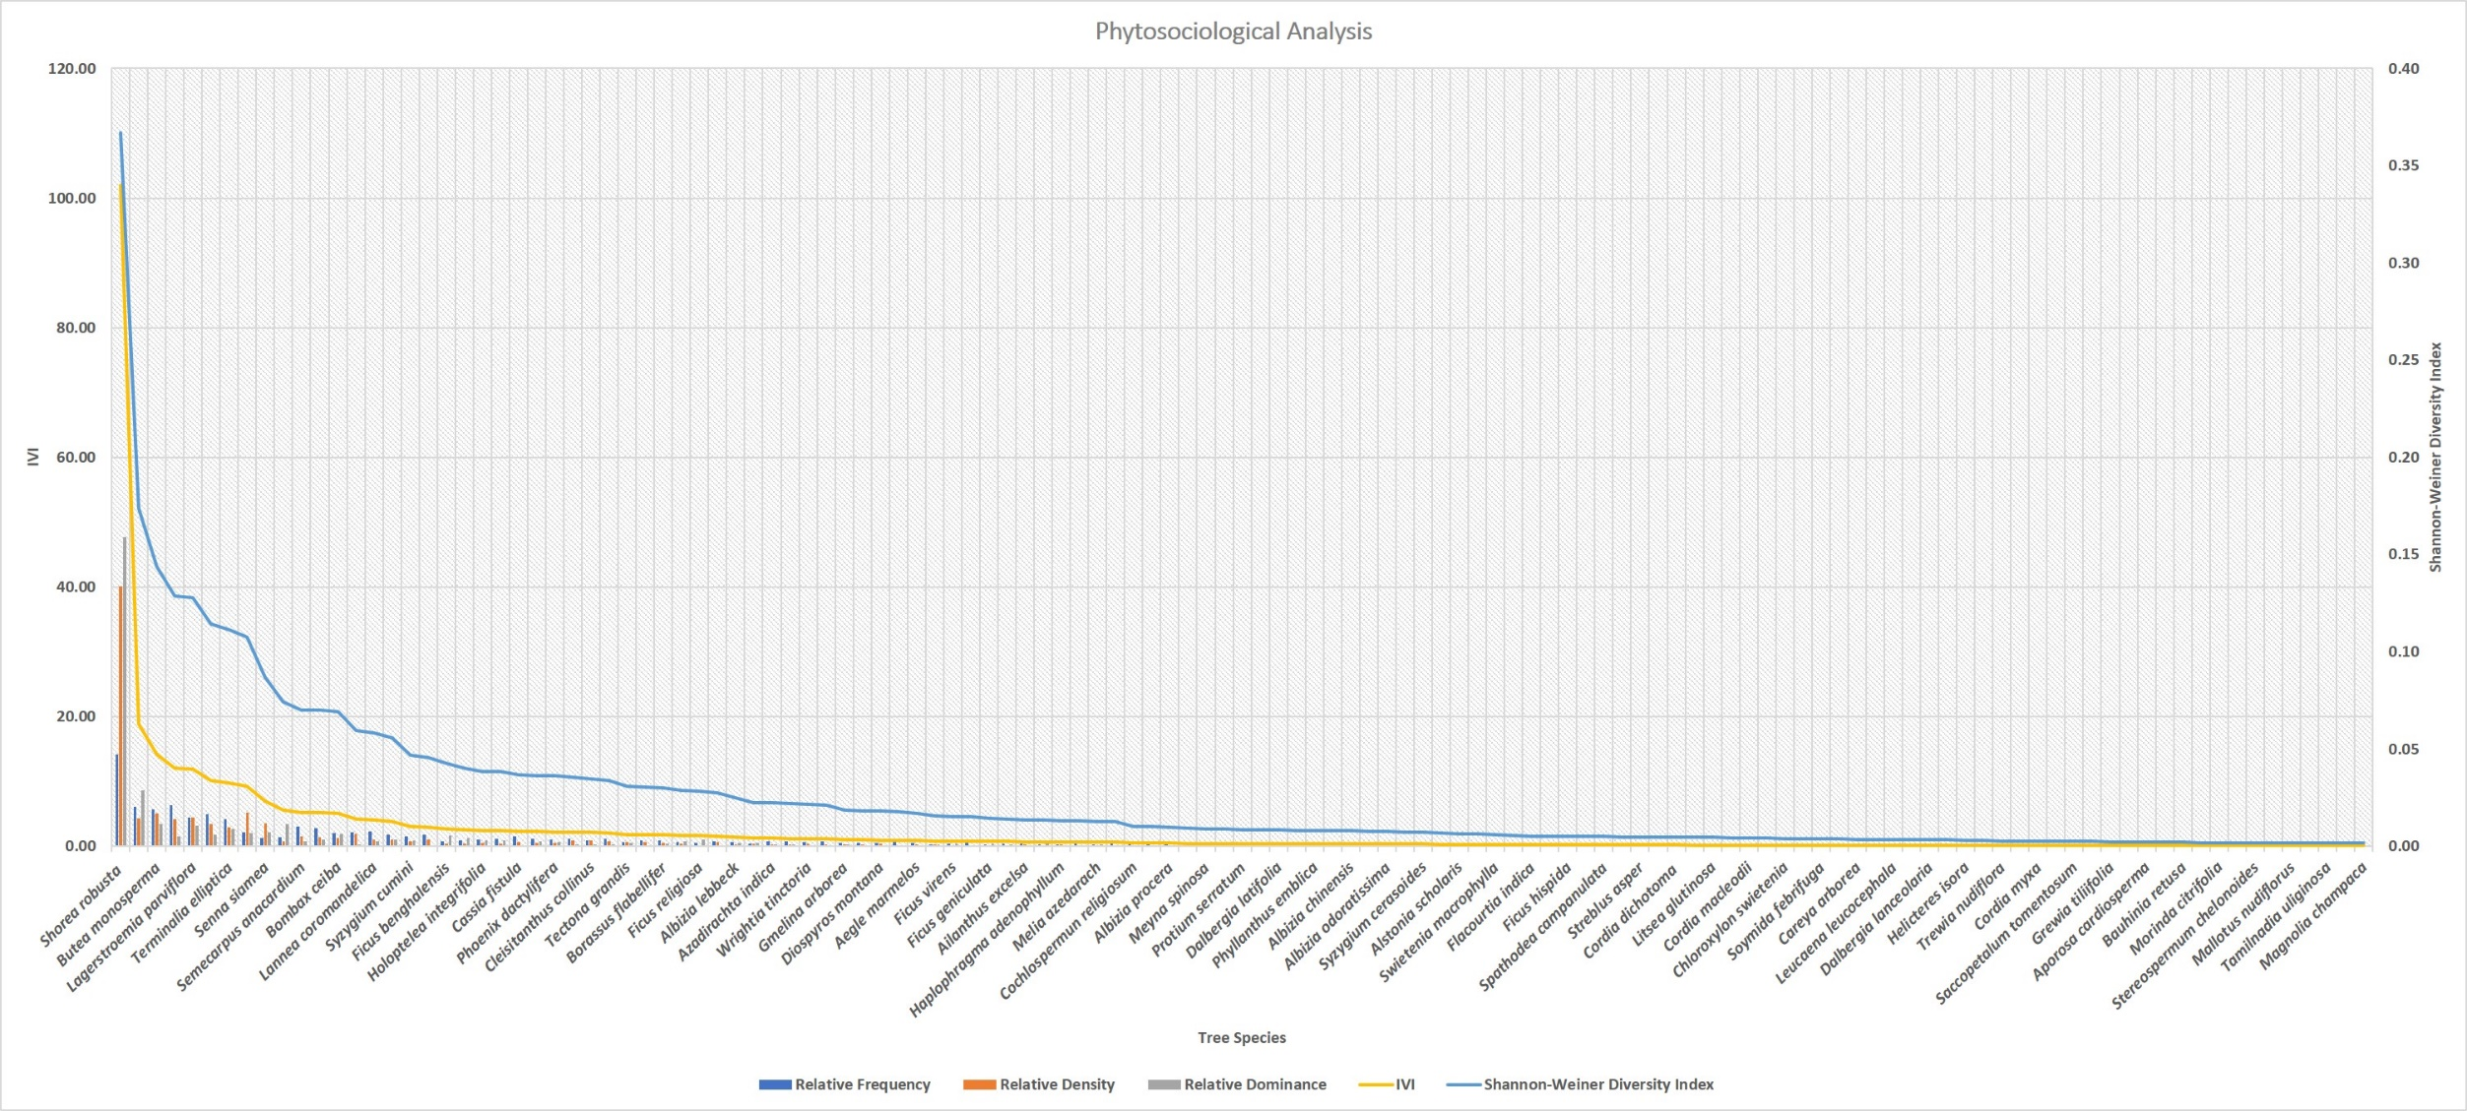
Supplementary Fig. 1 Phytosociological Distribution of tree species in Jharkhand.

