Long-term maintenance of regenerative agriculture enhances soil food webs and drives carbon accumulation
Tvisha Martin ^{1,2 *}, Christine Sprunger^{1,2}
¹W.K. Kellogg Biological Station, Hickory Corners, Michigan, USA ²Department of Plant Soil and Microbial Science, Michigan State University, East Lansing, Michigan, USA
Tvisha Martin
Email: mart2758@msu.edu

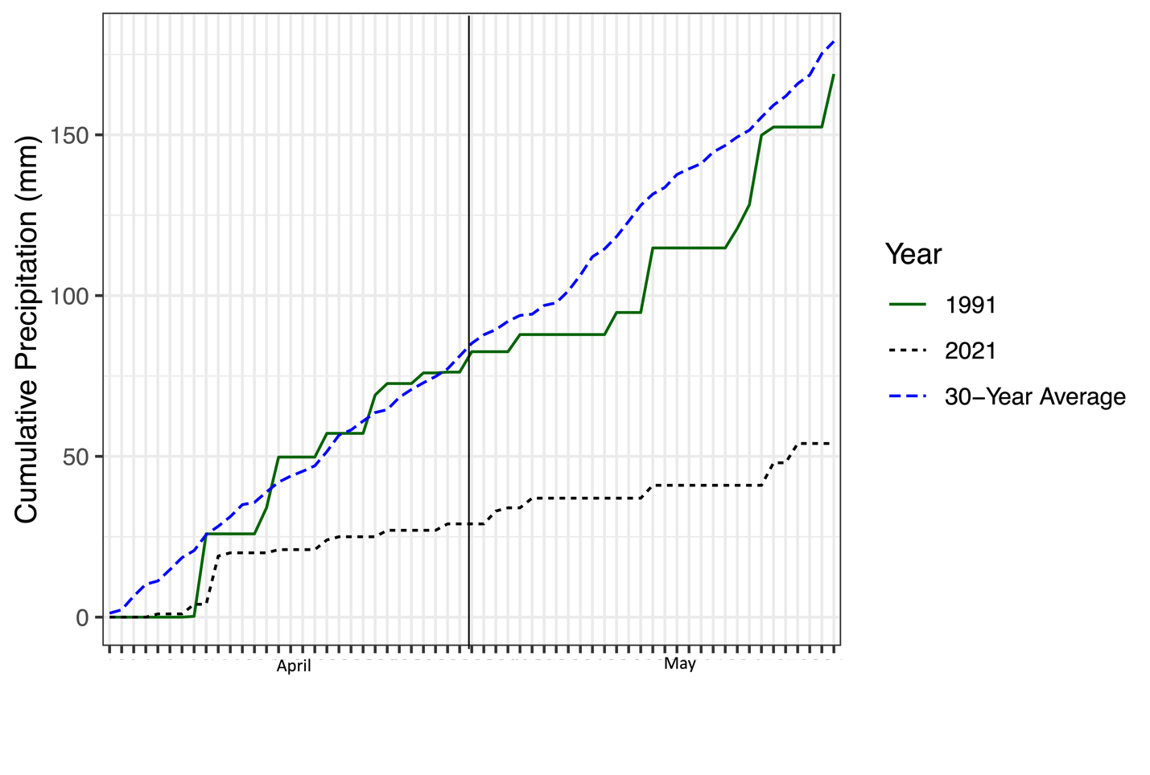Fig. S1. Cumulative precipitation in 1991 (green), 2021 (blue-dashed), and the 30-year average (black-dashed) in April and May.
Table S1. Percent soil moisture of all treatments within the KBS-LTER during the years 1991 and 2021. Data depict means (SE) of all six replicated of the eight treatments. Different letters depict a significant difference at one standard deviation from the mean after Tukey’s adjustment.
 | 1991 | 2021
Conventional | 19.08 (0.58) d | 12.53 (0.94) ab
No-till | 18.45 (1.02) d | 14.47 (2.07) abc
Reduced Input | 17.74 (0.53) cd | 11.65 (0.52) a
Biologically Based | 19.07 (0.53) d | 11.78 (1.33) a
Poplar | 18.17 (0.5) d | 10.6 (0.48) a
Switchgrass | 19.59 (0.81) de | 11.73 (0.64) a
Early Successional | 18.84 (0.75) d | 10.44 (0.26) a
Mowed grassland | 23.54 (0.93) e | 15.87 (0.59) bcd

Table S2. Permanova of nematode communities assessing the effect of treatment in 1991 and 2021 on nematode community composition
Factor | F | P
1991
Treatment | 4.33 | 0.001
2021
Treatment | 1.32 | 0.09

Table S3. F statistics and P-values for all nematode feeding groups for the linear mixed effect models used to test significant effects of treatment, timepoint, and the interaction between treatment and timepoint. Linear mixed effect models for fungivore, predator, omnivore, and plant parasitic feeding groups utilized a square root transformation. Fungivore:Bacterivore ratios utilized an unequal variance model.
Factor | Bacterivore |  | Fungivore |  | Predator |  | Omnivore |  | Plant Parasite |  | Fungivore:Bacterivore
 | F | P | F | P | F | P | F | P | F | P | F | P
Treatment | 2.74 | 0.01 | 3.59 | <0.001 | 1.83 | 0.09 | 2.36 | 0.03 | 1.07 | 0.39 | 15.12 | <0.001
Timepoint | 7.92 | 0.006 | 15.02 | <0.001 | 13.81 | <0.001 | 0.54 | 0.46 | 137.05 | <0.001 | 48.02 | <0.001
Treatment*Timepoint | 2.07 | 0.06 | 2.44 | 0.03 | 0.65 | 0.71 | 1.62 | 0.14 | 0.51 | 0.83 | 13.33 | <0.001

Table S4. F statistics and P-values for nematode indices for the linear mixed effect models used to test significant effects of treatment, timepoint, and the interaction between treatment and timepoint. An unequal variance model was used for CI. Linear mixed effects models for the CI utilized a unequal variance model.
Factor | MI |  | CI |  | EI
 | F | P | F | P | F | P
Treatment | 2.93 | 0.01 | 14.29 | <0.001 | 3.5 | 0.003
Timepoint | 17.95 | <0.001 | 27.5 | <0.001 | 15.19 | <0.001
Treatment*Timepoint | 1.06 | 0.40 | 1.89 | <0.001 | 1.52 | 0.023

Table S5. F statistics and P-values for soil C measurements. Linear mixed effect models were used to test significant effects of treatment, timepoint, and the interaction between treatment and timepoint on POXC, mineralizable carbon, and residuals. An unequal variance model was used for POXC and residuals and a log transformed model was used for mineralizable carbon.
Factor | POXC |  | Mineralizable Carbon |  | Residuals
 | F | P | F | P | F | P
Treatment | 43.40 | <0.001 | 11.2 | <0.001 | 38.11 | <0.001
Timepoint | 24.18 | <0.001 | 13.83 | <0.001 | 1.04 | 0.31
Treatment*Timepoint | 14.47 | <0.001 | 18.46 | <0.001 | 26.97 | <0.001

Table S6. P-values for correlations of mineralizable C and POXC with nematode community composition for the conducted vector analysis
Factor | 1991 | 2021
POXC | 0.001 | 0.040
Mineralizable Carbon | 0.023 | 0.025

Table S7. Average nematode abundance (%) and (SE) of nematode feeding groups in early successional and no-till systems in April and June of 2021
Treatment | Bacterivore | Fungivore | Plant Parasitic | Predator/ Omnivore
March 2021
Early Successional | 13.93 (0.04) | 69.91 (0.06) | 13.31 (0.03) | 1.43 (0)
No-till | 33.68 (0.14) | 30.02 (0.01) | 22.52 (0.07) | 6.9 (0.04)
June 2021
Early Successional | 11.2 (1.7) | 46.3 (10.6) | 33.5 (11) | 2.3 (1.34)
No-till | 40 (16.6) | 49.5 (15.9) | 9.7 (4.9) | 0.5 (0.3)

