Supplementary materials
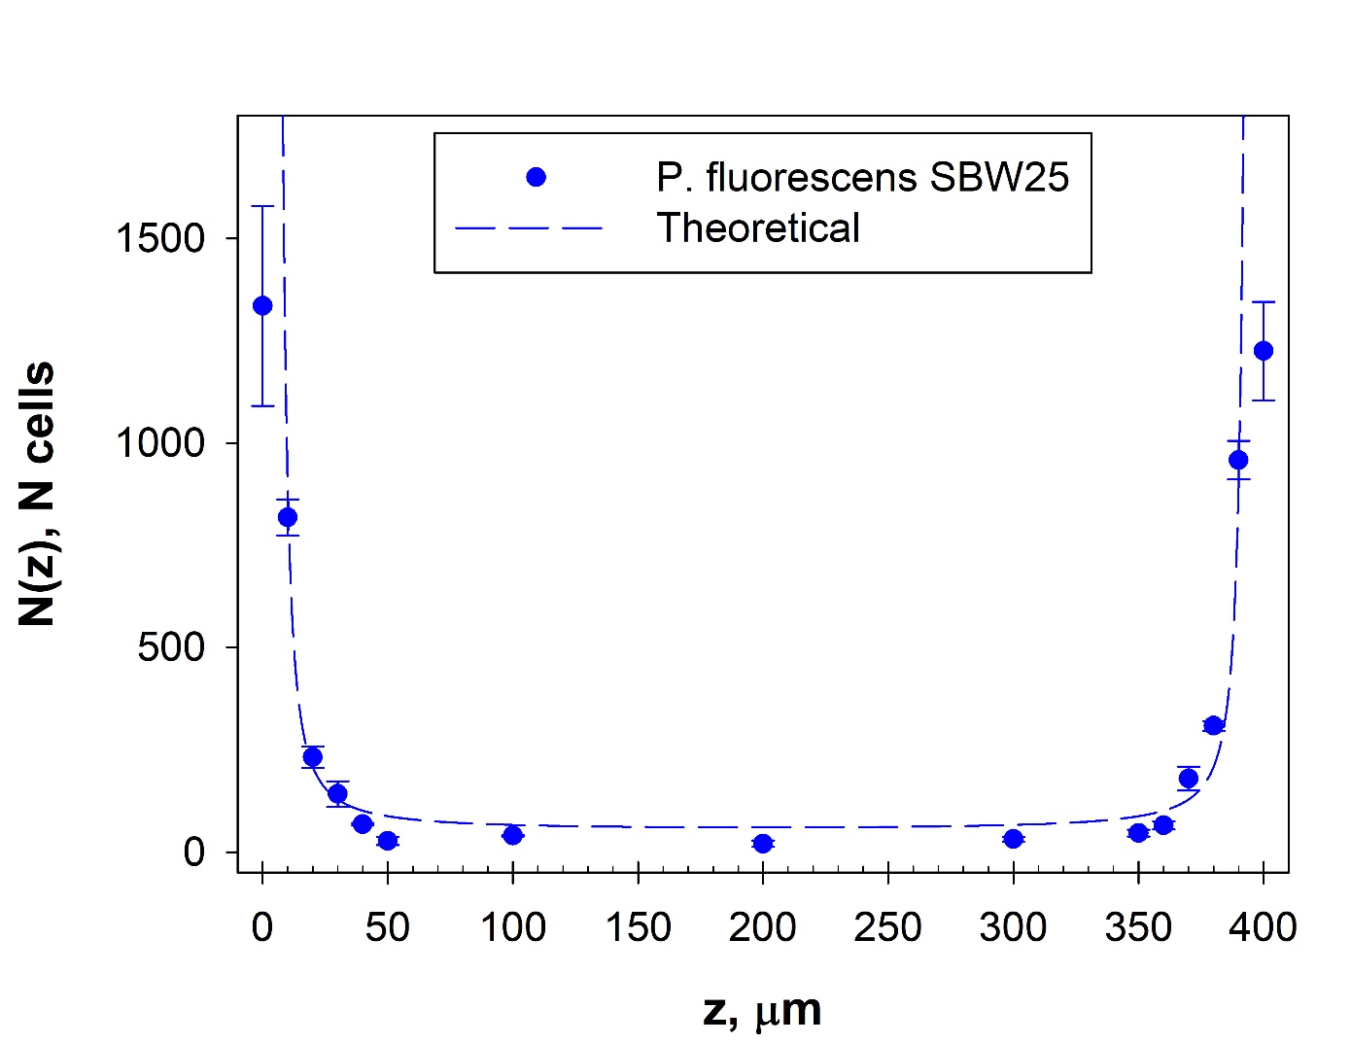
Supplementary figure 1
Concentration of motile P. fluorescens cells as a function of channel height z, from the bottom surface to the top. Blue dots indicate bright field mean count for three independent experiments. Dashed curve is best fit based on the model $\frac{n(z)}{n_{0}}=exp\left[L_{z}\left(\frac{1}{z}+\frac{1}{H-z}\right)\right],$ where H = 400 𝜇m is the microchannel depth, 𝑛₀ is the cell concentration in the bulk, and 𝐿_{z} is the characteristic accumulation length scale. Best fit yielded 𝐿_{z}= 29.1 𝜇m and 𝑛₀ = 45 cells. Error bars measure experimental standard deviations.
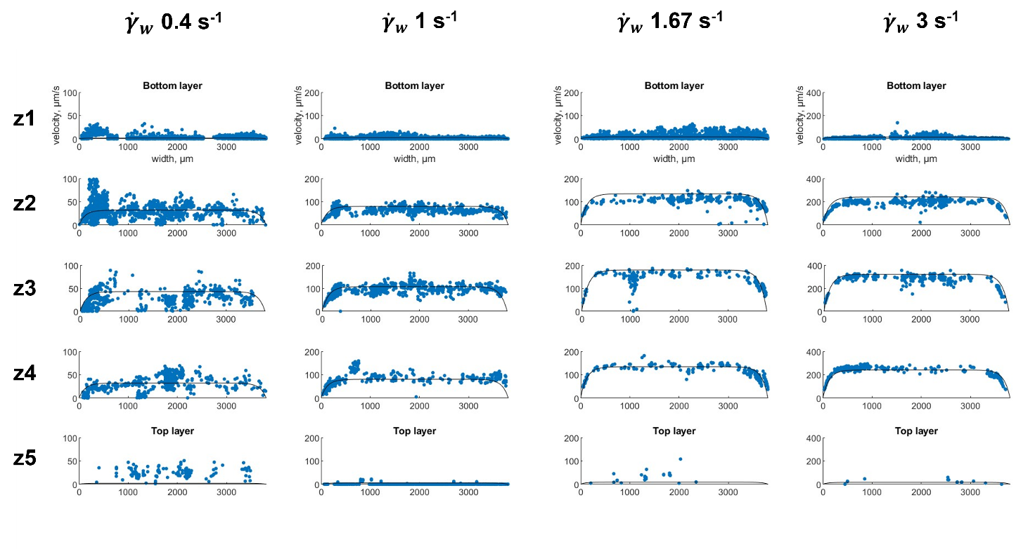
Supplementary figure 2
Polystyrene microparticles (diameter 2 𝜇m) velocities along channel width at the 5 different heights considered in the work. Each blue dot represents a single data acquisition. Those data were used to build a three-dimensional parabolic velocity profile.

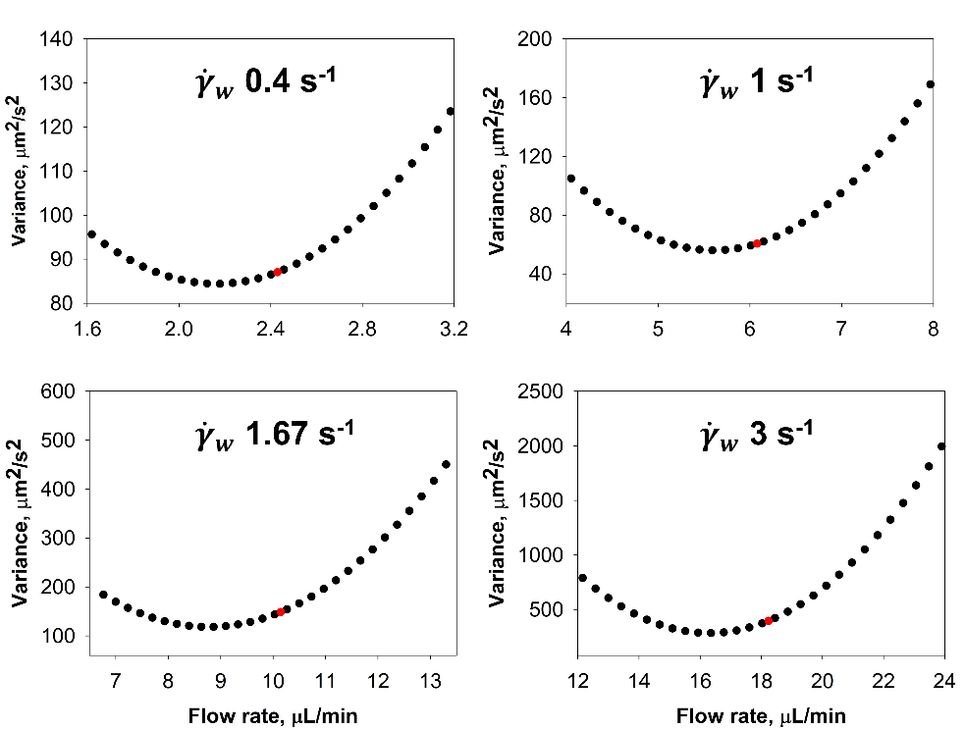
Supplementary figure 3
After allowing the flow to reach fully developed conditions, we experimentally measured the velocities of polystyrene particles at various points across the channel’s cross-section (Supp 2). The particle velocities were recorded and compared with the theoretical velocity profile expected for a fully developed flow evaluating variance. We then imposed a different flow rate in the parabolic equation and estimate the theoretical flow rate Q to minimize variance. Interestingly, our findings revealed that the nominal flow rate provided by the flow control system was approximately 10% higher than the flow rate derived from the experimental measurements and the parabolic velocity profile. This discrepancy was consistent across multiple tests and indicates that the nominal flow rate might be overestimated by the system.

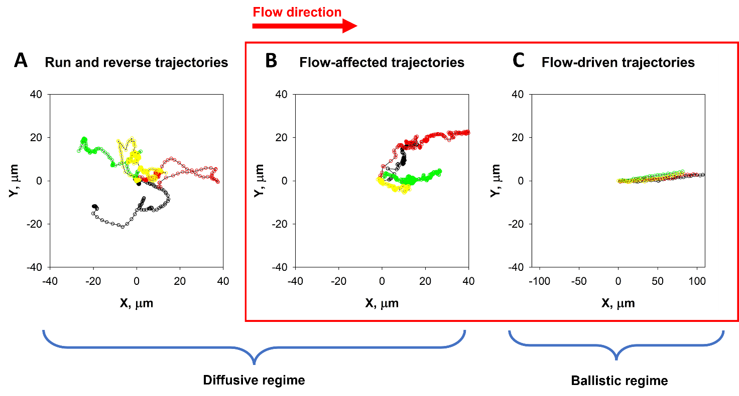
Trajectory behaviour | Speed, µm/s | Distance, µm | Direction
Ballistic | >0 | >0 | Always positive in x (flow direction)
Pirouette | <10 | <10 | Random
Passive diffusive | <10 | <10 | Random
Active diffusive (Curly Path, Run and Reverse) | >10 | >10 | Random

Supplementary figure 4
Bacterial trajectories behaviour, in the microfluidic channel. A) Mixed “run and reverse” and “curly path” trajectories, described as active diffusive microswimmers. B) Active diffusive trajectories affected by flow conditions. C) Purely flow-driven bacterial trajectories categorized as ballistic motion. Those bacterial trajectories were discarded for the characterization of motility coefficient.
In the table below, were represented bacterial trajectories behaviour and the numerical constraint employed for the categorization. Passive diffusive and Pirouette behaviour were distinguished by recording visual inspection.

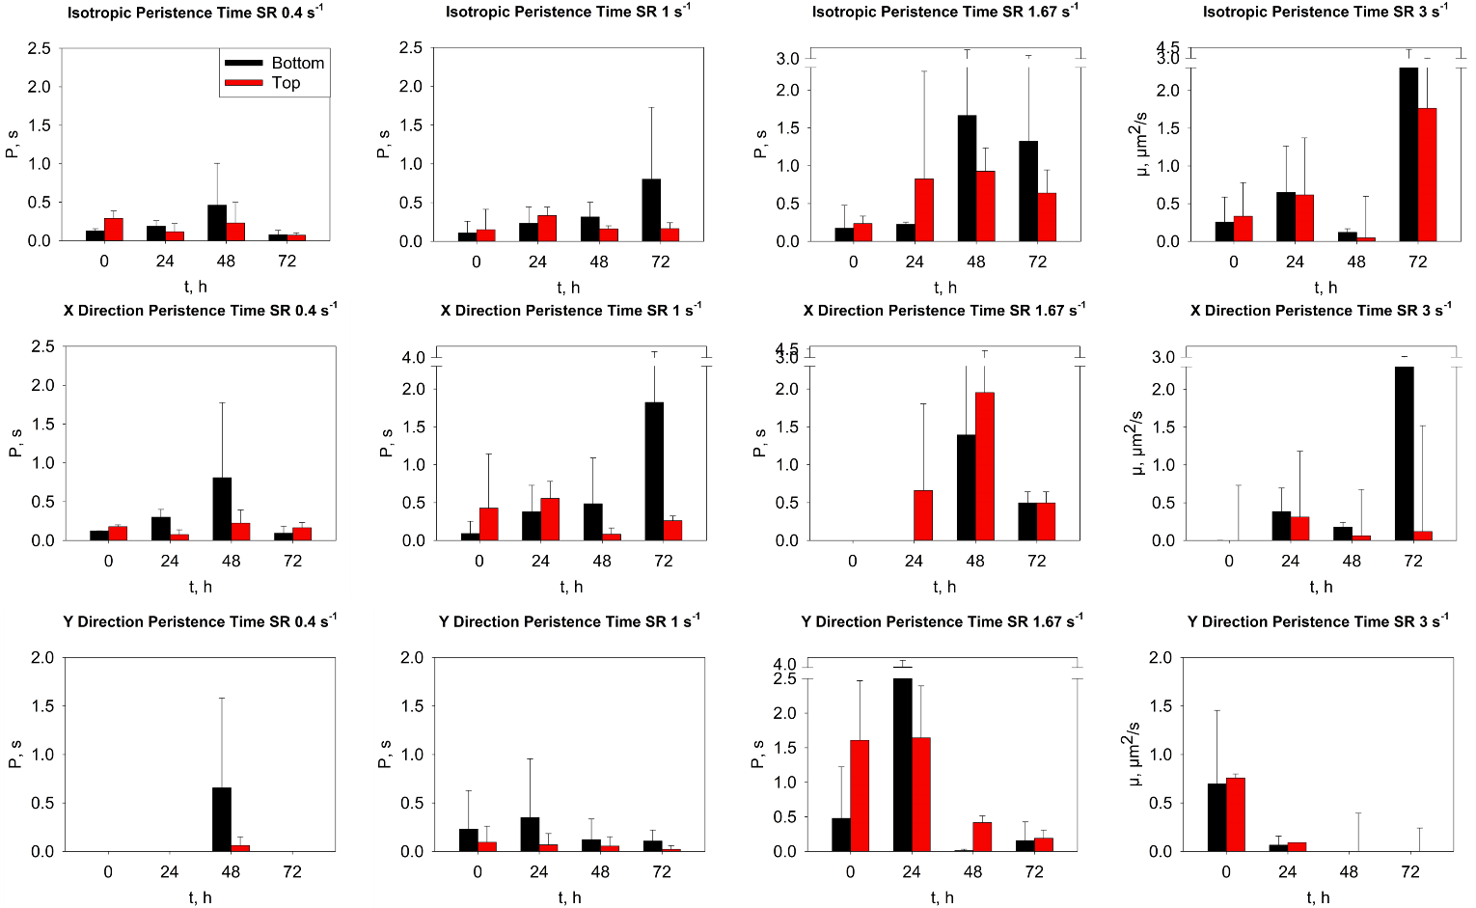
Supplementary figure 5
Persistence time P on top and bottom channel wall. P, representing the time in which bacteria follow the same path was estimated for the bottom (in black) and top (in red) surfaces of the microfluidic channel at various flow hours. Each row represents different shear rate values imposed. The first column reports isotropic motility coefficient, calculated according to eq. 7. In the second column the analysis of the same trajectories, focusing on the MSD along the x-axis (flow direction) only. In the third, the analysis of the same trajectories, considering the MSD along the y-axis (orthogonal to the flow direction) only. No specific trend was observed.

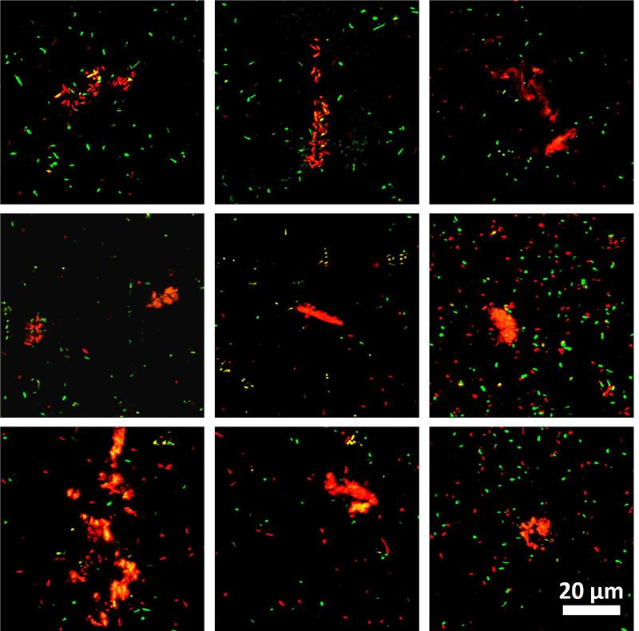
Supplementary figure 6
Biofilm filamentous structures, called “streamers”, composed mostly of cells enclosed in a extracellular DNA matrix. The formation of these structures is triggered by flow conditions and eDNA matrix is visible due to the propidium iodide staining, in red. The observation of this structures is commonly found in all flow conditions (except for ${\dot{γ}}_{w}$ 0.4 and 1.0 s⁻¹), both for top and bottom surfaces.

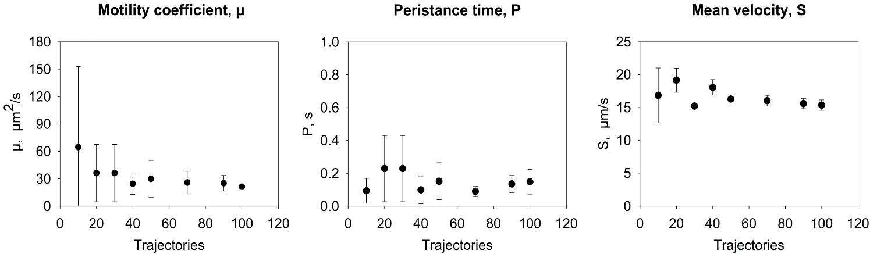
Supplementary figure 6
As described in the Materials and Methods section, for the estimation of motility parameters, at least 70 trajectories were considered in a single experiment to obtain a quantitative measure. To validate this approach, we report the motility coefficient and Persistence time obtained from independent groups of 20, 30, 70, and 140 cells within the same experiment. In this case, we present data from inoculum conditions.
Measurements were repeated three times, and the results are presented in the figure as averages, with the standard deviation indicated by error bars. By comparing the error bars, we determined that results obtained using a minimum of 70 trajectories are reliable.
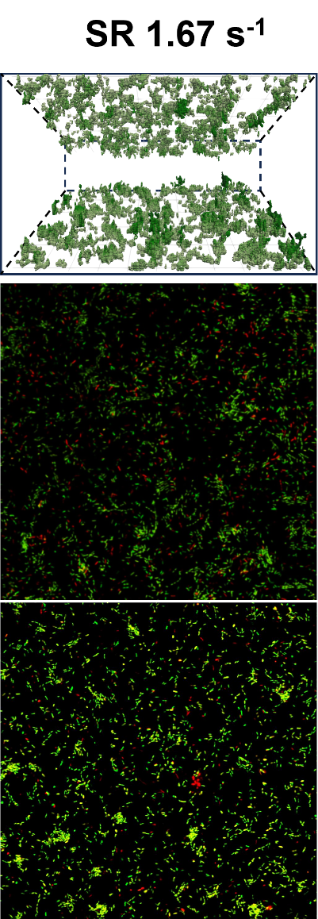
Supplementary figure 7
3D reconstruction generated in ParaView, along with representative images from the z-stack acquired through Confocal Laser Scanning Microscopy (CLSM) analysis of biofilm growth (as detailed in the Materials and Methods). The images correspond to the top and bottom surfaces of the channel under a shear rate of ${\dot{γ}}_{w}$ 1.67 s⁻¹.

