Supplementary Materials:
Tropical cyclones modulate drought characteristics in the Hurricane Region of the Americas
Dimitris A. Herrera^{1,2}, Christian Domínguez³, Abel Centella⁴, Ricardo Sánchez-Murillo⁵, Diego Pons⁶, Hugo Hidalgo⁷, Maibys Sierra-Lorenzo⁴, Benjamin I. Cook⁸, Joshua C. Bregy⁹, Arnoldo Bezanilla⁴
Tables:
Table S1: TCs and drought amelioration
Drought metric | Drought change | Significant | Drought end
SPEI scaled to one month (SPEI-1) | 67% | 20% | 13%
SPEI scaled to three months (SPEI-3) | 43% | - | 1.4%
SPEI scaled to six months (SPEI-6) | 27% | - | 0.5%
SPEI scaled to twelve months (SPEI-12) | 17% | - | 0.2%
SPI scaled to one month (SPI-1) | 72% | 12% | 17%
SPI scaled to three months (SPI-3) | 49% | - | 3.4%
SPEI scaled to six months (SPI-6) | 34% | - | 1.5%
scPDSI | 70% | 9% | 28%
Z-score | 76% | 41% | 22%
Drought change: Percentage of the HRA with an improvement of at least one drought rank (e.g., >0.99 in SPEI, SPI, scPDSI, or Z-score).
Significant: Percentage of the HRA area with statistically significant improvement in drought conditions.
Drought end: Percentage of the HRA area where TCs ended drought at least once in 1985-2023.
Table S2: Climate data used in this work
Variable | Climate data | Horizontal resolution | Temporal resolution | Time interval | Reference
Precipitation | CHIRPSv2 | 0.05° (~6 km) | Daily | 1981-present | Funk et al. (2015)
Precipitation | MSWEPv2 | 0.1° (~11 km) | Daily | 1979-present | Beck et al. (2019)
Potential evapotranspiration | CRUv4.02 | 0.5° (~56 km) | Monthly | 1901-2023 | Harris et al. (2020)
Available water capacity | IGBP-DIS | - | - | - | Global Soil Data Task Group (2000)
Tropical cyclone tracks | HURDAT2 | - | 6-hourly | - | Landsea and Franklin (2013)

Acronyms:
CHIRPS: Climate Hazards Group Infrared Precipitation with Station Data.
MSWEP: Multi-Source Weighted-Ensemble Precipitation.
CRU: Climatic Research Unit
IGBP-DIS: International Geosphere-Biosphere Programme (IGBP) Data and Information System (DIS)
HURDAT: Hurricane Databases

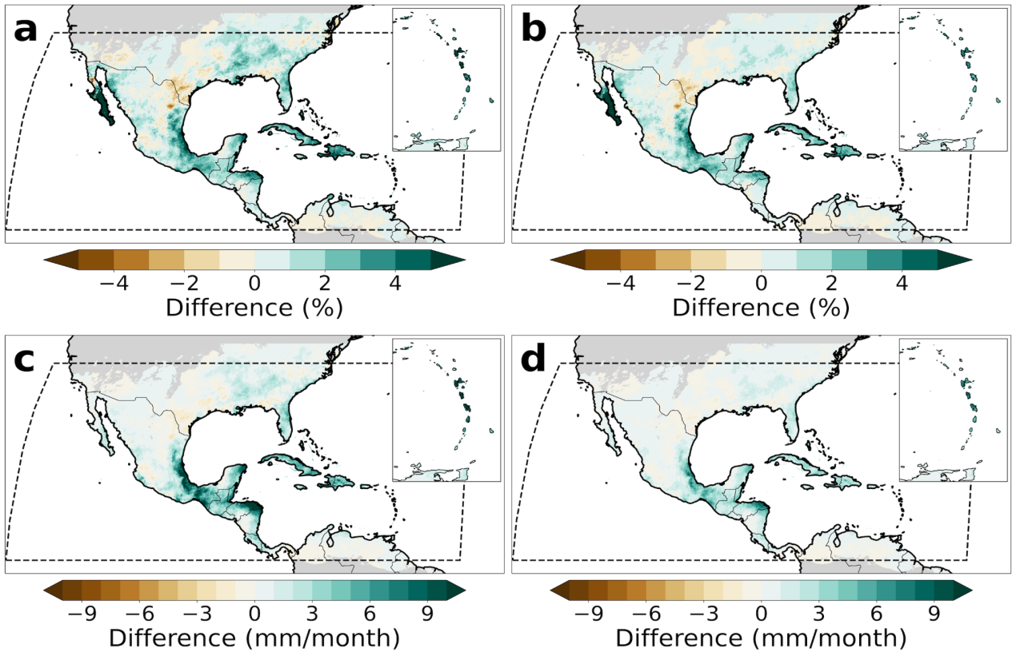
Figure S1: Changes in tropical cyclone contributions to precipitation. Panels (a) and (b) show the differences in tropical cyclone contributions between the periods 1985-2005 and 2005-2023. In most of the Hurricane Region of the Americas, the contributions for the 2005-2023 period are higher compared to 1985-2005, except in southern Central Plains where the opposite occurred. Panels (c) and (d) are similar to the upper panels but for changes in tropical cyclone-rainfall amounts. The areas with contributions below 1% were masked for visual purposes.

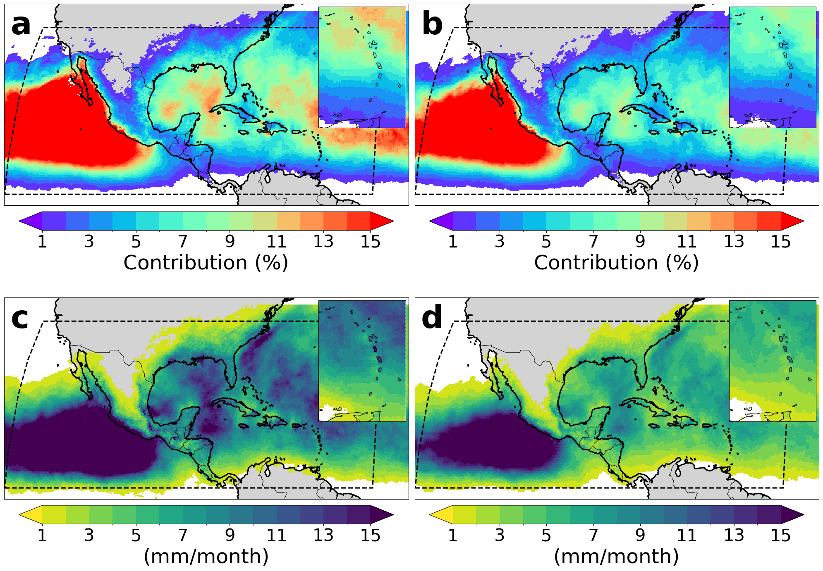
Figure S2: Tropical cyclone contributions to precipitation from the second version of the Multi-Source Weighted-Ensemble Precipitation (MSWEPv2). As in Fig. (2), panels (a) and (b) show the seasonal and annual mean contributions (as percentages) to rainfall, respectively. Panels (c) and (d) show the seasonal and annual mean precipitation from tropical cyclones. The spatial patterns and magnitude of TC contributions estimated from MSWEP over land are consistent with estimates from CHIRPS, showing the highest relative contributions in Baja California between 1985 and 2023.

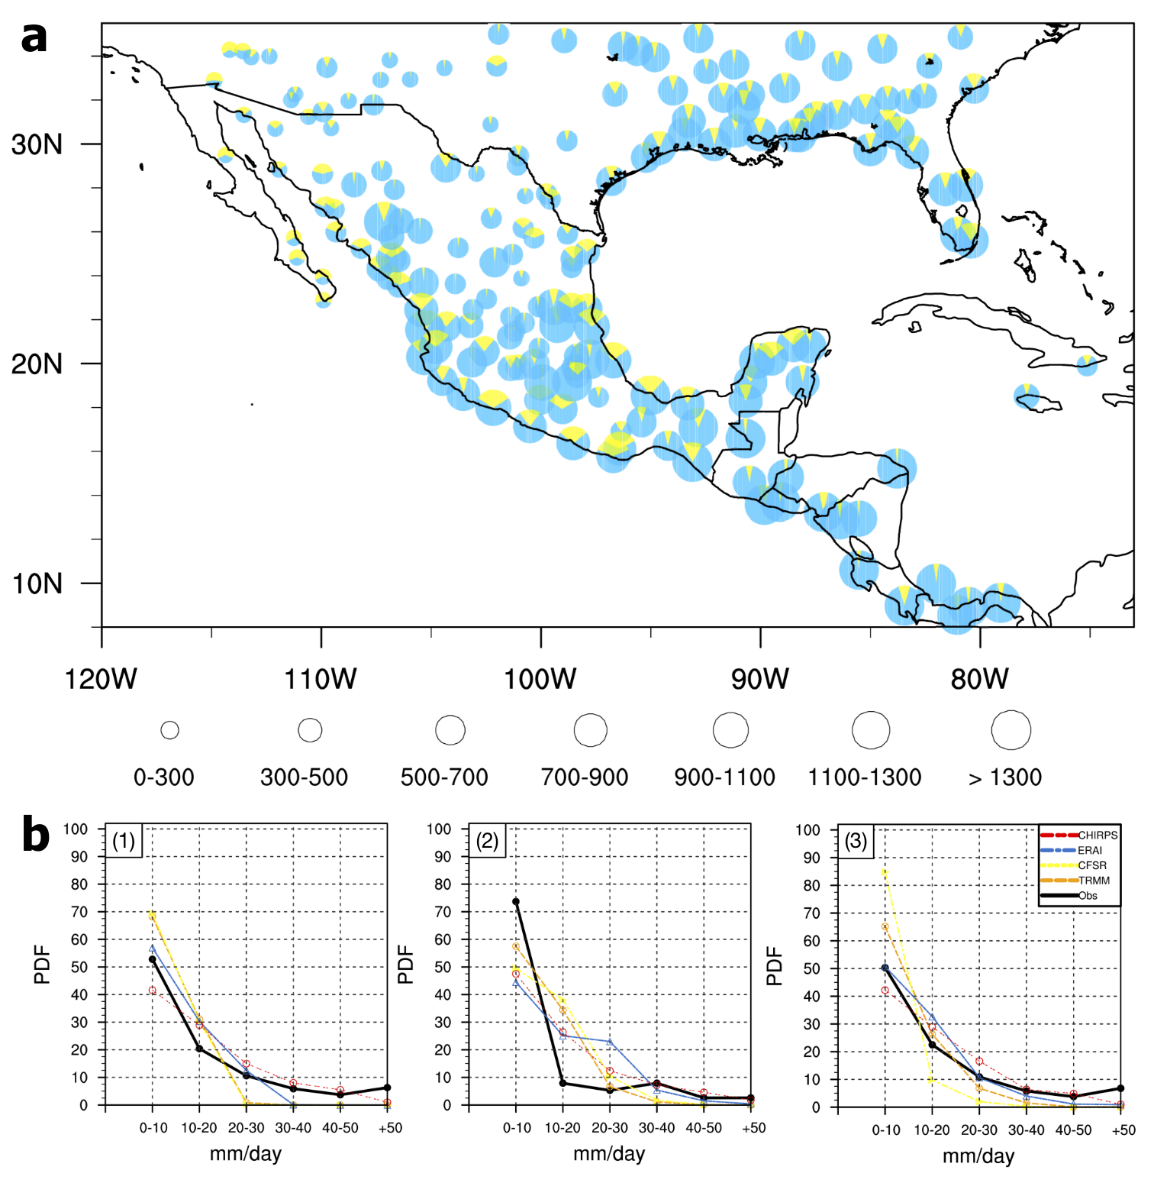
Figure S3: Tropical cyclone contributions from weather stations. Panel (a) shows the annual precipitation (in mm) from weather stations in Mexico, Central America, and southern U.S. (blue circles) and TC contributions (yellow fraction) between 1979 and 2013 as estimated by Dominguez and Magaña (2018). The circle size represents the amount of annual summer rainfall. Panel (b) shows the probability density function (PDF, percent) of daily precipitation in ERAI, CFSR, TRMM, CHIRPS, and weather stations for (1) Northern South America, (2) Central America and (3) Southern Mexico during 1997-2013 period.

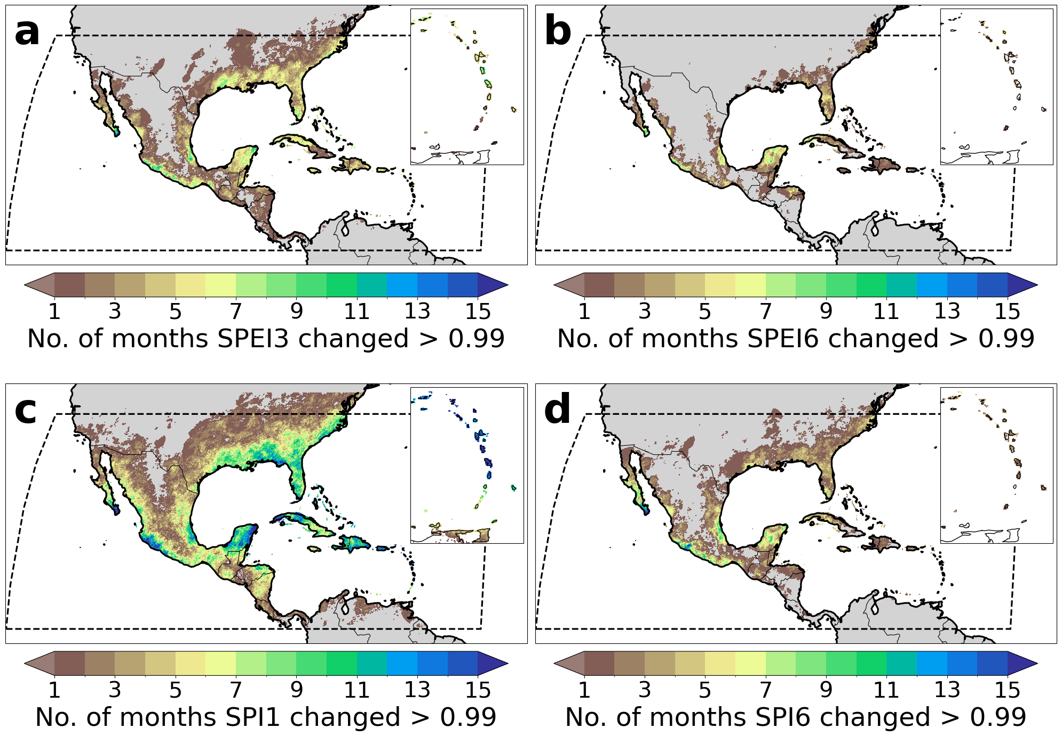
Figure S4: Changes in drought conditions from the Standardized Precipitation Index (SPI) and Standardized Precipitation minus Evaporation Index (SPEI) before and after removing monthly TC rainfall. Panel (a) shows the number of months between 1985 and 2023 in which a change of more than 0.99 units in the SPEI scaled to three months (SPEI3) occurs in each grid cell. Panels (b, c, and d) are the same as panel (a) but for SPEI scaled to six months (SPEI6), SPI scaled to one month (SPI1), and SPI scaled to six months (SPI6), respectively.

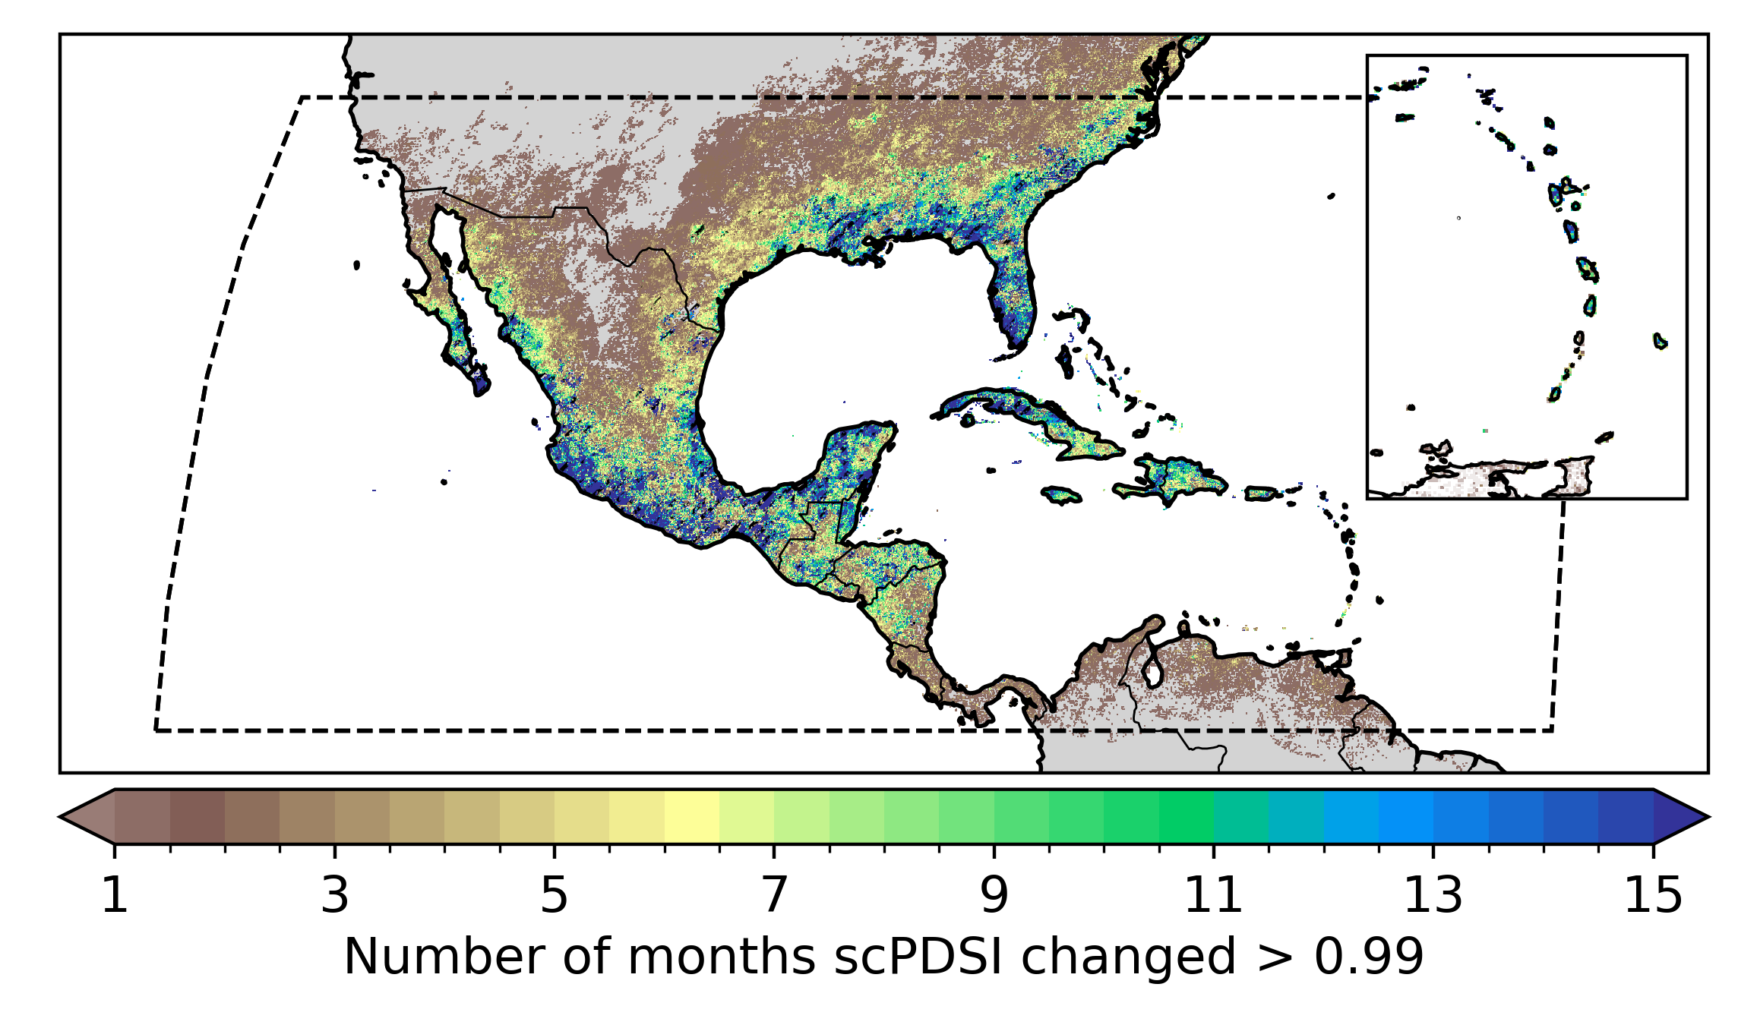
Figure S5: Changes in drought conditions from the “self-calibrated” Palmer Drought Severity Index (scPDSI) before and after removing monthly TC rainfall. As in Fig. S4, this estimate shows the number of months between 1985 and 2023 in which a change of more than 0.99 units in scPDSI occurs in each grid cell. Significant changes in drought conditions occurred over most of the Caribbean islands, the west coast of Mexico, and the southeastern US, especially Florida.

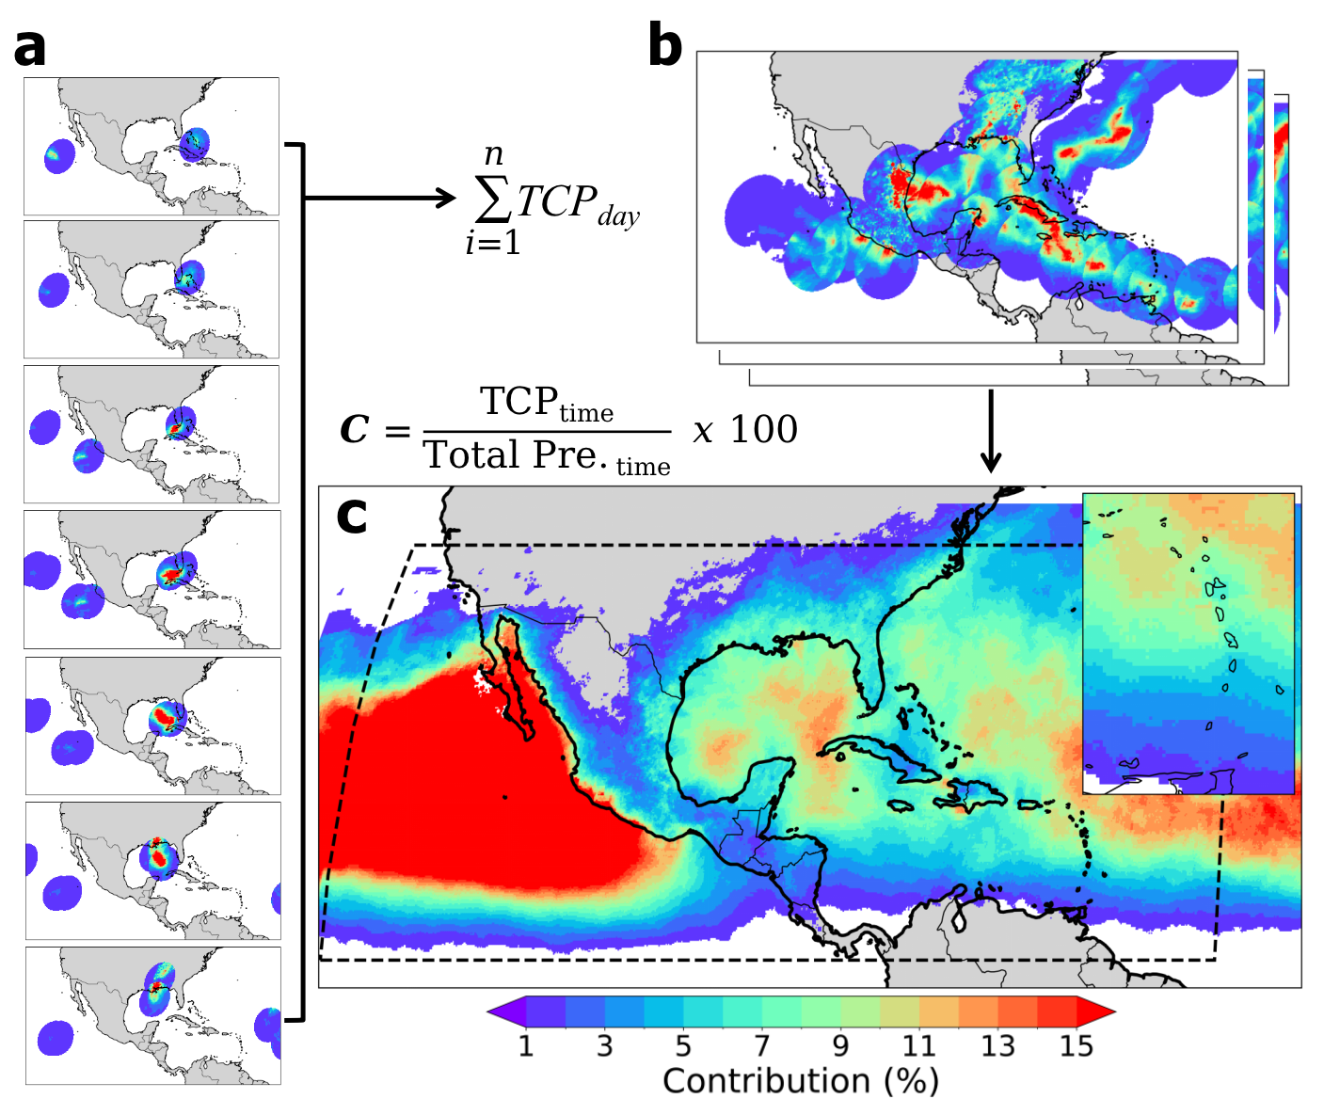
Figure S6: Procedure to estimate tropical cyclone contribution rainfall. Step 1 (panel (a)): The first step is to isolate the daily rainfall associated with each TC. The precipitation field is defined as the perimeter with a radius of 500 km from the center of the storm as obtained from HURDAT2. Step 2 (panel (b)): Once the daily TC precipitation is isolated from the daily precipitation product (e.g., CHIRPSv2 or MSWEPv2), the daily TC precipitation is aggregated into monthly, seasonal, and annual totals. Step 3 (panel (c)): Finally, TC contributions are estimated as the percentage of TC precipitation over total precipitation on monthly, seasonal, and annual time scales. TCP: tropical cyclone precipitation, Total Pre.: total precipitation, time: subscript indicating the sum of daily rainfall to monthly, seasonal, and annual totals.

