Supplementary Material 1
Screening strategies：“Spontaneous preterm labor” OR “spontaneous preterm birth” OR “spontaneous preterm delivery”OR “SPTB” and “prediction” OR “predictors” OR “prediction model”

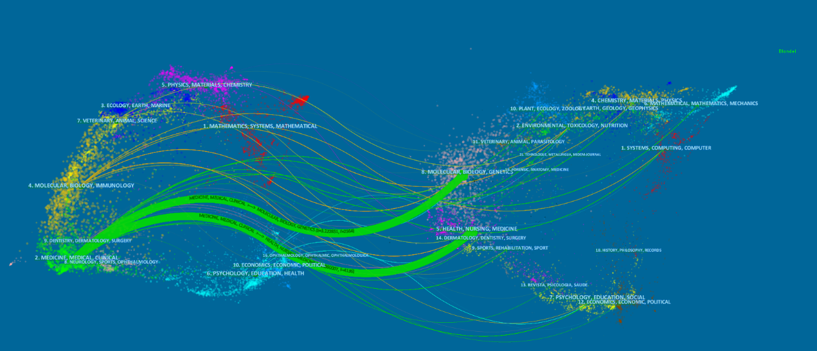

Fig.S1: The dual-map overlay of journals related to research on prediction of sPTB.

