Enhancing the Toughness of High-Entropy Carbide Ceramic (TiZrHfNbTa)_{0.2}C through Composite B₄C
Yunfeng Sheª†, Min Lianª†, Shuailing Ma^{a,}*, Wei Li^{c}, Hao Liª, Kaiping Huª, Junming Fengª, Xingbin Zhaoª, Mengyao Qiª, Wang Chenª, Songpeng Zhangª, Hao Jiangª, Pinwen Zhu^{b}, Tian Cui^{a,}*
a School of Physical Science and Technology & Institute of High-Pressure Physics, Ningbo University, Ningbo 315211, China
b. Synergetic Extreme Condition High-Pressure Science Center, State Key Laboratory of Superhard Materials, College of Physics, Jilin University, Changchun 130012, China
c. Department of Mechanical and Materials Engineering, University of Alabama at Birmingham, Birmingham, AL, 35294, USA

Email: mashuailing@nbu.edu.cn; cuitian@nbu.edu.cn

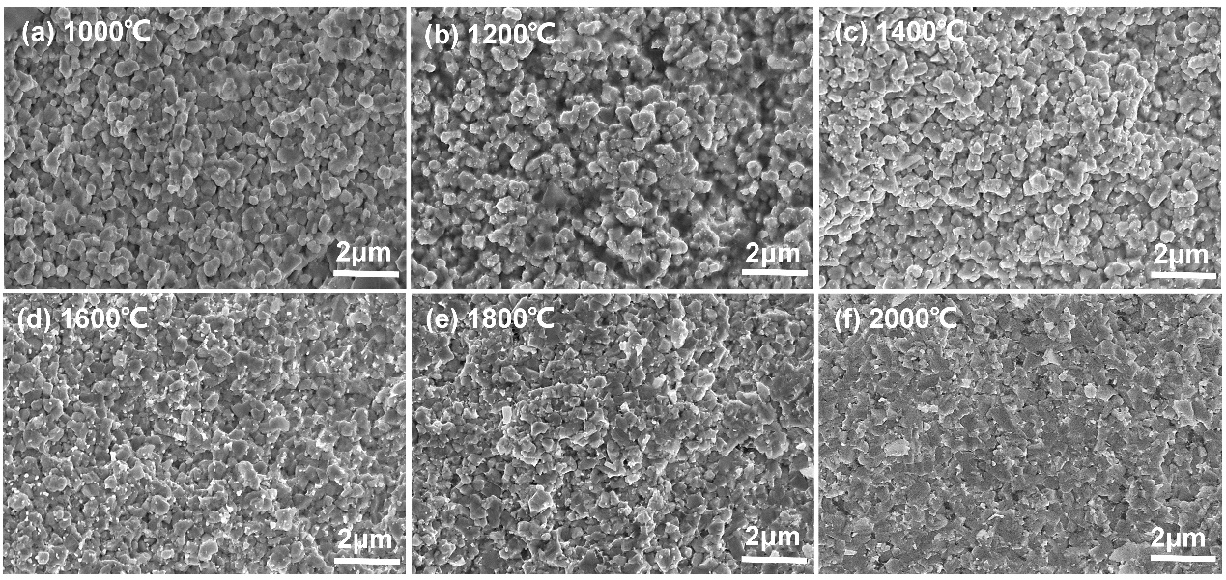
Fig. S1. SEM fractured surface of samples sintered at different temperatures (P = 5 GPa, T = 1000 ~ 2000 ℃) with HEC added 5 mol % B₄C.

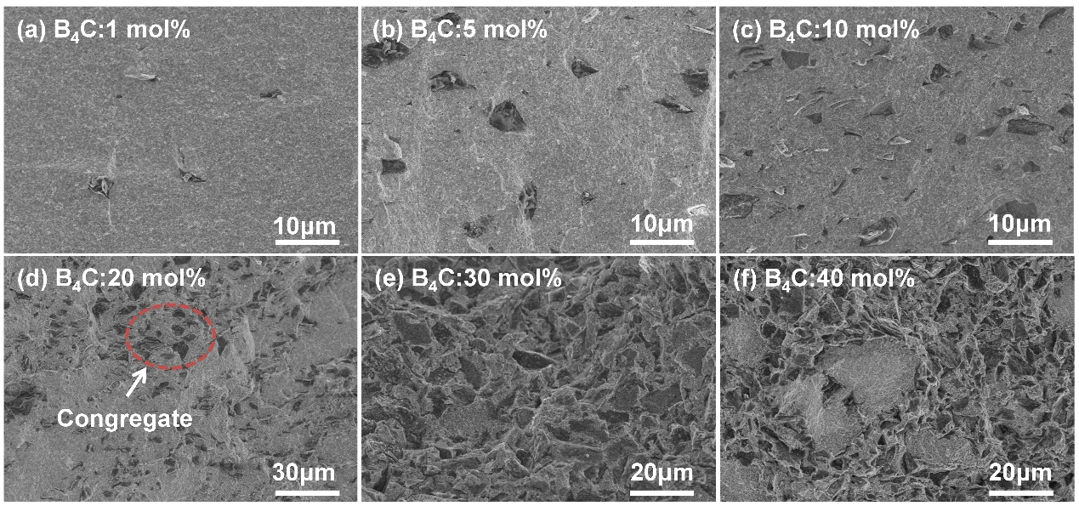
Fig. S2. SEM surface morphology of sintered HEC samples with different percentages of B₄C by HPHT (P = 5 GPa, T = 2000 ℃).

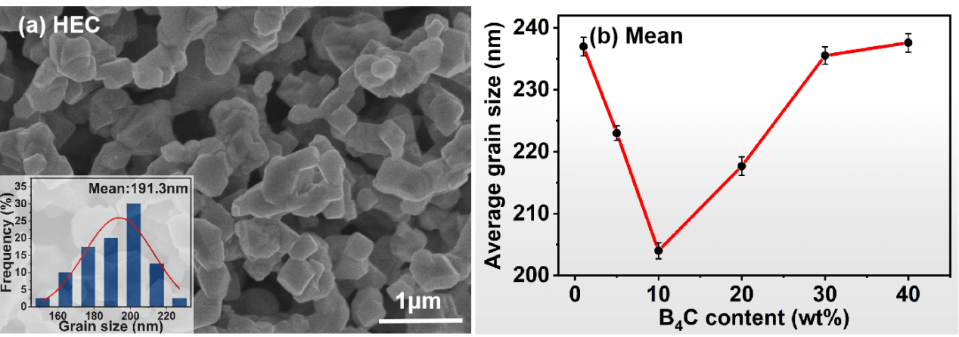
Fig. S3. SEM image: (a) Fractured surface of the high-entropy carbide ceramics (HEC, P = 5 GPa, T = 2000 ℃); (b) Average Grain Size Chart of HEC + B₄C composites;

