Zidda el al. Supplemental Material of “Early processing of traumatic material and contextual information in posttraumatic stress disorder and its relation to memory impairments”

Methods

Stimulus design

For the traumatic category, it was not possible to use already existing picture databases only and normative ratings. Tailored traumatic cues to the trauma-exposed groups were mostly taken from the internet. To control that the chosen stimuli were well tailored, each image was then individually rated for valence, arousal and personal relevance. We also tested whether the participants could identify cues and contexts in the pictures collecting a perceived item/background balance score. With this last one, participants had to indicate what they see in the picture, whether more item or background to control for identification biases. In a scale from 1 to 9, with 1 as pure item, 4.5 as item on a background and 9 pure background. Stimulus size was 1024 x 768 pixels.
There was no significant difference in valence, arousal, personal relevance or perceived item/background type of the images between the two trauma groups (see Table S1 and results section below for more details). There was no significant difference in any of the low-level image properties between the groups (see Table S2 for more details). The traumatic cues were inserted in different sort of contexts taken from the internet. The contexts were rated as neutral (landscapes, interiors of houses, buildings) in an independent internal validation study. Twenty healthy volunteers (12 females, mean age = 30 years, SD = 8.73 years) participated in the evaluation of the pictures. Inclusion criteria were normal or corrected to normal vision and no history of mental or neurological disorders. They were instructed to give valence and arousal ratings using the Self-Assessment Manikin (Bradley & Lang, 1994) both on a scale from 1 to 9. Mean arousal and valence ratings were respectively as follows: 3.09±0.66 (SD), 4.57±1.02 (SD). The contexts were kept stable across the seven trauma picture categories and the cues were mainly placed in the lower part of the picture but alternated with central and upper field positions to avoid predictability: lower part 81.46%; upper part 11.46% and central part 7.08%.

Negative, positive and neutral cues were taken from different databases, IAPS (Lang, 2008),GAPED (Dan-Glauser & Scherer, 2011) EmoPics (Wessa et al., 2010) and from the internet (see Table S4). The neutral contexts were also taken from the same databases and from the internet and were rated as neutral as described above.
Because we could not for sure know if valence and arousal of an image changed after coupling it with a new context, we ran a second independent validation study after the stimuli set was prepared. Thirty healthy volunteers (16 females, mean age = 31.3 years, SD = 11.82 years) participated in the evaluation of the pictures. Inclusion criteria were normal or corrected to normal vision and no history of mental or neurological disorders. They were instructed to give valence and arousal ratings using the Self-Assessment Manikin (Bradley & Lang, 1994). Mean arousal and valence ratings for the negative, positive and neutral cues created were respectively as follows, negative: 5.04±0.95 (SD), 6.67±0.67 (SD), positive: 3.37±0.73 (SD), 4.02±0.43 (SD), neutral: 2.60±0.41 (SD), 4.50±0.64 (SD).

EEG data acquisition

EEG data were continuously recorded with a high-density array of 128 silver-silver chloride electrodes (Electrical Geodesics, Eugene, OR, USA). Impedances were kept below 50 KΩ, as suggested by the manufacturer. The signal was amplified (x1000), filtered online with a band-pass of .01–100 Hz, then digitized at a sampling rate of 1 KHz. The electrooculogram was recorded from bipolar electrode pairs located at the outer canthi and above and below the left and right eyes.

Eye-tracking data acquisition

Visual stimuli were presented in a 17-inch Viewsonic VG710b LCD monitor with a 60 Hz refresh rate. The participants were comfortably seated in front of a table-mounted eye-tracking system which was approximately 70 cm away from participants’ faces. In order to standardize the distance from the screen and to reduce head movements, which would have led to de-calibration issues, participants were asked to place their chin in a headrest put in front of the screen. After successful calibration of the eye-tracking system to the participants’ eye movement patterns, the participants were instructed to watch the visual presentation and try to avoid moving or blinking as much as possible. At the end of the calibration procedure, the stimulus presentation started. Gaze position and fixations measures were recorded continuously during the entire length of the experimental task. We used an EAS binocular remote system complemented by two eye cameras and an IR light source from LC Technologies, Inc., (Fairfax, VA, USA) (sampling rate of 120 Hz, Gaze Position Accuracy <0.45°; Spatial Resolution 0.2°).
NYAN 2.0 software from Interactive Minds (IMD, Dresden, Germany) was used for both the picture presentation and for registering, recording, and analyzing participants’ eye-tracker data, using the table-mounted Eyegaze Analysis System from LC Technologies Inc.

ERP analyses

The raw data were preprocessed using a two-step procedure following Makoto's preprocessing pipeline (Makoto, 2018). The first preprocessing was done to allow a high quality ICA decomposition whose weights would then be used in a second moment on the original raw data. For the first step, the data were initially band-pass filtered (1 Hz - 30 Hz), resampled at 256 Hz, cleaned with the ASR (Artifact Subspace Reconstruction) toolbox (Mullen et al., 2015), segmented into epochs of 3 sec (-1 to 2 seconds around stimulus onset) and re-referenced to average reference. ASR operates as a sliding-window channel interpolation algorithm. It identifies a sparse subset of the contaminated channels and interpolates them using the non-contaminated channels through the use of principal component analysis (PCA) (Miyakoshi, 2023). The resulting data were decomposed by Infomax independent component analysis (ICA) with the algorithm “runica” (Makeig et al., 1997) as implemented in EEGLAB. The ICA matrix was then copied to the original data after a different preprocessing (see below). This allowed obtaining at the same time a cleaned ICA decomposition while preserving the signal from possible distortion due to high frequency filtering. Moreover, ICA allowed retaining as much information as possible by allowing cancellation of artefacts instead of epoch rejection from the EEG signal.
In a second step, the original data were band-pass filtered (0.1 Hz - 30 Hz) using a causal finite impulse response filter with half amplitude, resampled at 250 Hz, cleaned from noisy channels, segmented into epochs of 600 ms (-100–500 ms around stimulus onset) and re-referenced to average reference. At this stage, we copied to each dataset the previously ICA computed matrix (Makoto, 2018)) calculated with 1 Hz high-pass filtering (Winkler et al., 2015).
Artefactual components were identified on the basis of their dipole location, spectra and scalp maps and were excluded from further analysis (see procedures and tutorials as suggested on the EEGLAB developers’ website, https://eeglab.org/tutorials/06_RejectArtifacts/RunICA.html - optimizing-ica-decompositions-quality). For instance any component that reflected muscle activity (e.g. high frequencies >20Hz and located outside the scalp), electrocardiogram (e.g. clear QRS complex in the time series plot at about 1 Hz and near linear gradient scalp topography), or eye movements (e.g. smoothly decreasing EEG spectrum, scalp map with a strong far-frontal projection and individual eye movements in the component erpimage and time series) was considered artefact and removed (see also the ICLabel Tutorial at http://labeling.ucsd.edu/tutorial/about). Data were baseline corrected by subtracting the mean of the 100-ms pre-stimulus interval from each epoch.

Multiple hierarchical regressions

Independent variables included the eye-tracker TTtFF values for cue and context and the C1 ERP amplitudes. These variables were initially entered alone and then in blocks in order to highlight the respective proportion of change in the explained variance of the dependent memory retrieval variable.

Results

Ratings of the stimuli (picture ratings)

For the traumatic category, a two sample T-test for the main analysis showed no significant differences in arousal, valence, figure-ground balance scores and personal relevance between the trauma-exposed groups (see Table S1).
For all the pictures and groups, no significant difference in image hue, saturation, brightness, red-green-blue (RGB), or luminance across picture category or group was found (see table S2).

Hierarchical regression results

For the item memory category, none of the models were able to significantly predict retrieval performance.

Results of the model with covariates

The direction and the level of significance remained unchanged for all the variables. C1 mean peak F(1, 28) = 5.337, p = .030, partial η2 = .182; Time to first fixation for cue F(1,28) = .646, p = n.s., partial η2 = .026 and for context F(1,28) = 5.070, p = 0.34., partial η2 = .174; the mean for item F(1,28) = 1.051, p= .n.s., partial η2 = .042 and for context association F(1,28) = 6.495, p= .018, partial η2 = .213.
In the hierarchical regression, the addition of anxiety and depression scores to the best fitting model led to a non-significant increase in the prediction of the association memory (ΔR2 of .002, ΔF(2, 24) = .054, p =.948). Item memory was also again not significantly predicted by any of these variables.

Results with nontraumatic stimuli

ERP data

The three-way mixed ANOVA showed a significant three-way interaction between valence, laterality and group, F(4, 90) = 2.718, p < .05, partial η2 = .108 (see Fig S1).
There were no statistically significant simple two-way interactions of valence and laterality for any of the three groups.
Figure S1
ERP amplitude and polarity of the early visual C1
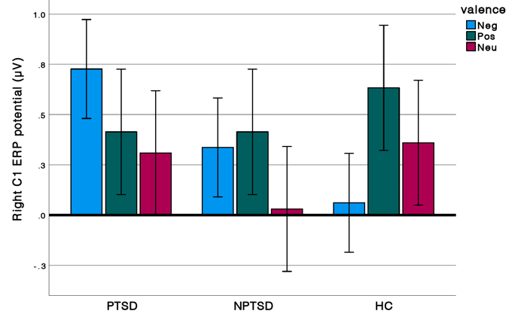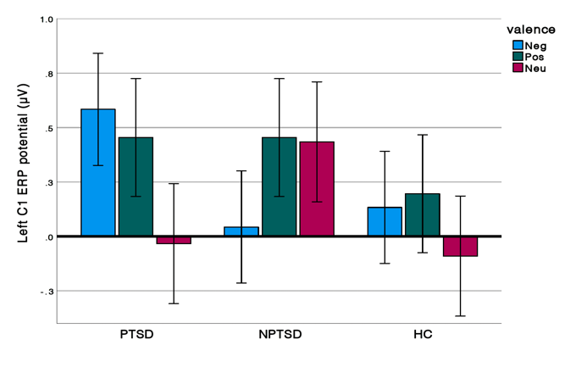
Note. Group with posttraumatic stress disorder (PTSD), trauma control group who did not develop PTSD (NPTSD) and the non-trauma healthy control group (HC).

Eye tracking results

The three-way mixed ANOVA showed no statistically significant three-way interaction between valence, cue-context and group, F(4, 100) = .379, p > .05, partial η2 = .015.
The two-way mixed ANOVA showed a trend in the interaction between cue-context and group (F(2, 50) = 2.303, p = .110, partial η2 = .084; see Fig. S2b).
Figure S2a
Mean eye-tracking time to first fixation.

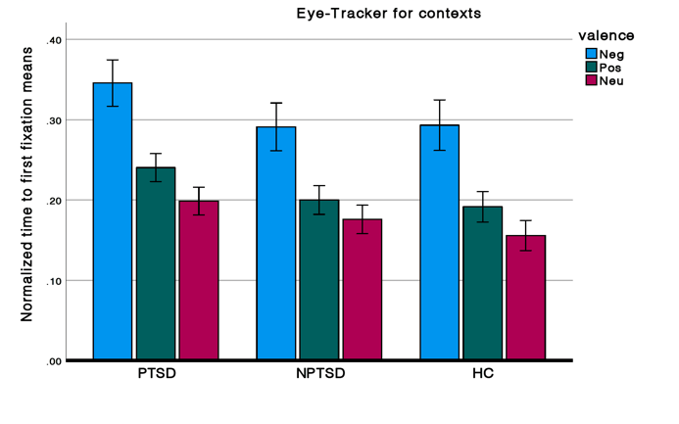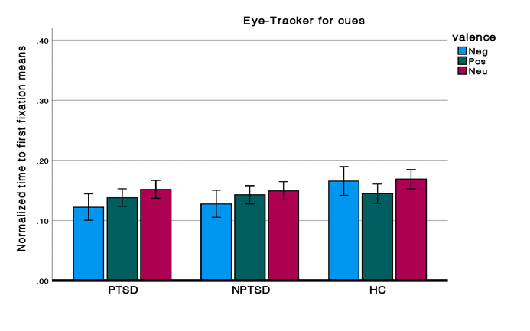
Note. All participants look later at the context compared with the cue especially in the negative category (n.s.).

Figure S2b
Mean eye-tracking time to first fixation for cue and context across valence
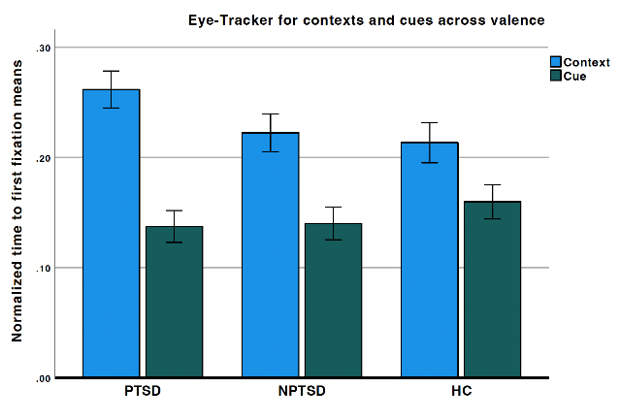
Note. PTSD always look later at the context (n.s. trend).”

Memory results

The three-way mixed ANOVA showed no statistically significant three-way interaction between valence, item-association and group, F(4, 108) = 1.705, p > .05, partial η2 = .059.
The two-way mixed ANOVA showed significant interaction between item-association and group (F(2, 54 = 4.129, p = .021, partial η2 = .133; see Fig. S3b). Post hoc tests were not significant. The two-way mixed ANOVA also showed a trend in the interaction between cue-context and valence (F(2, 50) = 2.247, p = .069, partial η2 = .077; see Fig. S2b).
The three-way mixed ANOVA with adjusted hit rates yielded similar results. We observed no statistically significant three-way interaction between valence, item-association and group, F (4, 108) = .275, p >.05, partial η2 = .010.

Figure S3
Memory strength in the three non-traumatic categories
Figure S3b
Memory strength in the non-traumatic categories across valence
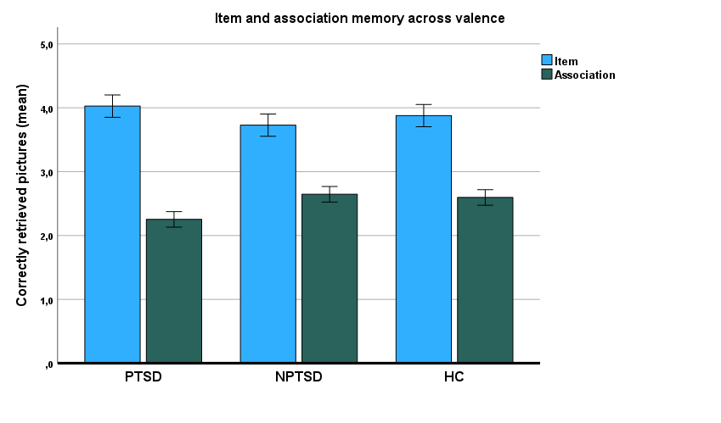

Note. Individuals diagnosed with posttraumatic stress disorder (PTSD), trauma-exposed control group who did not develop PTSD (NPTSD) and the healthy control group (HC).

Tables
Table S1
Traumatic picture ratings
 | PTSD | NPTSD | Statistic
Arousal (sd) | 5.41 (1.91) | 4.75 (1.66) | t(36) = 1.140, n.s.
Valence (sd) | 6.3 (1.20) | 6.14 (0.70) | t(36) = 0.476, n.s.
Personal relevance (sd) | 4.79 (1.96) | 5.68 (1.68) | t(36) = - 1.478, n.s.
Item/Background (sd) | 3.88 (1.48) | 4.07 (1.12) | t(36) = 0.445, n.s.
Note. sd= standard deviation
Table S2
Picture characteristics
 | Negative |  | Positive |  | Neutral |  | Trauma (accident) |  | Trauma  (aggression) |  | Trauma (suicide) |  | Trauma  (rape) |  | Trauma  (hospital) |  |  | Trauma  (war) |  | Trauma (fire)
Hue  (sd) | 0.31 (0.12) |  | 0.31 (0.15) |  | 0.30 (0.13) |  | 0.35 (0.08) |  | 0.35 (0.09) |  | 0.33 (0.10) |  | 0.35 (0.10) |  | 0.36 (0.08) |  |  | 0.34 (0.10) |  | 0.33 (0.11)
Saturation  (sd) | 0.31 (0.10) |  | 0.31 (0.13) |  | 0.28 (0.16) |  | 0.28 (0.13) |  | 0.28 (0.13) |  | 0.29 (0.13) |  | 0.29 (0.12) |  | 0.28 (0.11) |  |  | 0.28 (0.13) |  | 0.29 (0.11)
Brightness  (sd) | 0.53 (0.08) |  | 0.55 (0.09) |  | 0.55 (0.10) |  | 0.57 (0.09) |  | 0.56 (0.09) |  | 0.58 (0.09) |  | 0.56 (0.10) |  | 0.58 (0.09) |  |  | 0.56 (0.09) |  | 0.59 (0.09)
R  (sd) | 121.51 (19.56) |  | 127.14 (27.95) |  | 130.14 (27.47) |  | 126.56 (21.73) |  | 124.59 (19.29) |  | 131.13 (20.83) |  | 126.44 (21.30) |  | 127.28 (17.56) |  |  | 124.50 (21.24) |  | 134.51 (20.69)
G  (sd) | 117.72 (19.29) |  | 123.95 (22.74) |  | 126.73 (27.06) |  | 130.98 (20.96) |  | 128.72 (19.81) |  | 132.27 (21.38) |  | 128.57 (21.51) |  | 133.19 (18.70) |  |  | 128.35 (19.04) |  | 131.99 (18.26)
B  (sd) | 110.96 (25.90) |  | 114.42 (24.36) |  | 114.21 (35.47) |  | 122.95 (26.38) |  | 121.31 (26.27) |  | 122.76 (27.78) |  | 120.95 (27.71) |  | 127.28 (17.56) |  |  | 120.23 (25.20) |  | 122.72 (24.96)
Luminance (sd) | 118.09 (17.84) |  | 123.83 (22.98) |  | 126.33 (27.16) |  | 128.75 (20.53) |  | 126.64 (19.04) |  | 130.85 (20.52) |  | 127.07 (21.01) |  | 130.80 (18.11) |  |  | 126.28 (18.84) |  | 131.69 (18.47)
Visual angle |  | 7.185  (2.794) |  | 5.839  (2.752) |  | 5.815  (2.961) |  | 7.114 (2.375) |  | 8.757  (2.363) |  | 7.508  (2.577) |  | 8.691  (3,834) |  | 8.98  (1.84) | 7.939  (2.625) |  | 8.790  (3.650)
Note. KB= kilobytes; sd= standard deviation

Table S3
Talairach coordinates and nearest grey matter to the average dipole location of each of the four clusters of independent components
Cluster number | Tailarach Coordinates  X Y Z |  |  | Lobe | Nearest Grey Matter
5 | 7 | -67 | 14 | R-mid Occipital | Primary visual cortex
10 | 34 | -61 | 6 | R Occipital | Associative cortex
8 | -22 | -41 | 8 | L Temporal | Hippocampus
6 | 13 | -9 | -5 | Subcortical | Thalamus
3 | 7 | 26 | 15 | R Limbic | Anterior cingulate
17 | 3 | -40 | 43 | R-mid Limbic | Posterior cingulate

Table S4
Number of the pictures used to extract negative, positive and neutral cues
Negative Cues | Neutral Cues | Positive Cues
1110, 2691, 2692, 3015, 3400, 3500, 6020, 9041, 9252, 9265, 9300, 9400, 9409, 9410, 9480, 9561, 9570, 9571, 9622, 9810, e_219, e_243, e_247, e_248, i_19, i_30, i_31, i_32, iu_01, iu_02 | 1450, 2870, 7009, 7025, 7034, 7038, 7040, 7090, 7175, 7185, 7192, 7211, 7233, 7705, 7950, e_153, e_159, e_162, e_164, e_178, e_284, e_301, e_363, N089, i_92, iu_03, iu_04, iu_05, iu_06, iu_07 | 1016, 1600, 1610, 1603, 4004, 4006, 5470, 5626, 8032, 8460, 8502, e_32, e_63, e_256, i_4, i_43, i_44, i_46, i_52, i_53, i_62, i_64, i_71_i_79, i_80, i_84, i_86, i_90, i_97, iu_08
Note. IAPS database (1000-10000); EmoPics (e_xxx); Gaped (Nxxx); Internet (i_xx).

References for the Supplement:

Bradley, M. M., & Lang, P. J. (1994). Measuring emotion: the Self-Assessment Manikin and the Semantic Differential. J Behav Ther Exp Psychiatry, 25(1), 49-59. https://doi.org/10.1016/0005-7916(94)90063-9
Dan-Glauser, E. S., & Scherer, K. R. (2011). The Geneva affective picture database (GAPED): a new 730-picture database focusing on valence and normative significance. Behav Res Methods, 43(2), 468-477. https://doi.org/10.3758/s13428-011-0064-1
Fischl, B., Salat, D. H., Busa, E., Albert, M., Dieterich, M., Haselgrove, C., van der Kouwe, A., Killiany, R., Kennedy, D., Klaveness, S., Montillo, A., Makris, N., Rosen, B., & Dale, A. M. (2002). Whole brain segmentation: automated labeling of neuroanatomical structures in the human brain. Neuron, 33(3), 341-355. https://www.ncbi.nlm.nih.gov/pubmed/11832223
Fydrich, T., Renneberg, B., Schmitz, B., & Wittchen, H.-U. . ((1997)). SKID II. Strukturiertes Klinisches Interview für DSM-IV, Achse II: Persönlichkeitsstörungen. Interviewheft. Eine deutschspeachige, erw. Bearb. d. amerikanischen Originalversion d. SKID-II von: M.B. First, R.L. Spitzer, M. Gibbon, J.B.W. Williams, L. Benjamin, (Version 3/96). Hogrefe, Göttingen.
Lang, P. J., Bradley, M.M., & Cuthbert, B.N. (2008). International affective picture system (IAPS): Affective ratings of pictures and instruction manual. Technical Report A-8.
Logue, M. W., van Rooij, S. J. H., Dennis, E. L., Davis, S. L., Hayes, J. P., Stevens, J. S., Densmore, M., Haswell, C. C., Ipser, J., Koch, S. B. J., Korgaonkar, M., Lebois, L. A. M., Peverill, M., Baker, J. T., Boedhoe, P. S. W., Frijling, J. L., Gruber, S. A., Harpaz-Rotem, I., Jahanshad, N., . . . Morey, R. A. (2018). Smaller Hippocampal Volume in Posttraumatic Stress Disorder: A Multisite ENIGMA-PGC Study: Subcortical Volumetry Results From Posttraumatic Stress Disorder Consortia. Biol Psychiatry, 83(3), 244-253. https://doi.org/10.1016/j.biopsych.2017.09.006
Makeig, S., Jung, T. P., Bell, A. J., Ghahremani, D., & Sejnowski, T. J. (1997). Blind separation of auditory event-related brain responses into independent components. Proc Natl Acad Sci U S A, 94(20), 10979-10984. https://www.ncbi.nlm.nih.gov/pubmed/9380745
Makoto, M. (2018). Makoto's preprocessing pipeline. https://sccn.ucsd.edu/wiki/Makoto's_preprocessing_pipeline
Maren, S., Phan, K. L., & Liberzon, I. (2013). The contextual brain: implications for fear conditioning, extinction and psychopathology. Nat Rev Neurosci, 14(6), 417-428. https://doi.org/10.1038/nrn3492
Miyakoshi, M. (2023). Artifact subspace reconstruction: a candidate for a dream solution for EEG studies, sleep or awake. Sleep, 46(12). https://doi.org/10.1093/sleep/zsad241
Mullen, T. R., Kothe, C. A., Chi, Y. M., Ojeda, A., Kerth, T., Makeig, S., Jung, T. P., & Cauwenberghs, G. (2015). Real-Time Neuroimaging and Cognitive Monitoring Using Wearable Dry EEG. IEEE Trans Biomed Eng, 62(11), 2553-2567. https://doi.org/10.1109/TBME.2015.2481482
Pohlack, S. T., Nees, F., Liebscher, C., Cacciaglia, R., Diener, S. J., Ridder, S., Woermann, F. G., & Flor, H. (2012). Hippocampal but not amygdalar volume affects contextual fear conditioning in humans. Hum Brain Mapp, 33(2), 478-488. https://doi.org/10.1002/hbm.21224
Reuter, M., Rosas, H. D., & Fischl, B. (2010). Highly accurate inverse consistent registration: a robust approach. Neuroimage, 53(4), 1181-1196. https://doi.org/10.1016/j.neuroimage.2010.07.020
Reuter, M., Schmansky, N. J., Rosas, H. D., & Fischl, B. (2012). Within-subject template estimation for unbiased longitudinal image analysis. Neuroimage, 61(4), 1402-1418. https://doi.org/10.1016/j.neuroimage.2012.02.084
Rissling, A. J., Miyakoshi, M., Sugar, C. A., Braff, D. L., Makeig, S., & Light, G. A. (2014). Cortical substrates and functional correlates of auditory deviance processing deficits in schizophrenia. Neuroimage Clin, 6, 424-437. https://doi.org/10.1016/j.nicl.2014.09.006
Segonne, F., Dale, A. M., Busa, E., Glessner, M., Salat, D., Hahn, H. K., & Fischl, B. (2004). A hybrid approach to the skull stripping problem in MRI. Neuroimage, 22(3), 1060-1075. https://doi.org/10.1016/j.neuroimage.2004.03.032
Sled, J. G., Zijdenbos, A. P., & Evans, A. C. (1998). A nonparametric method for automatic correction of intensity nonuniformity in MRI data. IEEE Trans Med Imaging, 17(1), 87-97. https://doi.org/10.1109/42.668698
Wessa, M., Kanske, P., Neumeister, P., Bode, K., Heissler, J., & Schönfelder, S. (2010). EmoPics: Subjektive und psychophysiologische Evaluation neuen Bildmaterials für die klinisch-biopsychologische Forschung. Zeitschrift für Klinische Psychologie und Psychotherapie, 39.
Winkler, I., Debener, S., Muller, K. R., & Tangermann, M. (2015). On the influence of high-pass filtering on ICA-based artifact reduction in EEG-ERP. Conf Proc IEEE Eng Med Biol Soc, 2015, 4101-4105. https://doi.org/10.1109/EMBC.2015.7319296
Wittchen H.-U., W. U., Gruschwitz S., Zaudig M. . ((1997).). SKID. Strukturiertes Klinisches Interview für DSM-IV. Achse I: Psychische Störungen [Structured clinical interview for DSM-IV. Axis I: Mental disorders]. Hogrefe, Göttingen.

