Supplementary Material For:
“Optimal performance of simple low-cost optical physical unclonable functions resilient to machine learning attacks”
Marialena Akriotou¹, Theodoros Bartsokas², Christos Veinides², Dimitris Syvridis^{1,2}
¹Eulambia Advanced Technologies Ltd., Athens, Greece, ²Department of Informatics & Telecommunications, National and Kapodistrian University of Athens, Athens, Greece.
S. Supplementary Material

Post - Processing Algorithm

Fuzzy extractor
The left half of Fig S1 analyses the enrollment mode of the post-processing algorithm, whereby a challenge c is projected for the first time onto the scattering token p. The PUF’s response goes through the image hash function, the result of which is the extraction of a binary sequence $\overline{\text{r}}$ of length n ≥ 511; the requisite information for its reproduction is stored in a data file h_{r}. The binary sequence $\overline{\text{r}}$ is consequently directed to the cryptographic hash function SHA-256, whose output represents the encrypted output z of the system. In parallel, a pseudorandom binary message of length k ≤ n is being generated independently and is encoded using a BCH error correction algorithm. A second helper data file h_{z} is generated by XORing the binary sequence $\overline{\text{r}}$ and the encoded random message.
The authentication mode of the algorithm is shown on the right half of Fig S1; the same challenge c (as in the enrollment mode) is being used to obtain a response. The helper data h_{r} is being used to calculate the corresponding hashed binary sequence $\overline{\text{r}}$′; also, the XOR between $\overline{\text{r}}$′ and h_{z} is being extracted, which represents the error-affected encoded message. This is decoded by using the inverse BCH code and encoded again. The re-encoded result is XORed with helper data h_{z} and the output is the rectified hashed response. The conclusion of the algorithm is reached by feeding this rectified hashed response to the SHA-256 hash function, thereby producing z′.
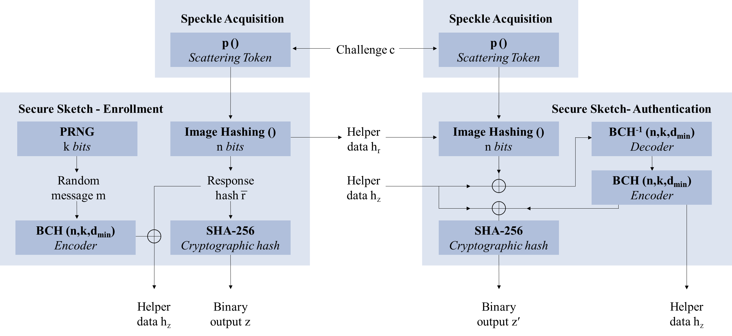
Fig. S1 The two modes of the algorithm developed for the generation of error-free binary sequences from the noisy responses of the PUF.
Interestingly, the parameters (n,k,d_{min}) of the BCH algorithm influence the effectiveness of the above described procedure significantly. As is dictated by the Error Correction Code (ECC) theory, the error correction capability of a BCH algorithm is t = (d_{min} - 1) / 2, where k is the number of information bits encrypted in a code-message of length n = 2^{ℓ} – 1, and d_{min} is the minimum number of bits that differ between two codes. In essence, this algorithm can correct up to t errors, using the redundant bits that were added during the encoding phase of the enrollment mode. For any fixed code-message length, the available overhead is inversely proportional to the length k and the error-correction capability t of the algorithm. For any single value of n, any increase of k has the effect of fewer bit-flip errors to be corrected, which in turn reduces the number of responses that are ultimately being mapped to one single output z.

Image Hashing Function
The image hashing function used for the extraction of the binary sequences is essentially a compressive sensing approach, which exploits the sparsity of signals in the frequency domain and the incoherency between the spatial and frequency domains to achieve compression with very few samples (below Nyquist rate) ¹.
Sparsity: A signal is sparse when most of its elements are zero/negligible. Most signals in nature can have a sparse representation when transformed in an appropriate base, a fact that is widely exploited for compression.
Incoherence: when the sampling of a signal is performed periodically and below the Nyquist rate, aliasing occurs. This happens because both the signal and sampling pattern are periodic, which causes them to coherently interfere with each other. If the sampling pattern is aperiodic, it is very unlikely for different signals to have identical values at every sample. The easiest way to break coherency is to use a random sampling pattern.
In that context, we perform random sampling of the speckle spectrum, after modulating the initial image with white noise in order to eliminate zero frequency areas ². These random samples are then quantized according to zero. The specific steps of the algorithm employed are:
- Alignment of the speckle patterns that are obtained during the authentication mode with the corresponding response captured during the enrollment. Their in-between displacement is computed by comparing the corners of their features. The corners are detected using the Harris algorithm ³, extracted via the FREAK method ⁴, and matched in pairs by minimizing their sum of squared differences. The required translation is performed by applying an appropriate affine transformation, in order to achieve subpixel accuracy. The image is finally cropped by 50 pixels from each side.
- Standardization of the aligned and cropped image: x_{i} = (x_{i}-μ)/σ where μ and σ denote the mean value and the standard deviation of the image pixel intensities x_{i}.
- White noise modulation: Element-wise multiplication of the standardized image with a pseudo-random Bernoulli matrix B, which contains only the values ±1.
- DFT application: Spectrum of the modulated image
- Sampling of spectrum elements via a pseudorandom selection matrix S. Specifically, the final hash contains 256 elements of the real part and 255 elements of the imaginary part of the DFT result.
- Quantization: values above zero are set equal to 1, values below zero are set equal to 0. Zero values remain 0 in case the median of all the elements is greater than zero.
It should be noted that the corners of the speckle patterns as well as the Bernoulli matrix B and the selection matrix S constitute the aforementioned helper data file h_{r}.
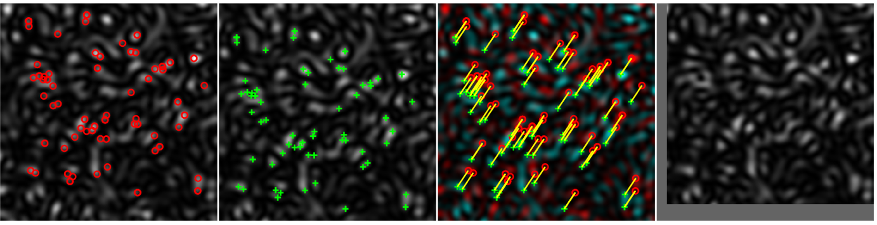
Fig S2: Alignment of two speckle pattern images : a) Experimental speckle obtained during the enrolment mode of the fuzzy extractor, along with the corners detected from the described alignment algorithm. b) Rerun of the same speckle, as captured in the authentication mode of the fuzzy extractor, along with its own detected corners. c) Overlapping visualization of the two speckles with their corresponding detected corners matched in pairs. d) the aligned version of the authenticated speckle before cropping. Its displacement with the enrolled speckle was found -20 pixels along the axis and -30pixels along the axis y respectively.
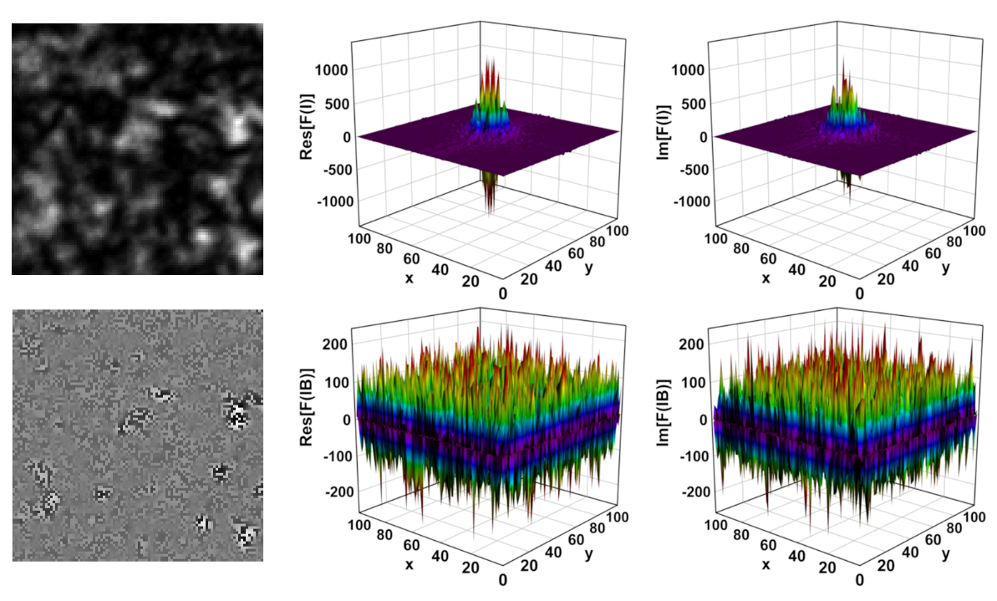
Fig S3: a) Raw experimental speckle along with b) the real and c) the imaginary part of its Fourier transform. d) The same speckle, modulated with white noise along with b) the real and c) the imaginary part of its Fourier transform.

Evaluation Methodology
- Cross-Correlation Coefficient and Hamming distance
As already mentioned in the main text of the current paper, the preliminary evaluation of the system’s performance was carried out employing two different metrics: the Pearson cross-correlation coefficient and the Hamming distance. The former, as defined in chapter 2.2 of the challenge generation algorithm, was used to quantify the similarities of the available speckle patterns r, after the application of the alignment process. The latter, which is the number of bits that differ between two binary sequences v, u ∈ {0,1}^{M} and is given by the following relation:
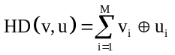 (S1)
was used to measure the similarity of their respective binary equivalents $\overline{\text{r}}$, before the application of the BCH code and the chosen cryptographic function.
The distributions derived from these two metrics are usually plotted in histogram form and in pairs (robustness - unpredictability) respectively for each metric. The pairing is used as a visual aid and as a visualization of any overlap between them. The existence of overlaps signifies the risk of an output from one challenge to be registered as the output of a different challenge, whereby the error-correction routines would perceive any differences as errors and correct them, producing an erroneous registration.
- Mathematical Definitions of Robustness and Unpredictability
With respect to the post-processing algorithm described in the previous paragraphs, the property of robustness can be quantified through the following equation ^{5–7}:
Robustness = Pr[PUF(p, c, h) → (z, h) : PUF(p, c, h) → (z, h)] (S2)
where c is an applied challenge to a single token p and z its corresponding output. The ε, h symbols refer to the input helper-data files of the enrollment mode and the authentication mode respectively, with ε being empty and h = {h_{r},h_{z}}. In other words, robustness for a given system expresses the conditional probability of generating an identical output z in both modes using the helper data created in the enrollment.
On the other hand, as the physical unpredictability of a PUF is defined the conditional probability of predicting the correct output z of a challenge c′, using a machine learning model that is trained on an already known set of challenge - response pairs, in which c′ is not included.
Unpredictability = Pr[Model(c′, h) → (z, h) : PUF(p, c, ε) → (z, h)] (S3)
- NIST Statistical Test Suite
The standard in testing for true randomness in variable-length binary sequences is the NIST Statistical test suite ⁸. It contains 15 tests specifically developed to challenge various aspects of randomness and detect different kinds of non-randomness that could emerge in binary sequences; some of the tests consist of subtests. Whenever a binary sequence goes through a test, its randomness is being evaluated on a scale of [0-1], which represents the probability of a TRNG to produce a sequence of less randomness than the binary sequence undergoing the test; this probability is referred to as a p-value. Each p-value is compared to a set level of significance (α), which by default has a value of 0.01; if the p-value > α, then the binary sequence is considered random; otherwise, the test is considered a failure. For the significance level to be 0.01, the input file must contain at least 100 sequences of 100 bits each. The results of the NIST test suite can be interpreted in many ways. NIST itself has chosen two interpretations:
- The examination of the proportion of sequences whose p-value > α; the relative number of sequences passing the test should be within a certain percentage
- The uniformity testing of p-values. p-values computed for random sequences should exhibit a uniform distribution in the interval [0,1). The p-value of the p-values (pop) should exceed 10⁻⁴.

NIST Results
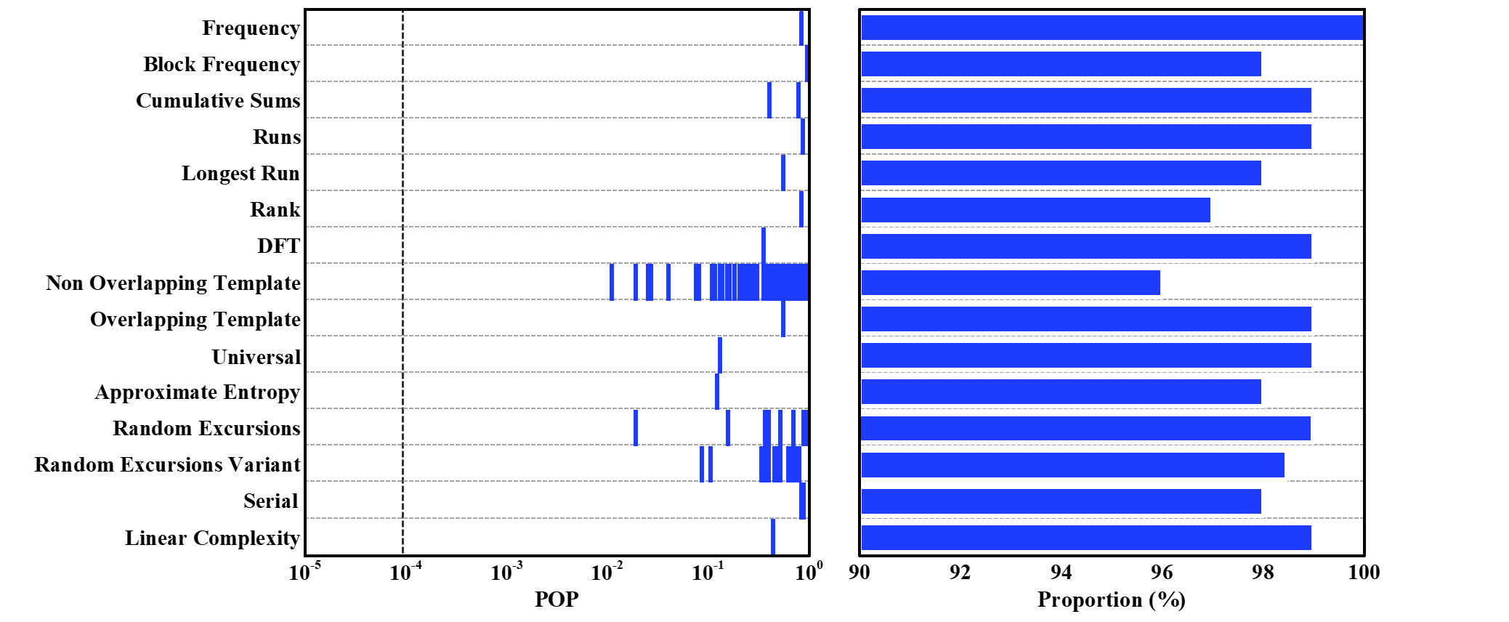
Fig. S4 NIST results for the binary sequences that have been extracted from the speckles produced by the U04 challenges. All tests are successfully passed. Pass proportion is equal to 96% except for Random Excursion and Random Excursion Variant tests which is 93.84% respectively.
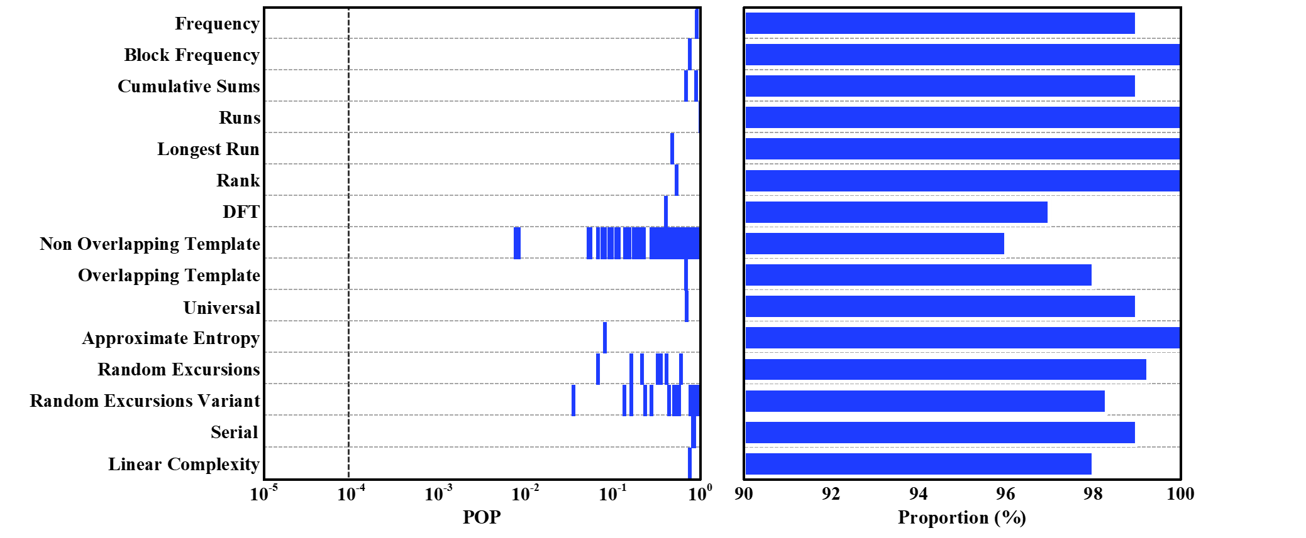
Fig. S5 NIST results for the binary sequences that have been extracted from the speckles produced by the U08 challenges. All tests are successfully passed. Pass proportion is equal to 96% except for Random Excursion and Random Excursion Variant tests which is 95% respectively.
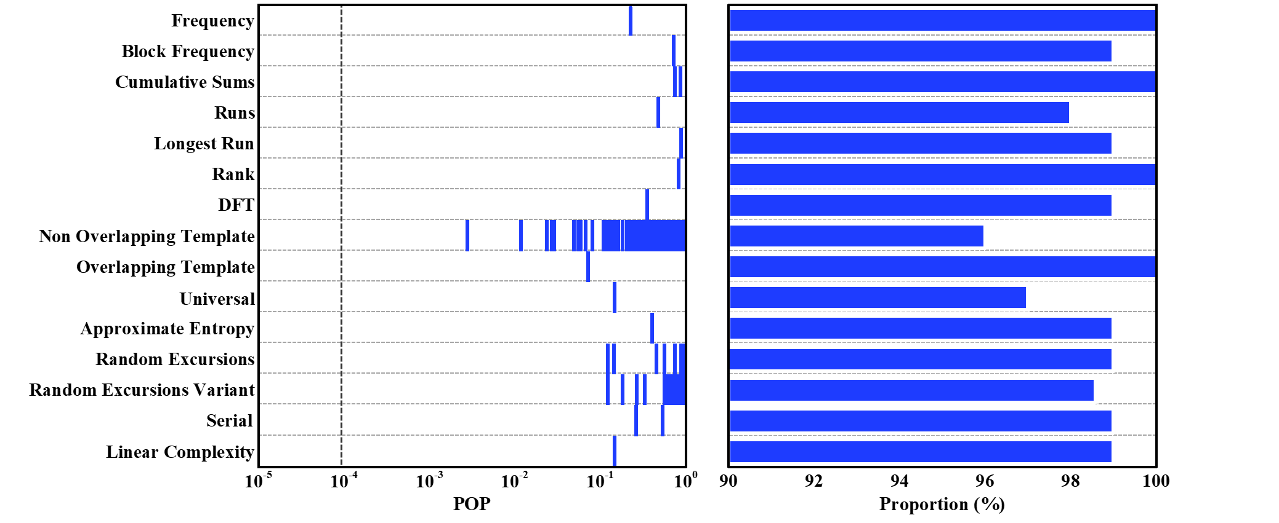
Fig. S6 NIST results for the binary sequences that have been extracted from the speckles produced by the U16 challenges. All tests are successfully passed. Pass proportion is equal to 96% except for Random Excursion and Random Excursion Variant tests which is 94.29% respectively.
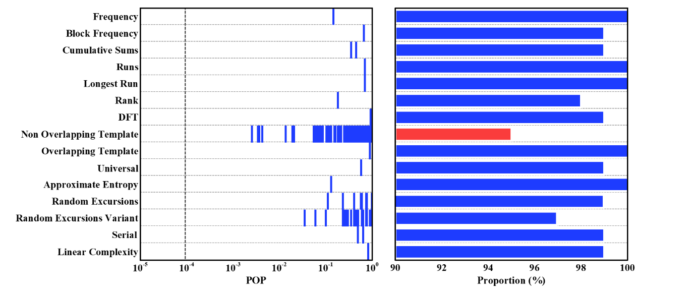
Fig. S7 NIST results for the binary sequences that have been extracted from the speckles produced by the C02 challenges. All tests are successfully passed. Pass proportion is equal to 96% except for Random Excursion and Random Excursion Variant tests which is 93.94% respectively.
Evidently, all the POP values for every dataset exceed 10⁻⁴ and all proportions are greater than the threshold imposed by the NIST tests, with the exception of one proportion out of the Non-Overlapping Template test for U02 dataset. In this test, the expected number of failed sequences was exceeded by just one. This kind of failure can be viewed as a statistical error, something which can happen even for verifiably random number generators.

References
1. Candès, E. J. & Wakin, M. B. An Introduction To Compressive Sampling. IEEE Signal Process Mag 25, 21–30 (2008).
2. Naini, F. M., Gribonval, R., Jacques, L. & Vandergheynst, P. Compressive Sampling of Pulse Trains: Spread the Spectrum! in IEEE International Conference on Acoustics Speech Signal Processing 2877–2880 (2009).
3. Harris, C. & Stephens, M. A Combined Corner and Edge Detector. in Proceedings of the 4th Alvey Vision Conference 147–152 (1988). doi:10.5244/C.2.23.
4. Alahi, A., Ortiz, R. & Vandergheynst, P. FREAK: Fast Retina Keypoint. in Proceedings of the IEEE Computer Society Conference on Computer Vision and Pattern Recognition 510–517 (IEEE, 2012). doi:10.1109/CVPR.2012.6247715.
5. Armknecht, F., Maes, R., Sadeghi, A. R., Standaert, F. X. & Wachsmann, C. A formal foundation for the security features of physical functions. in Proceedings - IEEE Symposium on Security and Privacy 397–412 (2011). doi:10.1109/SP.2011.10.
6. Armknecht, F., Moriyama, D. & Sadeghi, A. Towards a Unified Security Model for Physically Unclonable Functions. in The Cryptographers’ Track at the RSA Conference (ed. Sako, K.) 271–287 (Springer, San Francisco, 2016).
7. Shariati, S., Standaert, F.-X., Jacques, L. & Macq, B. Analysis and experimental evaluation of image-based PUFs. J Cryptogr Eng 2, 189–206 (2012).
8. Rukhin, A. et al. A Statistical Test Suite for Random and Pseudorandom Number Generators for Cryptographic Applications. Preprint at (2010).

