Supplementary Information
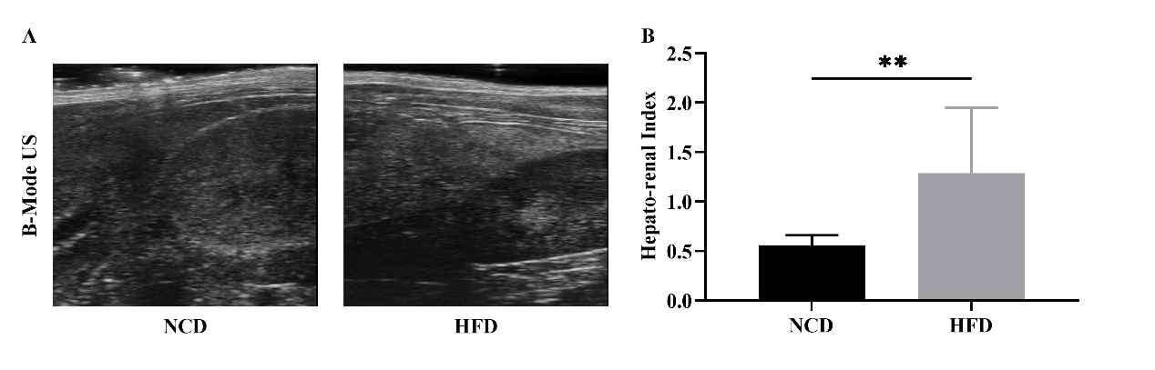
Supplementary Fig. 1 Results of the ultrasound echogenicity analysis. (A) Hepato-renal index (HRI) obtained from B-mode US images in NCD and HFD groups. (B) Quantitative analysis of HRI. *p<0.05 and **p<0.01, compared with the HFD group.
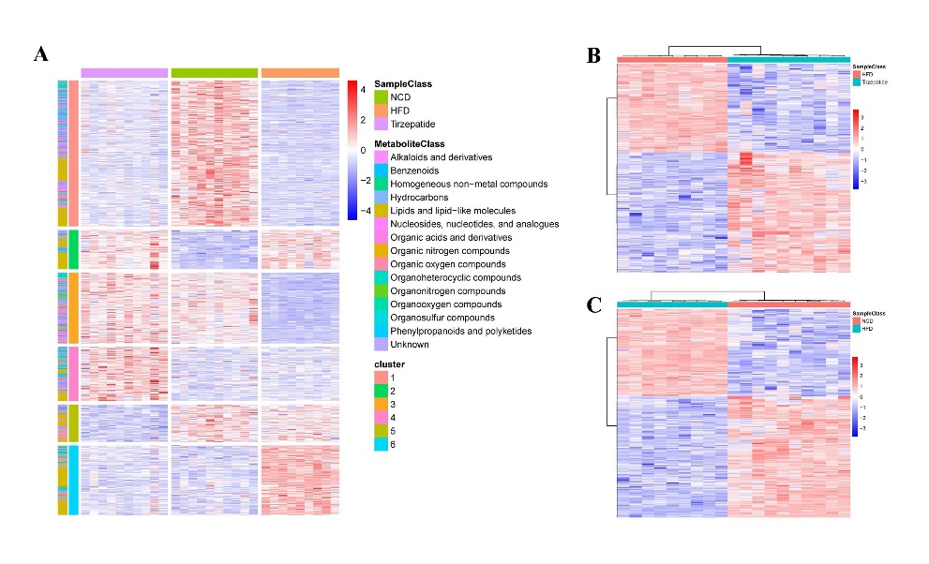
Supplementary Fig. 2 Differential analysis of liver metabolites in three groups. (A) Heatmap of hierarchical clustering analysis for differential metabolites among the NCD, HFD, and HFD + tirzepatide groups. (B) Heatmap of differential metabolites between the HFD and NCD groups. (C) Heatmap of differential metabolites between the HFD + tirzepatide and HFD groups.
Supplementary Table 1 Inclusion list of PRM.
Mass [m/z] | CS [z] | Polarity | Start [min] | End [min] | NCE | Comment
396.70896 | 2 | Positive | 21.94 | 26.94 | 30 | MGINVMK
451.25872 | 2 | Positive | 14.88 | 19.88 | 30 | LAALTAADR
451.77093 | 2 | Positive | 45.63 | 50.63 | 30 | TLPTVPFK
459.25617 | 2 | Positive | 13.61 | 18.61 | 30 | EQVLSVSR
468.25089 | 2 | Positive | 19.64 | 24.64 | 30 | EVGVGFATR
480.77727 | 2 | Positive | 21.07 | 26.07 | 30 | LSSASLNIR
503.27205 | 3 | Positive | 19.88 | 24.88 | 30 | THPELLVAHAYTR
547.76489 | 2 | Positive | 11.11 | 16.11 | 30 | GSVQVDGNYR
547.96048 | 3 | Positive | 72.12 | 77.12 | 30 | FLVPDHVNMSELIK
561.28787 | 2 | Positive | 13.21 | 18.21 | 30 | EVSDGVLTSSK
590.31317 | 2 | Positive | 60.17 | 65.17 | 30 | ETLAFIAQMR
610.28312 | 2 | Positive | 11.8 | 16.8 | 30 | AEIDSHSFGEK
641.8719 | 2 | Positive | 55.19 | 60.19 | 30 | VSIAAQLLQDPK
699.91377 | 2 | Positive | 80.49 | 85.49 | 30 | ADLLGIVSELQLK
723.89356 | 2 | Positive | 43.01 | 48.01 | 30 | DTVTTGLTGAVNVAK
740.35173 | 2 | Positive | 55.15 | 60.15 | 30 | LGVEFDEITADDR
786.14532 | 3 | Positive | 69.97 | 74.97 | 30 | LLPGAITTIVKPPSAIPQPTITK
814.08228 | 3 | Positive | 85.48 | 90.48 | 30 | TQEMLAQLQETLELIQHMQR
836.41486 | 2 | Positive | 64.15 | 69.15 | 30 | NYDIGAALDTIQYSK
850.79458 | 3 | Positive | 66.18 | 71.18 | 30 | LKPEQLGDISVGNVLQPGAGAIM[+15.99492]AR
850.90476 | 2 | Positive | 65.46 | 70.46 | 30 | IQLAMVC[+57.021464]YSPDFEK
855.96601 | 2 | Positive | 78.55 | 83.55 | 30 | MLSLNVFSVQVQAFK
871.37753 | 3 | Positive | 66.58 | 71.58 | 30 | FSFC[+57.021464]FSPEPEAEAQAAAGPGPC[+57.021464]ER
915.43287 | 3 | Positive | 76.48 | 81.48 | 30 | FC[+57.021464]TLLGGTTADAMC[+57.021464]PILEFEADRR
916.99127 | 2 | Positive | 66.07 | 71.07 | 30 | AVTQSAEITIPVTFEAR
919.44846 | 3 | Positive | 71.83 | 76.83 | 30 | SVDALQATFADAHC[+57.021464]LGDVAPTALAEGR
972.01167 | 2 | Positive | 79.47 | 84.47 | 30 | TYLDVEPITGFTLQFAK
983.16097 | 3 | Positive | 72.9 | 77.9 | 30 | LHLQSTDYGNFLANEASPLTVSVIDDK

