Dear editor,

Thank you for your kindness to give us the chance to revise the manuscript. We have considered the comments of reviewers carefully, consulted to the literature, re-checked the whole paper, conducted the additional experiments, and revised the paper accordingly. All the revisions are highlighted in yellow background. The detailed responses to the reviewer’s comments are summarized in Question Answer Part.
We hope that the paper at this stage can meet the requirement of the journal and be considered for the publication in Applied Biochemistry and Biotechnology.

Best regards,
Yours sincerely
Xia Zhang (Prof.)

Question Answer Part
General response to reviewers: We sincerely thanks the reviewers for the very helpful and constructive comments. Those comments are very valuable and helpful for us to improve our paper. Responses to each question are summarized below, and changes made in the manuscript and supplementary data are highlighted in yellow background. We hope that this complete revision warrants a publication in Applied Biochemistry and Biotechnology.

Reviewer 1:
Comments to the Author
- What is the pH stability of Cu-Mel? Is Cu-Mel soluble at the tested pH values? This information should be added to the article.
Response: Thanks for your comments. We have determined the pH value of the reaction solution, which is 5.8. And under this pH condition, the Cu-Mel can well disperse after ultrasonic treatment. Besides, we have tested the laccase-like activity of the Cu-Mel under other pH conditions including 2.6, 5.2, 8.2 and 9.7. As shown in Fig. 5e, the Cu-Mel demonstrated satisfactory catalytic performances under the pH range of 5.2-9.7, and a diminished catalytic activity at pH 2.6.
We have added Fig.5e in the revised manuscript, and the above discussions are listed on page. 16 in the revised manuscript.
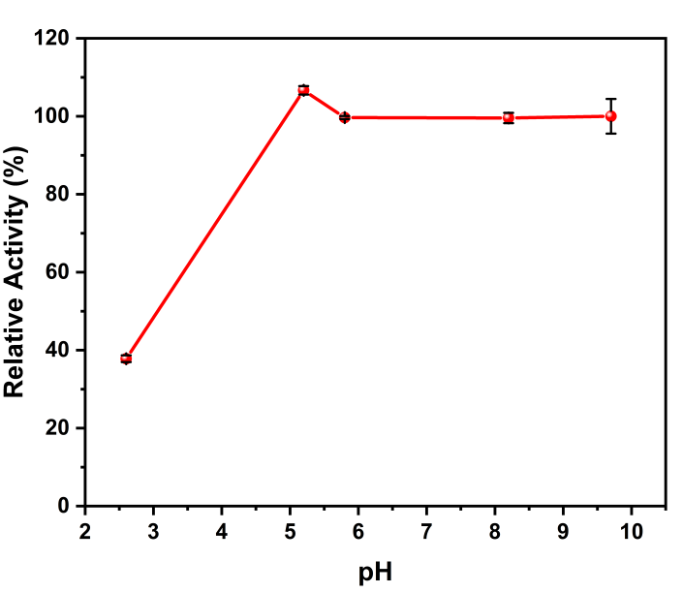
Fig. 5e The relative laccase-like activities of Cu-Mel under different pH values.

- Similarly, the reuse stability of Cu-Mel should be included in the manuscript.
Response: Thanks for your comments. We have conducted the catalytic experiments of the used Cu-Mel. As demonstrated in Figure 5f, the bad reusability was presented by the Cu-Mel, and only 24.8% of initial activity is presented. The diminished activity may be caused by the instability of Cu-Mel in the catalytic reactions.
We have added Fig. 5f in the revised manuscript, and the discussions are listed on page. 18 in the revised manuscript.

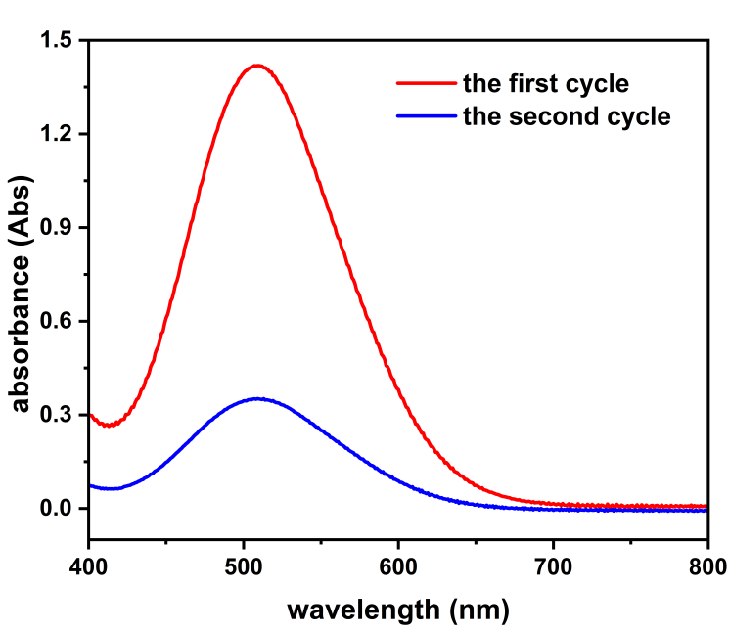
Fig. 5f The reusability of Cu-Mel

- Check the Fig 1a and Fig. 1b and correct the caption of Fig. 1 as FT-IR spectrum of Cu-Mel and melamine (a) and Powder XRD (PXRD) patterns of melamine, CuCl, reference and Cu-Mel (b). The similar corrections should be made within the manuscript.
Response: Thanks for your comments. We have corrected the caption of the figures in the revised manuscript.

- 2.2. Hydrothermal synthesis of Cu-Mel: ...........a literal work??? Check the literal (literary?)
Response: Thanks for your comments. We have revised the expression accordingly.

- What is the Mie constant? Is it Michaelis-Menten constant? Please check.
Response: Thanks for your comments. We have replaced Mie constant with Michaelis-Menten constant in the revised manuscript.

- It seems difficult to calculate the K_{m} and V_{max} values from Fig. 4b. Give the equation of the line in Fig. 4b.
Response: Thanks for your comments. We have given the equation of the fitting line in the part of 3.2 in the revised manuscript.
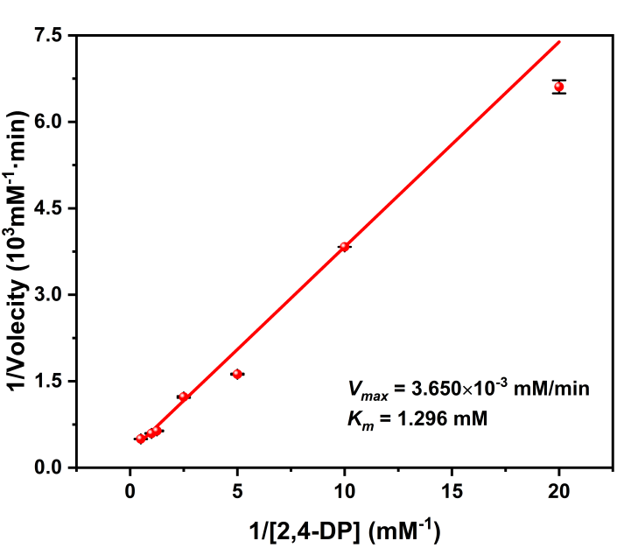
Fig. 4b Lineweaver-Burk plotting curve based on Michaelis-Menten equation

Reviewer 2:
Comments to the Author
- Several Cu-based nanozymes with laccase or oxidase activities have been reported. The authors should consider including more relevant references on this topic (e.g. Biosensors and Bioelectronics 2024, 266, 116747; ACS Appl. Nano Mater. 2023, 6, 1369-1378; J Agric Food Chem 2022, 70, 14522; Sensors 2023, 23, 8137; Scientific Reports 2019, 9, 17758; ACS Sustainable Chem. Eng. 2022, 10, 1398-1407)
Response: Thanks for your comments. We have included recommended references which highlighted yellow background in the reference list of the revised manuscript.

- In section 2.7, H₂O₂ was included in the Congo red degradation. To my understanding, H₂O₂ is not required for the laccase activity. Please clarify this point.
Response: Thanks for your advice. We have carried out the tests for Congo red degradation catalyzed by the resulting Cu-Mel but without H₂O₂ added. As shown in Fig. 7a., a good degradation percentage of Congo red were achieved while no H₂O₂ was used. At a concentration of 60 mg/L, the Cu-Mel demonstrated a high degradation rate of 89.8% for Congo red was presented while the concentration of 60 mg/L, indicating an effective degradation ability of Congo red. And with the increasing concentration of Congo red, the degradation rate slightly decreased but stayed above 70%. The degradation kinetics are exhibited in Fig. 7b. the Cu-Mel displayed the excellent degradation ability within 5 min with a degradation percentage of 80.8%.
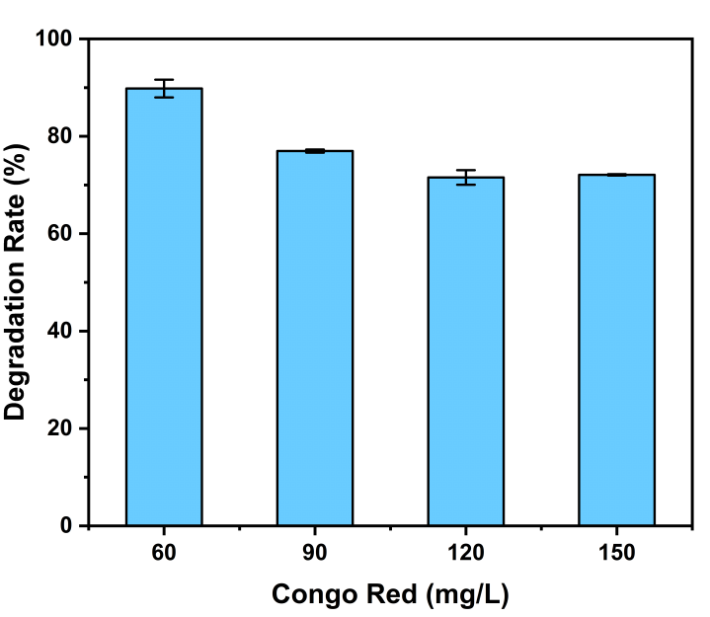
Fig. 7a The degradation percentages of Congo Red with different initial concentrations by Cu-Mel without H₂O₂ added.
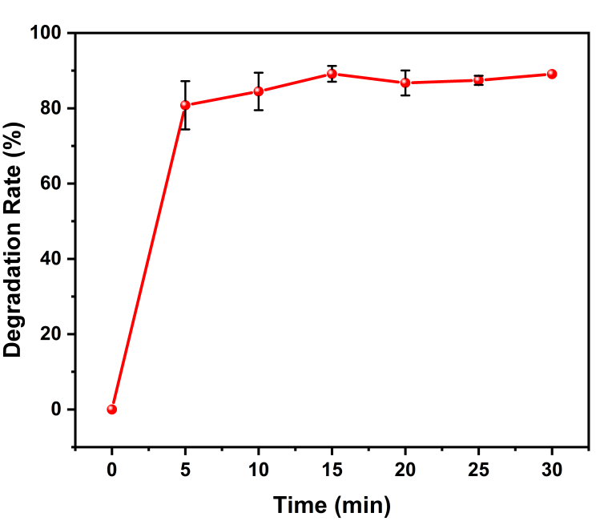
Fig. 7b Degradation kinetics of Congo Red by Cu-Mel without H₂O₂ added

- In Table 2, room illumination was included in the condition. To my understanding, light irradiation is not required for the reaction. Please clarify this point.
Response: Thanks for your comments. We have corrected the wrong expression in the Table 2 in the revised manuscript.

- Fig. 6b, an oxygen atom is missing from the structures of 4-AP and the colored oxidation product.
Response: Thanks for your comments. We have revised the structures of 4-AP and the colored oxidation product in Fig.6b and graphic abstract in the revised manuscript.
Fig.6b Reaction mechanism between 2,4-DP and 4-AP laccase-like catalytic characteristics of Cu-Mel are illustrated

- Fig. 7, the maximum value of the y-axis scale is 1.0. Since the label indicates the degradation rate in %, the figure should be 100 rather than 1.0.
Response: Thanks for your comments. We have revised it in the revised manuscript.

- Fig. 7a, The authors made a substantial discussion on the degradation efficiencies in relation to the Congo red concentration, but are these differences in the range of 87-93% significant enough?
Response: Thanks for your comments. As you proposed, the influences of the initial concentrations on the final degradation percentages are slightly. We also tested the influences of the concentrations on the degradation percentages by the resulting Cu-Mel with no H₂O₂, as exhibited in Fig. 7a, the degradation rate is in the range of 71-89%, showing a diminished degradation rated with increasing concentration of Congo red.

- There are language issues that require extensive polishing.
Response: Thanks for your comments. We have polished part of language in the revised manuscript.

