Supplementary Information for
Oncogenic Function of Growth Arrest-specific Transcript 5 by Competing with miR-423-3p to Regulate SMARCA4 in Hepatocellular Carcinoma

This file includes:
Supplementary Methods
Supplementary Tables 1 to 5
Supplementary Fig. 1 to 14

Supplementary Methods
Publicly available genomic data analyses
To investigate the gene expression levels of subunit genes in HCC, data were obtained from The Cancer Genome Atlas liver hepatocellular carcinoma project (TCGA_LIHC), the International Cancer Genome Consortium Liver Cancer–RIKEN, JP (ICGC_LIRI) and the Gene Expression Omnibus (GEO) database of the National Center for Biotechnology Information (NCBI) (Accession Numbers: GSE77276, GSE77314, GSE89377, and GSE114564). Level 3 mRNA expression data of TCGA datasets HTSeq-FPKM were log2 transformed [log2(fpkm+1)] and used to assess the gene expression levels. GAS5 expression in a variety of cancer was from the Gene Expression database of Normal and Tumor tissues (GENT2, http://gent2.appex.kr/gent2/) and Genomic Data Common (GDC) platform from TCGA datasets.

Cell culture
Human HCC cell lines (Hep3B, HepG2, Huh7, PLC/PRF/5, SNU-182, SNU-354, SNU-368, SNU-423, SNU-449, and SNU-475) were obtained from Korean Cell Line Bank (KCLB, Seoul, Korea). MIHA immortalized liver cell lines were kindly provided by Dr. Jayanta Roy-Chowdhury (Albert Einstein College of Medicine, New York, NY). Each cell line was cultured in EMEM (ATCC), RPMI-1640 or DMEM medium (GenDEPOT, Katy, TX, USA) containing 10% fetal bovine serum (FBS; GenDEPOT) and 100 units/mL of penicillin-streptomycin (GenDEPOT). All cells were cultured at 37℃ in a humidified incubator with 5% CO₂.

Transfection
Small interfering RNAs (si-RNAs) and miRNA mimics were synthesized by Genolution (Seoul, Korea). The sequence of the si-GAS5: 5’- GCAAAGGACUCAGAAUUCA -3’, si-SMARCA4: 5’- CUCGUUCCAGAGCUGAGAU -3’, si-Gas5: 5’- GGCACUGCAAACACAAUGAUU -3’ and si-Smarca4: 5’- CCCGCAUCACUGAGAAGUUUU -3’. SMARCA4 protein expression plasmid, subcloning gene ORF and 3’UTR region (NM_003072) in pBJ plasmid, was purchased from Addgene (Watertown, MA, USA). Transfections were carried out using Lipofectamine RNAiMAX or Lipofectamine 2000 reagent (Invitrogen, Carlsbad, CA, USA), according to the manufacturer’s instructions.

RNA extraction and quantitative real-time polymerase chain reaction (qRT-PCR)
Total RNA was isolated from frozen human tissues and cell lines using TRIzol reagent (Invitrogen, Carlsbad, CA) according to the manufacturer's instruction. For synthesis of cDNAs specific to miRNAs, miScript II RT kit (Qiagen, Manchester, UK) was used. For synthesis of cDNAs specific to mRNAs and lncRNAs, Tetro cDNA synthesis kit (Bioline, London, UK) was used. qRT-PCR was performed with a SensiFASTTM SYBR® NoROX Kit (Bioline). To normalize differences in the amount of total cDNA added to each reaction; U6 for miRNA and glyceraldehyde-3-phosphate dehydrogenase (GAPDH) for mRNA were used as the endogenous control.

Western blotting analysis
Patient frozen tissue (or mouse HCC tissues) and human HCC cell lines were lysed in protein extraction buffer (50mM of HEPES, 5 mM of ethylenediaminetetraacetic acid, 50 mM of NaCl, 1% Triton X-100, 50 mM of NaF, 10 mM of Na₂P₂O₇, 1 mM of Na₃VO₄, and 100X Halt protease inhibitor cocktail or 100X Halt protease & phosphatase inhibitor). Lysates containing equal amounts of proteins were separated by sodium dodecyl sulfate/polyacrylamide gel electrophoresis and transferred onto polyvinylidene difluoride membrane (Bio-Rad, Hercules, CA). The blots were blocked with a 5% skim milk solution and incubated with the respective antibodies information is summarized in Table S4. The Immobilon western detection system (Merck Millipore, Burlington, MA) was used to detect antibodies. The Immobilon™ western blot detection system (Millipore) was used to detect bound antibodies. The intensities of the western blot bands were quantified using LAS-4000 (Fuji Photo Film Co., Tokyo, Japan).

Cell growth assay
Cells were seeded in a 12-well plate to 40% confluency for transfection. After transfection, cells were incubated with 0.5 mg/ml of MTT [3-(4,5-dimethylthiazol-2-yl)-2,5-diphenyltetrazolium bromide] solution (Biosesang, Seoul, Korea) for 1 hr. The dark blue formazan products formed by viable cells were dissolved in dimethyl sulfoxide (DMSO; Sigma, St. Louis, MO, USA), and absorbance was measured using a SYNERGY H1 Multilabel plate reader (Bio-Tek, Winooski, VT, USA).

5-Bromo-2’-deoxyuridine (BrdU) cell proliferation assay
Cells were seeded in a 24-well plate to 40% confluency for transfection. After transfection, BrdU reagent for 6h with cells. The assay was performed with a BrdU cell proliferation assay kit (Millipore) in accordance with the manufacturer’s protocol every 24 hours. The final product was quantified at 450nm by SYNERGY H1 multilabel plate reader

Clonogenic assay
For clonogenic cell proliferation assay, negative control siRNA (si-Cont) and si-GAS5 transfected cells were seeded in 6-well plate (1000 cells/well). After 12days, colonies were fixed with 1% paraformaldehyde for 30 min at room temperature and stained with 0.5% crystal violet for 1 hour at room temperature. The stained colonies were counted using commercial software (Clono-counter).

Cell cycle analysis
Cells were transfected with siRNAs for each gene in 60 mm diameter cell culture dishes. After 48 hours incubation, cells were harvested by Trypsin-EDTA, washed with cold phosphate buffered saline (PBS), fixed in 70% ethanol, resuspended in 200 ul PBS containing 3 mg/ml RNase A (Sigma,), 50 ug/ml propidium iodide (PI, Sigma) and 1% Triton X-100. Cells incubated in the dark for 45 min at 37℃. Stained cells fractions were detected using FACS CantoTM flow cytometer (BD Biosciences, San Jose, CA, USA).

Apoptosis analysis
The Annexin V-FITC Apoptosis Detection Kit I (BD Biosciences, San Jose, CA) was used to measure the level of apoptosis. After transfection or treatment for 48 hr, cells were harvested by Trypsin-EDTA, washed with PBS, and resuspended using 1 × binding buffer and 100 ul containing 1 × 105 cells were transferred to 5 ml culture tube. Then, 5 ul of Annexin V-FITC and 10 ul of propidium iodide (PI) solution were added. Cells were incubated in the dark for 15min at room temperature. After incubation, a 400 ul of 1 × binding buffer was put to each tube, and apoptotic fractions were detected using the FACS CantoTM flow cytometer (BD Biosciences).

Boyden chamber motility and transwell invasion assays
For in vitro cell motility and invasion assays, cell motility was measured by modified Boyden chamber assay. Cell invasion assay were used transwell plates and cell culture inserts (BD Biosciences). For invasion assay, Matrigel (BD Biosciences) was diluted to 0.3 mg/ml concentration with coating buffer (0.01 M Tris, 0.7% NaCl, pH 8.0) and 100μl Matrigel was coated onto the upper of the cell culture insert. After incubation for 1 hour at 37℃, the cell culture insert was ready for seeding. cells were seeded (1×10⁵ cells/well for the motility assay, 1.5×10⁵ cells/well for the invasion assay) into the cell culture insert with serum-free medium and lower transwell contained the presence of 2% FBS as chemoattractant. The plate was incubated for 12 hours at 37℃. After, stained for cells were using Diff-Quik staining kit (Sysmex, Kobe, Japan). Cells were photographed using an Axiovert 200 inverted microscope (Zeiss, Jena, Germany) at x200 magnification. Cells were counted in three random images.

Scratch wound healing assay
Cells were transfected for 24 hours in 60 mm diameter cell culture dishes. Then, cells were cells were harvested by Trypsin-EDTA, and 1×10⁶ cells were seeded in wells of a 6-well cell culture plate. Incubation at overnight, scratch made on a uniform layer using a micropipette tip. Photographs of the same area of the wound were taken after 0 hour and 24 hours with IX70 photomicroscope (Olympus, Tokyo, Japan)

Supplementary Table 1. Candidate RNAs with m6A methylations in HCC
No. | Gene | Gene type | GSE90684 |  |  |  | TCGA_LIHC | Catholic_LIHC  (GSE114564) | ICGC_LIRI | GSE77314
No. | Gene | Gene type | shIGF2BP1 | shIGF2BP2 | shIGF2BP3
1 | UBE2C | protein coding | -2.50 | -10.19 | -1.98 |  | 6.11 | 12.55 | 11.13 | 26.05
2 | CDC20 | protein coding | -2.20 | -8.98 | -1.87 |  | 5.34 | 13.52 | 11.44 | 31.94
3 | PTTG1 | protein coding | -2.66 | -2.41 | -2.20 |  | 4.93 | 9.57 | 7.83 | 17.91
4 | E2F1 | protein coding | -1.98 | -8.22 | -1.96 |  | 4.87 | 10.12 | 8.66 | 15.71
5 | CCNB1 | protein coding | -2.92 | -6.79 | -2.21 |  | 4.80 | 8.22 | 8.75 | 16.57
6 | TK1 | protein coding | -3.98 | -10.78 | -4.54 |  | 4.70 | 4.86 | 4.88 | 6.15
7 | MYBL2 | protein coding | -3.27 | -17.73 | -3.03 |  | 4.64 | 21.27 | 11.50 | 37.41
8 | TOP2A | protein coding | -2.33 | -10.00 | -3.62 |  | 4.52 | 16.62 | 11.97 | 20.35
9 | RRM2 | protein coding | -1.96 | -11.89 | -3.64 |  | 3.95 | 10.33 | 7.80 | 12.59
10 | GAS5 | lincRNA | -2.38 | -3.59 | -1.88 |  | 3.90 | 1.63 | 2.63 | 2.76
11 | ZWINT | protein coding | -2.10 | -7.50 | -2.46 |  | 3.76 | 5.60 | 6.03 | 8.65
12 | MCM2 | protein coding | -2.51 | -2.48 | -2.17 |  | 3.55 | 4.59 | 5.21 | 8.85
13 | MCM3 | protein coding | -2.58 | -2.93 | -2.29 |  | 3.39 | 2.31 | 3.38 | 5.01
14 | FEN1 | protein coding | -1.88 | -4.15 | -3.58 |  | 3.29 | 2.94 | 3.69 | 5.98
15 | KPNA2 | protein coding | -1.51 | -1.94 | -2.10 |  | 3.28 | 2.60 | 3.73 | 7.77
16 | CDK1 | protein coding | -2.59 | -22.36 | -2.91 |  | 3.28 | 9.06 | 8.81 | 14.78
17 | RECQL4 | protein coding | -2.10 | -2.59 | -1.64 |  | 3.22 | 3.24 | 4.23 | 10.52
18 | IRAK1 | protein coding | -1.73 | -2.06 | -1.54 |  | 3.20 | 1.78 | 3.26 | 3.87
19 | CDT1 | protein coding | -2.69 | -8.75 | -1.91 |  | 3.17 | 3.48 | 7.37 | 9.01
20 | MCM7 | protein coding | -2.56 | -4.47 | -2.90 |  | 3.16 | 1.93 | 2.80 | 2.85
21 | AURKB | protein coding | -1.82 | -11.03 | -1.74 |  | 3.09 | 5.41 | 7.89 | 12.46
22 | CDCA5 | protein coding | -2.52 | -12.29 | -2.10 |  | 3.03 | 8.22 | 9.42 | 15.54
23 | H2AFZ | protein coding | -1.64 | -2.34 | -1.93 |  | 2.94 | 1.55 | 2.71 | 3.66
24 | MCM4 | protein coding | -1.86 | -3.67 | -3.13 |  | 2.84 | 2.41 | 3.97 | 4.59
25 | TACC3 | protein coding | -1.77 | -5.56 | -1.50 |  | 2.77 | 2.70 | 3.51 | 4.86
26 | MCM5 | protein coding | -3.40 | -5.57 | -2.71 |  | 2.77 | 1.75 | 2.73 | 4.41
27 | CDC6 | protein coding | -2.34 | -6.80 | -2.45 |  | 2.63 | 10.29 | 6.29 | 9.13
28 | TROAP | protein coding | -2.42 | -14.84 | -1.70 |  | 2.60 | 10.92 | 10.33 | 21.35
29 | MKI67 | protein coding | -2.32 | -15.20 | -1.91 |  | 2.58 | 9.53 | 8.36 | 15.47
30 | GLA | protein coding | -1.76 | -1.58 | -1.58 |  | 2.57 | 1.69 | 2.45 | 3.05
31 | PLK1 | protein coding | -2.20 | -7.53 | -1.95 |  | 2.57 | 5.20 | 6.40 | 5.67
32 | CKAP4 | protein coding | -1.56 | -1.66 | -3.09 |  | 2.52 | 2.00 | 2.83 | 2.85
33 | TUBA1B | protein coding | -2.21 | -3.25 | -2.01 |  | 2.43 | 1.51 | 2.95 | 4.08
34 | NCAPG | protein coding | -2.03 | -8.93 | -2.45 |  | 2.41 | 16.49 | 4.51 | 11.39
35 | LMNB1 | protein coding | -1.73 | -7.71 | -1.75 |  | 2.31 | 2.16 | 2.72 | 4.64
36 | PAQR4 | protein coding | -1.76 | -1.71 | -3.10 |  | 2.13 | 2.84 | 3.86 | 5.41
37 | CSE1L | protein coding | -1.51 | -2.21 | -2.52 |  | 2.12 | 1.60 | 2.06 | 2.21
38 | C16orf59 | protein coding | -1.94 | -2.03 | -1.58 |  | 2.10 | 6.59 | 5.42 | 6.57
39 | KIF18B | protein coding | -2.14 | -15.41 | -1.66 |  | 2.02 | 19.41 | 7.77 | 24.36
40 | TTLL4 | protein coding | -1.80 | -1.72 | -1.77 |  | 1.97 | 2.27 | 2.52 | 2.51
41 | NDOR1 | protein coding | -1.72 | -1.77 | -1.54 |  | 1.96 | 1.61 | 2.03 | 1.49
42 | CHTF18 | protein coding | -2.54 | -2.42 | -1.59 |  | 1.93 | 1.70 | 2.49 | 2.53
43 | PKMYT1 | protein coding | -3.01 | -3.76 | -2.21 |  | 1.90 | 5.91 | 4.56 | 5.76
44 | HSPH1 | protein coding | -1.58 | -1.91 | -1.96 |  | 1.90 | 1.54 | 1.26 | 1.72
45 | COCH | protein coding | -1.90 | -1.62 | -2.10 |  | 1.88 | 6.86 | 12.96 | 13.62
46 | MAD2L1 | protein coding | -2.04 | -9.79 | -1.85 |  | 1.88 | 4.00 | 5.34 | 6.31
47 | CDC23 | protein coding | -1.70 | -1.70 | -1.54 |  | 1.82 | 1.62 | 2.09 | 1.44
48 | RFC5 | protein coding | -1.69 | -1.80 | -1.90 |  | 1.72 | 1.52 | 1.95 | 1.58
49 | CBX2 | protein coding | -7.65 | -4.63 | -2.96 |  | 1.62 | 4.22 | 5.64 | 6.23
50 | CDCA7 | protein coding | -2.60 | -3.61 | -3.73 |  | 1.60 | 9.12 | 7.39 | 19.82
51 | KNOP1 | protein coding | -1.77 | -2.18 | -2.06 |  | 1.51 | 1.68 | 1.95 | 1.47

Supplementary Table 2. GAS5 fold change in GENT and TCGA
No. | Organ | GENT F.C. | TCGA project | TCGA F.C.
1 | Liver | 2.10 | LIHC | 3.17
2 | Colon | 2.06 | COAD | 2.12
3 | Kidney | 1.89 | KICH | -1.18
 | Kidney | 1.89 | KIRC | 2.97
4 | Kidney | 1.89 | KIRP | 1.65
 | Bladder | 1.77 | BLCA | 1.32
5 | Brain | 1.70 | GBM | 2.10
6 | Prostate | 1.55 | PRAD | 1.91
7 | Stomach | 1.31 | STAD | 1.58
8 | Lung | 1.27 | LUAD | 1.96
9 | Lung | 1.27 | LUSC | 1.74
9 | Thyroid | 1.27 | THCA | 1.62
10 | Skin | 1.15 | SKCM | -1.37
11 | Ovary | 1.09 | OV | N/A
12 | Endometruim | 1.03 | UCEC | -1.07
N/A: Not available
F.C.: Fold Change

Supplementary Table 3. Pearson’s positive correlation between GAS5 and ceRNA candidates
No. | Genes | TCGA_LIHC | Catholic_LIHC | ICGC_LIRI | GSE77314 | Mean of Pearson's  correlation in HCC
1 | SMARCA4 | 0.561 | 0.241 | 0.357 | 0.762 | 0.480
2 | JRK | 0.582 | 0.277 | 0.455 | 0.410 | 0.431
3 | ZSCAN2 | 0.591 | 0.314 | 0.252 | 0.539 | 0.424
4 | LPCAT1 | 0.452 | N/A | 0.331 | 0.484 | 0.422
5 | CCDC137 | 0.617 | 0.073 | 0.390 | 0.425 | 0.376
6 | PABPC1 | 0.000 | 0.619 | 0.371 | 0.508 | 0.375
7 | RNF220 | 0.562 | 0.326 | 0.401 | 0.180 | 0.367
8 | ADPRHL2 | 0.417 | 0.348 | 0.304 | 0.245 | 0.329

Supplementary Table 4. List of antibodies used in western blot analysis and Chromatin immunoprecipitation
protein | Manufacturer | Catlog No. | Application | Dilution
AGO2 | MBL life science | RN003M | Western blot | 1:1000
caspase3 | Cell signaling | #9668 | Western blot | 1:1000
cleaved caspase3 | Cell signaling | #9661 | Western blot | 1:500
CDK2 | Cell signaling | #2546 | Western blot | 1:1000
CDK4 | Cell signaling | #12790 | Western blot | 1:1000
CDK6 | Cell signaling | #3136 | Western blot | 1:1000
cleaved PARP | Cell signaling | #9541 | Western blot | 1:1000
Cyclin D1 | Cell signaling | #2978 | Western blot | 1:1000
Cyclin E | Santa Cruz | sc-481 | Western blot | 1:1000
E-cadherin | BD Transduction | 610404 | Western blot | 1:1000
Fibronectin | Santa Cruz | sc-9068 | Western blot | 1:1000
GAPDH | Santa Cruz | sc-32233 | Western blot | 1:1000
IGF2BP1 | Cell signaling | #8482 | Western blot | 1:1000
IGF2BP2 | Cell signaling | #14672 | Western blot | 1:1000
IGF2BP3 | Cell signaling | #57145 | Western blot | 1:1000
m6A | Synaptic Systems | 202 003 | Western blot | 1:1000
METTL3 | abcam | 195352 | Western blot | 1:1000
N-cadherin | BD Transduction | 610920 | Western blot | 1:1000
p27 | Santa Cruz | #3686 | Western blot | 1:1000
PARP | Cell signaling | #9542 | Western blot | 1:1000
p-pRb | Cell signaling | #9308 | Western blot | 1:1000
Slug | Assay Biotech | R12-2357 | Western blot | 1:1000
SMARCA4 | Santa Cruz | sc-10768 | Western blot | 1:1000
Smarca4 | BETHYL | A303-877A | Western blot | 1:1000
Snail | Assay Biotech | B1235 | Western blot | 1:1000
Vimentin | GeneTex | GTX100619 | Western blot | 1:1000
AGO2 | MBL life science | RN003M | Immunoprecipitation | 1:50
IGF2BP1 | Cell signaling | #8482 | Immunoprecipitation | 1:50
IGF2BP2 | Cell signaling | #14672 | Immunoprecipitation | 1:50
IGF2BP3 | Cell signaling | #57145 | Immunoprecipitation | 1:50
m6A | Synaptic Systems | 202 003 | Immunoprecipitation | 1:50
METTL3 | abcam | 195352 | Immunoprecipitation | 1:50

Supplementary Table 5. List of primer sequence used in PCR experiments
Gene | Primer | Nucleotide sequence | experiments
GAS5 | Forward | 5'- AGCTGGAAGTTGAAATGG -3' | qRT-PCR
 | Reverse | 5'- CAAGCCGACTCTCCATACC -3'
 | Forward | 5'- TTTCGAGGTAGGAGTCGACT -3' | RT-PCR
 | Reverse | 5'- TTAATAAATTTTTGCAATCC -3'
SMARCA4 | Forward | 5'- CATCATCGTGCCTCTCTCAA -3' | qRT-PCR
 | Reverse | 5'- TTCAACGTCTTGCTGACGAC -3'
Gas5 | Forward | 5'- TCTCACAGCCAGTTCTGTGG -3' | qRT-PCR
 | Reverse | 5'- TTGCAGTGCCTTCACTTGAG -3'
mmu-miR-423-3p | Forward | 5'- AGCUCGGUCUGAGGCCCCUCAGU -3' | qRT-PCR
 | Reverse | 5'- GTGCAGGGTCCGAGGT -3'
U6 | Forward | 5'- GTGCTCGCTTCGGCAGCA -3' | qRT-PCR
 | Reverse | 5'- CAAATATGGAACGCTTC -3'
GAPDH | Forward | 5'- ACCAGGTGGTCTCCTCTGAC -3' | qRT-PCR
 | Reverse | 5'- TGCTGTAGCCAAATTCGTTG -3'
Gapdh | Forward | 5'- CCACCCAGAAGACTGTGGAT -3' | qRT-PCR
 | Reverse | 5'- CACATTGGGGGTAGGAACAC -3'

Supplementary Figure & Figure legends
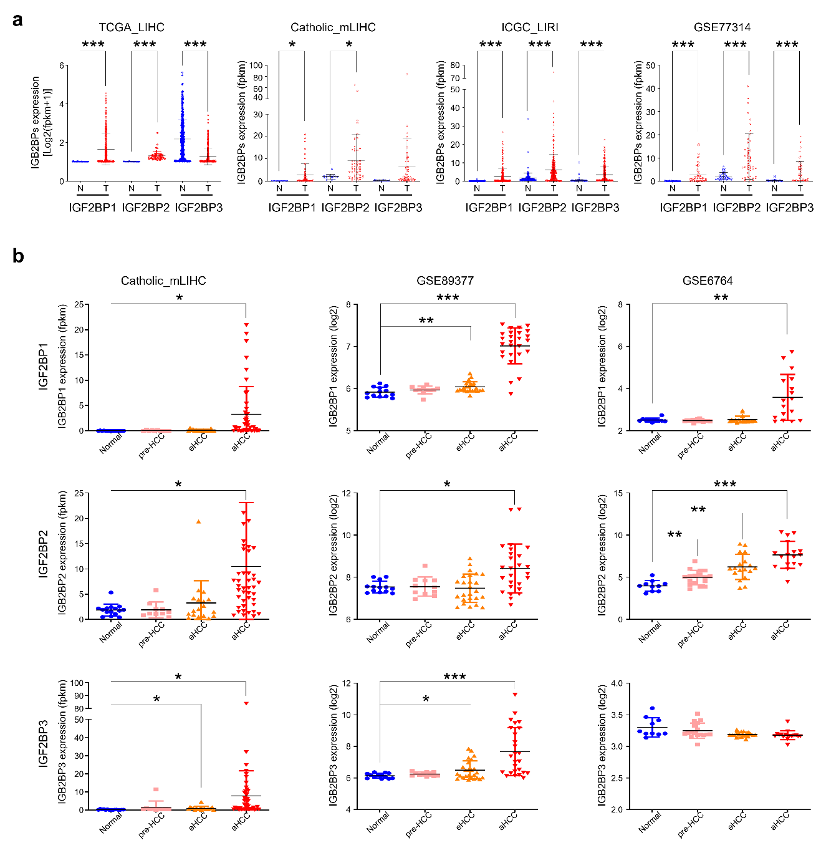
Supplementary Fig. 1 Overexpression of IGF2BP2 member positively correlated with advanced HCC. a Expression-pattern of IGF2BP family members were compared between HCC patients and healthy normal with TCGA_LIHC, Catholic_mLIHC (GSE114564), ICGC_LIRI, and GSE77314 datasets. b Expression-pattern of (top) IGF2BP1, (middle) IGF2BP2, and (bottom) IGF2BP3 were compared among multistage HCC patients of Catholic_mLIHC, GSE89377, and GSE6764 datasets.

Supplementary Fig. 2 GAS5 (or m6A modified GAS5) expression was enriched by m6A- or METTL3 (writer)-bounded RNA immunoprecipitations. (a-b) The RNA-IP assays were performed to assess m6A methylated GAS5, using control IgG, anti-m6A, or anti-METTL3 in Hep3B, Huh7, SNU-449, SNU-182, or PLC/PRF/5 liver cancer cell lines. The amount of precipitated RNA by indicated antibodies is shown as relative fold enrichment.

Supplementary Fig. 3 GAS5 (or m6A modified GAS5) expression was enriched by IGF2BP2 (reader)-bounded RNA immunoprecipitations. (a-b) RNAfold web server designed secondary structures of GAS5 WT and GAS5 random mutations. The growth of SNU-387 and SNU-423 liver cancer cells was determined by MTT assay after being transfected with GAS5 WT or GAS5 mutant (Mut) vectors. (c-e) The RNA-IP assays were performed using control IgG, anti-IGF2BP1, anti-IGF2BP2, or anti-IGF2BP3 in Hep3B, Huh7, SNU-449, SNU-182, or PLC/PRF/5 liver cancer cell lines. The amount of precipitated RNA by indicated antibodies is shown as relative fold enrichment.
Supplementary Fig. 4 GAS5 is associated with advanced HCC. a Heatmap of 1,009 lncRNAs expression were significantly upregulated in advanced HCC, when analyzed multistage HCC patients of Catholic_mLIHC (GSE114564). b Driver lncRNAs expression-pattern with fold-change was analyzed in multistage HCC patients of Catholic_mLIHC (GSE114564). Red curve line indicates GAS5. c Expression of GAS5 (a driver lncRNA) was analyzed in multistage HCC patients of Catholic_mLIHC. All data are shown as the mean ± SEM, *p < 0.05, **p < 0.01, ***p < 0.001; unpaired t test..

Supplementary Fig. 5 Apoptosis, cell cycle, and EMT-related major proteins were down-regulated in highly GAS5-overexpressed liver cancer cell lines. a Endogenous RNA expression of GAS5 in liver cancer cell lines (Hep3B, Huh7, PLC/PRF/5, SNU-182, and SNU-449) including normal cell lines (MIHA, LO2) was analyzed by qRT-PCR. b The cell growth (top) or cell viability (bottom) was determined by MTT assay in highly GAS5-overexpressed liver cancer cell lines (SNU-182 and PLC/PRF/5), after transfected with si-Cont or si-GAS5. c The BrdU assay (top), and clonogenic assay (bottom) were performed to measure cellular growth after transfected with si-Cont or si-GAS5 in SNU-182 and PLC/PRF/5. d Scratch wound healing assay was evaluated by migrated cell images (left) and a bar graph (right) with the percentage of migration, after transfected with si-Cont or si-GAS5 in SNU-182 and PLC/PRF/5. All data are shown as the mean ± SEM, *p < 0.05, **p < 0.01, ***p < 0.001; unpaired t test.

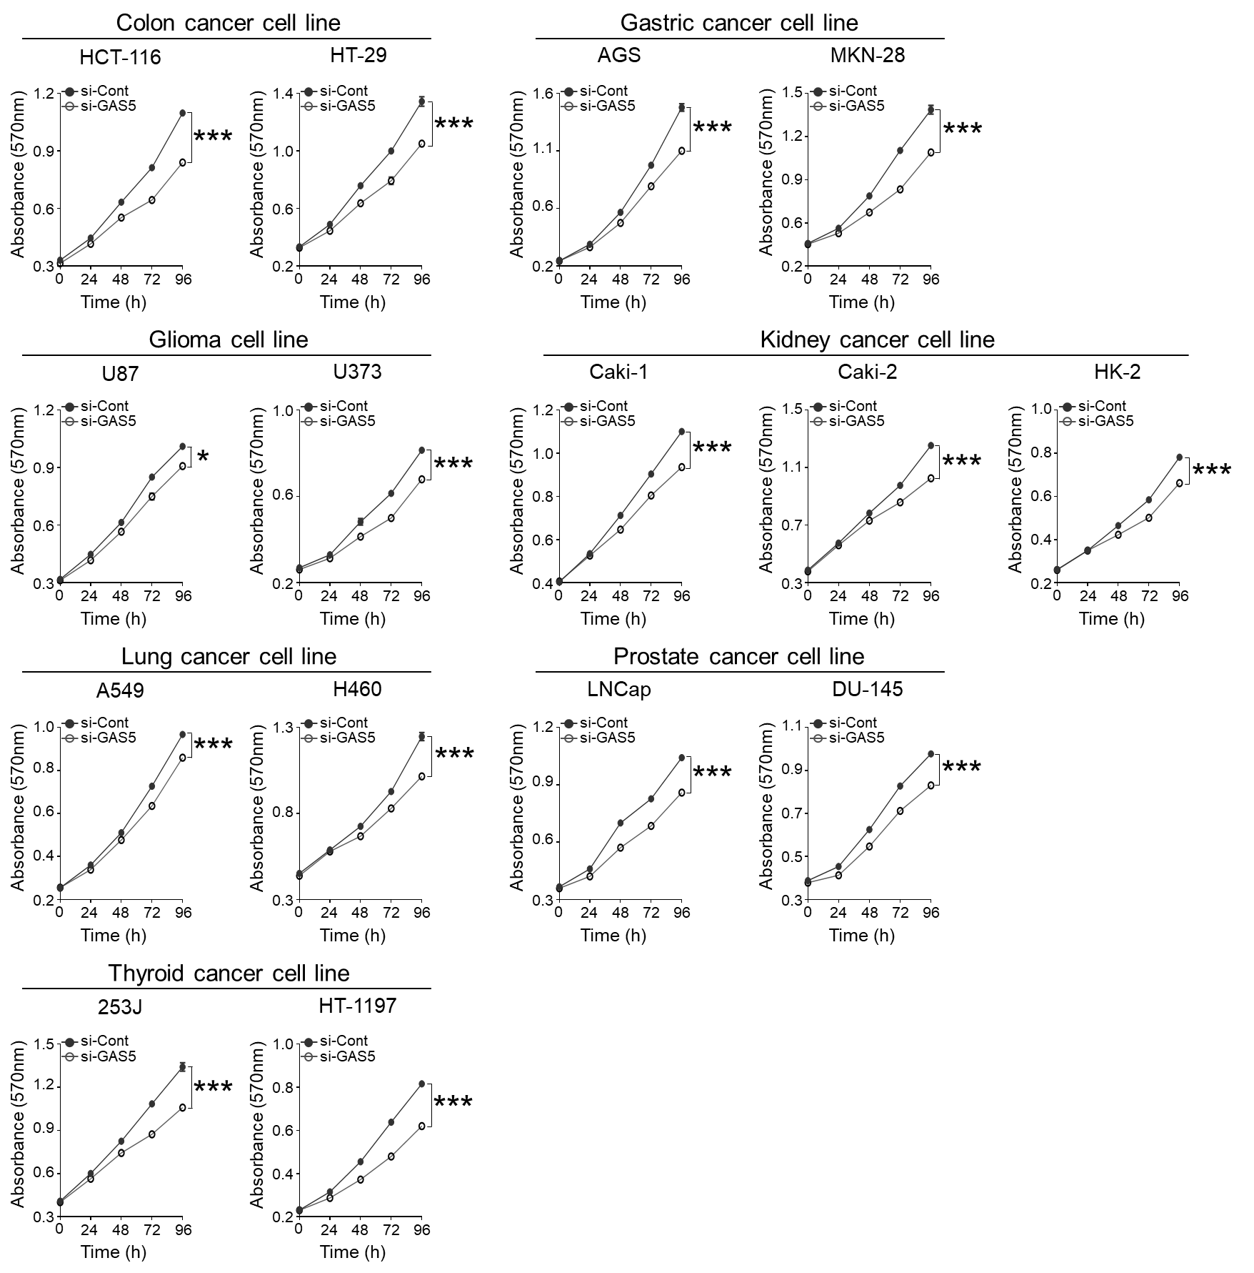
Supplementary Fig. 6 In vitro tumor cell growth of GAS5 in cancer cells. cell growth of each cancer cells transfected with si-Cont and si-GAS5 was determined by MTT assay.

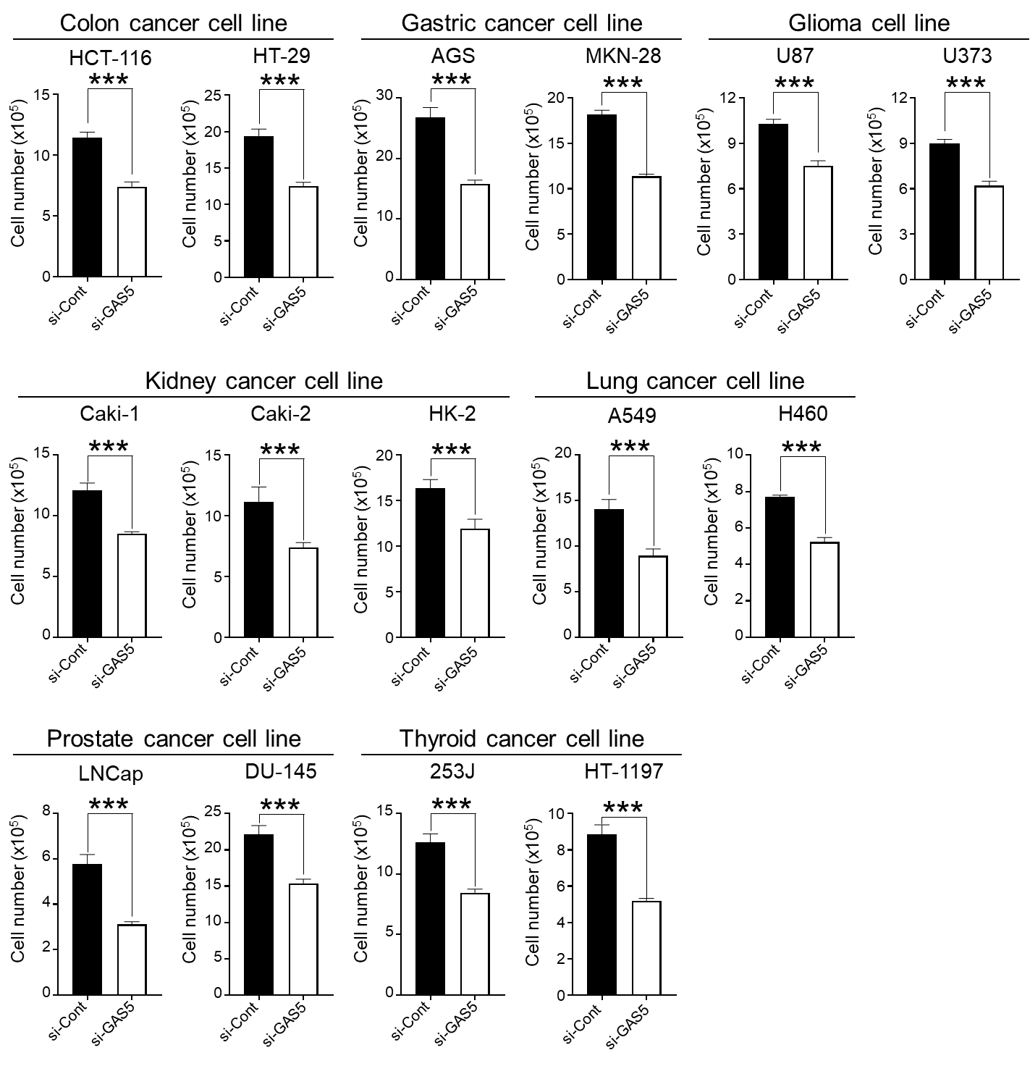
Supplementary Fig. 7 In vitro tumor cell viability of GAS5 in cancer cells. cell viability of each cancer cells transfected with si-Cont and si-GAS5 was determined by cells were counted using hemocytometer.

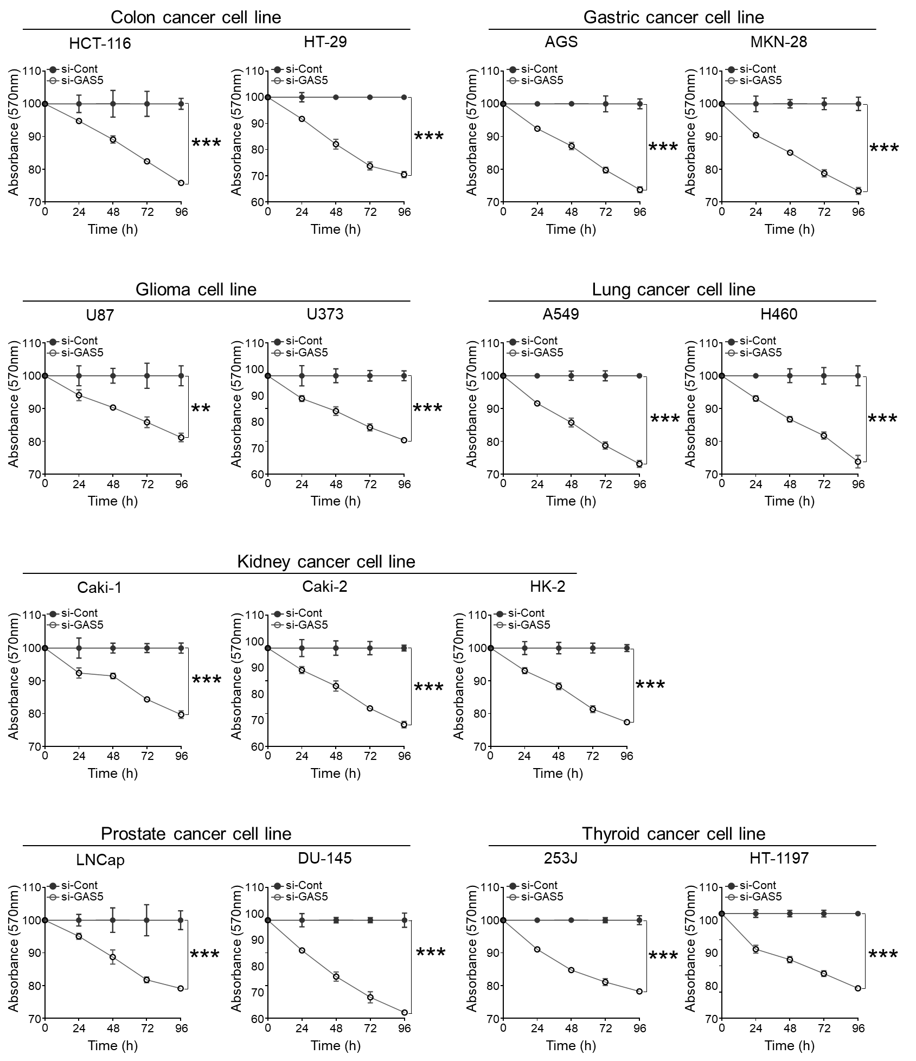
Supplementary Fig. 8 In vitro tumor cell proliferation of GAS5 in cancer cells. cell proliferation of each cancer cells transfected with si-Cont and si-GAS5 was determined by BrdU assay.
Supplementary Fig. 9 The miR-423-3p was identified as specifically binding miRNA to both GAS5 and SMARCA4 mRNA in liver cancer cell lines. a Ago2-IP assay was performed to evaluate GAS5 binding on miRNAs. GAS5 binding to miRNAs was verified by RT-PCR and western blot analysis in SNU-182, or PLC/PRF/5 liver cancer cell lines. b Venn diagram shows overlapped miRNAs of GAS5 binding miRNAs predicted ENCORI and qPCR array (top). Schematic strategy image shows how to identify GAS5 binding miRNAs (bottom). c Schematic presentation indicates the miR-423-3p (red) and miR-452-5p (blue) targeting sites in GAS5.

Supplementary Fig. 10 The miR-423-3p was identified as specifically binding miRNA to both GAS5 and SMARCA4 mRNA in liver cancer cell lines. a Venn diagram shows that 151 mRNAs were identified using overlapped genes of miRNA targets, miR-423-3p and miR-452-5p (top). Schematic strategy image how eight ceRNAs including SMARCA4 with similar GAS5 expression correlations, were identified in HCC database (bottom). b The SMARCA4 null liver cancer cell line, PLC/PRF/5 was co-transfected with pBJ-SMARCA4, and miR-423-3p mimic sequentially. SMARCA4 expression was then determined using qRT-PCR and western blotting analysis. All data are shown as the mean ± SEM, *p < 0.05, **p < 0.01, ***p < 0.001; unpaired t test.
Supplementary Fig. 11 Knocking-out of either GAS5 or SMARC4 expression inhibits tumorigenesis with similar phenotypes of overexpressed miR-423-3p in Huh7 and SNU-449 liver cancer cell lines. (a-b) The cell growth was measured by MTT assay or BrdU assay, after transfections of si-Cont, si-GAS5, si-SMARCA4, and miR-423-3p mimic in liver cancer cells (Huh7 and SNU-449). c Cell cycle profiles were analyzed after transfections of si-Cont, si-GAS5, si-SMARCA4, and miR-423-3p mimic in liver cancer cells (Huh7 and SNU-449). Bar graph indicates the percentage at each cell cycle phase in liver cancer cells. d Cell cycle modulators were analyzed with western-blot analysis in liver cancer cells (Huh7 and SNU-449), after transfected with si-Cont or siRNA specific for indicated gene, and miR-423-3p mimic in liver cancer cells. GAPDH was used as a loading control. (e-f) Boyden chamber motility assay and transwell invasion assay were performed with analysis of cell images in liver cancer cells (Huh7 and SNU-449), after transfections of si-Cont, si-GAS5, si-SMARCA4, and miR-423-3p mimic in liver cancer cells. The bar graph shows number of migrated liver cancer cells. All data are shown as the mean ± SEM, *p < 0.05, **p < 0.01, ***p < 0.001; unpaired t test.
Supplementary Fig. 12 HCC progression is repressed by inhibition of sponge effect with GAS5-miR-423-3p-SMARCA4. a Time schedule of tail vein injection and ultrasonography into Ras-Tg mouse model. b The tumor mass number of each mouse at indicated weeks of age are listed in table. c Bar charts show liver weight per body weight ratio in each group. d Quantitative RT-PCR analysis were performed for Gas5 and mmu-miR-423-3p expression. The Gapdh and U6 were used for loading control. e Tumor growth as measured by every three days in each group, and finally tumor weight (bottom) was measured 33 days after injection. f Dot plots show tumor weight in each group. All data are shown as the mean ± SEM, *p < 0.05, **p < 0.01, ***p < 0.001; unpaired t test.

Supplementary Fig. 13 Ultrasonic images indicated that double knock-out of GAS5 and SMARCA4 significantly prevents tumorigenesis in liver cancer models in vivo. a The schedule indicated tail vein injection (0; mass detection) for si-Cont, si-Gas5, si-Smarca4, si-Gas5+si-Smarca4 mix, sorafenib, C12-SPM-siRNA mix or C12-SPM-GAL-siRNA combination in Ras-Tg mouse models and sacrificed at eight weeks after injections. Ultrasonic images were observed every week. b Weekly ultrasonography images of Ras-Tg mice injected with si-Cont, si-Gas5, si-Smarca4, si-Gas5+si-Smarca4 mix. c Weekly ultrasonography images of Ras-Tg mice injected with si-Cont, siRNAs encapsulated liposomal nanoparticles (C12-SPM-siRNA mix or C12-SPM-GAL-siRNA mix), or sorafenib.
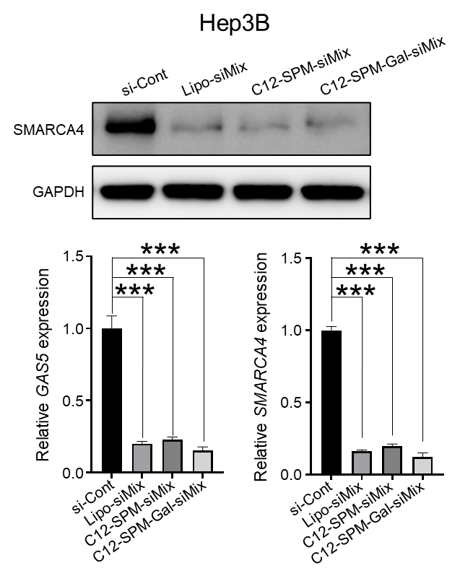
Supplementary Fig. 14 Knock-down efficiency using liposomal nanoparticles were evaluated with C12-SPM-siRNA mix or C12-SPM-GAL-siRNA mix in vitro. SMARCA4 expression (western blot analysis) or GAS5 expression (qRT-PCR) were measured in Hep3B liver cancer cell lines, after transfected with si-Con, Lipo-siMix, C12-SPM-siRNA mix or C12-SPM-GAL-siRNA combination.

