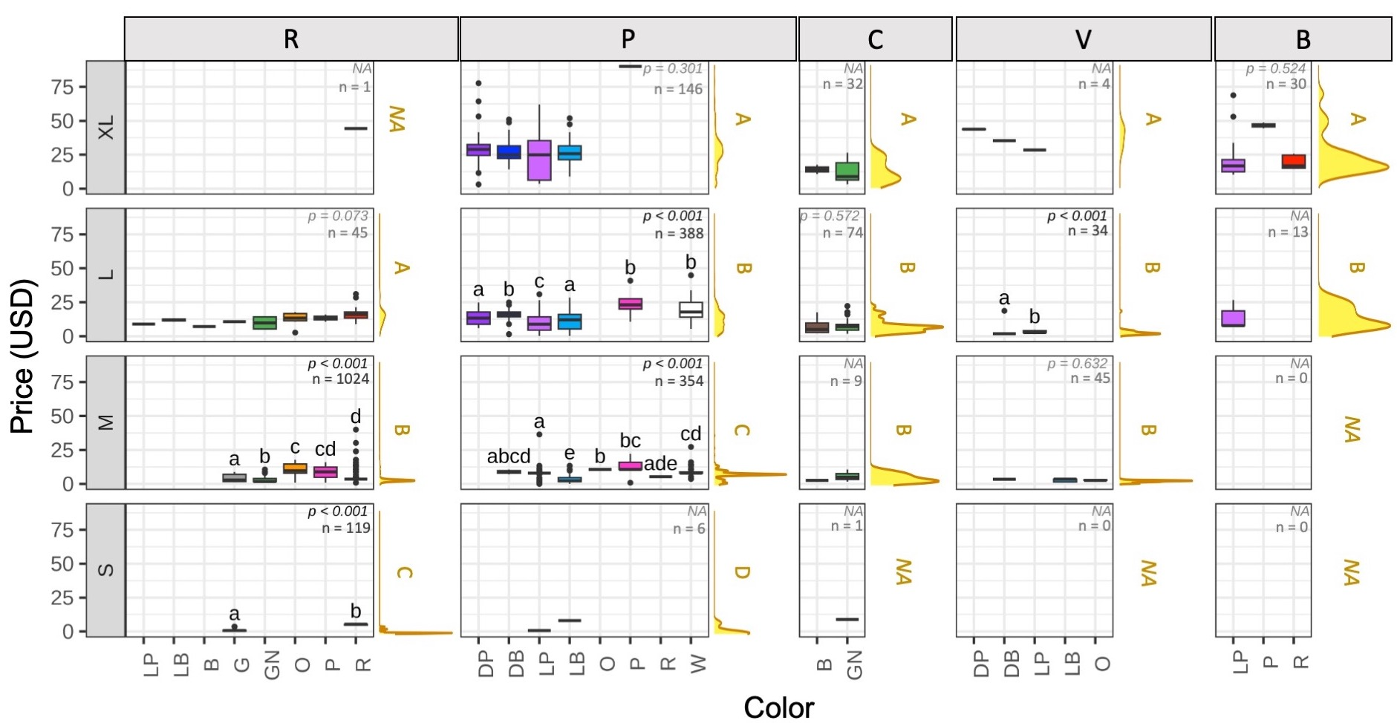
Supplementary 2. Comparative analysis of price by body size and color, divided by species. For species: B = C. brevimanus, C = C. cavipes, P = C. purpureus, R = C. rugosus, V = C. violascens. For color: DP = deep purple, DB = deep blue, LP = light purple, LB = light blue, B = brown, G = gray, GN = green, O = orange, P = pink, R = red, W = white. Lowercase letters indicate significant differences between colors within a certain body size of a particular species, while uppercase letters indicate significant differences between body sizes within the same species (different letters signify significant differences).

