Supporting Information
Unbiased picture of the ligand docking process for the hevein protein–oligosaccharide complex
Toshifumi Yui^{1,}* and Takuya Uto¹
¹Department of Chemistry, Faculty of Engineering, University of Miyazaki, Nishi 1-1 Gakuen Kibanadai, Miyazaki 889-2192, Japan.
*Corresponding author
Tel.: +81-985-58-7319; Fax: +81-985-58-7323; E-mail address: tyui@cc.miyazaki-u.ac.jp

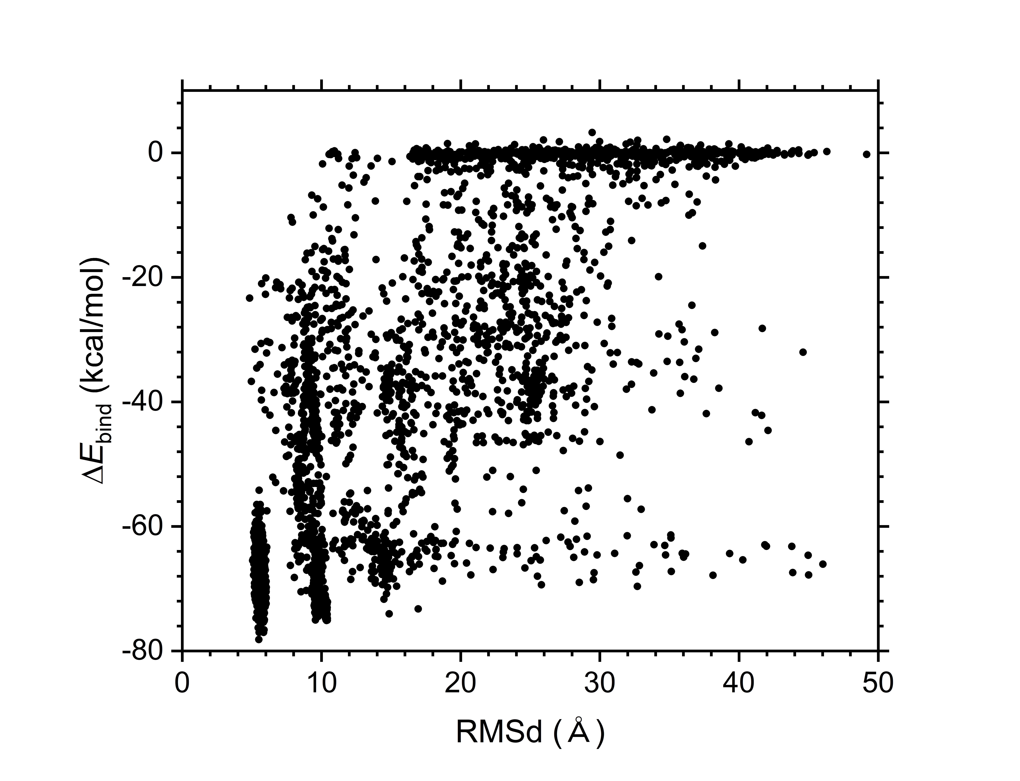
Fig. S1. Ligand docking behavior of the binary solution containing hevein and GlcNAc₃ molecules. The two-dimensional ligand-RMSd (Å) and binding energy (ΔE_{bind}, kcal/mol) distributions were obtained by combining six simulation runs. Each dot represents a spatial arrangement of the two solute molecules with the average ligand-RMSd and ΔE_{bind} values obtained from a 1 ns MD trajectory.

