Appendix 6. Art Exhibit and Panel Discussion to Engage with Student Community
Our team curated a compelling exhibition and panel discussion at the UCLA campus, with more than 120 attendees. Featuring diverse artworks and interactive exhibits, we ignited vital conversations and heightened awareness about on-campus sexual violence. This event showcased passionate student activists and experts from UCLA, as well as student organizations like Activism Through Policy and Bruin Consent Coalition. Furthermore, our outreach within our home institution expanded through fruitful collaborations with other campuses in Southern California, including University of Southern California (USC), Occidental College, Pomona College, and Claremont McKenna College. It has fostered a holistic and inclusive approach to our project's objectives, leaving a lasting legacy of unity, art, and activism in the pursuit of a safer and more inclusive college environment.
Date: April 23, 2024
Location: Los Angeles, California, USA

Picture 1. Fabric art of quotes
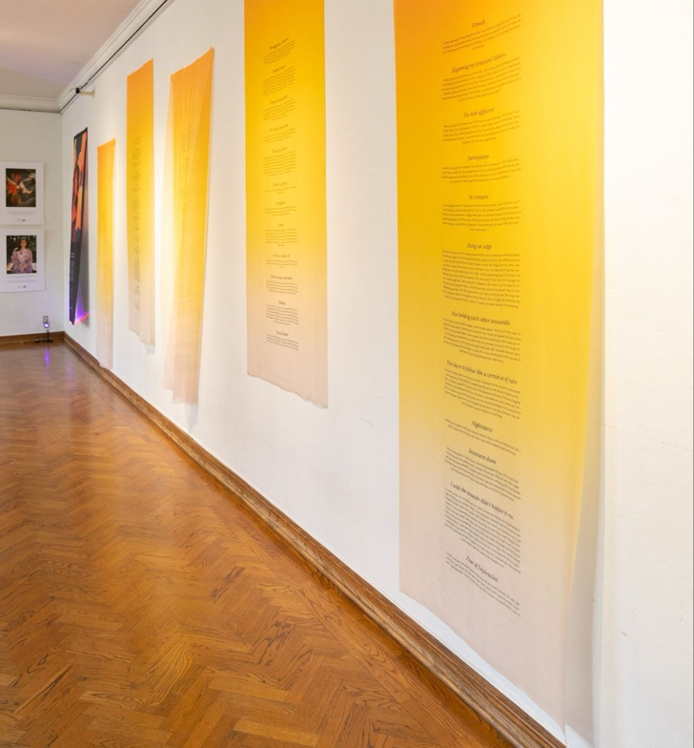

Picture 2. Fabric art of quotes
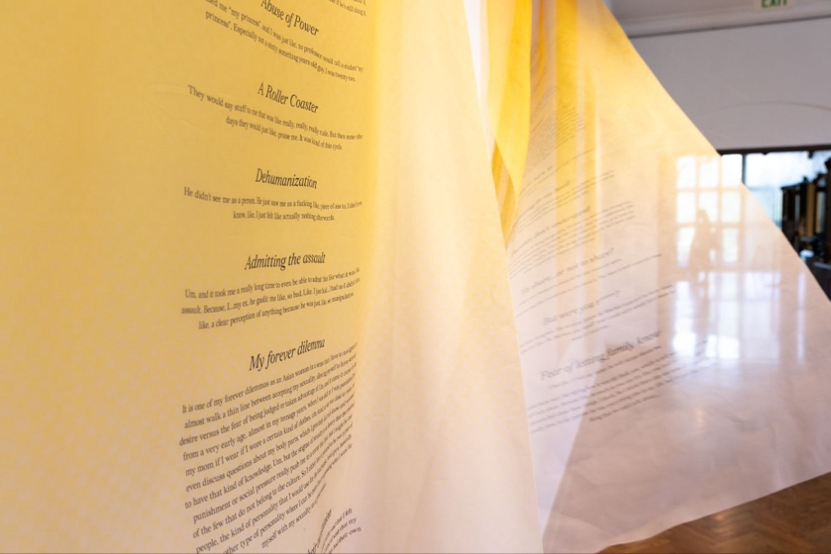
Picture 3. Community exhibition at UCLA
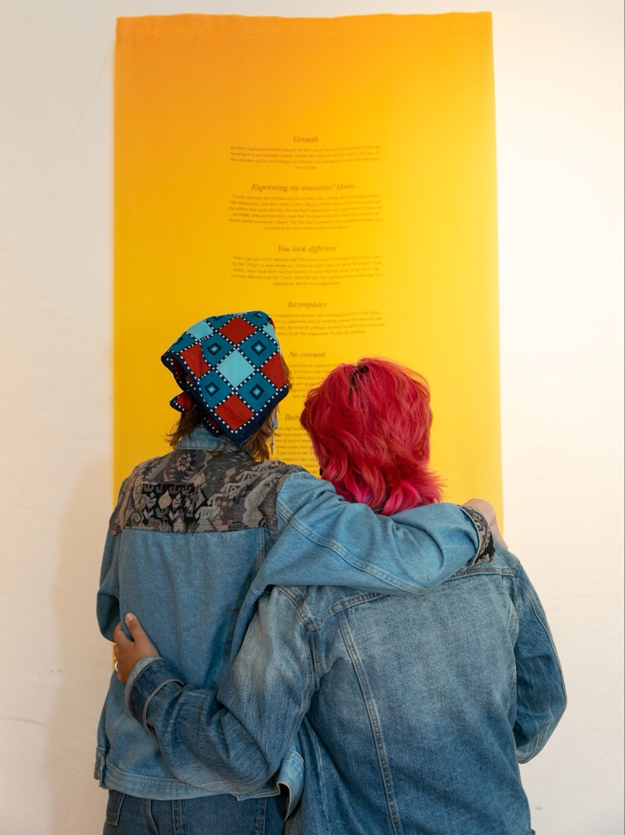

Picture 4. Community exhibition at UCLA
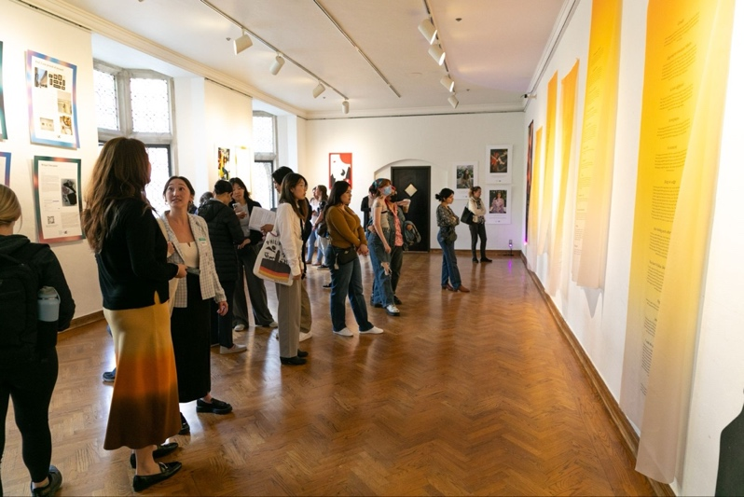

Picture 5. Community discussion at UCLA
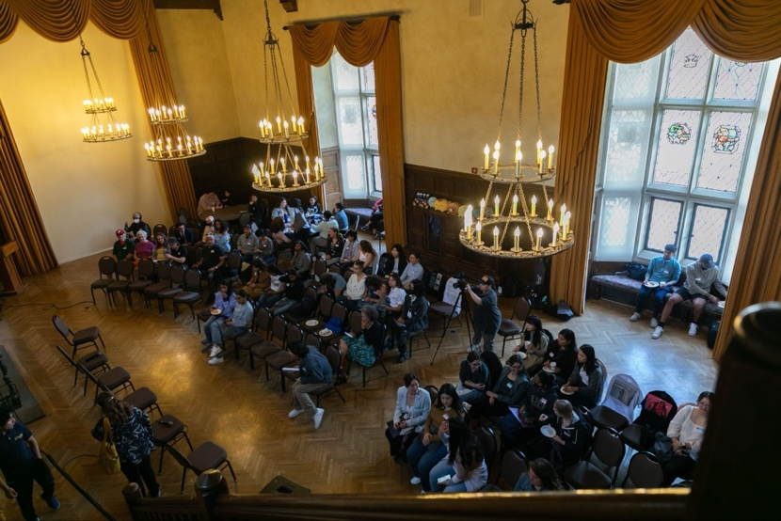
Picture 6. Panel discussion at UCLA
