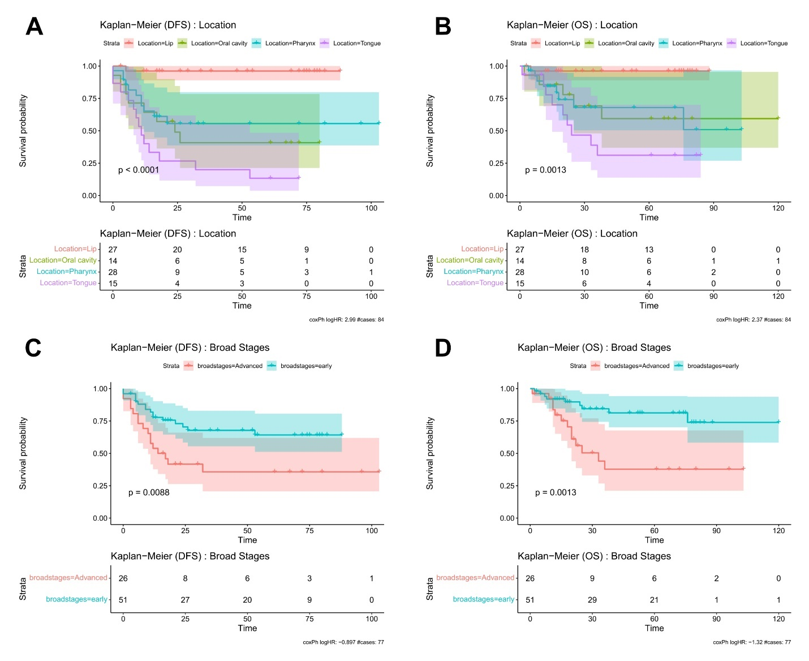
Supplemental Figure 1 : Patient survival analysis based on clinical characteristics for patients common for all cases in the cohort. Kaplan Meier survival analysis based on DFS or OS data and events for samples that’s common across the three assays. KM analysis modelled with tumour location for either (A) DFS or (B) OS, or broad stages of disease (stages I and II = early, stages > III = advanced) for either (C) DFS and (D) OS. Note: N = 77 cases utilized.

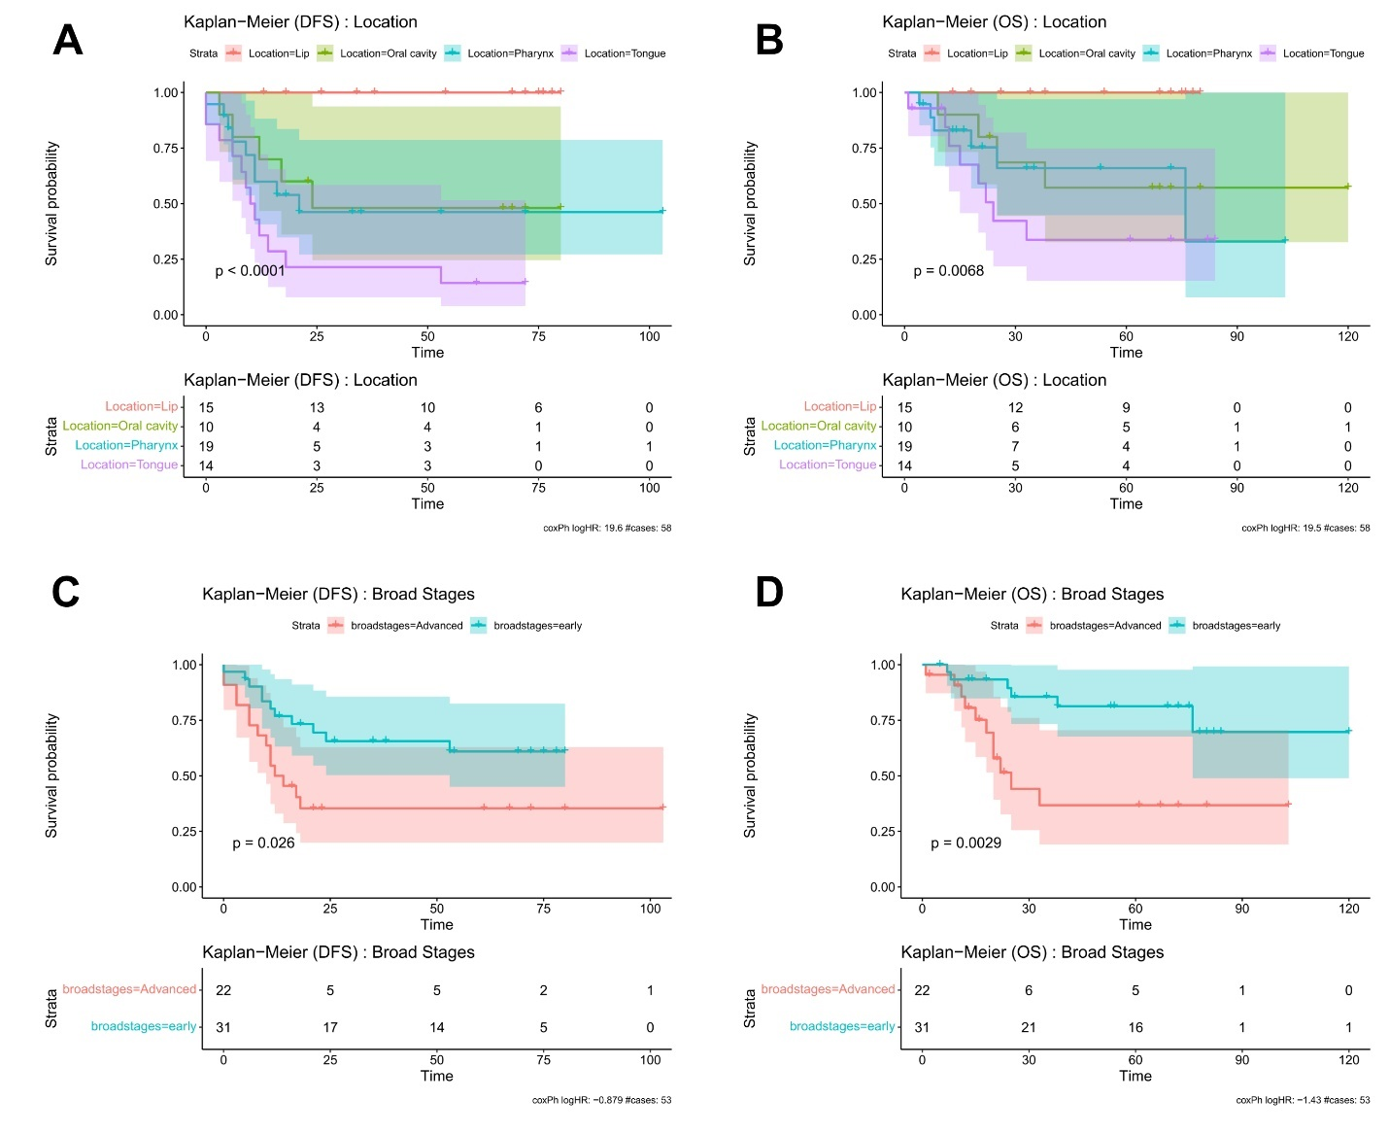
Supplemental Figure 2 : Patient survival analysis based on clinical characteristics for patients common between the IPA, WTA and PCF assays. Kaplan Meier survival analysis based on DFS or OS data and events for samples that’s common across the three assays. KM analysis modelled with tumour location for either (A) DFS or (B) OS, or broad stages of disease (stages I and II = early, stages > III = advanced) for either (C) DFS and (D) OS. Note: N = 53 cases utilised.

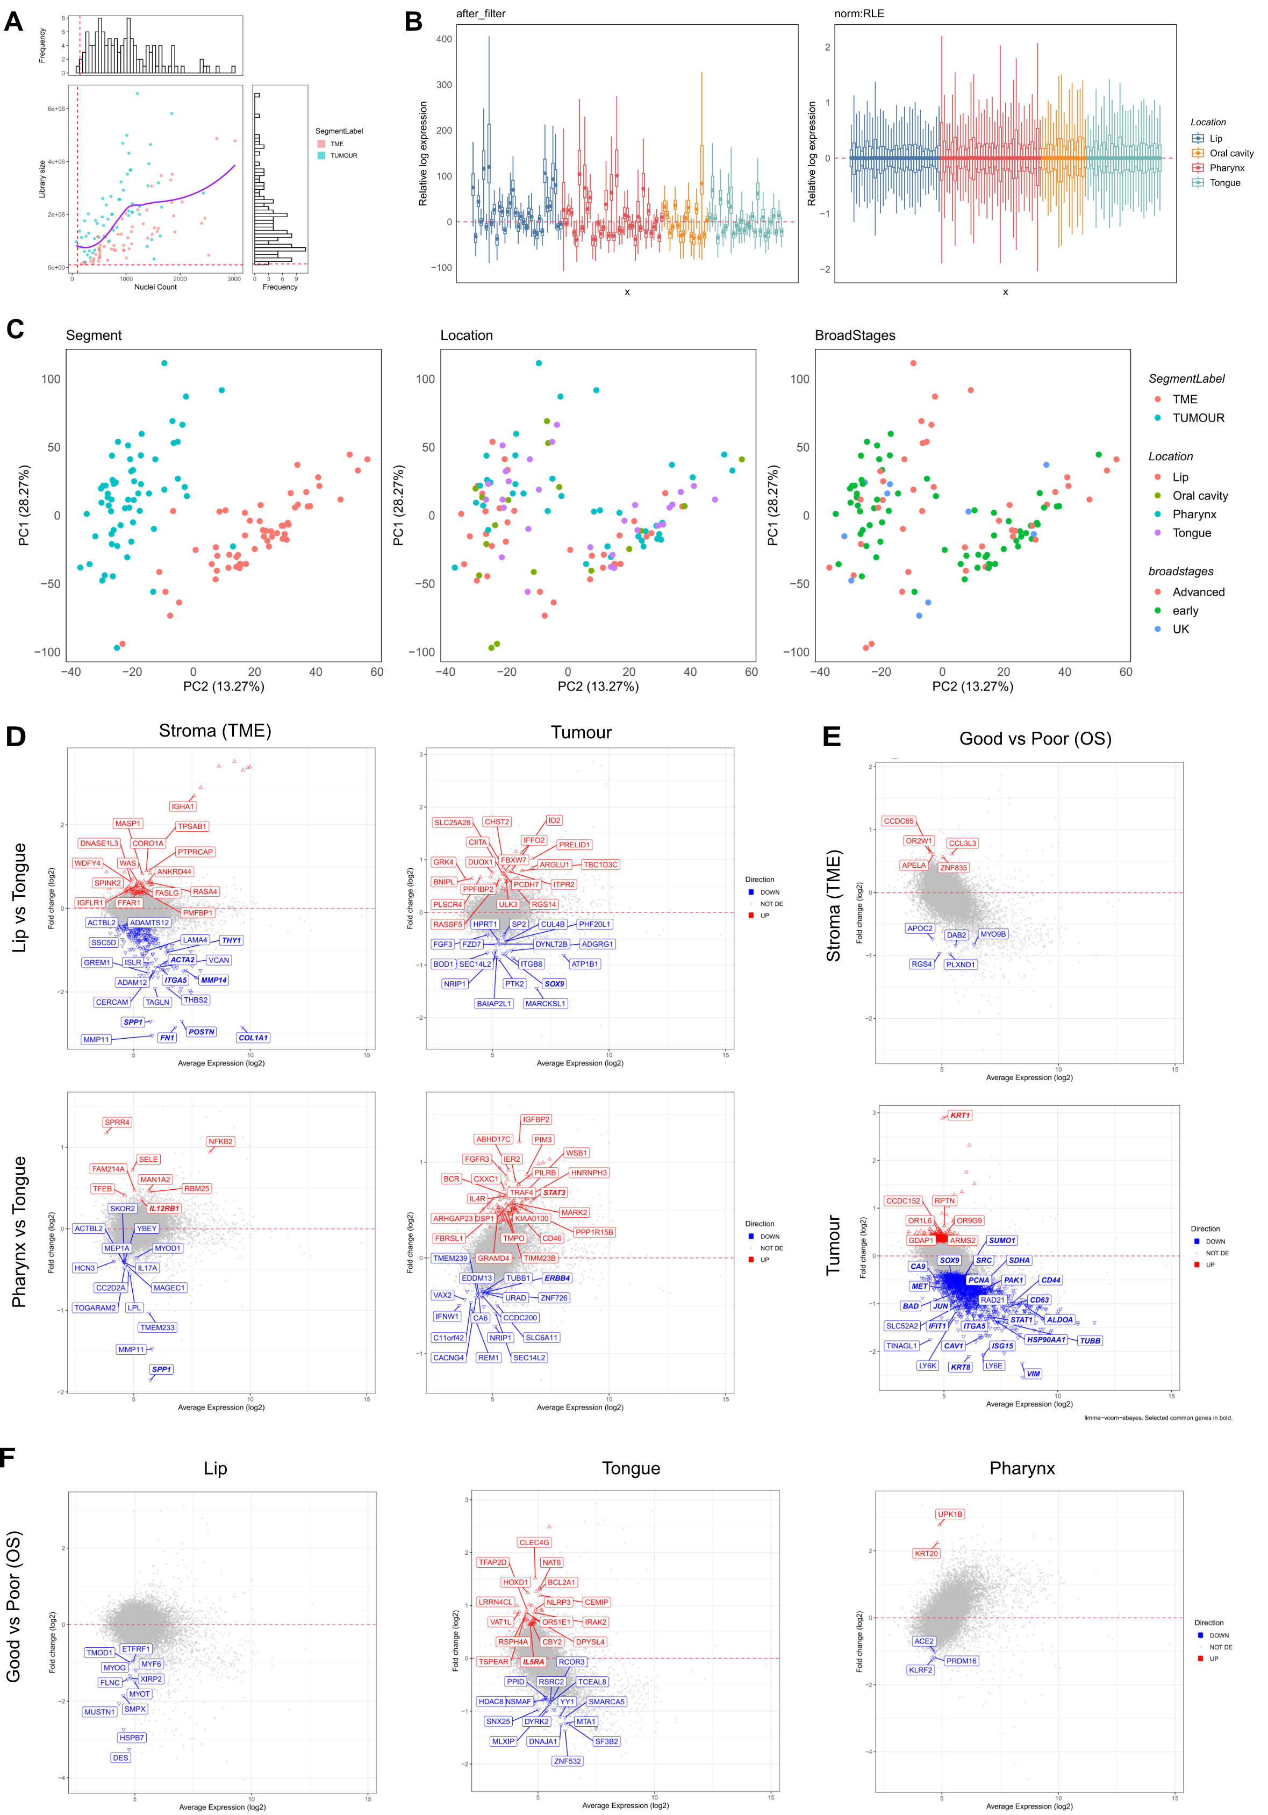
Supplemental Figure 3 : Quality Control (QC) assessment and DE analysis results for the WTA assay. (A) Sample QC plot inspecting library sizes and nuclei count distributions of the samples. (B) Assessment of data normalization using an RLE plot. Log expressions of the data are successfully centered after applying RLE scaling method. (C) PCA plots stratified by key factors segment, stages and broadstages, indicating that in this data, tumour-stroma variations are accounted for by PC1 and PC2. DE analysis results presented as M (log ratio)-A (mean average) plots of: (D) lip vs tongue and pharynx vs tongue in either the stroma or tumour segments. (E) Samples with good overall survival (OS) outcomes vs those with poor OS outcomes in either the stroma or tumour. (F) Samples with good overall survival (OS) outcomes vs those with poor OS outcomes in either the lip, tongue or pharynx originated samples. Limma-voom ebayes pipeline used for DE analysis with a significance cutoff based on the adjusted p-value of ≤ 0.05 using the Benjamini Hochberg procedure. Good vs Poor outcomes groups stratified based on the top and bottom quantile of the event of interest (i.e. OS durations for those with OS events).

Supplemental Figure 4 : Genes significantly associated with disease free survival in the WTA assay. CoxPH hazard ratio (HR) plots with corresponding Kaplan Mier plots for four selected proteins of interest each for each HR category (i.e. HR >= 1 and HR <1). Results for analysis on the (left) TME (Stroma) samples based on Disease Free Survival (DFS) data and events. Results for analysis of the (right) tumour samples based on DFS data and events. Univariate CoxPH with wald p-value < 0.01 was applied on each feature for DFS as events. Results are grouped into either hazard ratio <1 (low, highlighted green) or ≥ 1(high, highlighted orange) and followed up with a Kaplan Meier survival analysis where samples are grouped into categories based on the top and bottom quantile of the feature of interest with significance defined as p value < 0.05.
Supplemental Figure 5 : Genes significantly associated with overall survival in the WTA assay. CoxPH hazard ratio (HR) plots with corresponding Kaplan Mier plots for four selected proteins of interest each for each HR category (i.e. HR >= 1 and HR <1). Results for analysis on the (left) TME (Stroma) samples based on Overall Survival (OS) data and events. Results for analysis of the (right) tumour samples based on OS data and events. Univariate CoxPH with wald p-value < 0.01 was applied on each feature for OS as events. Results are grouped into either hazard ratio <1 (low, highlighted green) or ≥ 1(high, highlighted orange) and followed up with a Kaplan Meier survival analysis where samples are grouped into categories based on the top and bottom quantile of the feature of interest with significance defined as p value < 0.05.
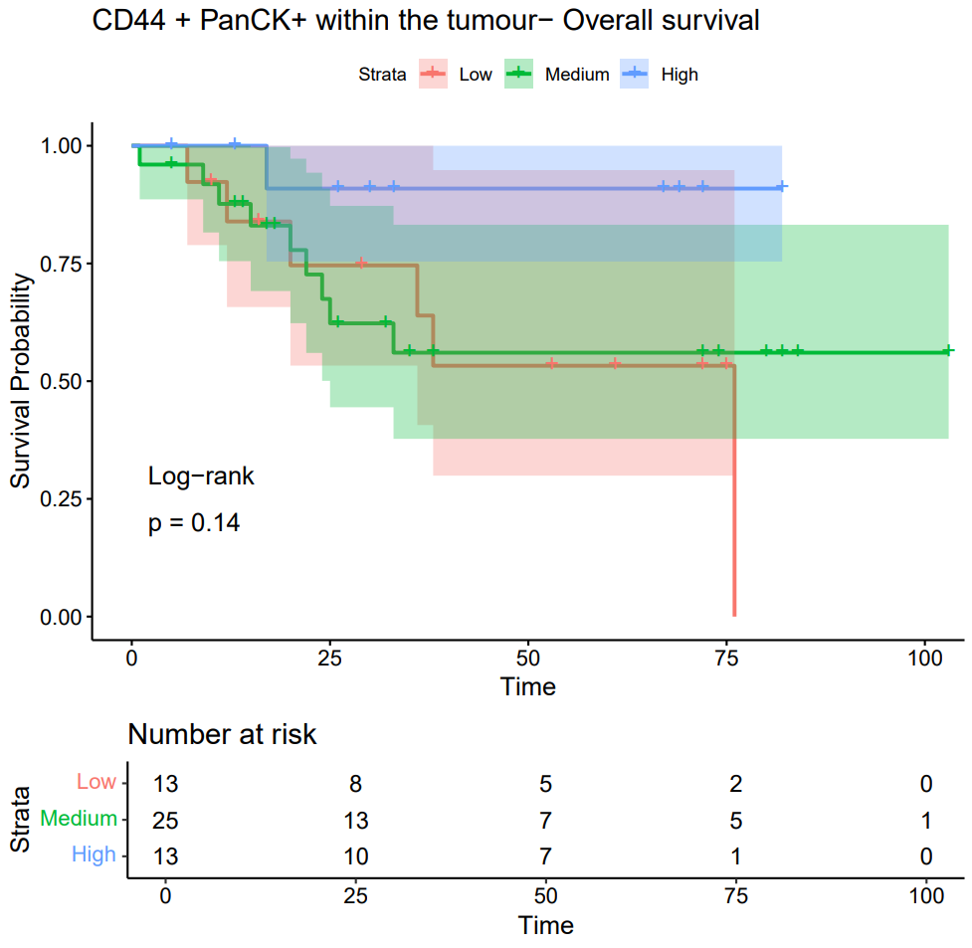
Supplemental Figure 6: Kaplan Meier curve based on immunofluorescent PCF data for proportion of CD44+PanCK+ cells within the tumor region associated with overall survival.

