Supplementary Data
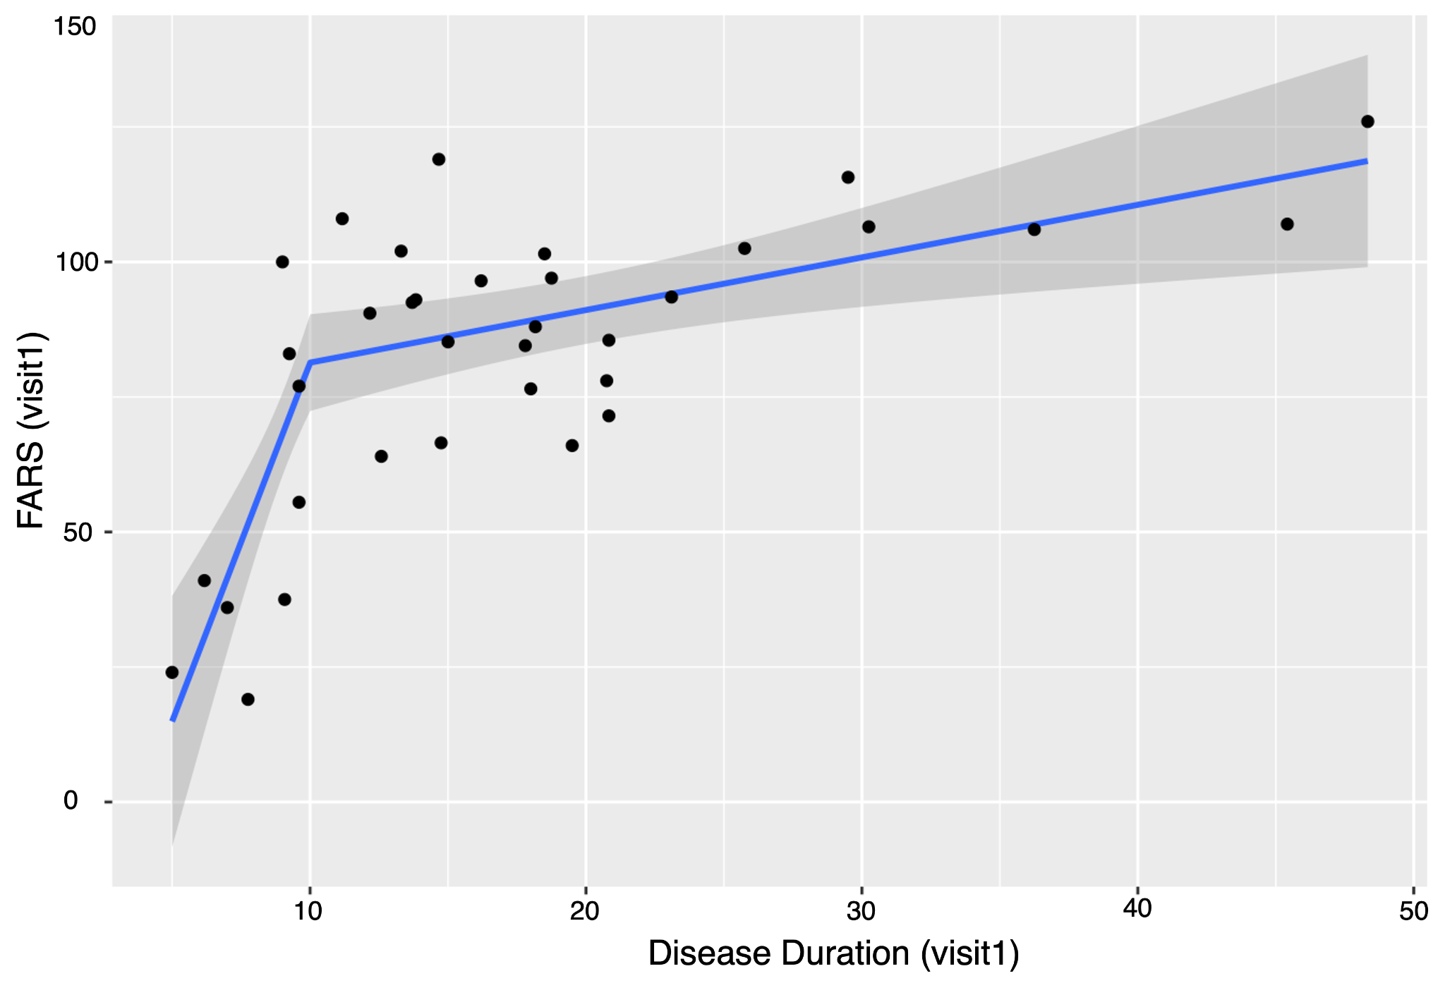
Figure S1: Plot of FARS scores against disease duration, at visit1
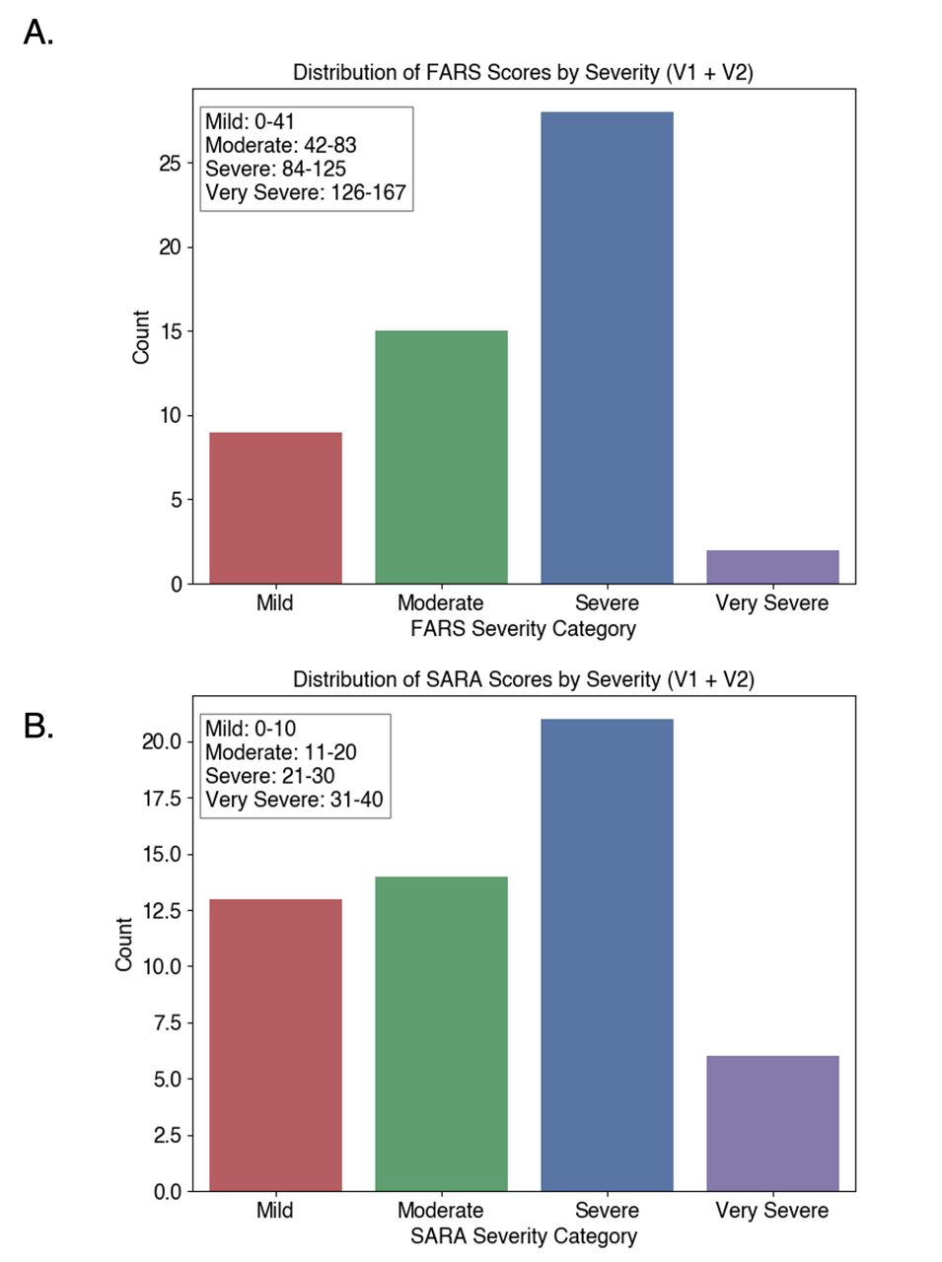
Figure S2: Distribution of FARS and SARA scores (according to disease severity level). The severity categorisation for FARS and SARA scores is based on quartile approximations of their total score ranges.

Table S1: Statistical measures related to disease progression sensitivity for additional composites (highest to lowest d-scores), surrogates or complementary to FARS
Biomarker | group | n | r2 | mean_  change | sd_  change | d
QSM | FRDA | 20 | 0.72 | 7.3 | 5.3 | 1.39*
QSM | Control | 18 | 0.84 | 3.8 | 2.7 | 1.43*
background+structural | FRDA | 25 | 0.89 | 6.8 | 8.8 | 0.78*
background+QSM | FRDA | 20 | 0.95 | 6.6 | 8.5 | 0.77*
background | FRDA | 31 | 0.95 | 6.4 | 8.2 | 0.77*
all_neuroimaging | FRDA | 15 | 0.89 | 5.2 | 7.4 | 0.7*
all_neuroimaging | Control | 14 | 0.32 | -2.5 | 13.0 | -0.19
background+structural+diffusion | FRDA | 23 | 0.93 | 5 | 7.7 | 0.64*
structural | FRDA | 25 | 0.85 | 6.7 | 10.6 | 0.63*
structural | Control | 27 | 0.87 | 2.0 | 7.0 | 0.29
background+diffusion | FRDA | 26 | 0.94 | 3.9 | 7.2 | 0.54*
diffusion | FRDA | 26 | 0.89 | -0.6 | 6.8 | -0.09 (p=0.05)
diffusion | Control | 28 | 0.15 | -4.1 | 10.5 | -0.39
n = no of participants; sd = standard deviation; *= p<0.05
Table S2: Statistical measures related to disease progression sensitivity for single imaging biomarkers
Biomarker | group | n | r2 | mean_  change | sd_  change | d
scp_vol | Control | 27 | 0.87 | -11.5 | 27.2 | -0.42*
scp_vol | FRDA | 25 | 0.85 | -23.1 | 32.0 | -0.72*
mcp_vol | Control | 27 | 0.96 | -1 | 213 | -0.01
mcp_vol | FRDA | 25 | 0.93 | -66 | 307 | -0.21
icp_vol | Control | 27 | 0.91 | -36 | 103 | -0.35
icp_vol | FRDA | 25 | 0.88 | -85 | 124 | -0.69*
midbrain_vol | Control | 27 | 0.73 | -97 | 358 | -0.27
midbrain_vol | FRDA | 25 | 0.79 | -232 | 354 | -0.65*
pons_vol | Control | 27 | 0.96 | -78 | 378 | -0.21
pons_vol | FRDA | 25 | 0.95 | -210 | 434 | -0.48*
medualla_vol | Control | 27 | 0.84 | -88 | 195 | -0.45*
medualla_vol | FRDA | 25 | 0.71 | -162 | 292 | -0.56*
ant_CBLM_I_V_vol | Control | 27 | 0.95 | -106 | 348 | -0.3
ant_CBLM_I_V_vol | FRDA | 25 | 0.97 | -46 | 278 | -0.16
sup-post_CBLM_VI_VII_vol | Control | 27 | 0.86 | -813 | 2076 | -0.39
sup-post_CBLM_VI_VII_vol | FRDA | 25 | 0.88 | -1900 | 2713 | -0.7*
inf-post_CBLM_VIII_IX_vol | Control | 27 | 0.89 | -115 | 704 | -0.16
inf-post_CBLM_VIII_IX_vol | FRDA | 25 | 0.88 | 115 | 979 | 0.12
floc_CBLM_X_vol | Control | 27 | 0.82 | -9.5 | 36.6 | -0.26
floc_CBLM_X_vol | FRDA | 25 | 0.82 | -4.4 | 41.1 | -0.11
vermis_CBLM_vol | Control | 27 | 0.82 | -32 | 154 | -0.21
vermis_CBLM_vol | FRDA | 25 | 0.87 | 7 | 187 | 0.04
dentate_L_vol | Control | 18 | 0.83 | -139 | 123 | -1.13*
dentate_L_vol | FRDA | 20 | 0.83 | -102 | 93 | -1.1*
dentate_R_vol | Control | 18 | 0.9 | -103 | 107 | -0.97*
dentate_R_vol | FRDA | 20 | 0.47 | -125 | 154 | -0.81*
dentate_L_susceptibility | Control | 18 | 0.9 | 0.0064 | 0.0084 | 0.76*
dentate_L_susceptibility | FRDA | 20 | 0.54 | 0.0167 | 0.0185 | 0.9*
dentate_R_susceptibility | Control | 18 | 0.88 | 0.0001 | 0.01 | 0.01
dentate_R_susceptibility | FRDA | 20 | 0.71 | 0.01 | 0.02 | 0.8*
scp_fa | Control | 28 | 0.36 | 0.003 | 0.0117 | 0.25
scp_fa | FRDA | 26 | 0.82 | -0.004 | 0.0086 | -0.46*
mcp_fa | Control | 28 | 0.33 | 0.0043 | 0.0198 | 0.22
mcp_fa | FRDA | 26 | 0.62 | -0.0024 | 0.0154 | -0.16
icp_fa | Control | 28 | 0.19 | 0.0047 | 0.0209 | 0.22
icp_fa | FRDA | 26 | 0.72 | 0.0014 | 0.0163 | 0.08
scp_md | Control | 28 | 0.4 | -0.0044 | 0.0204 | -0.21
scp_md | FRDA | 26 | 0.83 | -0.0031 | 0.0124 | -0.25
md_mcp | Control | 28 | 0.1 | -0.0088 | 0.0338 | -0.26
md_mcp | FRDA | 26 | 0.8 | -0.0009 | 0.0169 | -0.05
icp_md | Control | 28 | 0 | -0.0094 | 0.038 | -0.24
icp_md | FRDA | 26 | 0.51 | -0.0026 | 0.039 | -0.07
scp_ad | Control | 28 | 0.33 | -0.0042 | 0.03 | -0.14
scp_ad | FRDA | 26 | 0.73 | -0.01 | 0.02 | -0.40
mcp_ad | Control | 28 | 0.08 | -0.01 | 0.04 | -0.22
mcp_ad | FRDA | 26 | 0.81 | -0.0026 | 0.0162 | -0.16
icp_ad | Control | 28 | 0.01 | -0.0087 | 0.0493 | -0.18
icp_ad | FRDA | 26 | 0.36 | -0.0023 | 0.0481 | -0.05
scp_rd | Control | 28 | 0.46 | -0.0045 | 0.0167 | -0.27
scp_rd | FRDA | 26 | 0.89 | -0.0010 | 0.0102 | -0.1
mcp_rd | Control | 28 | 0.12 | -0.0088 | 0.0325 | -0.27
mcp_rd | FRDA | 26 | 0.78 | 0.0000 | 0.0184 | 0.001
icp_rd | Control | 28 | 0 | -0.0097 | 0.0342 | -0.28
icp_rd | FRDA | 26 | 0.6 | -0.0028 | 0.0355 | -0.08
FRDA = Friedreich Ataxia; sd = standard deviation; n = no of participants; *= p<0.05

Table S3: Predictive performance of composites for SARA (Scale for Assessment and Rating of Ataxia) scores and their sensitivity to FRDA progression; bold represents the recommended surrogate biomarker for SARA
Composites/Single biomarkers | n_{pred} | n_{sensitivity} |  | R² | RMSE | d-score
background+all_neuroimaging | 31 | 15 | 0.72 |  | 4.68 | 1.09*
background+structural+diffusion | 31 | 23 | 0.82 |  | 3.78 | 0.62*
background+QSM | 31 | 31** | 0.5 |  | 6.52 | 0.59*
background+structural | 31 | 25 | 0.5 |  | 6.08 | 0.86*
background+diffusion | 31 | 26 | 0.55 |  | 5.95 | 0.47*
background | 31 | 31 | 0.5 |  | 6.28 | 0.71*
all_neuroimaging | 31 | 15 | 0.64 |  | 5.35 | 1.09*
structural | 31 | 25 | 0.35 |  | 7.18 | 0.81*
diffusion | 31 | 26 | 0.29 |  | 7.52 | -0.07*
QSM | 31 | 20 | -0.07 |  | 9.21 | 1.48*
SARA |  | 27 |  |  |  | 0.8*
n_{pred} = no of samples (visits) included in the predictive-ML model
n_{sensitivity} = no of participants included in the sensitivity analysis
*= p<0.05
** The background and QSM composite didn’t include any QSM components with non-zero coefficients, making it measurable in 31 participants with FRDA.
Table S4: Composite Score Equation (background+all_neuroimaging), compliments or surrogates to SARA (with the original weights of predictors estimated by the model in their original scale)
Background components | 1.254sex - 0.057age_{onset} + 0.002GAA1_{repeatlength} - 0.007GAA2_{repeatlength} + 0.026age_{scan} + 1.552DiseaseDuration_{to_10} + 0.15DiseaseDuration_{10_up}
 | +
Structural neuroimaging components | 0.008scp_{vol} + 0.003mcp_{vol} - 0.012icp_{vol} - 0.002midbrain_{vol} + 0.001pons_{vol}  + 0.004medulla_{vol} - 0.003ant_CBLM_I_V_{vol} + 0.001inf-post_CBLM_VIII_IX_{vol} + 0.024floc_CBLM_X_{vol} - 0.007vermis_CBLM_{vol}  +
Diffusion  neuroimaging components | 69.736scp_fa - 110.578mcp_fa - 91.69icp_fa - 3.848scp_md - 15.102mcp_md + 18.733icp_md - 0.038scp_ad - 31.902mcp_ad - 10.083mcp_ad - 5.045scp_rd - 4.351mcp_rd + 32.105icp_rd  +
QSM  neuroimaging components | 0.004dentate_L_{vol} - 0.003dentate_R_{vol} + 11.217dentate_L_{susceptibility} + 26.242dentate_L_{susceptibility}

