Fine mapping and candidate gene analysis of the major QTL qSW-A03 for seed weight in Brassica napus
Jiangyu Meng^{1,2,3}, Dingxue Hu^{2,3}, Bin Wang^{1,2,3}, Yuelin Zhu^{1,2,3}, Chunyan Lu^{2,3}, Yan Deng^{1,2,3}, Huiying Cai^{1,2,3}, Baohua Wang⁴, Yajun He^{1,2,3}*, Wei Qian^{1,2,3}*

1 Integrative Science Center of Germplasm Creation in Western China (Chongqing) Science City, College of Agronomy and Biotechnology, Southwest University, Chongqing 400715, China
2 Academy of Agricultural Sciences, Southwest University, Chongqing 400715, China
3 Engineering Research Center of South Upland Agriculture, Ministry of Education, Chongqing 400715, China
4 School of Life Sciences, Nantong University, Nantong 226019, Jiangsu, China
*Corresponding author: hyj790124@163.com (Yajun He), qianwei666@hotmail.com (Wei Qian).

Supplementary figures
Fig.S1 The sources of chromosomal fragments of 80 lines in the RIL population
Fig.S2 Collinearity between the genetic and physical map
Fig.S3 GO and KEGG analysis of 299 genes coexpressed with BnaDUF1666 in Module 1

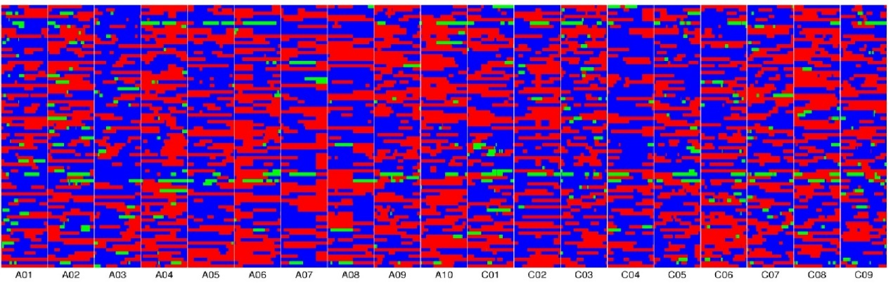
Fig.S1 The sources of chromosomal fragments of 80 lines in the RIL population
Blue: genotype of ZS11; red: genotype of DL704; green: heterozygous genotype. The whole map contains 1,306 bin markers. Chromosomes are separated by vertical white lines.

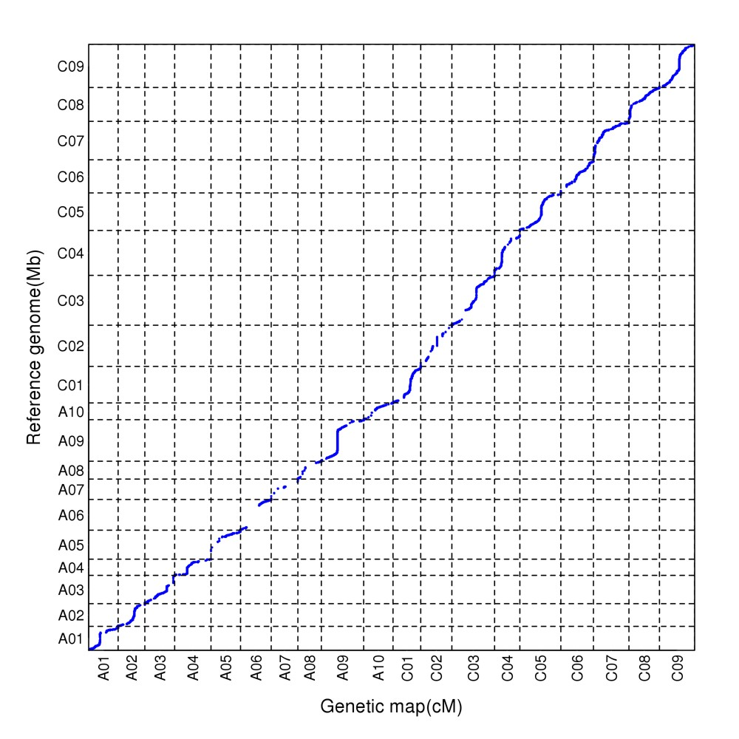
Fig.S2 Collinearity between the genetic and physical map

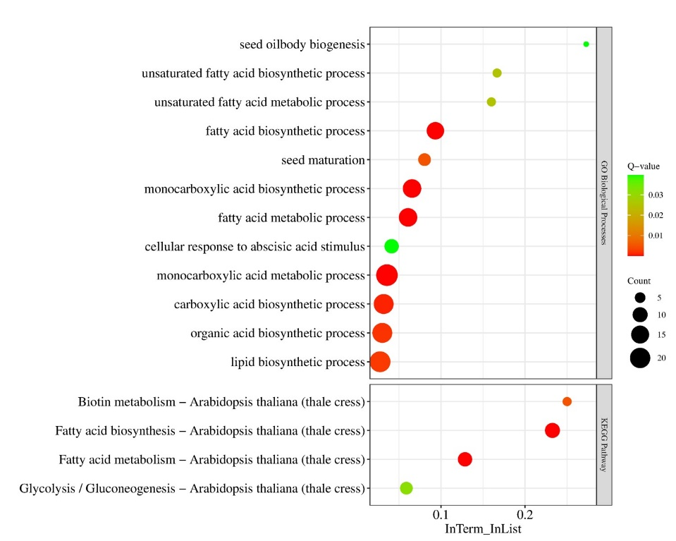
Fig.S3 GO and KEGG analysis of 299 genes coexpressed with BnaDUF1666 in Module 1
X-axis and Y-axis represent the gene ratio (InTerm/InList) and enrichment terms, respectively.

