APPENDIX A
Other Investigators (OLIVO Study Group): Centre for Genetic Engineering and Biotechnology, Havana, Cuba (E García-Iglesias BSc, L Ávila-Díaz BSc, S Chávez-Valdés BSc, G Lemos-Pérez MSc, Y Mendoza-Mari PhD, N Figueroa-Baile BSc, G Melo-Suárez Tech); “Carlos J. Finlay” Hospital, Havana, Cuba (Y Rodríguez-Porres MD, G Hernández-Montero MD, G Martínez-Aching MSc, Y Ávila-Martínez BSc, MV. Pérez-Pérez BSc, M Peña-Martínez BSc, E Mezquía-Álvarez BSc, Mayra Bosque-Herrera BSc, N Barrios-Núñez Tech, M E González-Soriz MSc, D González-Rodríguez BSc).

Appendix B. Supplementary Figure legends
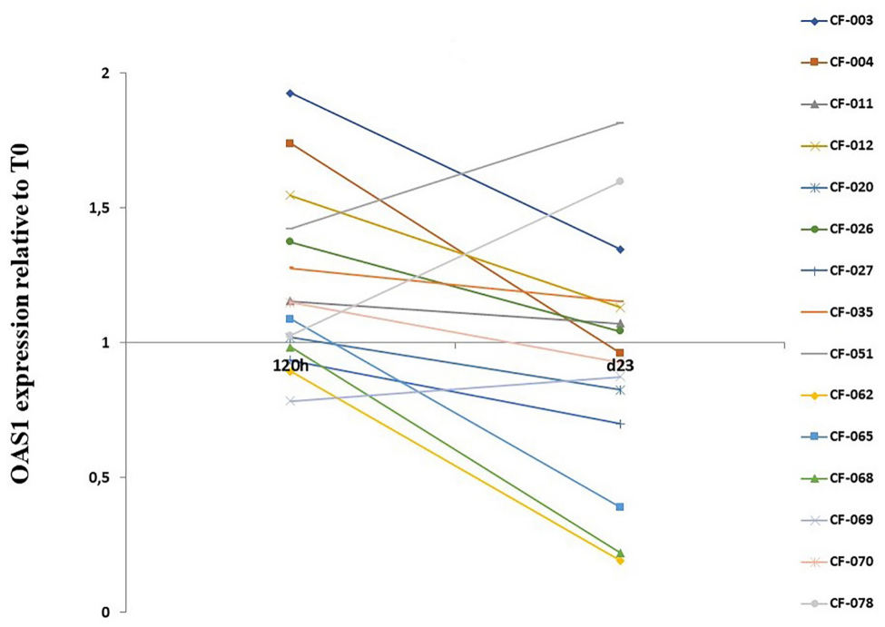

Figure S1. Relative expression of OAS1 over time relative to T0. Group (Behavior A) in PBMC samples.
The y-axis cuts at basal 1 value.

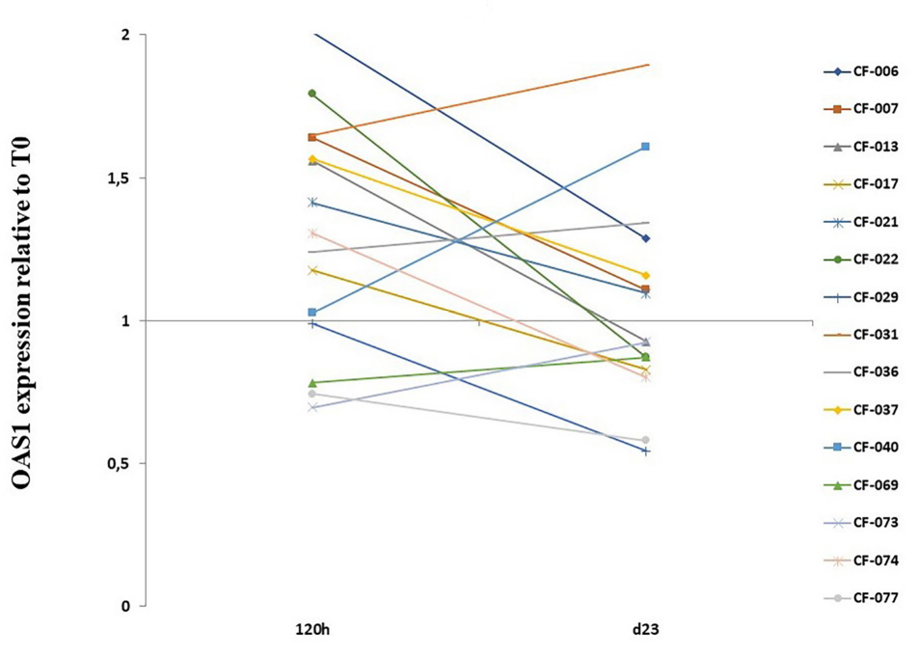
Figure S2. Relative expression of OAS1 over time relative to T0. Group (Behavior B) in PBMC samples.
The y-axis cuts at basal 1 value.

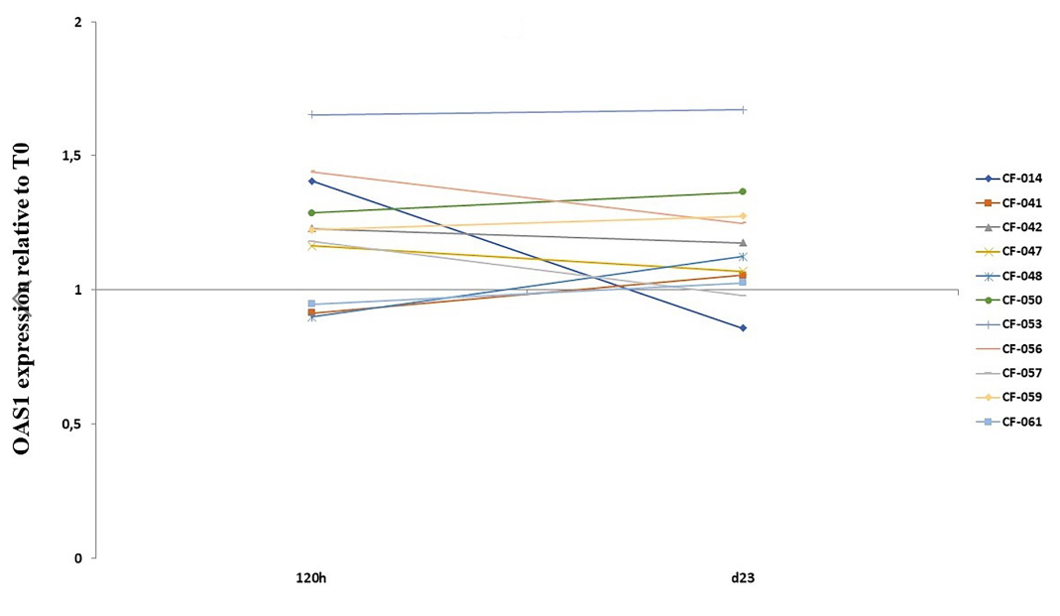

Figure S3. Relative expression of OAS1 over time relative to T0. Group (Behavior C) in PBMC samples.
The y-axis cuts at basal 1 value.

