Supplementary Data for

Phase distribution and lattice coherency for Li-rich zero-deformation cathode design

Hyeong-Jun Nam^{1†}, Daeyeon Lee^{1†}, Jiye Moon^{1†}, Seok Hyun Song^{2,3,4}, Kyoung Sun Kim^{2,3}, Hyoi Jo¹, Jingyu Choi¹, Jeeho Ha¹, Seok Ju Kang¹, Hyungsub Kim^{2,5*}, and Sung-Kyun Jung^{1*}

Affiliation
¹Department of Energy Engineering School of Energy and Chemical Engineering, Ulsan National Institute of Science and Technology (UNIST), 50 UNIST-gil, Ulsan 44919, Republic of Korea
²Neutron Science Division, Korea Atomic Energy Research Institute (KAERI), 111 Daedeok-daero 989 Beon-Gil, Yuseong-gu, Daejeon 34057, Republic of Korea
³Department of Chemical and Biological Engineering, Korea University, 145 Anam-Ro, Seongbuk-Gu, Seoul 02841, Republic of Korea
⁴Gwangju Clean Energy Research Center, Korea Institute of Energy Research (KIER), 270-25 Samso-ro, Buk-gu, Gwangju, 61003, Republic of Korea
⁵Advanced Energy Research Institute, Chungbuk National University, Cheongju, Chungbuk 28644, Republic of Korea
† These authors contributed equally to this work.
* Corresponding to: hyungsubkim@kaeri.re.kr and skjung@unist.ac.kr

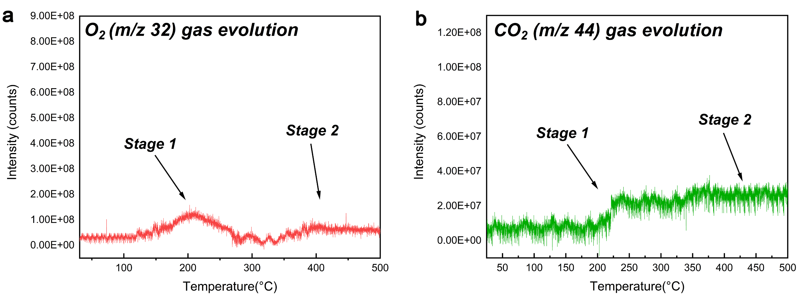
Supplementary Figure 1. Electron ionization mass spectrometry (EI-MS) of mixed precursor. (a) O₂ gas and (b) CO₂ gas evolution spectra of mixed precursor. Stage 2 showed a comparatively less release of gas, then stage 1, suggesting the presence of hidden chemistry of intergrown synthesis distinct from the conventional synthesis of layered cathodes.

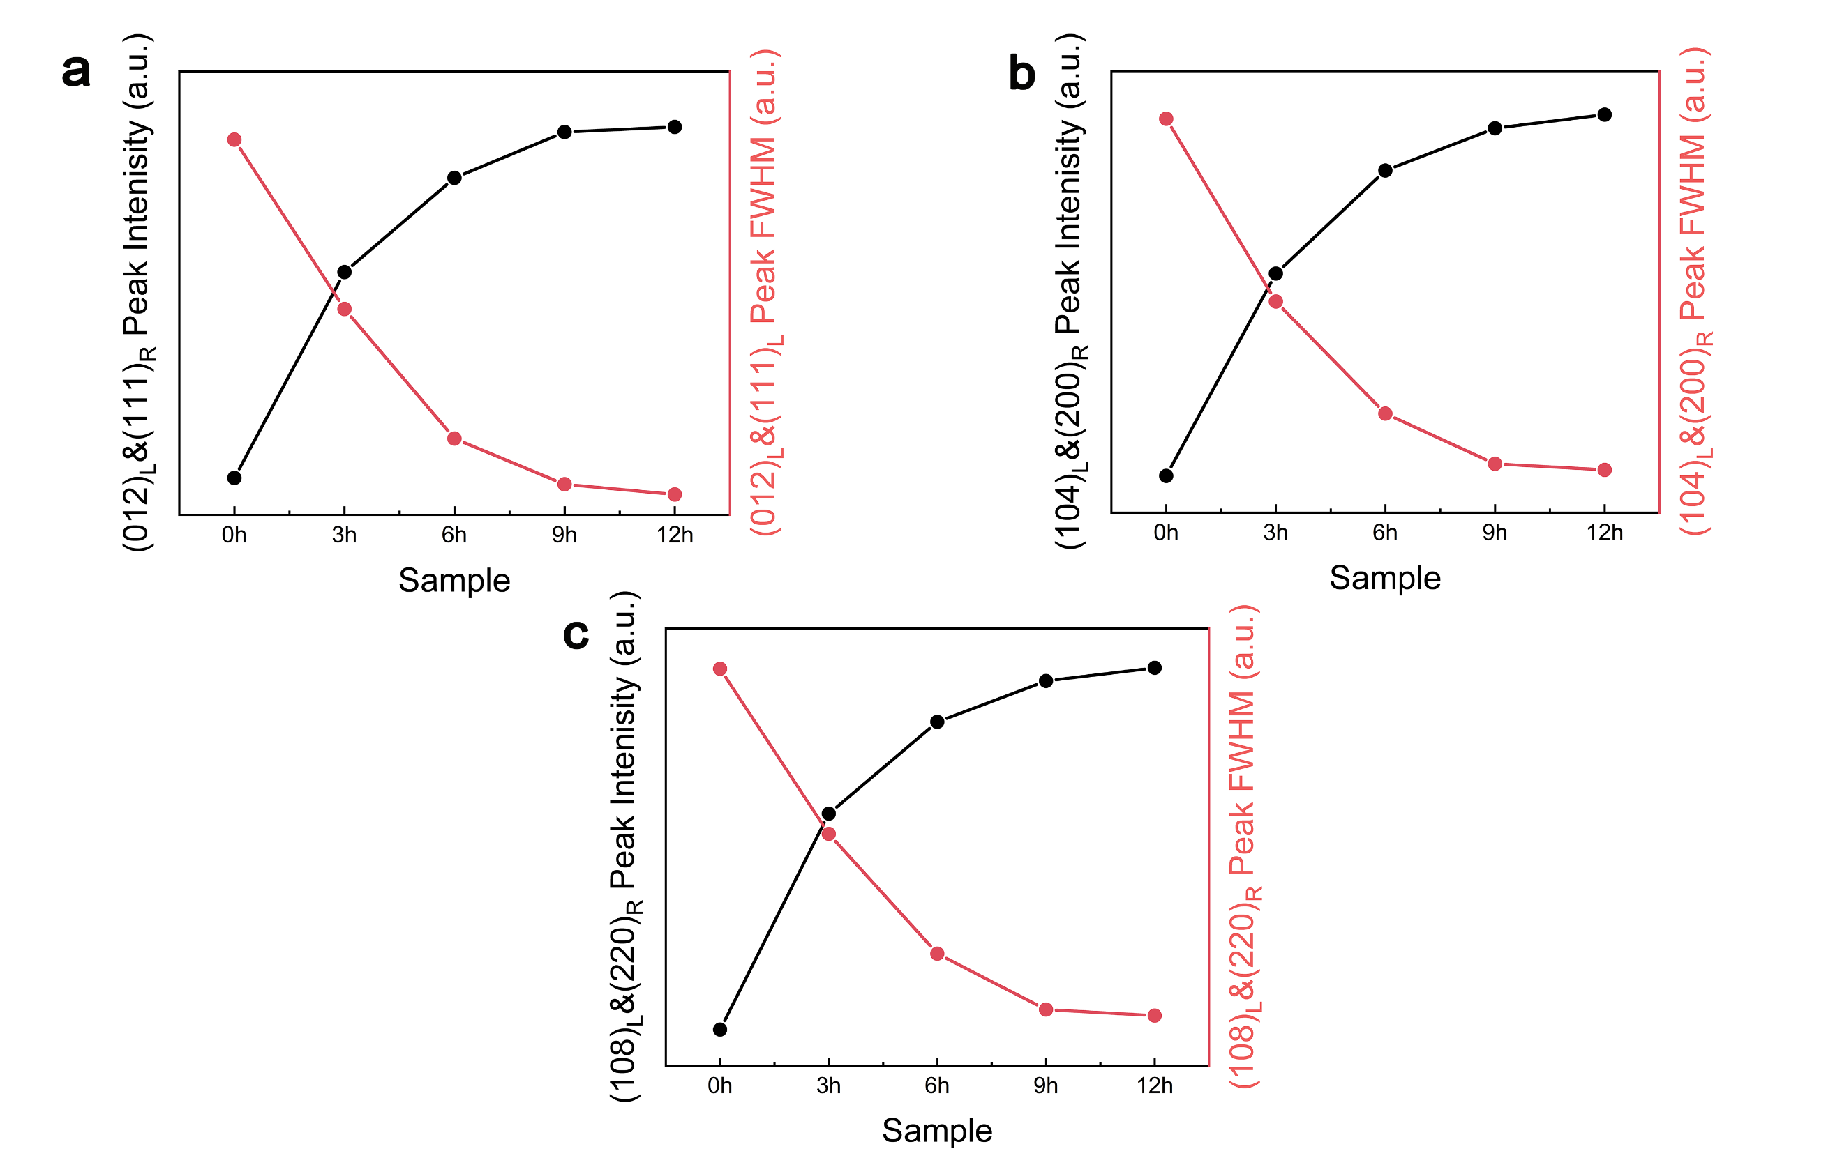
Supplementary Figure 2. Normalized intensity and full width at half maximum (FWHM) of layered (a) (012)_{L}&(111)_{R} , (b) (104)_{L}&(200)_{R} , (c) (108)_{L}&(220)_{R} peaks for layered and rocksalt phases as a function of aging time at 450 ℃ in ex-situ XRD. The values of peak intensity and FWHM is maintained up to 9 hours of aging, and reached saturation corresponding to (003)_{L}

Supplementary Figure 3. Phase fraction of layered and rocksalt at pristine state of 0h/1h/3h/6h/9h-LNROs. The result shows that all pristine state of LNROs show similar phase fraction about 7:3 ratio. Therefore, we can evaluate the factor parameter of domain distribution to the zero-strain behavior regardless of the phase fraction effect.

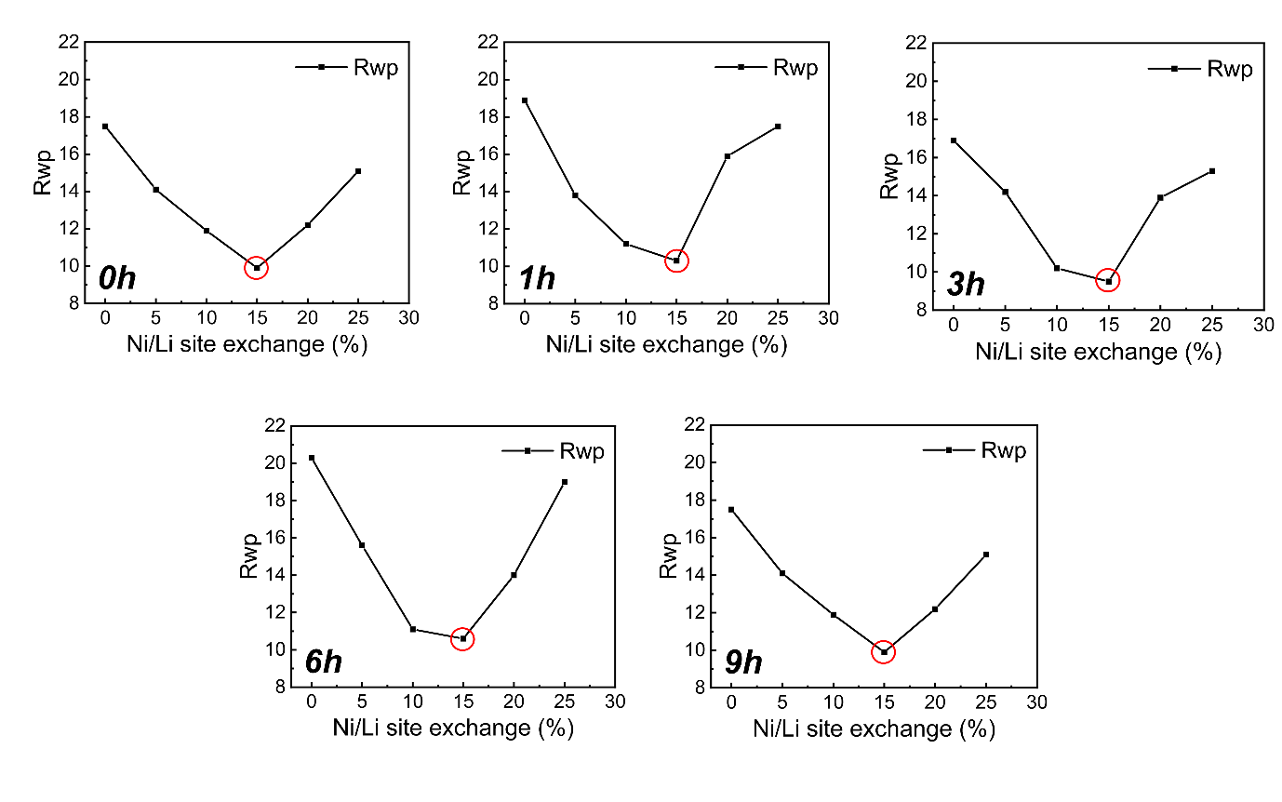Supplementary Figure 4. R_{wp} trends of Rietveld refinement results based on Li/Ni site exchange in single layered phase model. The result shows that R_{wp} of 15% Ni/Li site exchange is minimum in all types of LNROs. 15% site exchange means 30% fraction of disordered rocksalt phase in two phase model(15% order + 15% disorder). There are similar values of phase fraction in both of two phase and single phase model.

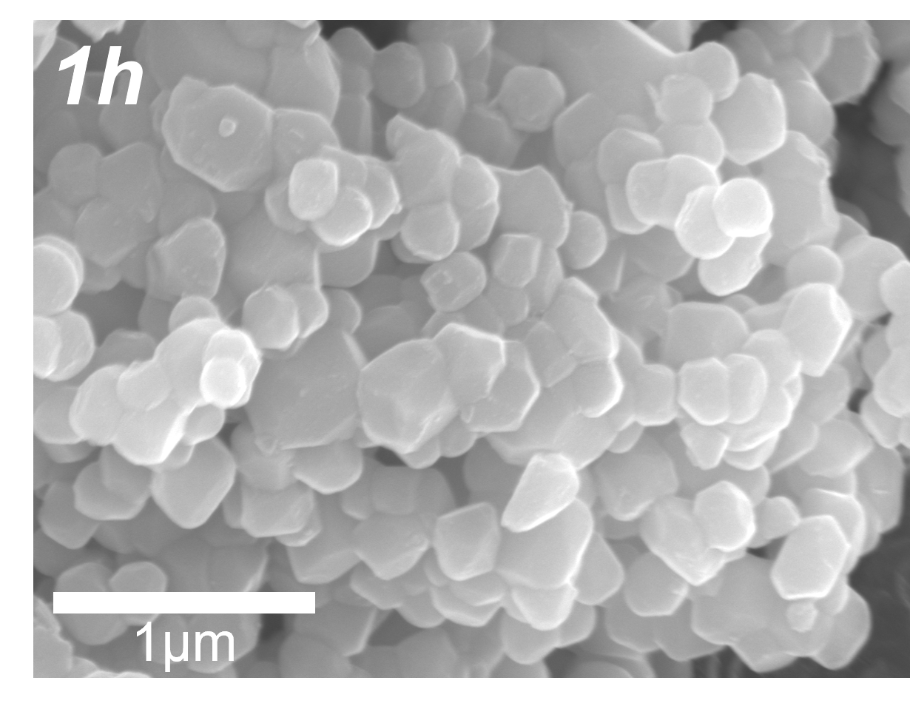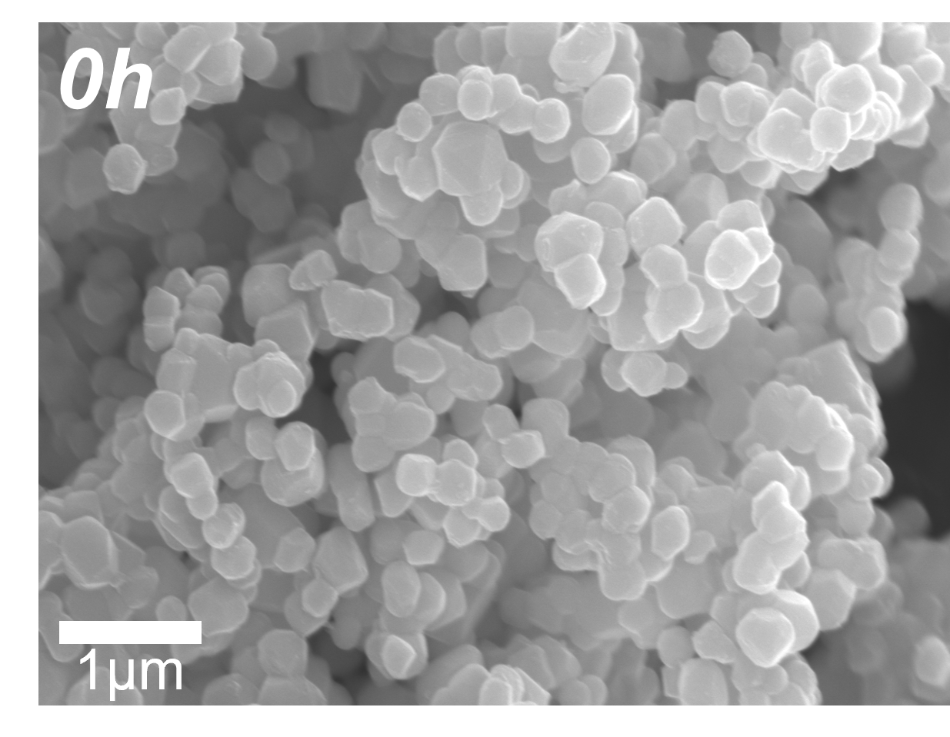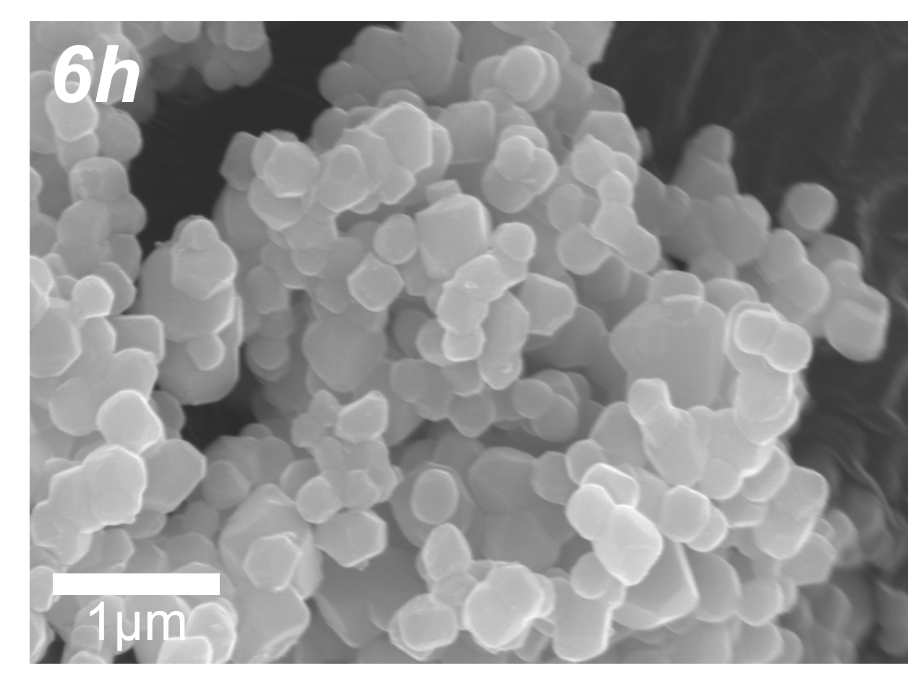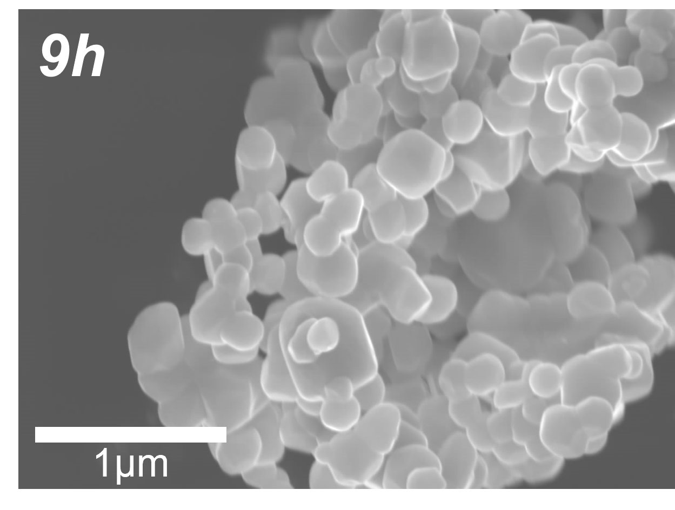
Supplementary Figure 5. Morphology of pristine state of 0h/1h/6h/9h-LNRO cathodes. Including 3h-LNRO, all pristine state of LNROs show similar single particle size of 300 ~ 500 nm.

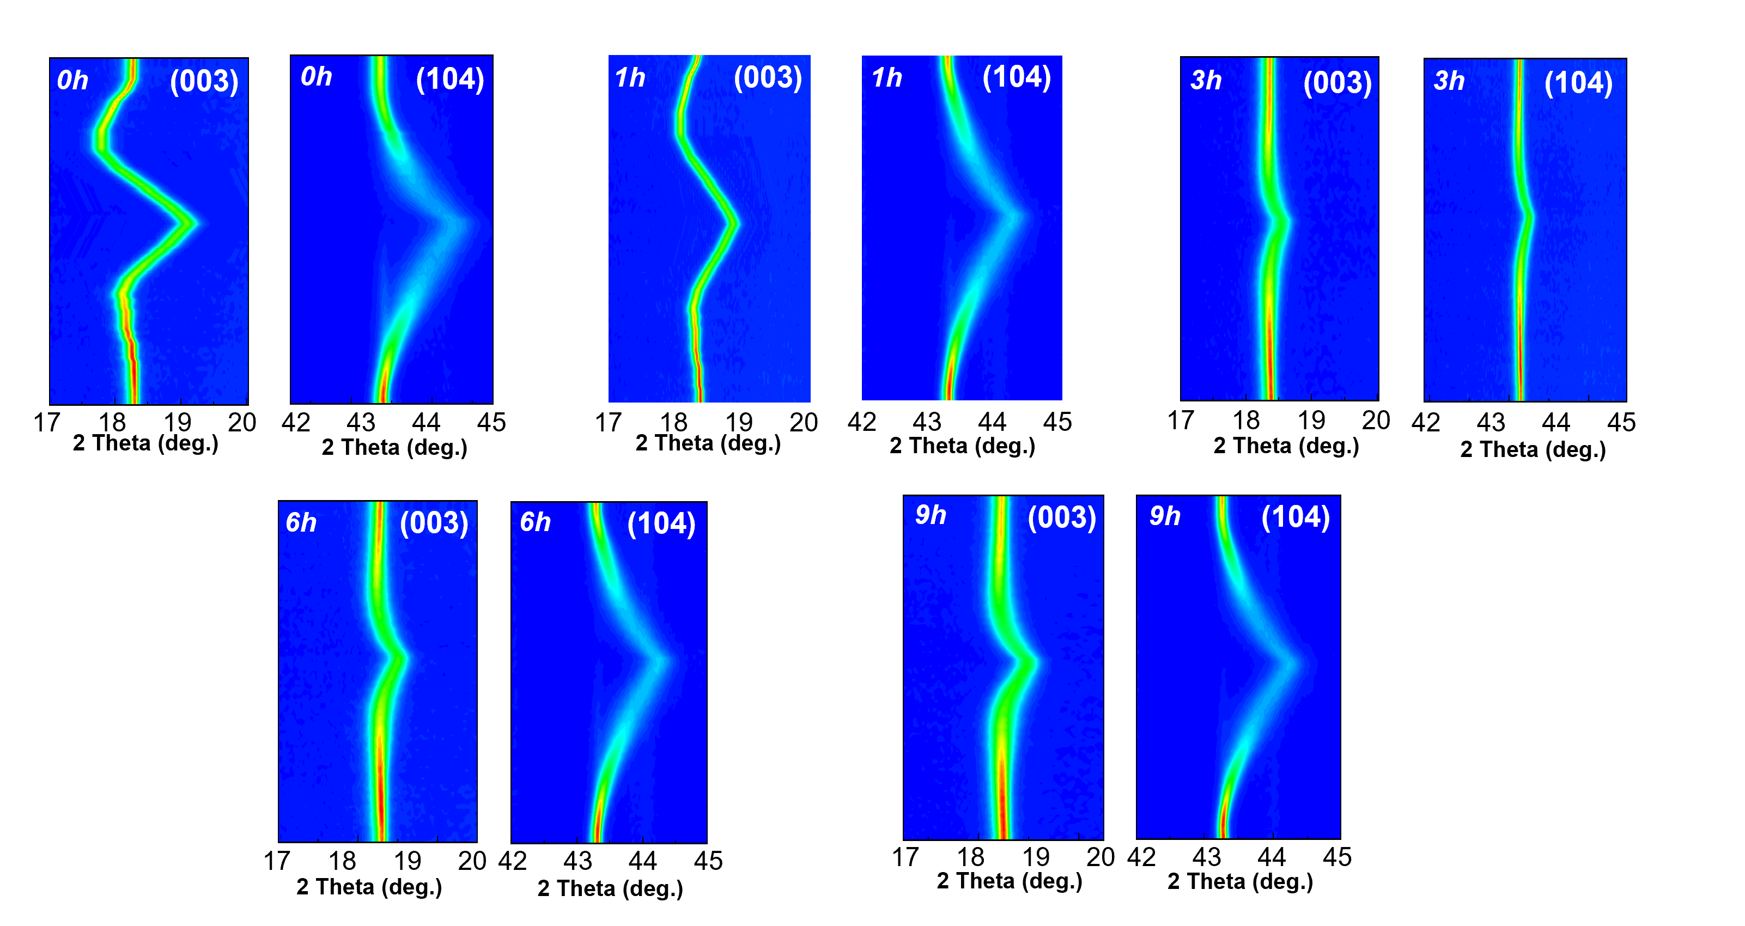
Supplementary Figure 6. In-situ XRD pattern of (003)_{L} and (104)_{L} during initial cycle of all LNROs. 3h-LNRO shows minimum peak shifting and isotropic feature. 6h/9h-LNROs also show isotropic feature as shown in main figure. However, 0h/1h-LNRO shows large peak shifting and anisotropic behavior.

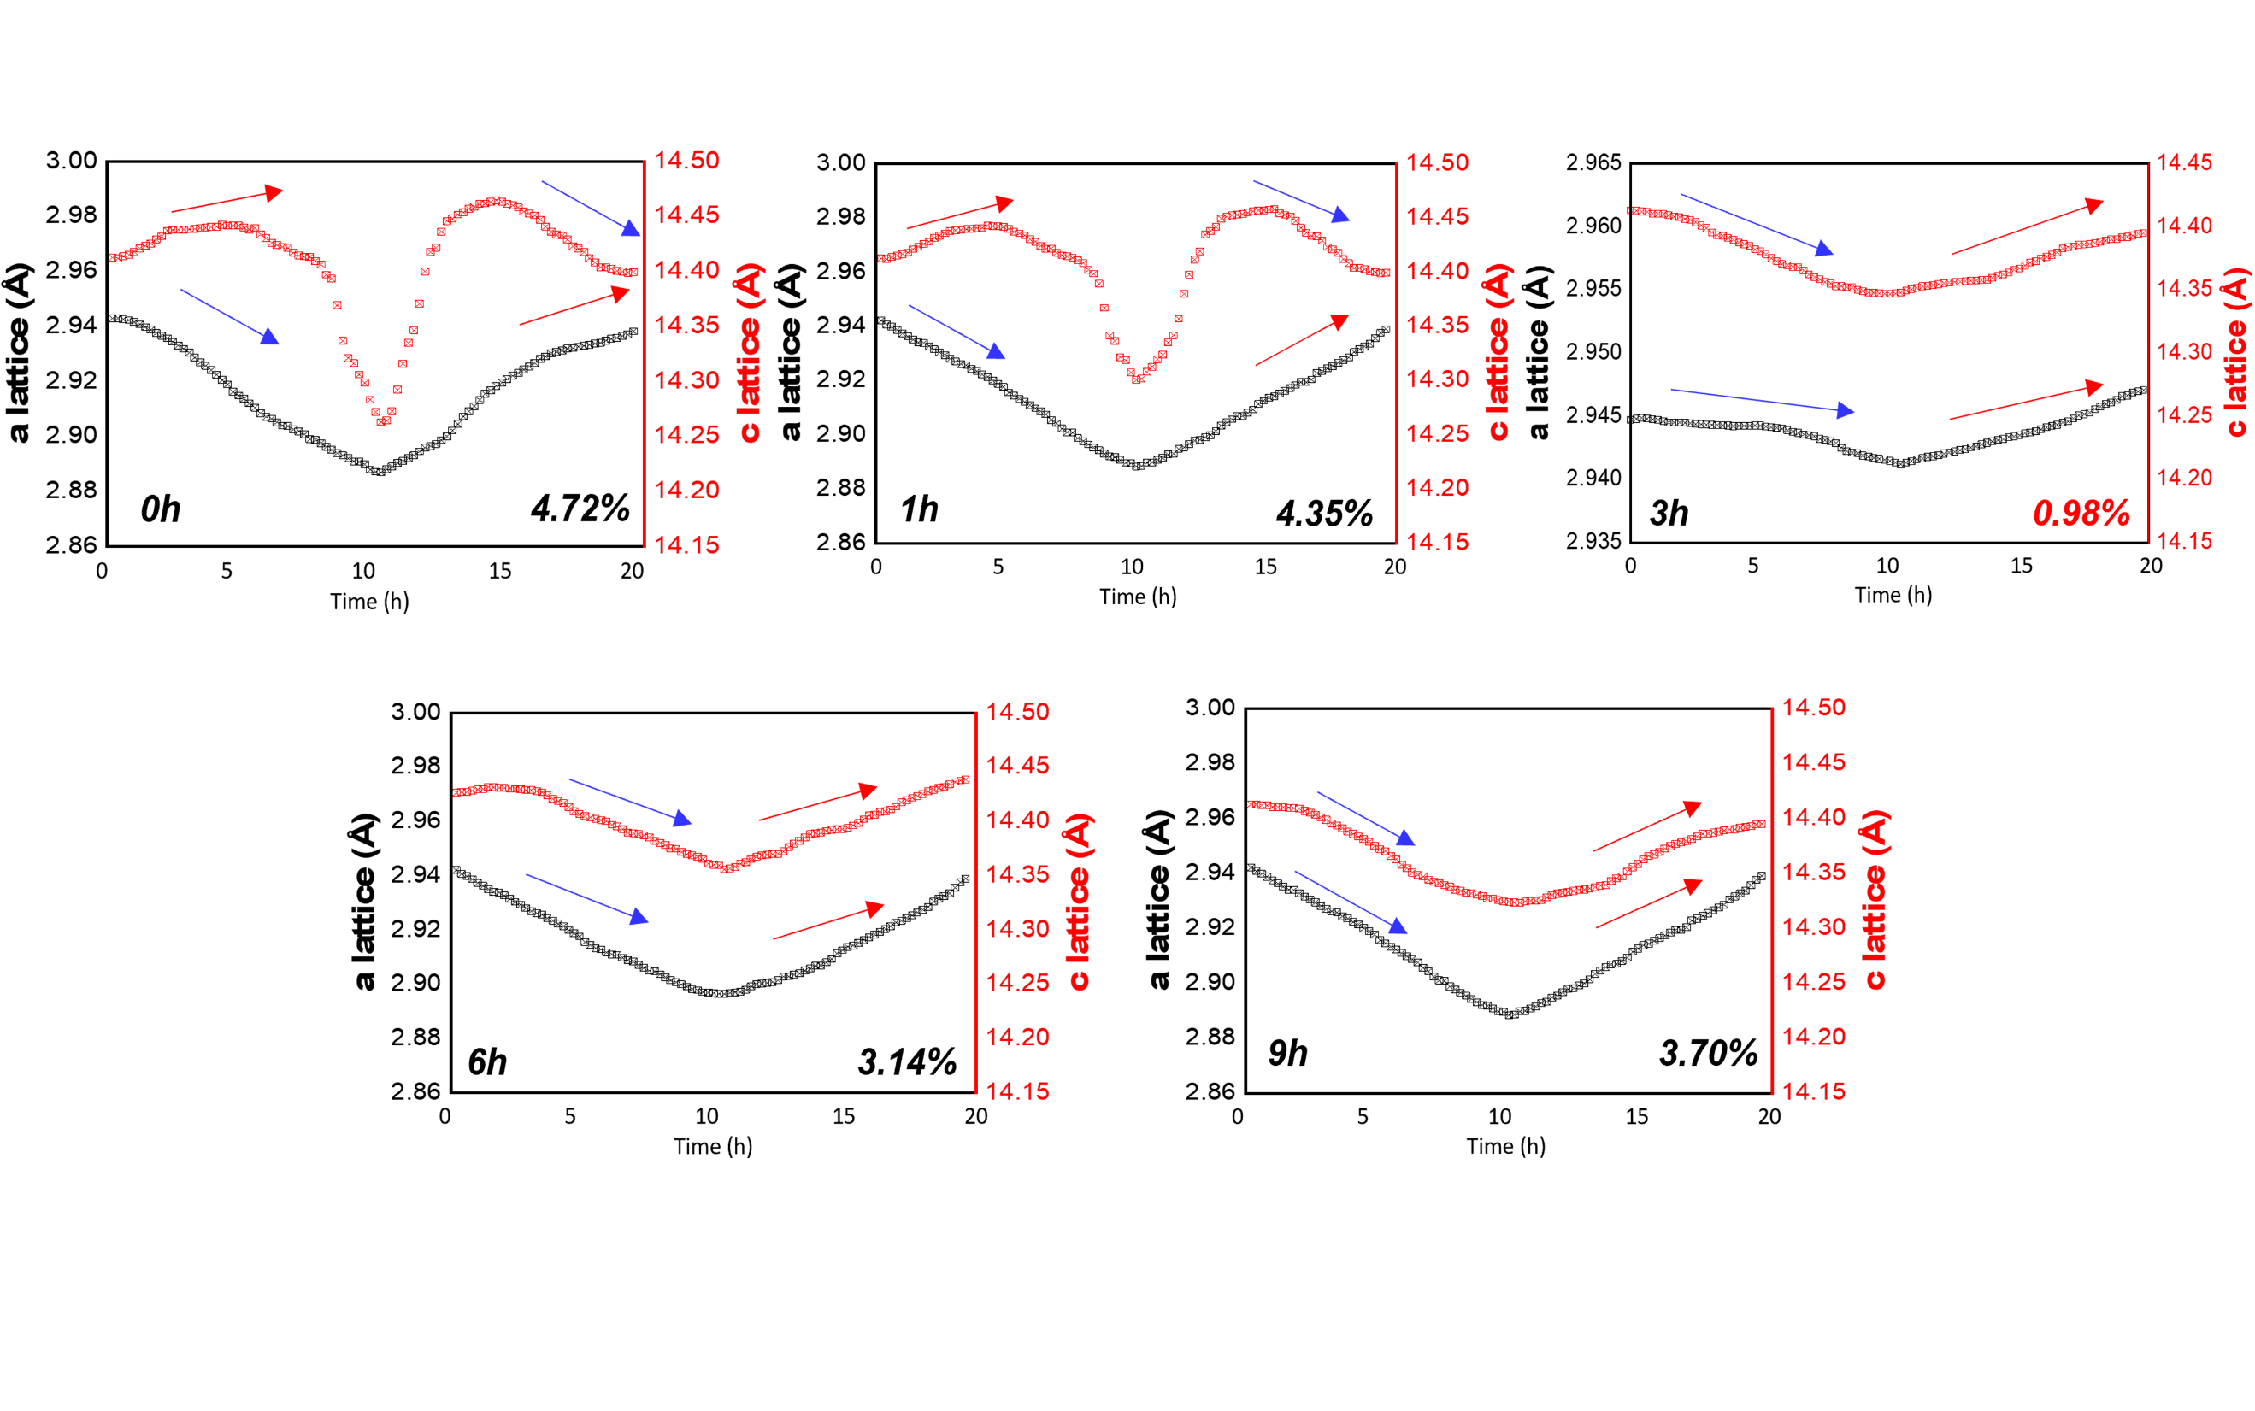
Supplementary Figure 7. Lattice parameters change of all LNROs during initial cycling. 0h/1h shows anisotropic lattice parameter change and large unit cell volume change rather than 3h-LNRO shows less than 1% of unit cell volume change and isotropic feature. 6h/9h-LNROs also show isotropic feature as shown in main figure.

Supplementary Figure 8. Normalized lattice parameter (c/c_{o}) versus (ab/a_{o}b_{o}) and volume change (V/V_{o}) according to state of charge.

Supplementary Figure 9. Results of unit cell volume change during first cycle for 0h/1h/6h/9h-LNRO.

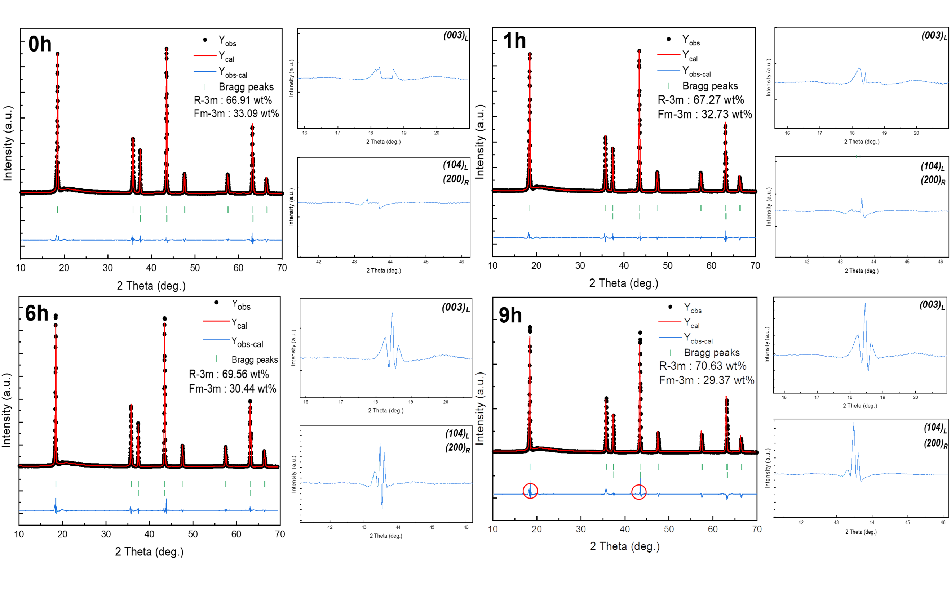Supplementary Figure 10. Results of Rietveld refinement of X-ray diffraction of 0h/1h/6h/9h-LNRO. Rather than XRD refinement result of 3h-LNRO, 0h/1h-LNRO shows better fit of refinement at (003)_{L} and (104)_{L} peaks. But 6h/9h-LNRO show same trend with 3h-LNRO at the two representative peaks.

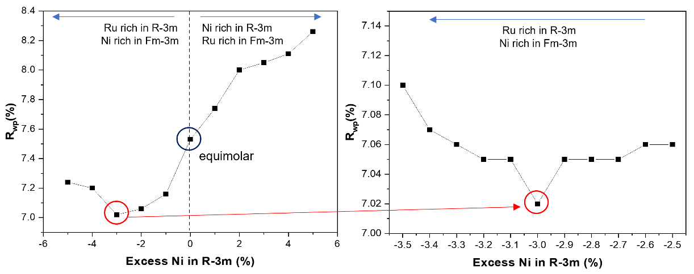
Supplementary Figure 11. Trend of R_{wp} of 3h-LNRO’s XRD-Rietveld refinement according to degree of interphase atomic mixing. It was observed that the R_{wp} tends to decrease when Ru is rich in the layered phase and Ni is rich in the rocksalt phase, compared to the case where the composition of Li/Ni/Ru is the same (equimolar case). Finally, it was confirmed that the R_{wp} factor saturates at its lowest value when 3% intermixing occurs.

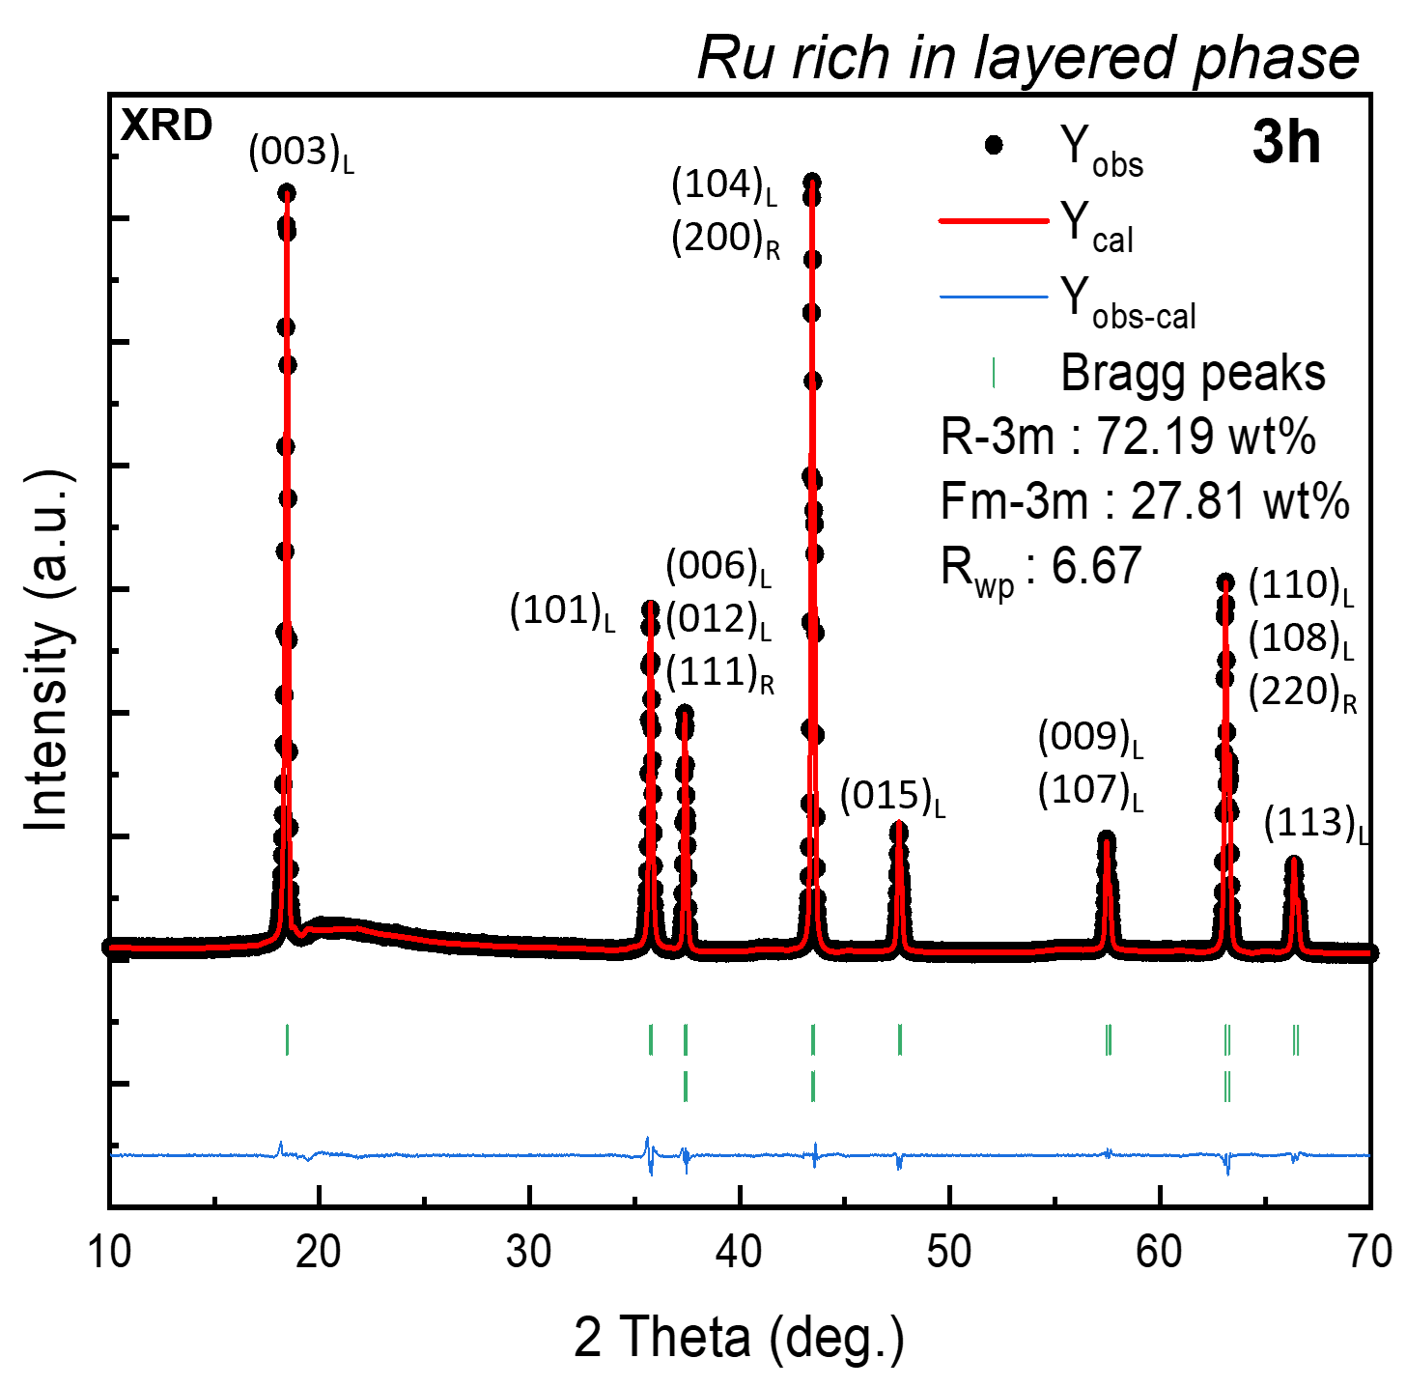
Supplementary Figure 12. Modified XRD refinement of 3h-LNRO based on interphase atomic mixing model. Compared to Fig. 3a, modified refinement result based on ND result shows well fit of all peaks.

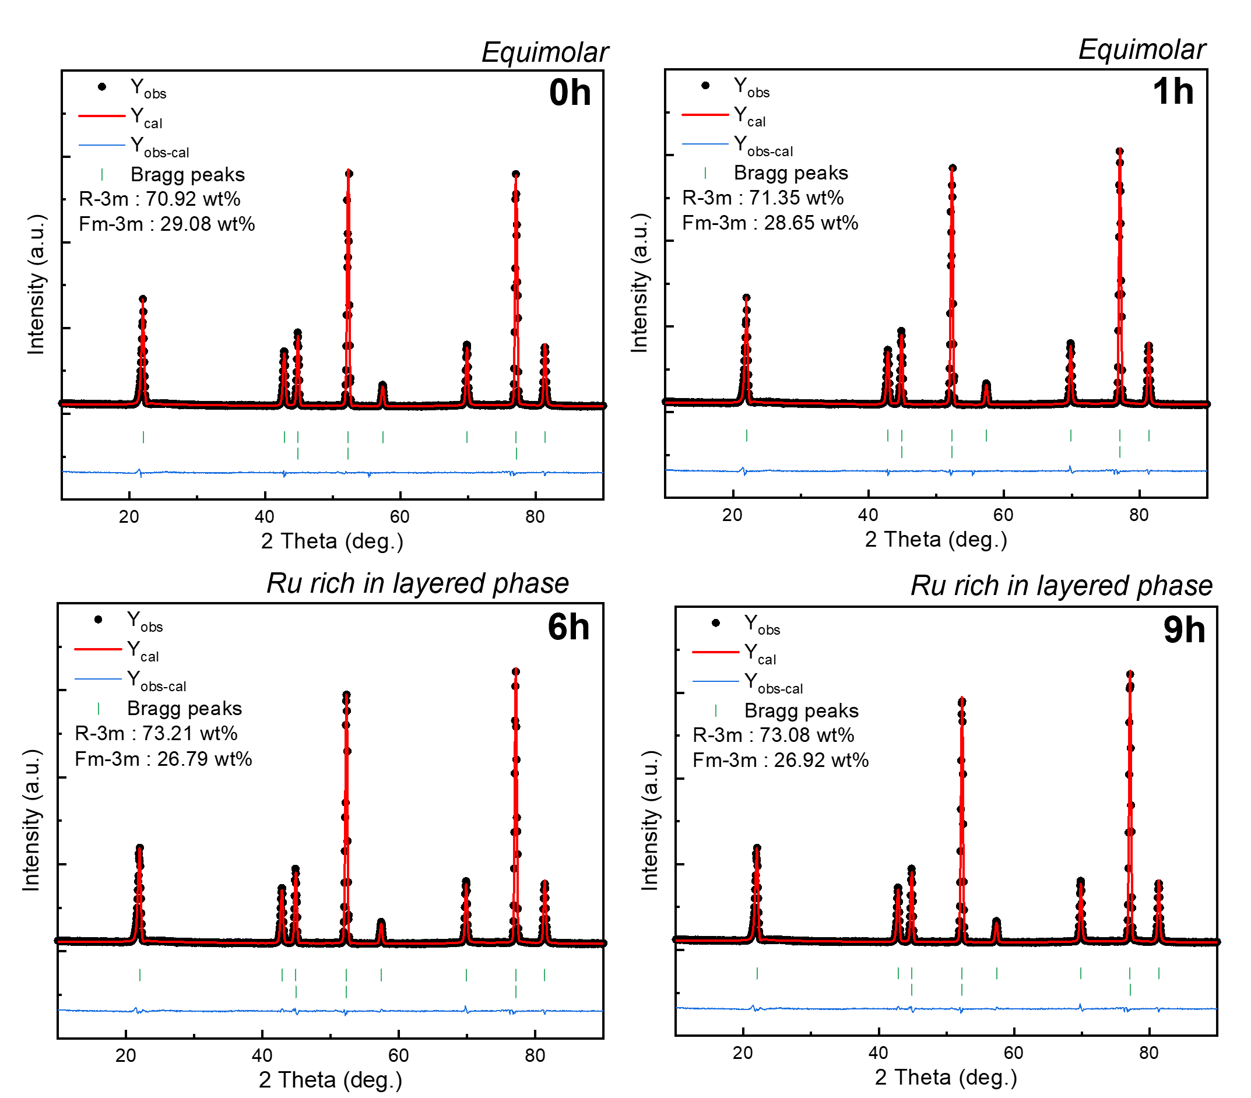
Supplementary Figure 13. Results of neutron diffraction refinement of 0h/1h/6h/9h-LNRO. Same trend with XRD refinement results, including 3h-LNRO, 6h/9h-LNRO are well fitted with the model of interphase atomic intermixing. And 0h/1h-LNRO show better fit of refinement with the case of equimolar model
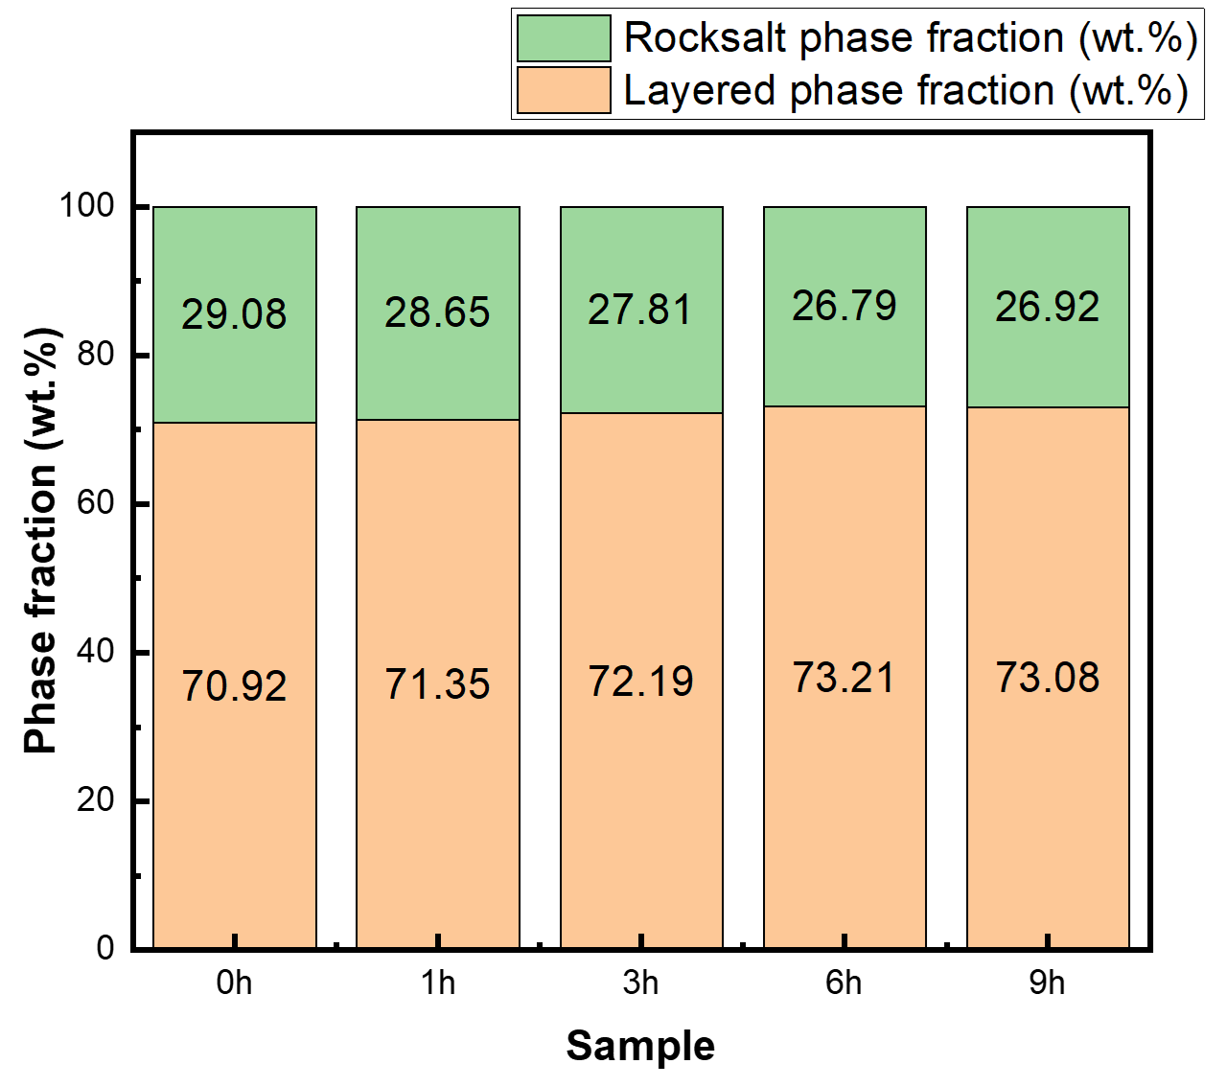
Supplementary Figure 14. Phase fraction of layered and rocksalt at pristine state of 0h/1h/3h/6h/9h-LNROs using the interphasial atomic intermixing model. The result shows that all pristine state of LNROs still show similar phase fraction about 7:3 ratio.

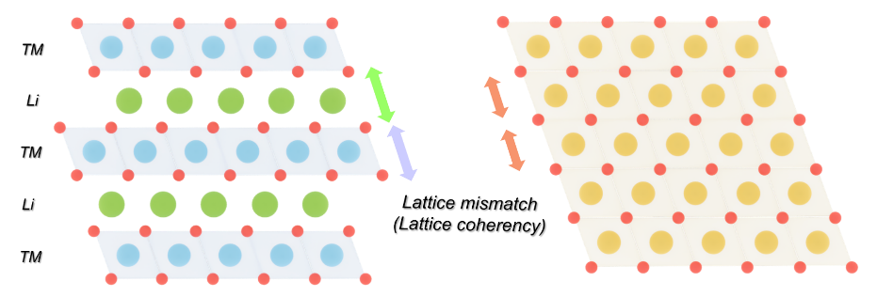
Supplementary Figure 15. Relative lattice mismatch of 0h and 3h-LNRO based on XRD refinement. Due to interphase atomic intermixing, lattice mismatch between layered Li slab-rocksalt slab, and layered TM slab-rocksalt slab is mitigated by ionic radius difference of Li and transition metal ion.

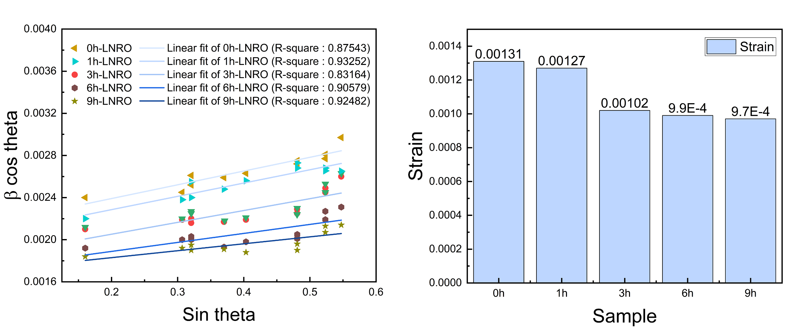
Supplementary Figure 16. Williamson-Hall plot and strain of all LNROs based on XRD patterns. The difference in domain distribution and lattice coherency resulted in variations in initial microstrain, with 0h-LNRO exhibiting the highest initial strain.

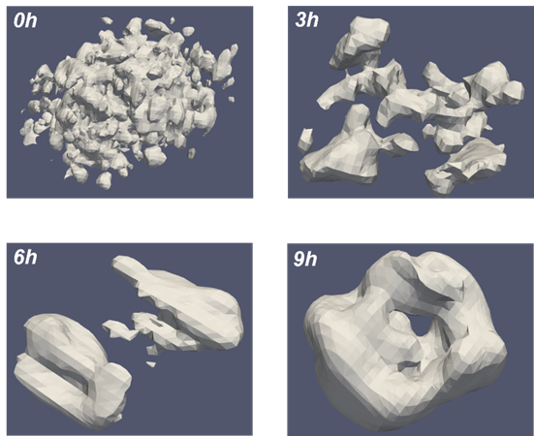
Supplementary Figure 17. 3D reconstructed Bragg coherent diffraction imaging(BCDI) results for pristine single particle of 0h/1h/6h/9h-LNRO. The white regions, reconstructed through (003)_{L} peak rocking, represent only the layered phase domains, excluding the rocksalt domains within the single particle. This supports the high correlation with the mosaic to island phase domain distribution observed in the 2D TEM-Darkfield image.

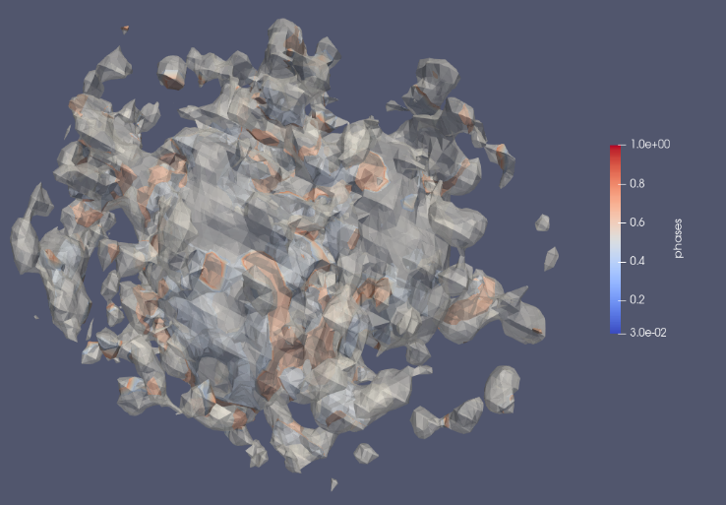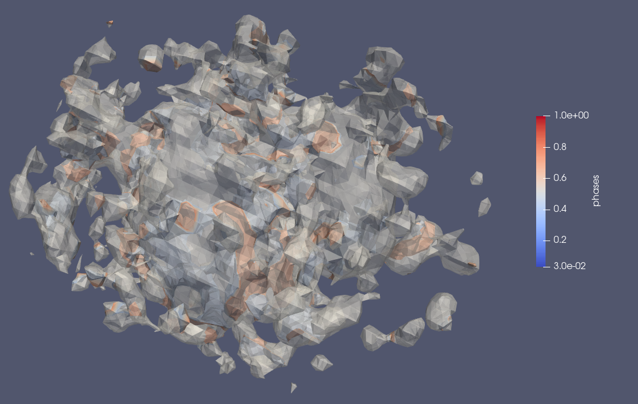
c
a
b
d
a
b
c
d
0h
Supplementary Figure 18. Reconstructed Bragg coherent diffraction imaging (BCDI) with displace field applied model for pristine single particle of 0h-LNRO. In 0h-LNRO, many regions experiencing the tensile and compressive stress were observed simultaneously within a single domain.

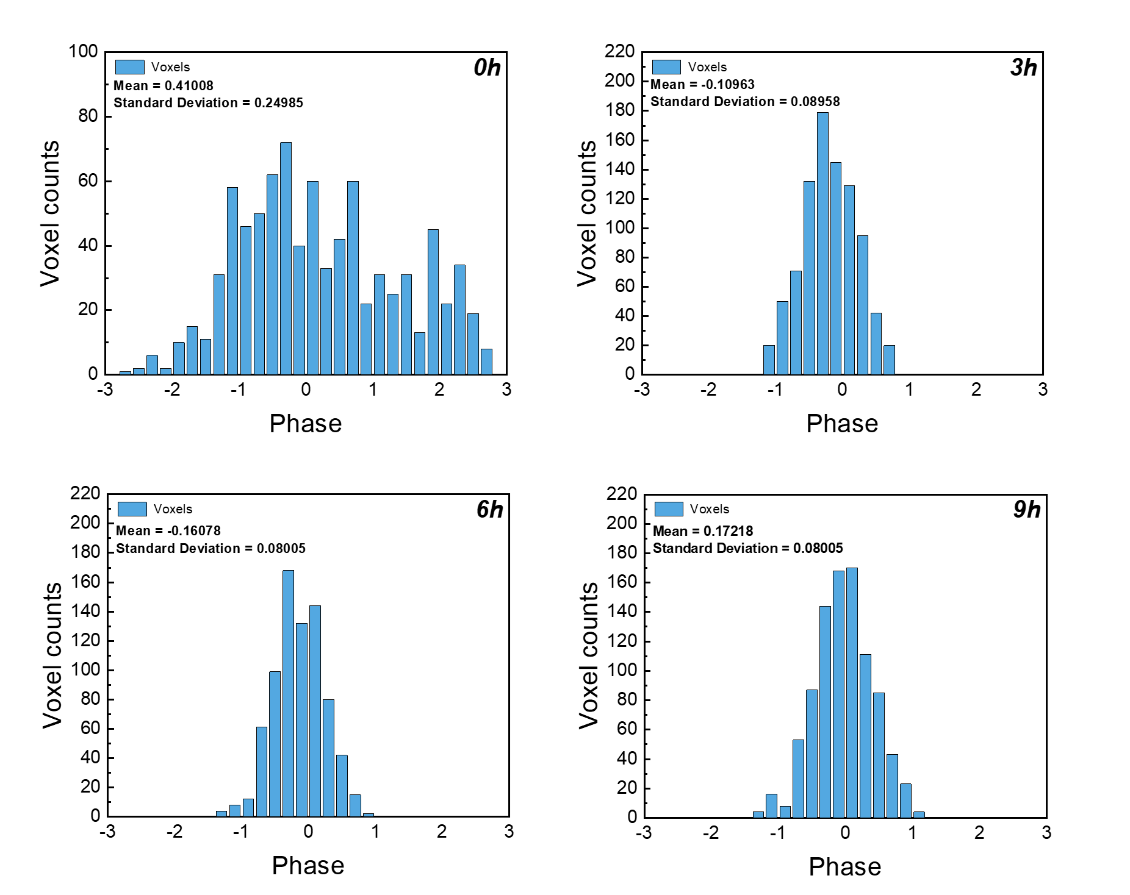
Supplementary Figure 19. Color distribution of voxels for 0h/3h/6h/9h-LNROs. 0h-LNRO showed a more heterogeneous color distribution than 3h, 6h, and 9h-LNRO samples. It indicates 0h-LNRO shows low lattice coherency than 3h/6h/9h-LNROs

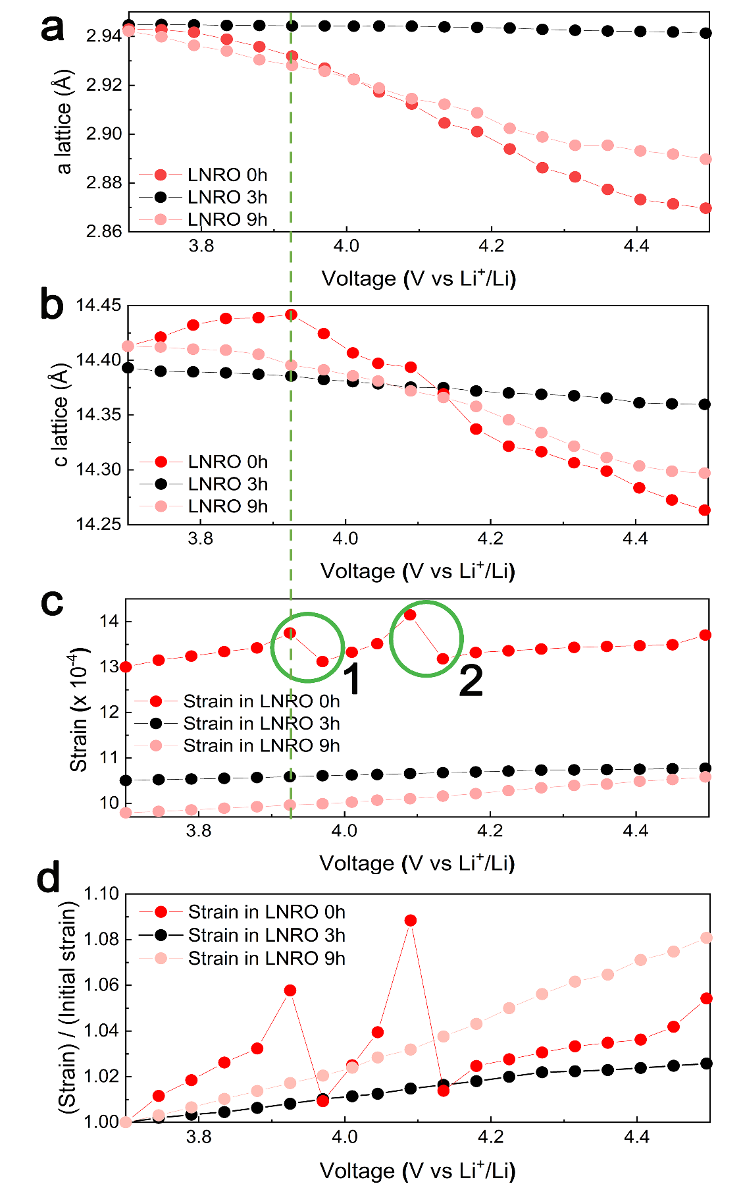
Supplementary Figure 20. Changes in a and c lattice parameter and strain during the first charge process. (a) a-lattice parameter, (b) c-lattice parameters change, (c) microstrain, and (d) rate of strain accumulation according to state of charge (SOC) during the initial charging process for 0h, 3h and 9h-LNRO representatively.

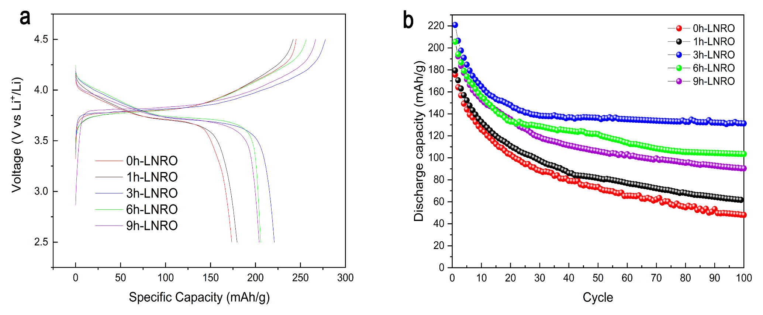
Supplementary Figure 21. Electrochemical test results of 0h/1h/3h/6h/9h-LNROs. (a) Initial voltage profiles of five LNROs. (b) Capacity retention of five LNROs. Voltage range is 2.5-4.5V at C/10. 3h-LNRO which undergoes minimum volume change shows better reversibility of electrochemical performance among all LNROs.

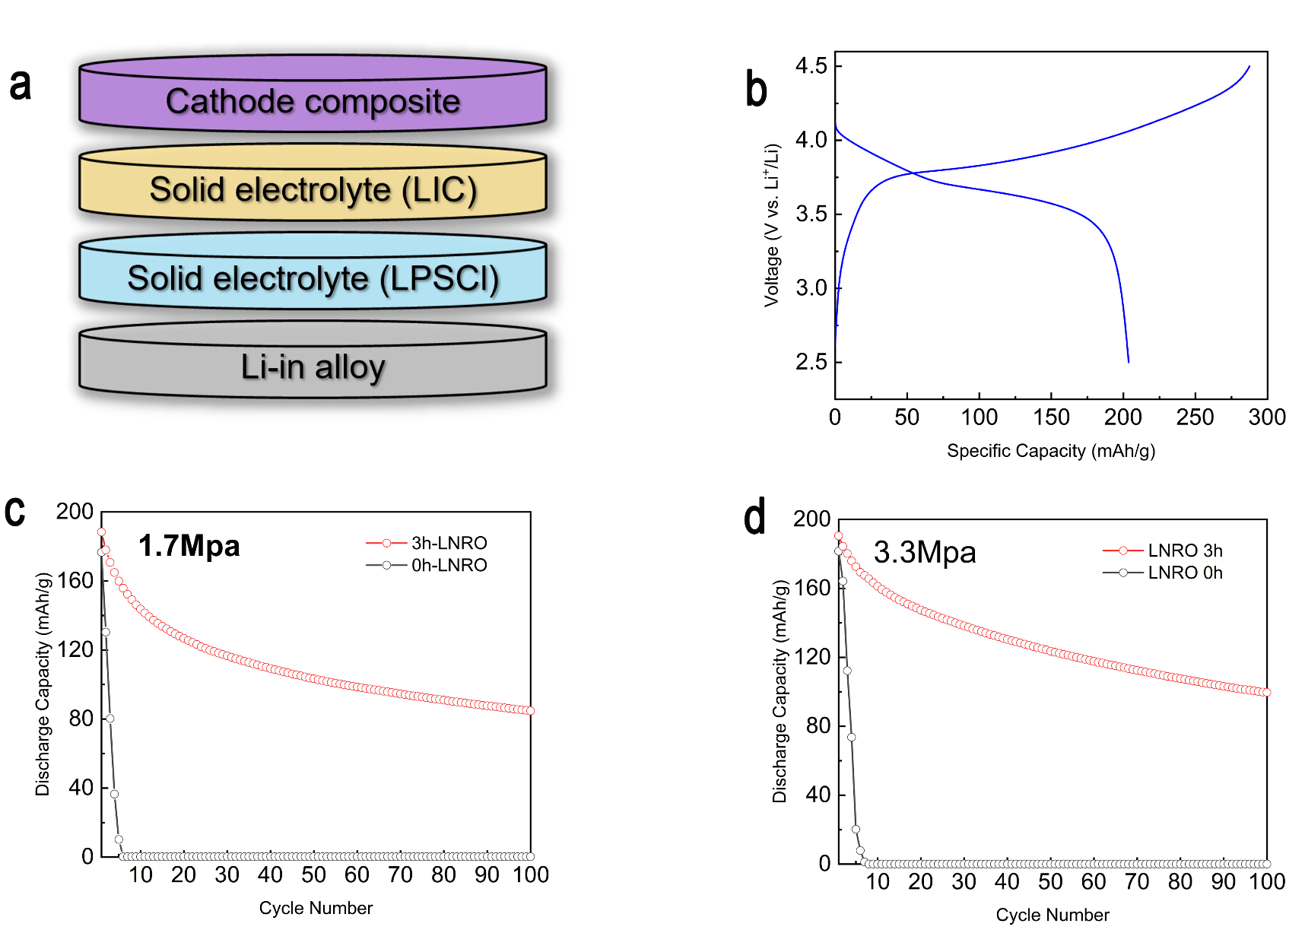
Supplementary Figure 22. Electrochemical performance of 0h,3h-LNRO in all-solid-state battery system with low stack pressure. (a) Cell configuration of solid-state battery. Lithium indium chloride (LIC) is used for solid electrolyte to suppress chemical degradation. (b) Voltage profile of LIB and ASSB system (c),(d) Relative capacity retention of 3h-LNRO and 0h-LNRO in low stack pressure of 3.3MPa and 1.7Mpa each.

Supplementary Table 1 │ XRD refinement of 0h-LNROs based on $R\overline{3}m$ and $Fm\overline{3}m$ biphasic model
Li_{1.2}Ni_{0.4}Ru_{0.4}O₂: $R\overline{3}m$
Atom | Wyckoff | x | y | z | Occupancy | B_{iso}
Li(1) | 3b | 0 | 0 | 0.5 | 1 | 0.35(3)
Li(2) | 3a | 0 | 0 | 0 | 0.200 | 0.0312(4)
Ni(1) | 3a | 0 | 0 | 0 | 0.400 | 0.0312(4)
Ru(1) | 3a | 0 | 0 | 0 | 0.400 | 0.0312(4)
O(1) | 6c | 0 | 0 | 0.254010(3) | 1 | 0.019(2)
Li_{1.2}Ni_{0.4}Ru_{0.4}O₂: $Fm\overline{3}m$
Li(1) | 4a | 0 | 0 | 0 | 0.600 | 0.0203
Ni(1) | 4a | 0 | 0 | 0 | 0.200 | 0.0203
Ru(1) | 4a | 0 | 0 | 0 | 0.200 | 0.0203
O(1) | 4b | 0 | 0 | 0.5 | 1 | 0.028
0h-LNRO lattice parameter: $R\overline{3}m$, $66.91(2)$ wt%, $a=b=2.9429(3) Å$, $c=14.4199(1) Å$, $α=β={90}^{°}$, $r={120}^{°}$, $Fm\overline{3}m$, $33.09(7)$ wt%, $a=b=c=4.13817(5) Å$, $α=β=γ={90}^{°}$.

Supplementary Table 2 │ XRD refinement of 1h-LNROs based on $R\overline{3}m$ and $Fm\overline{3}m$ biphasic model
Li_{1.2}Ni_{0.4}Ru_{0.4}O₂: $R\overline{3}m$
Atom | Wyckoff | x | y | z | Occupancy | B_{iso}
Li(1) | 3b | 0 | 0 | 0.5 | 1 | 0.42(4)
Li(2) | 3a | 0 | 0 | 0 | 0.200 | 0.0334(2)
Ni(1) | 3a | 0 | 0 | 0 | 0.400 | 0.0334(2)
Ru(1) | 3a | 0 | 0 | 0 | 0.400 | 0.0334(2)
O(1) | 6c | 0 | 0 | 0.253952(4) | 1 | 0.045(1)
Li_{1.2}Ni_{0.4}Ru_{0.4}O₂: $Fm\overline{3}m$
Li(1) | 4a | 0 | 0 | 0 | 0.600 | 0.0154
Ni(1) | 4a | 0 | 0 | 0 | 0.200 | 0.0154
Ru(1) | 4a | 0 | 0 | 0 | 0.200 | 0.0154
O(1) | 4b | 0 | 0 | 0.5 | 1 | 0.022
1h-LNRO lattice parameter: $R\overline{3}m$, $67.27(3)$ wt%, $a=b=2.94119(5) Å$, $c=14.4226(2) Å$, $α=β={90}^{°}$, $r={120}^{°}$, $Fm\overline{3}m$, $32.73$(2) wt%, $a=b=c=4.13501(6) Å$, $α=β=γ={90}^{°}$.

Supplementary Table 3 │ XRD refinement of 3h-LNROs based on $R\overline{3}m$ and $Fm\overline{3}m$ biphasic model
Li_{1.2}Ni_{0.4}Ru_{0.4}O₂: $R\overline{3}m$
Atom | Wyckoff | x | y | z | Occupancy | B_{iso}
Li(1) | 3b | 0 | 0 | 0.5 | 1 | 0.32(6)
Li(2) | 3a | 0 | 0 | 0 | 0.200 | 0.0309(3)
Ni(1) | 3a | 0 | 0 | 0 | 0.400 | 0.0309(3)
Ru(1) | 3a | 0 | 0 | 0 | 0.400 | 0.0309(3)
O(1) | 6c | 0 | 0 | 0.254139(1) | 1 | 0.027(5)
Li_{1.2}Ni_{0.4}Ru_{0.4}O₂: $Fm\overline{3}m$
Li(1) | 4a | 0 | 0 | 0 | 0.600 | 0.0275
Ni(1) | 4a | 0 | 0 | 0 | 0.200 | 0.0275
Ru(1) | 4a | 0 | 0 | 0 | 0.200 | 0.0275
O(1) | 4b | 0 | 0 | 0.5 | 1 | 0.031
3h-LNRO lattice parameter: $R\overline{3}m$, $67.34(7)$ wt%, $a=b=2.94351(2) Å$, $c=14.4205(4) Å$, $α=β={90}^{°}$, $r={120}^{°}$, $Fm\overline{3}m$, $32.66(2)$ wt%, $a=b=c=4.13735(7) Å$, $α=β=γ={90}^{°}$.

Supplementary Table 4 │ XRD refinement of 6h-LNROs based on $R\overline{3}m$ and $Fm\overline{3}m$ biphasic model
Li_{1.2}Ni_{0.4}Ru_{0.4}O₂: $R\overline{3}m$
Atom | Wyckoff | x | y | z | Occupancy | B_{iso}
Li(1) | 3b | 0 | 0 | 0.5 | 1 | 0.39(1)
Li(2) | 3a | 0 | 0 | 0 | 0.200 | 0.0292(4)
Ni(1) | 3a | 0 | 0 | 0 | 0.400 | 0.0292(4)
Ru(1) | 3a | 0 | 0 | 0 | 0.400 | 0.0292(4)
O(1) | 6c | 0 | 0 | 0.254117(3) | 1 | 0.031(5)
Li_{1.2}Ni_{0.4}Ru_{0.4}O₂: $Fm\overline{3}m$
Li(1) | 4a | 0 | 0 | 0 | 0.600 | 0.0231
Ni(1) | 4a | 0 | 0 | 0 | 0.200 | 0.0231
Ru(1) | 4a | 0 | 0 | 0 | 0.200 | 0.0231
O(1) | 4b | 0 | 0 | 0.5 | 1 | 0.041
6h-LNRO lattice parameter: $R\overline{3}m$, $69.56(2)$ wt%, $a=b=2.94258(1) Å$, $c=14.4197\left(4\right) Å$, $α=β={90}^{°}$, $r={120}^{°}$, $Fm\overline{3}m$, $30.44$(1) wt%, $a=b=c=4.13229(5) Å$, $α=β=γ={90}^{°}$.

Supplementary Table 5 │ XRD refinement of 9h-LNROs based on $R\overline{3}m$ and $Fm\overline{3}m$ biphasic model
Li_{1.2}Ni_{0.4}Ru_{0.4}O₂: $R\overline{3}m$
Atom | Wyckoff | x | y | z | Occupancy | B_{iso}
Li(1) | 3b | 0 | 0 | 0.5 | 1 | 0.43(5)
Li(2) | 3a | 0 | 0 | 0 | 0.200 | 0.0246(3)
Ni(1) | 3a | 0 | 0 | 0 | 0.400 | 0.0246(3)
Ru(1) | 3a | 0 | 0 | 0 | 0.400 | 0.0246(3)
O(1) | 6c | 0 | 0 | 0.254337(5) | 1 | 0.027(1)
Li_{1.2}Ni_{0.4}Ru_{0.4}O₂: $Fm\overline{3}m$
Li(1) | 4a | 0 | 0 | 0 | 0.600 | 0.0202
Ni(1) | 4a | 0 | 0 | 0 | 0.200 | 0.0202
Ru(1) | 4a | 0 | 0 | 0 | 0.200 | 0.0202
O(1) | 4b | 0 | 0 | 0.5 | 1 | 0.021
9h-LNRO lattice parameter: $R\overline{3}m$, $70.63(3)$ wt%, $a=b=2.94145(5) Å$, $c=14.4183(1) Å$, $α=β={90}^{°}$, $r={120}^{°}$, $Fm\overline{3}m$, $29.37(3)$ wt%, $a=b=c=4.13241(2) Å$, $α=β=γ={90}^{°}$.

Supplementary Table 6 │XRD refinement of 3h-LNRO based on $R\overline{3}m$ and $Fm\overline{3}m$ biphasic model where Ru 3% was rich in $R\overline{3}m$ (with Ni-rich in $Fm\overline{3}m$ for charge balance)
Li_{1.2}Ni_{0.4}Ru_{0.4}O₂: $R\overline{3}m$
Atom | Wyckoff | x | y | z | Occupancy | B_{iso}
Li(1) | 3b | 0 | 0 | 0.5 | 1 | 0.4(1)
Li(2) | 3a | 0 | 0 | 0 | 0.164 | 0.0219(2)
Ni(1) | 3a | 0 | 0 | 0 | 0.388 | 0.0219(2)
Ru(1) | 3a | 0 | 0 | 0 | 0.412 | 0.0219(2)
O(1) | 6c | 0 | 0 | 0.254010(3) | 1 | 0.027(4)
Li_{1.2}Ni_{0.4}Ru_{0.4}O₂: $Fm\overline{3}m$
Li(1) | 4a | 0 | 0 | 0 | 0.618 | 0.0154
Ni(1) | 4a | 0 | 0 | 0 | 0.206 | 0.0154
Ru(1) | 4a | 0 | 0 | 0 | 0.194 | 0.0154
O(1) | 4b | 0 | 0 | 0.5 | 1 | 0.022
3h-LNRO lattice parameter: $R\overline{3}m$, $72.69(2)$ wt%, $a=b=2.94183(2) Å$, $c=14.4216(5) Å$, $α=β={90}^{°}$, $r={120}^{°}$, $Fm\overline{3}m$, $27.31(3)$ wt%, $a=b=c=4.15612(4) Å$, $α=β=γ={90}^{°}$.

Supplementary Table 7 │ Neutron diffraction refinement of 0h-LNRO based on $R\overline{3}m$ and $Fm\overline{3}m$ biphasic model with no interphasial intermixing
Li_{1.2}Ni_{0.4}Ru_{0.4}O₂: $R\overline{3}m$
Atom | Wyckoff | x | y | z | Occupancy | B_{iso}
Li(1) | 3b | 0 | 0 | 0.5 | 1 | 0.32(3)
Li(2) | 3a | 0 | 0 | 0 | 0.200 | 0.0317(1)
Ni(1) | 3a | 0 | 0 | 0 | 0.400 | 0.0317(1)
Ru(1) | 3a | 0 | 0 | 0 | 0.400 | 0.0317(1)
O(1) | 6c | 0 | 0 | 0.254179(4) | 1 | 0.021(1)
Li_{1.2}Ni_{0.4}Ru_{0.4}O₂: $Fm\overline{3}m$
Li(1) | 4a | 0 | 0 | 0 | 0.600 | 0.0211
Ni(1) | 4a | 0 | 0 | 0 | 0.200 | 0.0211
Ru(1) | 4a | 0 | 0 | 0 | 0.200 | 0.0211
O(1) | 4b | 0 | 0 | 0.5 | 1 | 0.025
0h-LNRO lattice parameter: $R\overline{3}m$, $70.92(4)$ wt%, $a=b=2.94852(1) Å$, $c=14.4267(3) Å$, $α=β={90}^{°}$, $r={120}^{°}$, $Fm\overline{3}m$, $29.08(1)$ wt%, $a=b=c=4.13910(2) Å$, $α=β=γ={90}^{°}.$

Supplementary Table 8 │ Neutron diffraction refinement of 1h-LNRO based on $R\overline{3}m$ and $Fm\overline{3}m$ biphasic model with no interphasial intermixing
Li_{1.2}Ni_{0.4}Ru_{0.4}O₂: $R\overline{3}m$
Atom | Wyckoff | x | y | z | Occupancy | B_{iso}
Li(1) | 3b | 0 | 0 | 0.5 | 1 | 0.31(4)
Li(2) | 3a | 0 | 0 | 0 | 0.200 | 0.0316(5)
Ni(1) | 3a | 0 | 0 | 0 | 0.400 | 0.0316(5)
Ru(1) | 3a | 0 | 0 | 0 | 0.400 | 0.0316(5)
O(1) | 6c | 0 | 0 | 0.254022(2) | 1 | 0.027(2)
Li_{1.2}Ni_{0.4}Ru_{0.4}O₂: $Fm\overline{3}m$
Li(1) | 4a | 0 | 0 | 0 | 0.600 | 0.0179
Ni(1) | 4a | 0 | 0 | 0 | 0.200 | 0.0179
Ru(1) | 4a | 0 | 0 | 0 | 0.200 | 0.0179
O(1) | 4b | 0 | 0 | 0.5 | 1 | 0.019
1h-LNRO lattice parameter: $R\overline{3}m$, $71.35(3)$ wt%, $a=b=2.94779(2) Å$, $c=14.4256(4) Å$, $α=β={90}^{°}$, $r={120}^{°}$, $Fm\overline{3}m$, $28.65(2)$ wt%, $a=b=c=4.13851(4) Å$, $α=β=γ={90}^{°}$.

Supplementary Table 9 │ Neutron diffraction refinement of 3h-LNRO based on $R\overline{3}m$ and $Fm\overline{3}m$ biphasic model obtained from where Ru 3% was rich in $R\overline{3}m$ (with Ni-rich in $Fm\overline{3}m$ for charge balance)
Li_{1.2}Ni_{0.4}Ru_{0.4}O₂: $R\overline{3}m$
Atom | Wyckoff | x | y | z | Occupancy | B_{iso}
Li(1) | 3b | 0 | 0 | 0.5 | 1 | 0.41(2)
Li(2) | 3a | 0 | 0 | 0 | 0.16352 | 0.0357(1)
Ni(1) | 3a | 0 | 0 | 0 | 0.38784 | 0.0357(1)
Ru(1) | 3a | 0 | 0 | 0 | 0.41216 | 0.0357(1)
O(1) | 6c | 0 | 0 | 0.254291(4) | 1 | 0.031(2)
Li_{1.2}Ni_{0.4}Ru_{0.4}O₂: $Fm\overline{3}m$
Li(1) | 4a | 0 | 0 | 0 | 0.61824 | 0.0290
Ni(1) | 4a | 0 | 0 | 0 | 0.20608 | 0.0290
Ru(1) | 4a | 0 | 0 | 0 | 0.19392 | 0.0290
O(1) | 4b | 0 | 0 | 0.5 | 1 | 0.032
3h-LNRO lattice parameter: $R\overline{3}m$, $72.19(6)$ wt%, $a=b=2.94171(2) Å$, $c=14.4209(1) Å$, $α=β={90}^{°}$, $r={120}^{°}$, $Fm\overline{3}m$, $27.81(3)$ wt%, $a=b=c=4.15874(3) Å$, $α=β=γ={90}^{°}$.

Supplementary Table 10 │ Neutron diffraction refinement of 6h-LNRO based on $R\overline{3}m$ and $Fm\overline{3}m$ biphasic model obtained from where Ru 3% was rich in $R\overline{3}m$ (with Ni-rich in $Fm\overline{3}m$ for charge balance)
Li_{1.2}Ni_{0.4}Ru_{0.4}O₂: $R\overline{3}m$
Atom | Wyckoff | x | y | z | Occupancy | B_{iso}
Li(1) | 3b | 0 | 0 | 0.5 | 1 | 0.39(5)
Li(2) | 3a | 0 | 0 | 0 | 0.16256 | 0.0342(3)
Ni(1) | 3a | 0 | 0 | 0 | 0.38752 | 0.0342(3)
Ru(1) | 3a | 0 | 0 | 0 | 0.41248 | 0.0342(3)
O(1) | 6c | 0 | 0 | 0.254302(4) | 1 | 0.029(2)
Li_{1.2}Ni_{0.4}Ru_{0.4}O₂: $Fm\overline{3}m$
Li(1) | 4a | 0 | 0 | 0 | 0.61872 | 0.0276
Ni(1) | 4a | 0 | 0 | 0 | 0.20624 | 0.0276
Ru(1) | 4a | 0 | 0 | 0 | 0.19376 | 0.0276
O(1) | 4b | 0 | 0 | 0.5 | 1 | 0.028
6h-LNRO lattice parameter: $R\overline{3}m$, $73.21(4)$ wt%, $a=b=2.94154(3) Å$, $c=14.4241(5) Å$, $α=β={90}^{°}$, $r={120}^{°}$, $Fm\overline{3}m$, $26.79(1)$ wt%, $a=b=c=4.15925(1) Å$, $α=β=γ={90}^{°}$.

Supplementary Table 11 │ Neutron diffraction refinement of 9h-LNRO based on $R\overline{3}m$ and $Fm\overline{3}m$ biphasic model obtained from where Ru 3% was rich in $R\overline{3}m$ (with Ni-rich in $Fm\overline{3}m$ for charge balance)
Li_{1.2}Ni_{0.4}Ru_{0.4}O₂: $R\overline{3}m$
Atom | Wyckoff | x | y | z | Occupancy | B_{iso}
Li(1) | 3b | 0 | 0 | 0.5 | 1 | 0.37(2)
Li(2) | 3a | 0 | 0 | 0 | 0.1622 | 0.0339(3)
Ni(1) | 3a | 0 | 0 | 0 | 0.3847 | 0.0339(3)
Ru(1) | 3a | 0 | 0 | 0 | 0.4126 | 0.0339(3)
O(1) | 6c | 0 | 0 | 0.254313(2) | 1 | 0.025(1)
Li_{1.2}Ni_{0.4}Ru_{0.4}O₂: $Fm\overline{3}m$
Li(1) | 4a | 0 | 0 | 0 | 0.6189 | 0.0271
Ni(1) | 4a | 0 | 0 | 0 | 0.2063 | 0.0271
Ru(1) | 4a | 0 | 0 | 0 | 0.1937 | 0.0271
O(1) | 4b | 0 | 0 | 0.5 | 1 | 0.030
9h-LNRO lattice parameter: $R\overline{3}m$, $73.08(4)$ wt%, $a=b=2.94148(3) Å$, $c=14.4219\left(1\right) Å$, $α=β={90}^{°}$, $r={120}^{°}$, $Fm\overline{3}m$, $26.92(3)$ wt%, $a=b=c=4.15942(2) Å$, $α=β=γ={90}^{°}$.

Supplementary Table 12│Relative slab distance of 0h and 3h-LNRO based on XRD refinement. Due to interphase atomic intermixing, that TM slab decreases from 2.462 to 2.368 Å, metal slab in rocksalt phase increases from 2.323 to 2.466 Å, and Li slab increases.

No interphasial intermixing (0h) | Slab distance ($Å)$ | Lattice parameter ($Å)$
$$R\overline{3}m$$ | 2.591(Li slab) / 2.462(TM slab) | a=2.94852 / c=14.4267
$$Fm\overline{3}m$$ | 2.323 | a=b=c=4.13910

Ru 3% intermixing (3h) | Slab distance ($Å)$ | Lattice parameter ($Å)$
$$R\overline{3}m$$ | 2.642(Li slab) / 2.368(TM slab) | a=2.94171 / c=14.4209
$$Fm\overline{3}m$$ | 2.466 | a=b=c=4.15874

