Supplementary information:
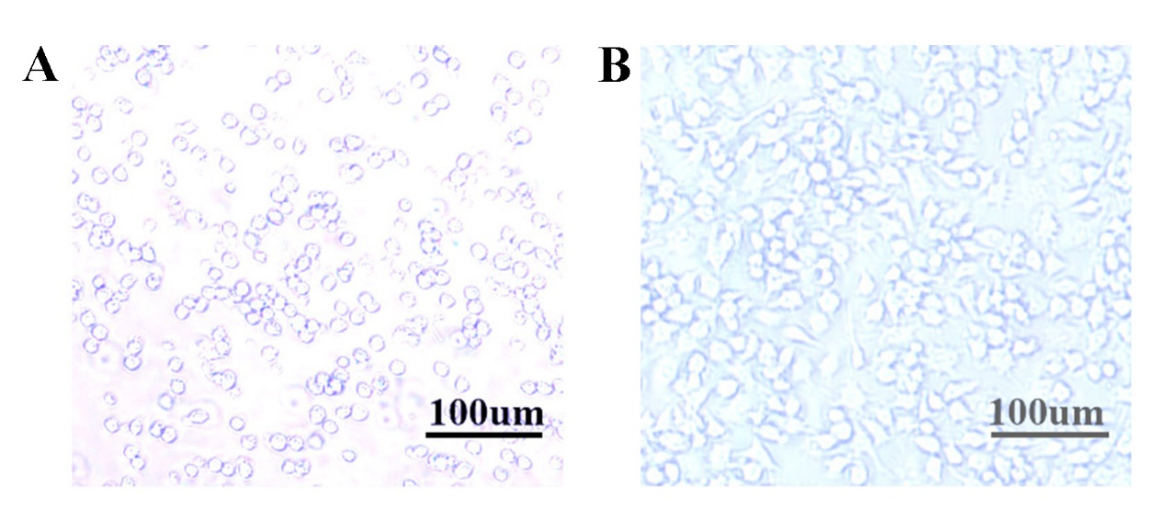
Successful modeling of cellular inflammation. Optical microscope images of RAW264.7 cells before (A) and after (B) stimulation with LPS.

