Table 1 Volcanic debris avalanche lithofacies related to structural units
Structural units | Descriptions | Volcanic debris avalanche lithofacies
Tutupaca ridges in Peru | The undulating contact between the interstratified pyroclastic units and the avalanche breccias, showing granular segregation and fingering instabilities along cross-sections within the Tutupaca ridge | 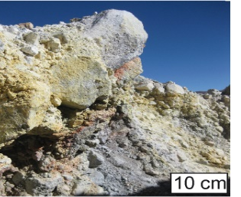
Distal graben structures from the Pichu Pichu volcanic complex in Peru | Graben structures are filled by the mixed matrix overlain by coarse- to medium-grained debris-flow deposits. Hyperconcentrated flow deposits are preserved in backward frontal thrusts  Coarse- to medium-grained debris-flow deposits ==> | 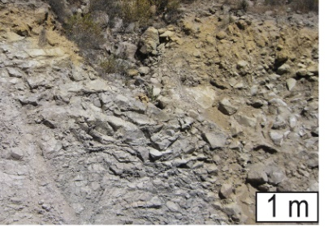
Along the frontal thrust lobe and in upstream diluted tail | Structural gradation of matrix breccias are observed with reverse grading in lithofacies assemblage The matrix transformation into debris flow at the confluence of the distal thrust lobe is associated with the impact wave and frontal surge in downstream areas (Meager in British Columbia). | 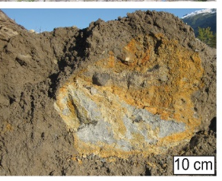
Upper sheared contact of rock-avalanche debris flow | Coating matrix, showing lava clasts with the rim and reverse grading (Meager in British Columbia), changes the initial granular distributions by increasing the clast size and aggregating the finer clayey fraction. The finer grain-size fraction disappears into the coating matrix. The proximal rock avalanche is transformed into a highly mobile debris flow (Bernard 2020). | 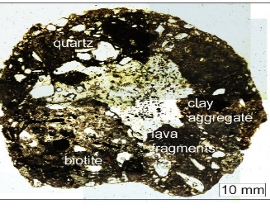

Table 2
Statistical parameters from sieved samples of the 17 VDADs showing seven statistical parameters from published data (Glicken 1986; Siebert et al. 1987; Belousov et al. 1999; Waythomas et al. 2000; Capra 2002; Capra and Macías 2002; Caballero and Capra 2011; Roverato et al. 2014; Bernard et al. 2017; Bustos et al. 2022): 1. Geographical location; 2. Avalanche area (A in km²); 3. Run out distance (L in km); 4. H/L; 5. Median diameter (Md = (Φ₁₆ + Φ₅₀ ₊ Φ₈₄) / 3) in phi unit (Φ); 6. Matrix percent; 7. Sand-sized matrix/gravel ratio; 8. Sorting index (σ= ((Φ₈₄ - Φ₁₆) / 4) + (Φ_{95 –} Φ₅) / 6.6); 9. Skewness (SKG = ((Φ₁₆ + Φ₈₄ - 2Φ₅₀) / 2(Φ_{84 –} Φ₁₆)) + ((Φ5 + Φ95 - 2Φ₅₀) / 2(Φ₉₅ – Φ₅)); 10. Kurtosis (K = (Φ₉₅ - Φ₅) / 2.44(Φ₇₅ - Φ₂₅), Folk and Ward 1957); 11. Reported age (ka) from published data
 |  |  | 1 | 2 | 3 | 4 | 5 | 6 | 7 | 8 | 9 | 10 | 11 | References
 | No. | VDADs | Geographical location | Area (km²) | L  (km) | H/L | Md  (Φ) | Matrix % | Matrix  / gravels | σ | SKG | K | Reported  age (ka) | References
Miocen | 1 | Chimpa | 24°01'33.1''N  66°06'18.04''W | 10 |  | 0,09 | -2,04 | 49,32 | 0,75 | 2,84 | 0,09 | 0,85 | 12-7 Ma | Bustos et al. 2022
Pleistocen | 2 | Azufral | 1°05'10''N  77°43'08''W | 56,01 | 13 | 0,11 | -0,27 | 60,5 | 1,54 | 2,12 | -0,17 | 0,86 | -18 | Moreno et al. 2021
Pleistocen | 3 | Misti | 16°17'38''S  71°24'32''W | - | 25 | 0,7 | -0,83 | 54,67 | 1,19 | 1,85 | 0,29 | 0,756 | -11.2 | Bernard et al. 2017
Pleistocen | 4 | Chimborazo | 1°27'50''S  78°48'54''W | 150 | 35 | 0,1 | -2,34 | 70,31 | 6,01 | 3,38 | 0,1 | 1,01 | -50 | Bernard et al. 2008
Pleistocen | 5 | Nevado de Toluca | 19°06'30''N  99°45'30''W | 22 | 55 | 0,05 | -2,68 | 34,89 | 0,53 | 3,31 | 0,18 | 0,94 | -28 | Caballero and Capra 2011
Pleistocen | 6 | Taranaki | 39°17'47''S  174°03'50''E | 200-250 | >30 | 0,07 | -2,47 | 43,05 | 0,75 | 2,98 | 0,13 | 1,02 | -25 | Roverato et al. 2014
Pleistocen | 7 | Colima | 19°30'45''N  103°37'06''W | 1200 | 43 | 0,09 | 0,46 | 53,38 | 1,14 | 5,2 | 0,26 | 0,78 | -18.52 | Roverato et al. 2011
Holocene  (Meghalayen) | 8 | Antuco | 37°24'40''S  72°21'12''W | 200 | 25 | 0,1 | 4,5 | 44,58 | 0,8 | 5,5 | 0 | 1,89 | -7.1 | Romero et al. 2022
Holocene  (Meghalayen) | 9 | Nevada de Colima | 19°33'48''N  103°36'30''W | 2200 | 120 | 0,04 | -0,5 | 48,33 | 0,94 | 4,71 | 0,32 | 0,83 | -4.3 | Capra and Macias 2002
Holocene  (Meghalayen) | 10 | Illiamna | 60°01'55''N  153°05'29''W | 20 | 5,5 | 0,27 | -1,17 | 46,16 | 0,857 | 2,6 | 0,18 | - | -2 | Waythomas et al. 2000
Holocene  (Meghalayen) | 11 | Shiveluch | 59°39'12''N  161°21'42''E | 196 | 35 | 0,02 | -0,1 | 59,8 | 2,34 | 1,48 | 3,1 | - | -0.6 | Belousov et al. 1999
Holocene  (Meghalayen) | 12 | Tutupaca | 17°01'30''S  70°21'29''W | 12 | 7 | 0,17-0,23 | -3,02 | 25,2 | 0,34 | 2,5 | 0,35 | 0,96 | -0.218 | Bernard et al. 2022
Holocene  (Meghalayen) | 13 | Illiamna | 60°01'55''N  153°05'29''W | 7,4 | 5,5 | 0,3 | -0,85 | 51,33 | 1,054 | 2,22 | 0,203 | - | -0.1 | Waythomas et al. 2000
Holocene  (Meghalayen) | 14 | Shiveluch | 59°39'12''N  161°21'42''E | 98 | 35 | 0,07-0,17 | 0,97 | 70,1 | 2,34 | 2,77 | 2,99 | - | 1964 | Belousov et al. 1999
Holocene  (Meghalayen) | 15 | Illiamna | 60°01'55''N  153°05'29''W | 1,5 11 | 5,5 | 0,24-0,29 | -1,25 | 40 | 0,92 | 2,72 | 0,268 | - | 1964 | Waythomas et al. 2000
Holocene  (Meghalayen) | 16 | Mount St- Helens | 46°11'29''N  122°11'44''E | 64 | 25 | 0,11 | -0,6 | 54,43 | 1,21 | 3,43 | 0,12 | 0,96 | 1980 | Glicken 1986
Holocene  (Meghalayen) | 17 | Meager | 50°40'N  123°31'W | 16,6 | 12 | 0,17 | -1,36 | 40,89 | 0,89 | 1,45 | -0,16 | 0,9 | 2010 | Bernard 2020
Mean |  |  | - | 282,06 |  | 0,16 | -1,18 | 50,49 | 1,48 | 2,87 | 0,61 | 0,91 | -

Table 3
Synthesis of sedimentological parameters related to spatio-temporal distributions and the morphological parameters of the volcanic complex and the associated avalanche deposits (Figs. 10-15)
 | Regressions for the calculated parameters related to the collapsed volcanic edifices
 | Spatial distribution | Time | Elevation | Flank slope gradient | Profil shape | Volcanic area
Matrix % | 10. f(x) = -19ln(x) + 240.9  11. f(x) = 49ln(x) – 144.4  12. f(x) = 1.5x – 102.9  13. f(x) = 2.2x – 220.2 | 14. f(x) = 15288.1ln(x) - 62631  15. f(x) = 19848ln(x) – 98768 | 16. f(x) = 18x + 4632.3  17. f(x) = 844ln(x) – 233 | 29. f(x) = 3.4x^{0,4} | 30. f(x) = -1.6ln(x) + 6 | 31. f(x) = 0x^{5.34}
Median  Matrix/  gravels | 19. f(x) = 0.02x – 1.8  21. f(x) = -0.016x - 3.7  22. f(x) = 0.026x – 3.5  18. f(x) = 0.01x + 1.1  20. f(x) = 0.3 * 0.9^{x} | 24. f(x) = 0x – 0.96  25. f(x) = 0x - 3.12  23. f(x) = 0.77 * 1^{x} | 27. f(x) = -4.3ln(x) + 35.9  28. f(x) = 9.5ln(x) – 77.3  26. f(x) = 0.001x – 2.83 | 34. f(x) = 0.1x - 3.8  33. f(x) = 0.03x^{1.14} | 35. f(x) = -0.8ln(x) – 2  32. f(x) = 1.5 * 0.5^{x} | 37. f(x) = 0.42ln(x) – 3  36. f(x) = 0.39x^{0.18}
Sorting  Skewness  Kurtosis | 38. f(x) = 2.7 * 0.9^{x}  41.f(x) = 0.6 * 0.9^{x}  42. f(x) = 0.03x - 2.9  40. f(x) = 0.09 * 1.05^{x}  44. f(x) = 0.01x + 1.16  39. f(x) = 1.03 * 0.9^{x}  43. f(x) = 0.9 * 1.001^{x} | 45. f(x) = 2.18 * 1x  47.f(x) = -121.29ln(x) + 921.9  46. f(x) = 0x + 0.89 | 48. f(x) = 0.001x – 1.71  50. f(x) = 0x – 0.2  49. f(x) = 0.71 * 1^{x} | 51. f(x) = -0.05x + 3  52. f(x) = -2ln(x)+ 8  53. f(x) =-0.1ln(x)+1 | 54. f(x) = 3.1x^{0.23}  56. f(x)=-0.6ln(x)+ 0.05  55. f(x) = 0.8x^{-0.07} | 57. f(x) = 1.6x^{0.07}  58. f(x) = 0.4ln(x) – 1.5  59. f(x) = 0x + 0.85
Results | Correlation between spatial distribution with sedimentological parameters | Correlation between time and elevation with sedimentological parameters related to Quaternary erosion |  | Correlation between sedimentological parameters related to Quaternary morphological parameters of the collapsed edifices

