Influence of Lipid Profiles on Type 2 Diabetes Risk in Nigerian Patients
Supplementary Figures
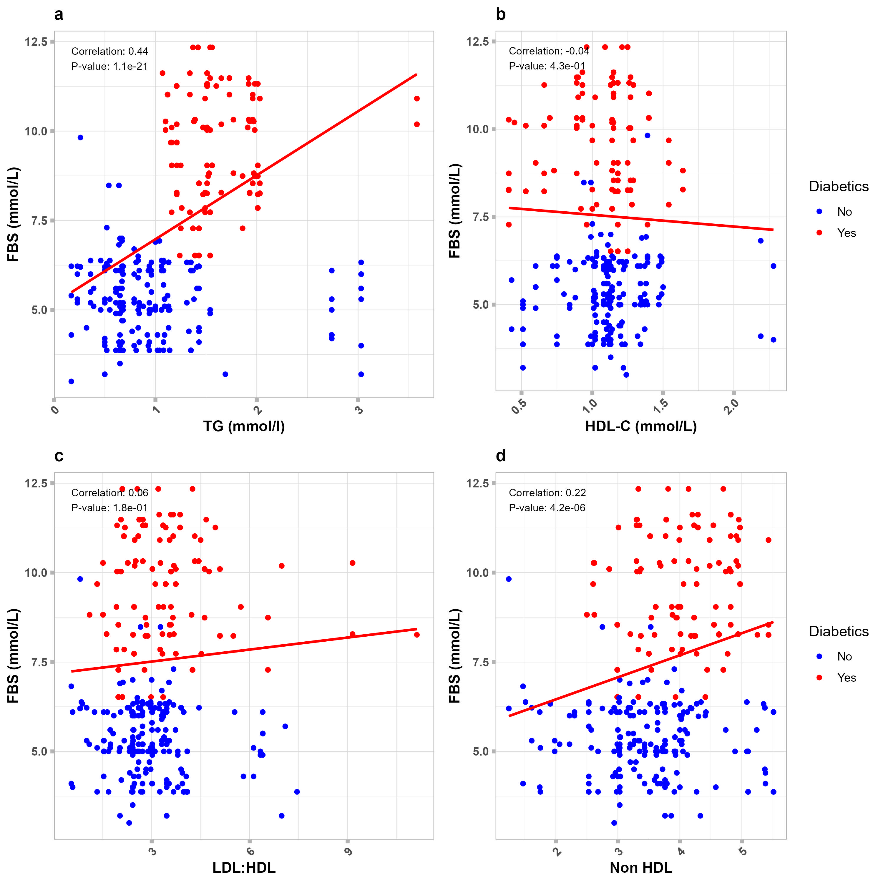
Fig.1a. Showing the correlation between type-2 diabetes as measured by FBS and some lipids at the optimum level of LDL-c

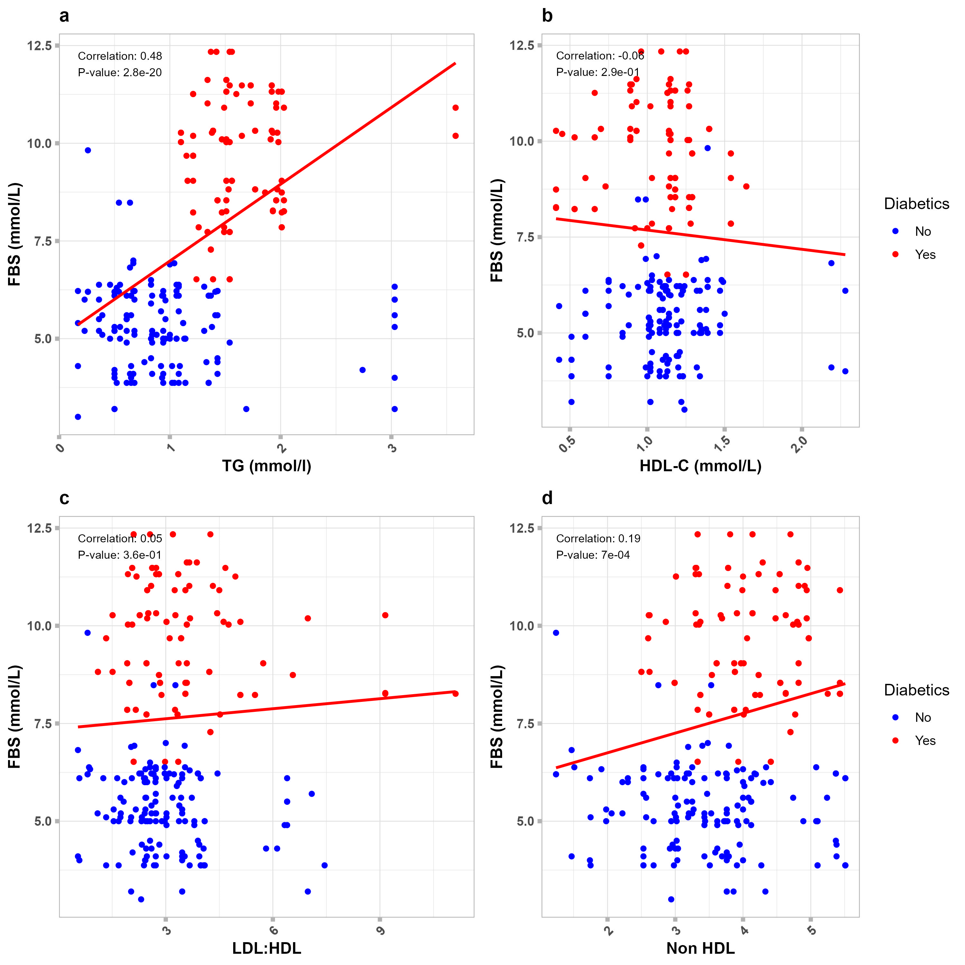
Fig.1b. Showing the correlation between type-2 diabetes (in Female Patients) as measured by FBS and some lipids at the optimum level of LDL-c

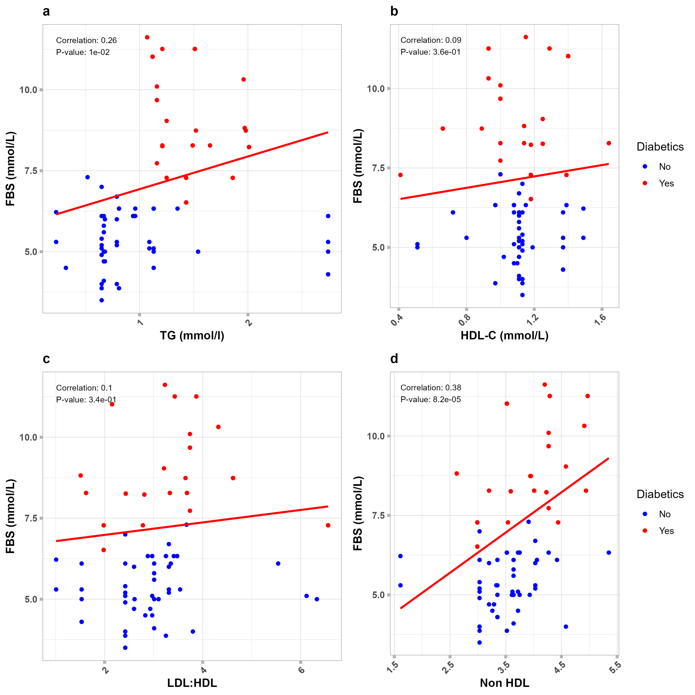
Fig.1c. Showing the correlation between type-2 diabetes (in Male Patients) as measured by FBS and some lipids at the optimum level of LDL-c

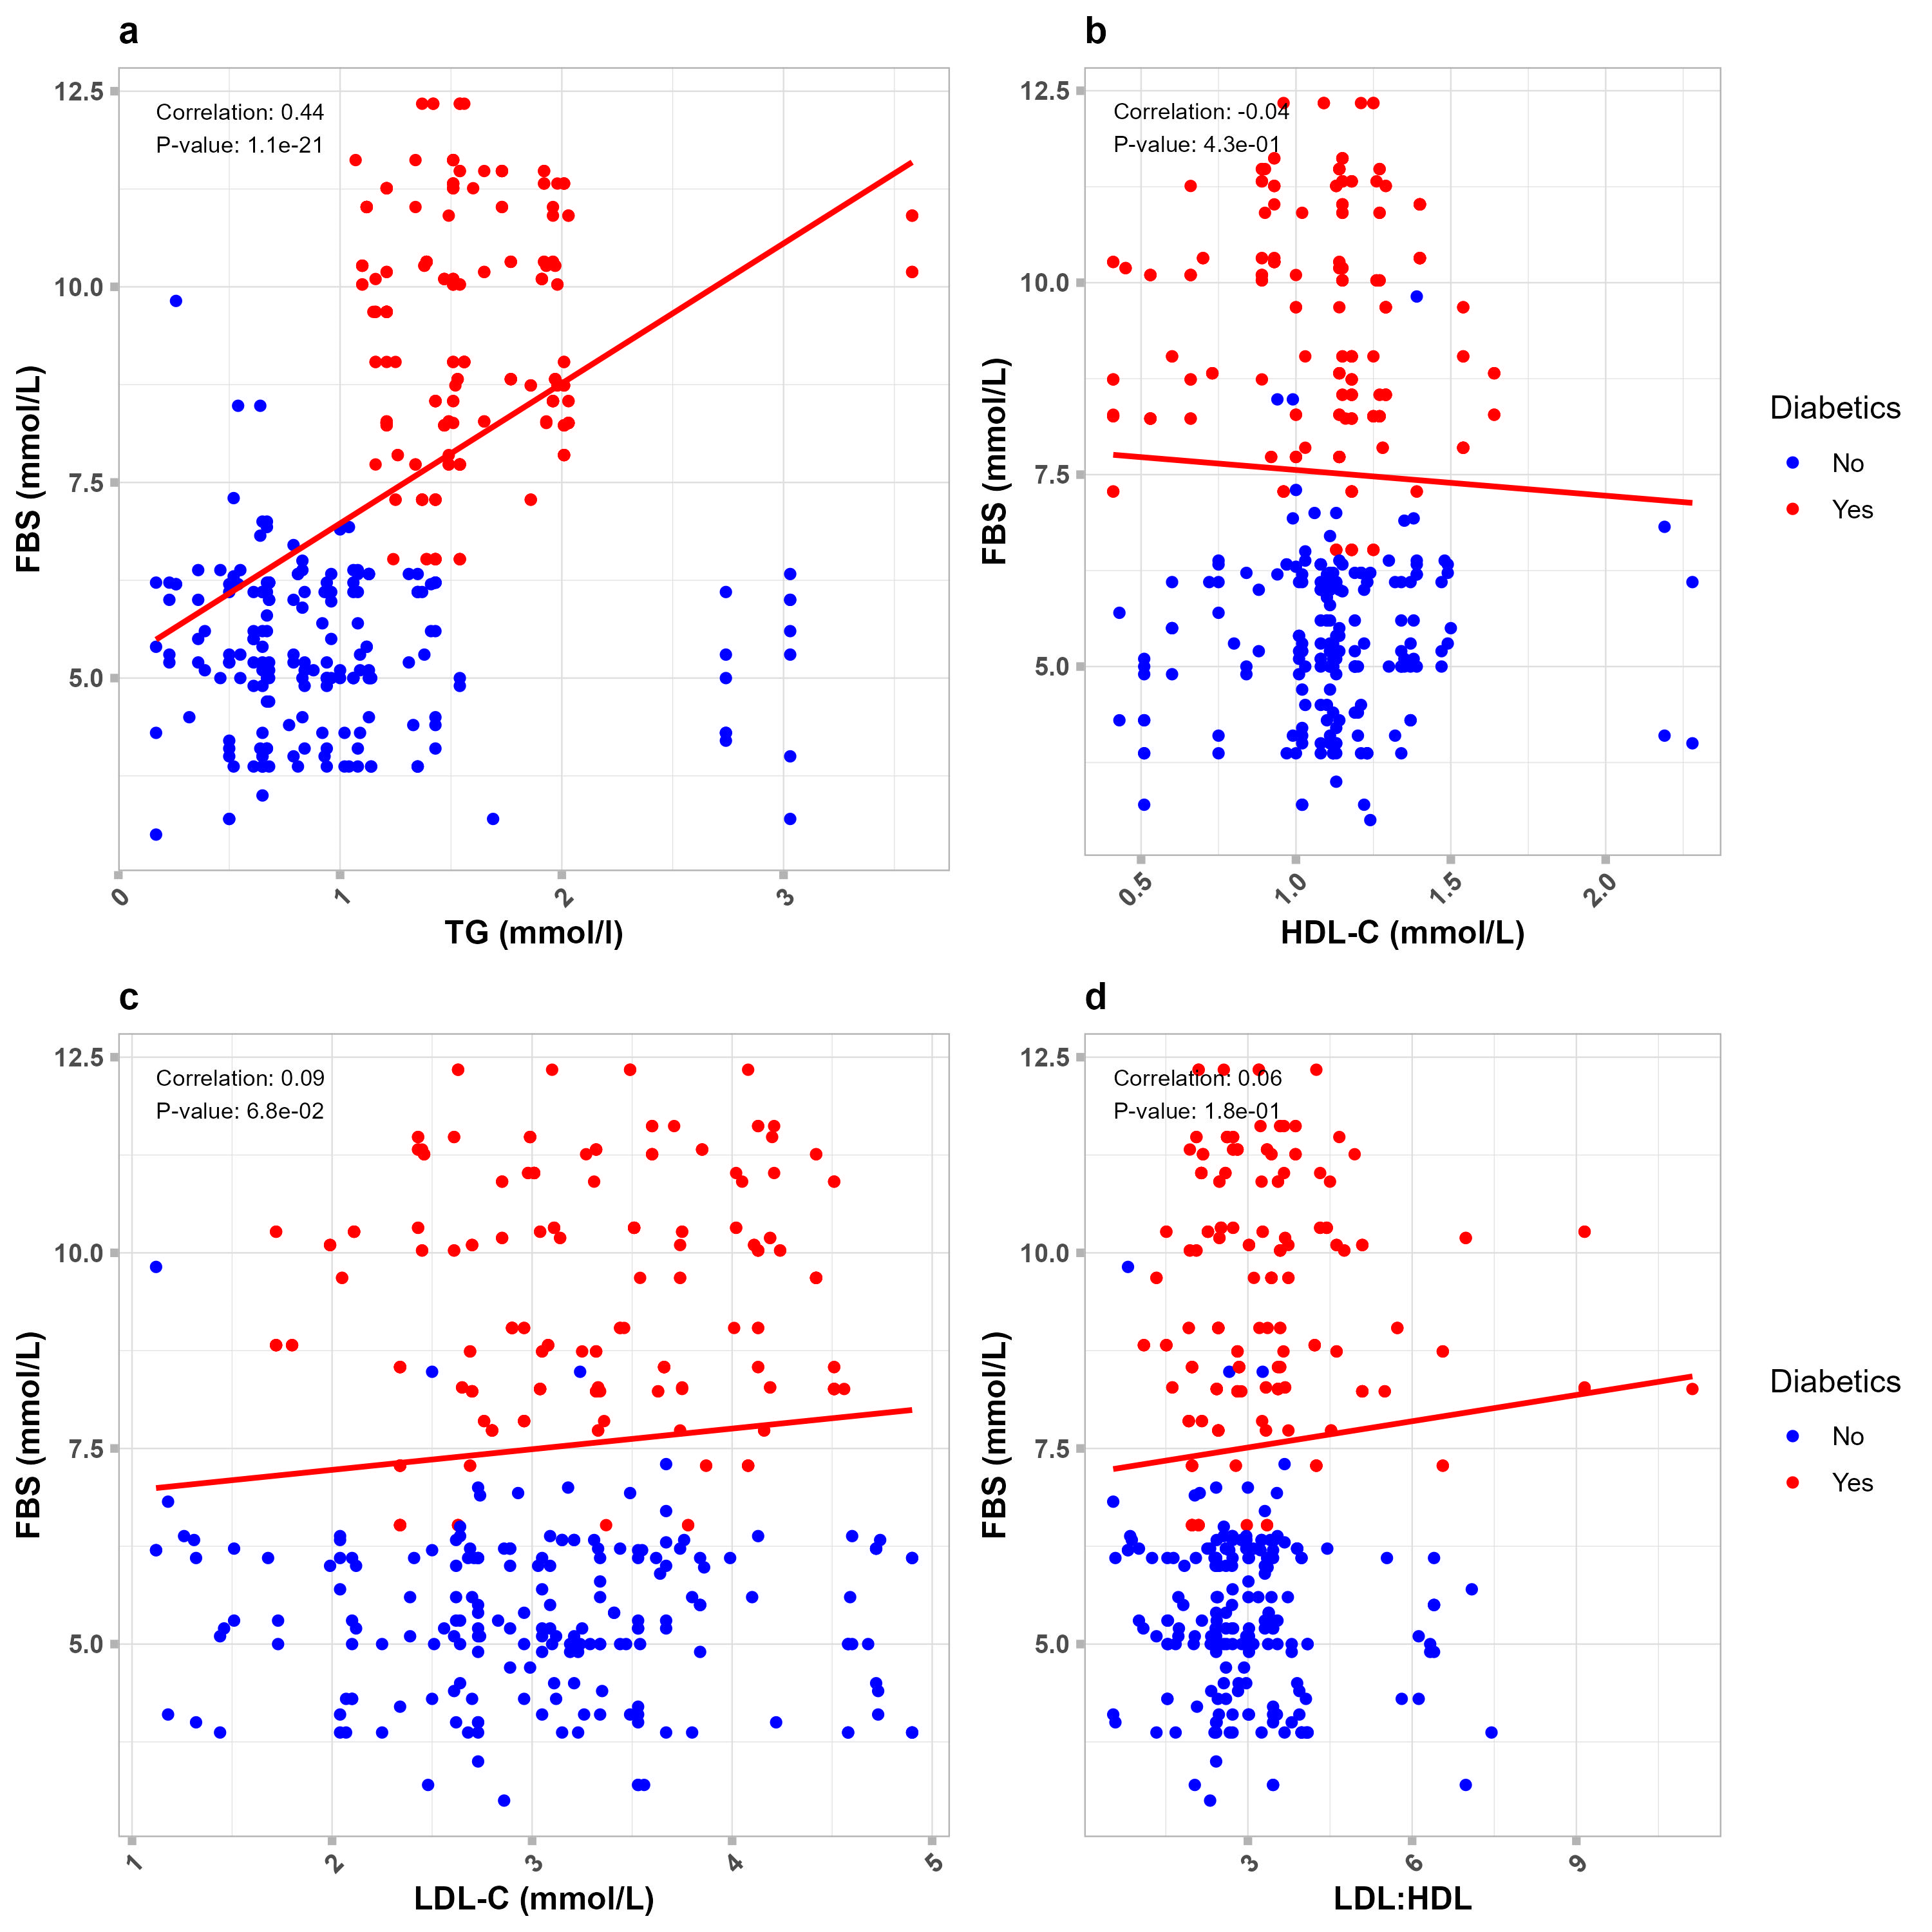
Fig.2a. Showing the correlation between type-2 diabetes as measured by FBS and some lipids at the optimum level of Non-HDL-c

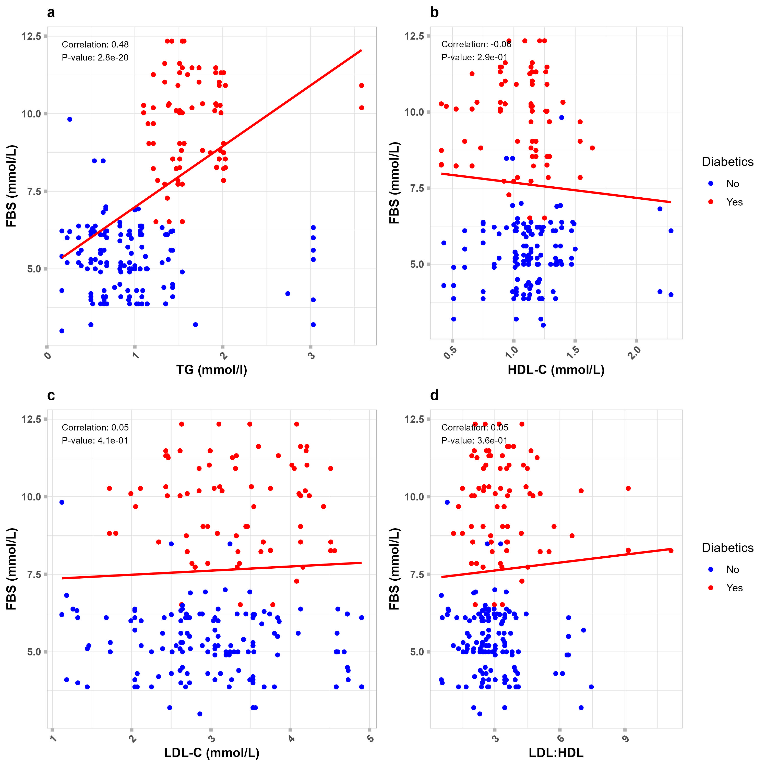

Fig.2b. Showing the correlation between type 2 diabetes (in Female Patients) as measured by FBS and some lipids at the optimum level of Non-HDL-c

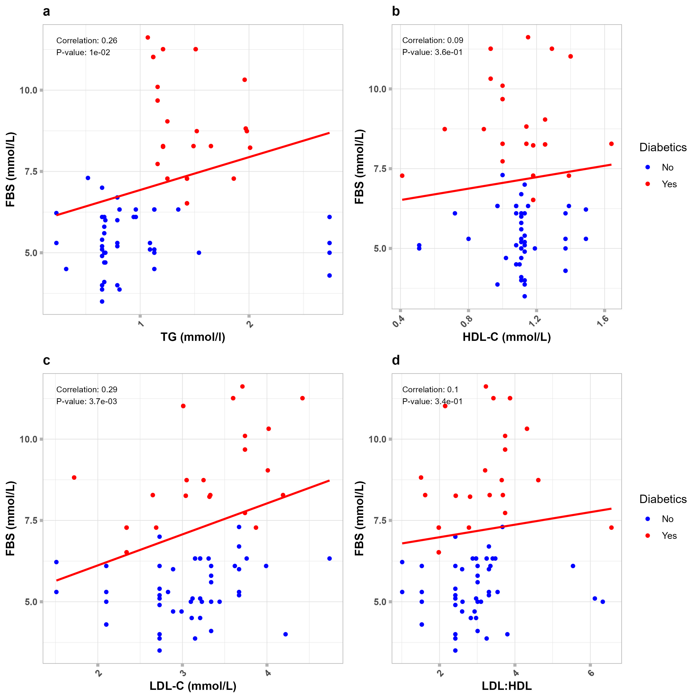
Fig.2c. Showing the correlation between type 2 diabetes (in Male Patients) as measured by FBS and some lipids at the optimum level of Non-HDL-c

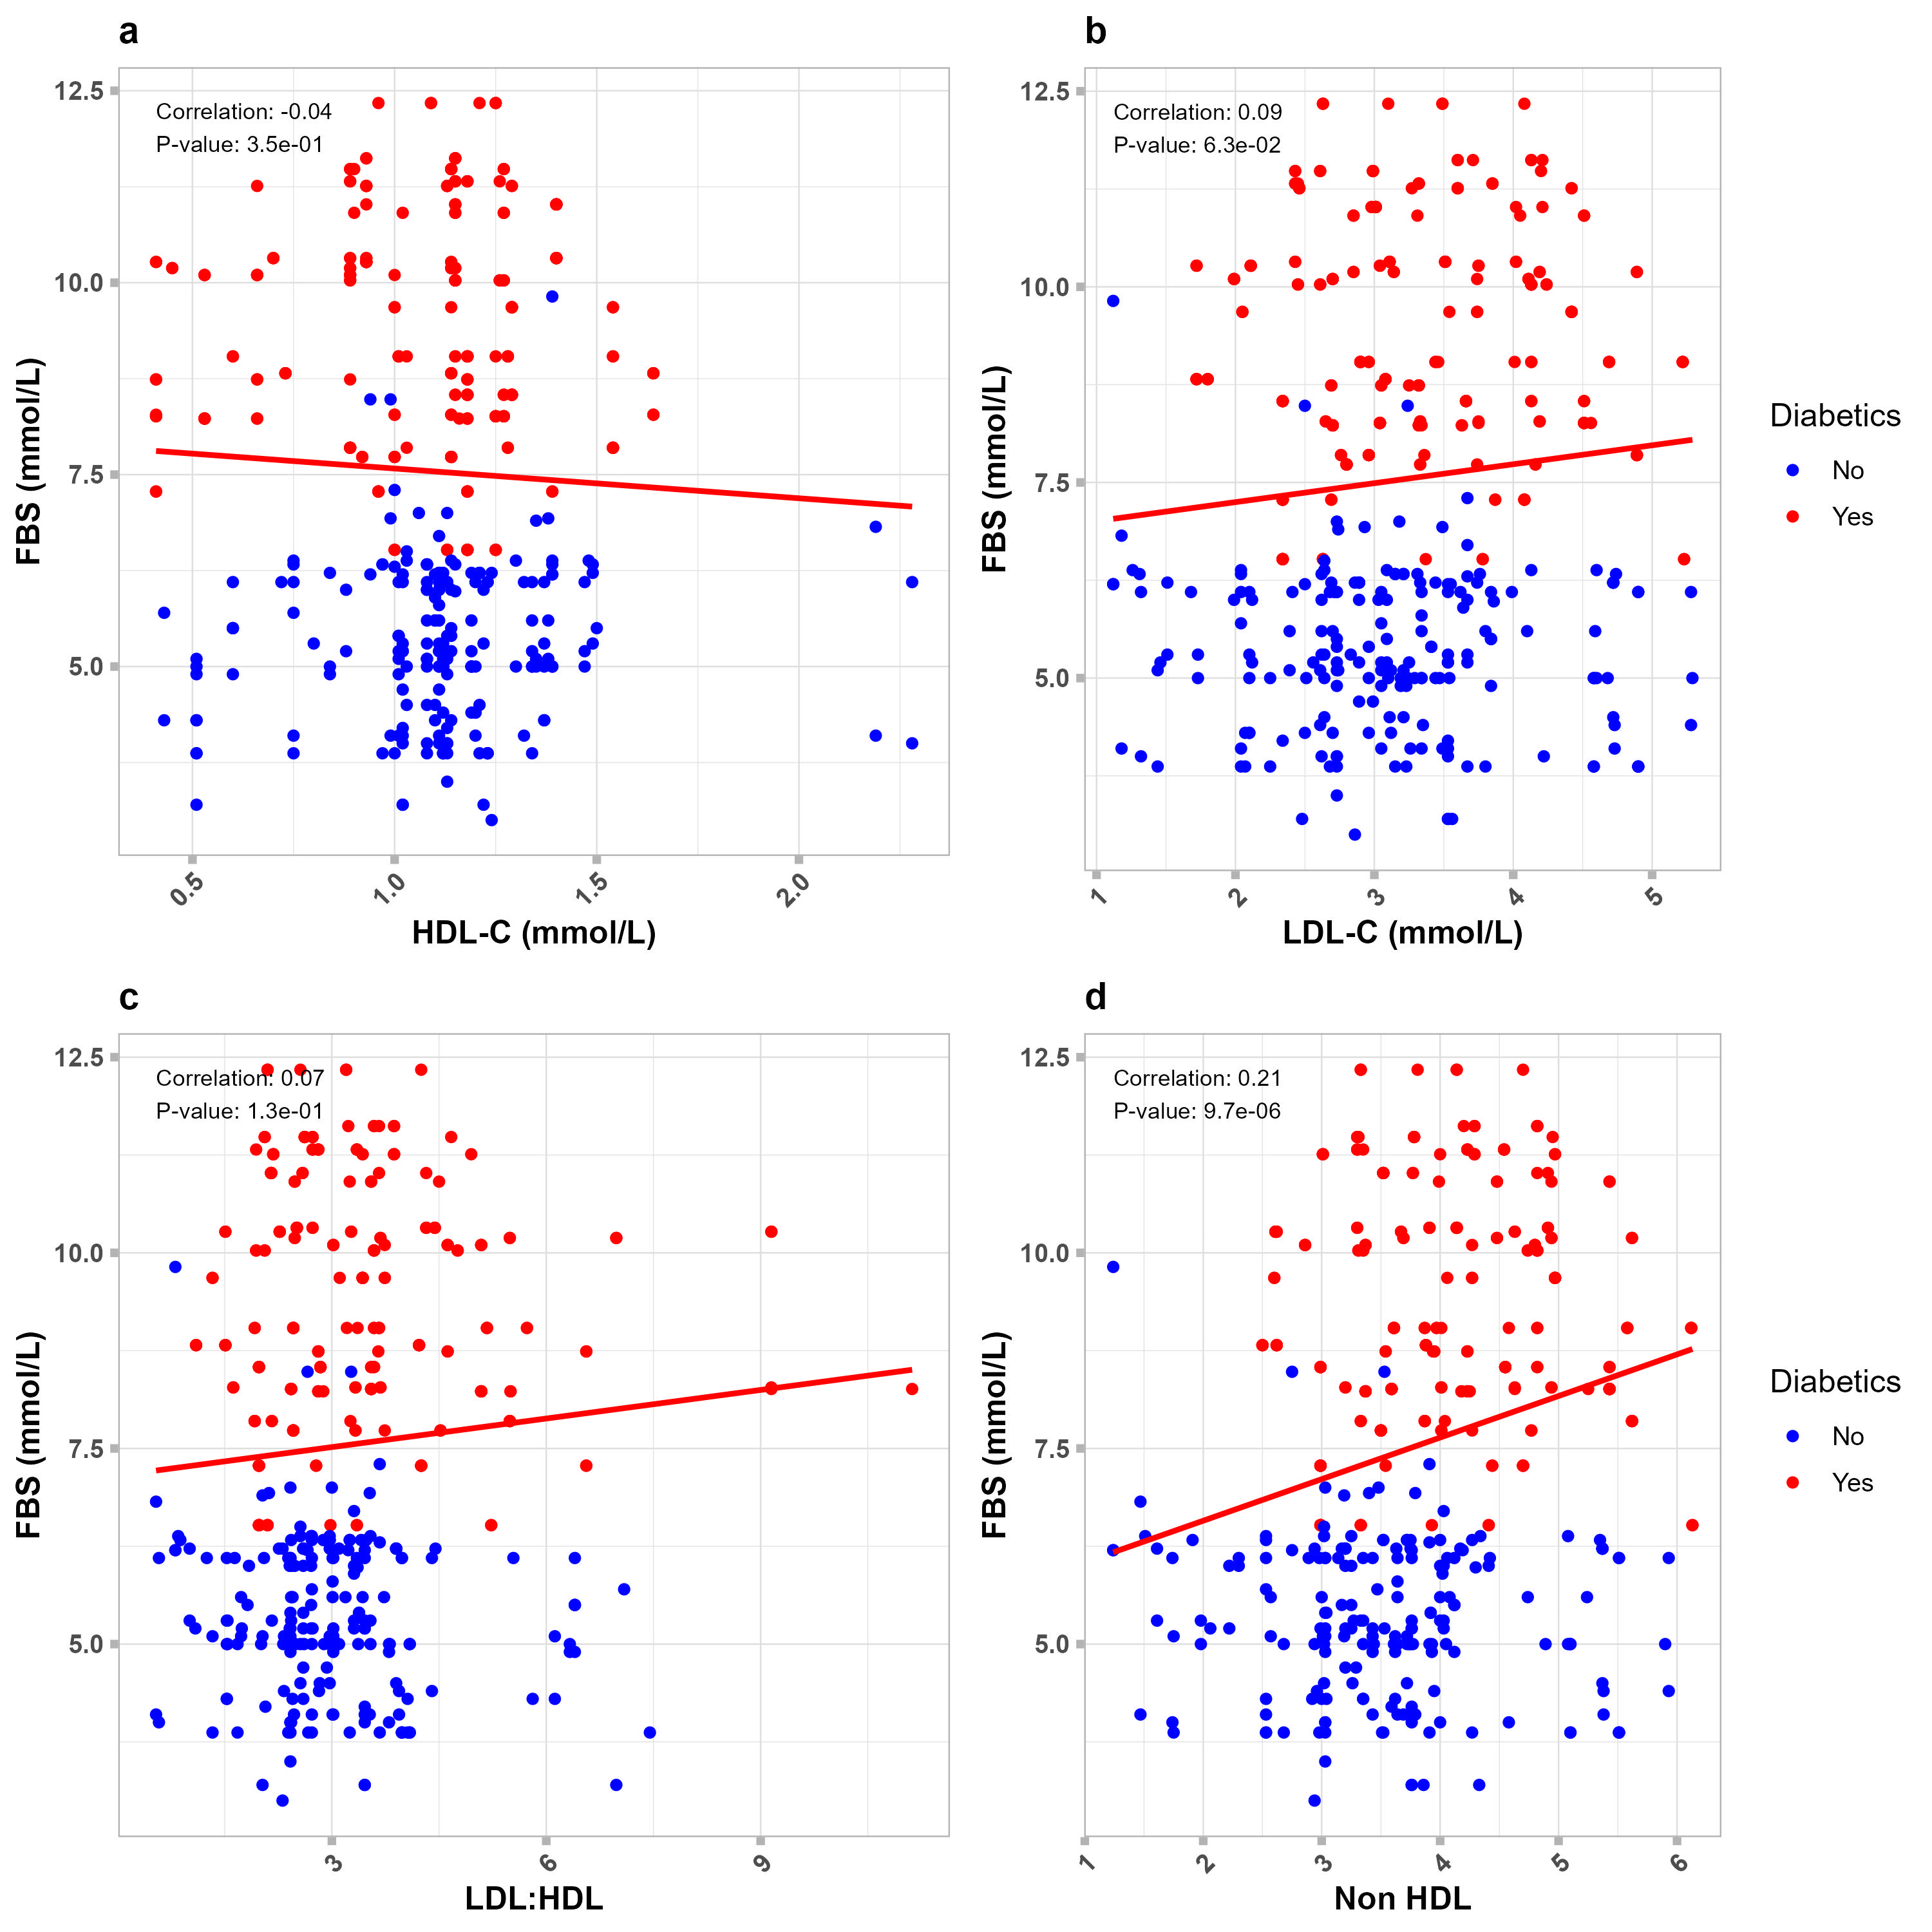
Fig.3a. Showing the correlation between type-2 diabetes as measured by FBS and some lipids at the optimum level of TG

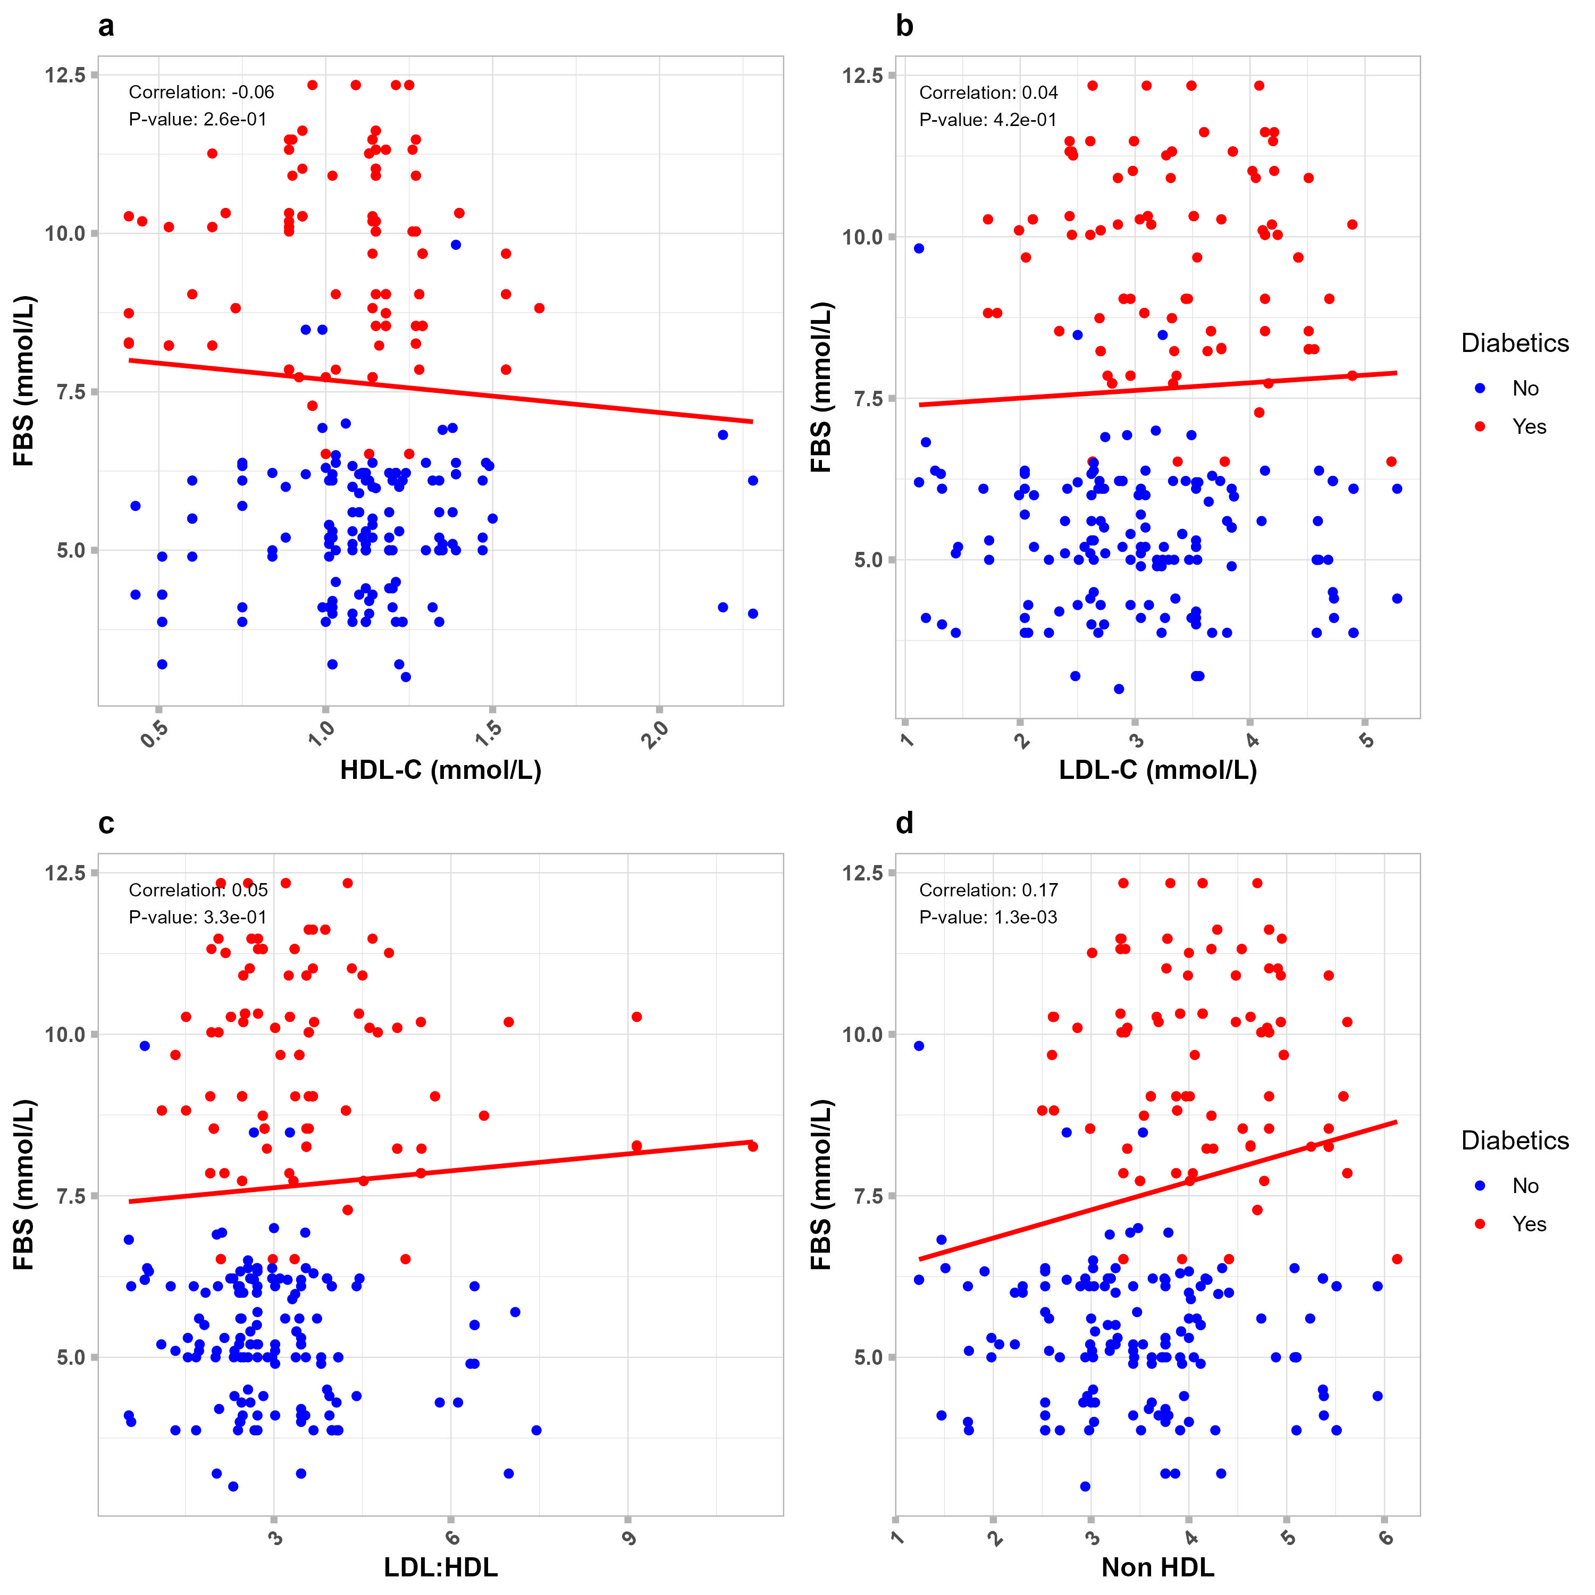
Fig.3b. Showing the correlation between type 2 diabetes (in Female Patients) as measured by FBS and some lipids at the optimum level of TG

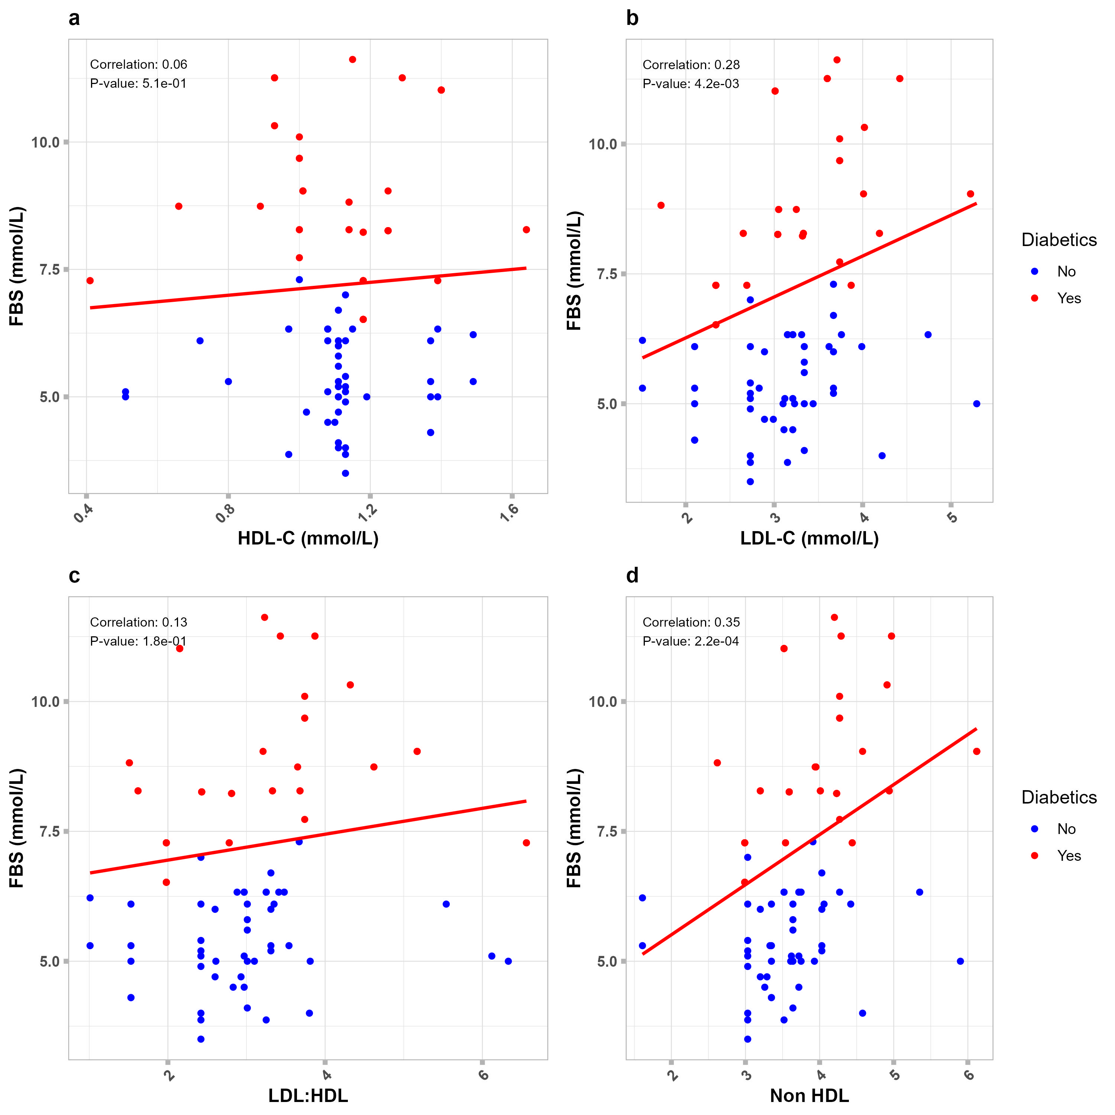
Fig.3c. Showing the correlation between type 2 diabetes (in Male Patients) as measured by FBS and some lipids at the optimum level of TG

