WNT3 promotes chemoresistance to oxaliplatin in oral squamous cell carcinoma via regulating ABCG2 expression

Supplementary figures
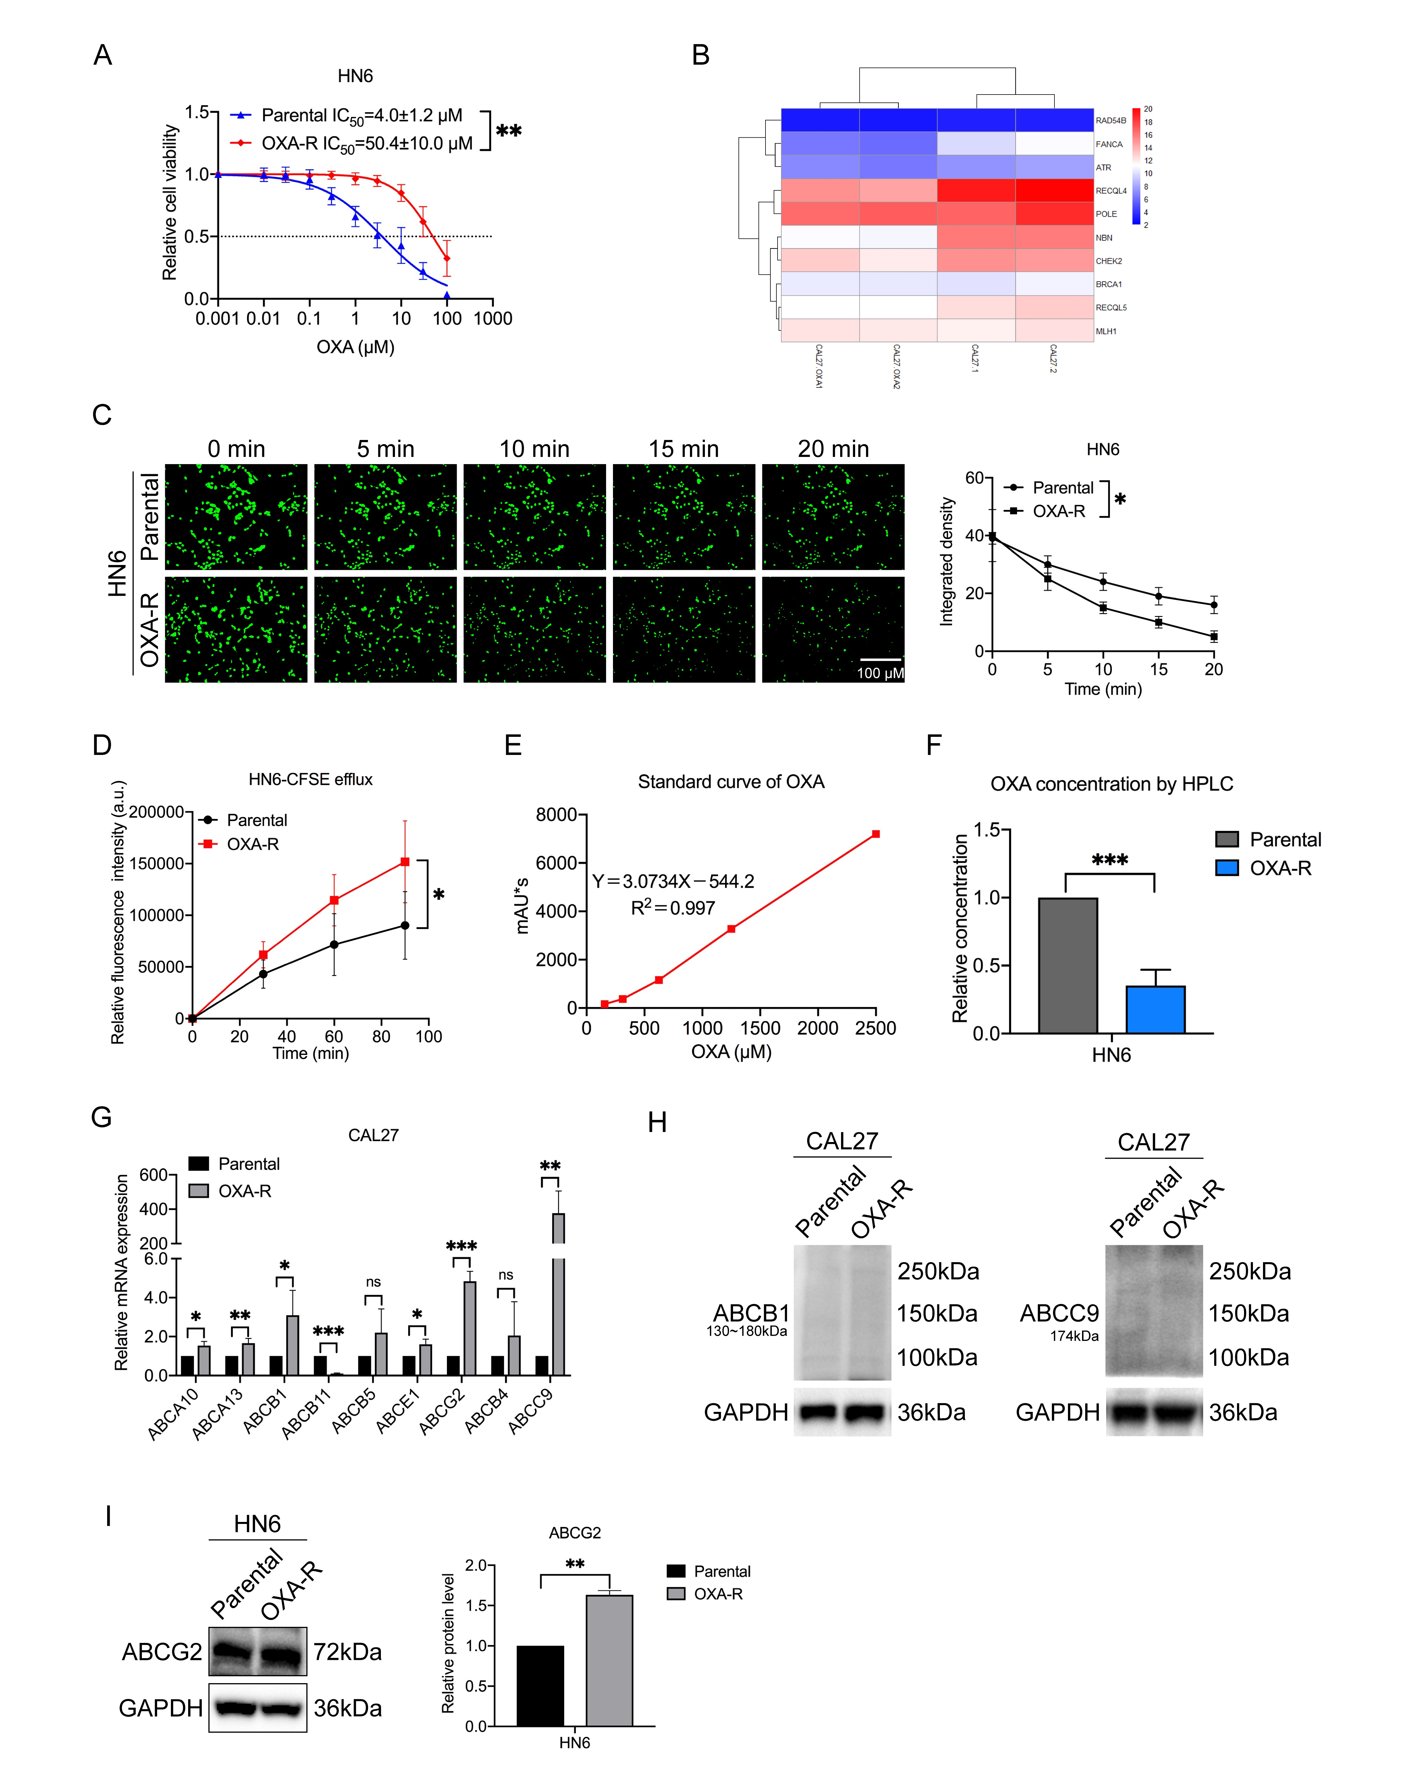
Fig. S 1 Enhanced efflux capacity in HN6 oxaliplatin-resistant (OXA-R) cells and the upregulation of the ABCG2 transporter. (A) The cell viabilities and IC₅₀ of oxaliplatin were compared between HN6 parental and OXA-R cells using the CCK-8 assay. (B) A heatmap analysis indicated no significant changes in genes related to DNA damage repair between the resistant and parental cells. (C) Fluorescence microscopy revealed a faster decay in the fluorescence of CFSE in OXA-R cells compared to parental cells within the same time frame (100×). (D) Flow cytometry demonstrated a significant increase in the fluorescence output of OXA-R cells of OSCC. (E) The oxaliplatin concentration versus peak area curve. (F) The HPLC analysis revealed a lower relative concentration of oxaliplatin in HN6/OXA cells compared to parental cells. (G) The expression of ABC transporters in CAL27/OXA and CAL27 cells were analyzed using RT-qPCR. (H) The protein expression of ABCB1 and ABCC9 in CAL27/OXA and CAL27 cells were analyzed using western blotting. (I) The protein expression of ABCG2 in HN6/OXA and HN6 cells was analyzed using western blotting. Data shown as mean ± SD (n = 3). Statistical significance was denoted as follows: *, P< 0.05; **, P< 0.01; and ***, P< 0.001.
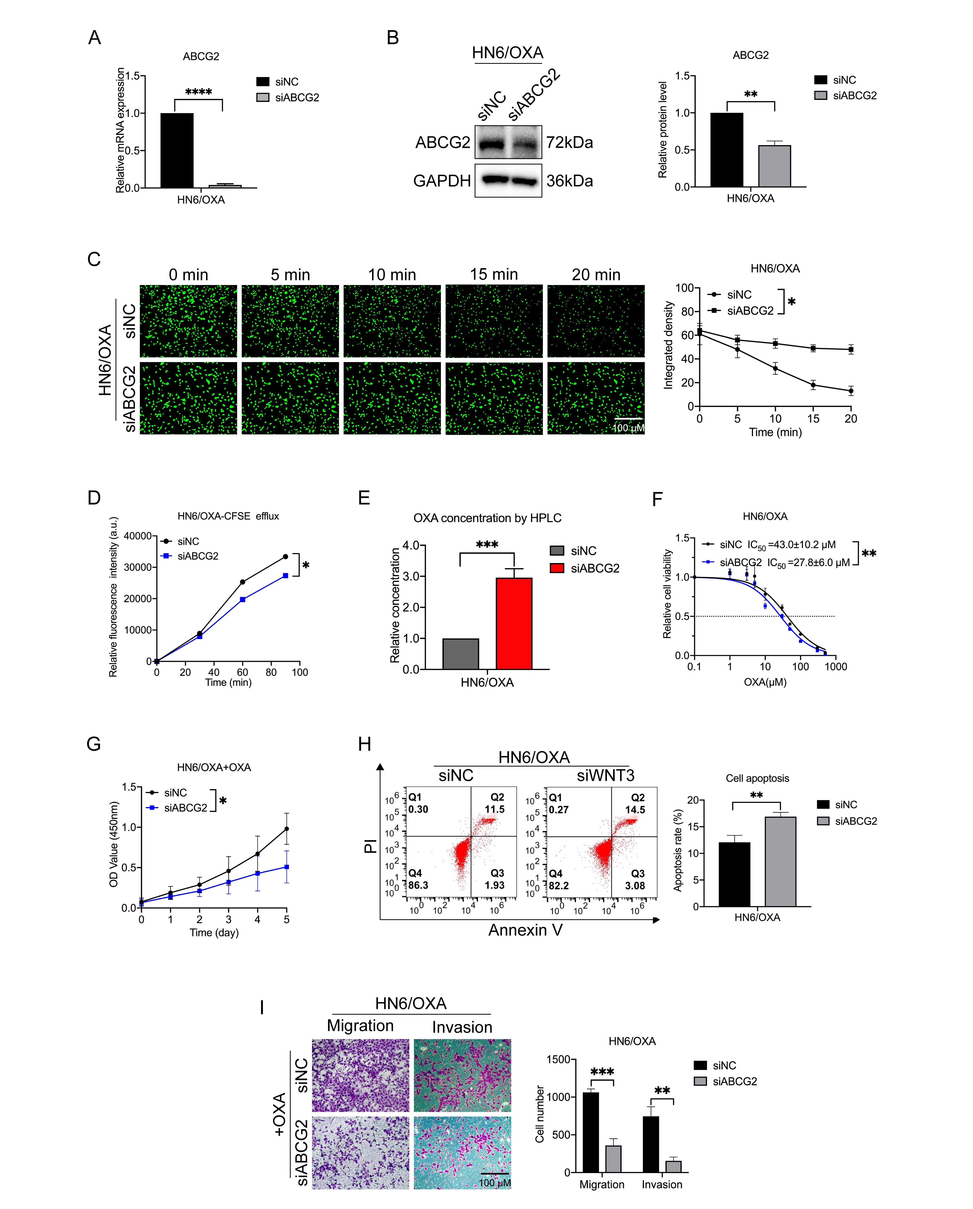
Fig. S 2 ABCG2 knockdown reduced the efflux of oxaliplatin and chemoresistance in HN6/OXA cells. (A-B) RT-qPCR (A) and western blotting (B) analyses confirmed the efficacy of ABCG2 knockdown using siRNA interference. (C) The CFSE fluorescence efflux assay demonstrated a decreased efflux ability in HN6/OXA cells after transfection with siABCG2. (D) Flow cytometry showed a reduction in the fluorescence output of CFSE after ABCG2 knockdown in HN6/OXA cells. (E) HPLC analysis revealed an increased relative oxaliplatin content after ABCG2 knockdown in HN6/OXA cells. (F) The CCK-8 assay indicated a decreased IC₅₀ of oxaliplatin in HN6/OXA cells following ABCG2 knockdown. (G-H) Proliferation (G) and anti-apoptotic effects (H) were inhibited in HN6/OXA cells under oxaliplatin exposure after transfection with siABCG2. (I) Diminished migration and invasion (100×) were observed in HN6/OXA cells under oxaliplatin exposure after ABCG2 knockdown. Data shown as mean ± SD (n = 3). Statistical significance was denoted as follows: *, P< 0.05; **, P< 0.01; ***, P< 0.001; and ****, P< 0.0001.
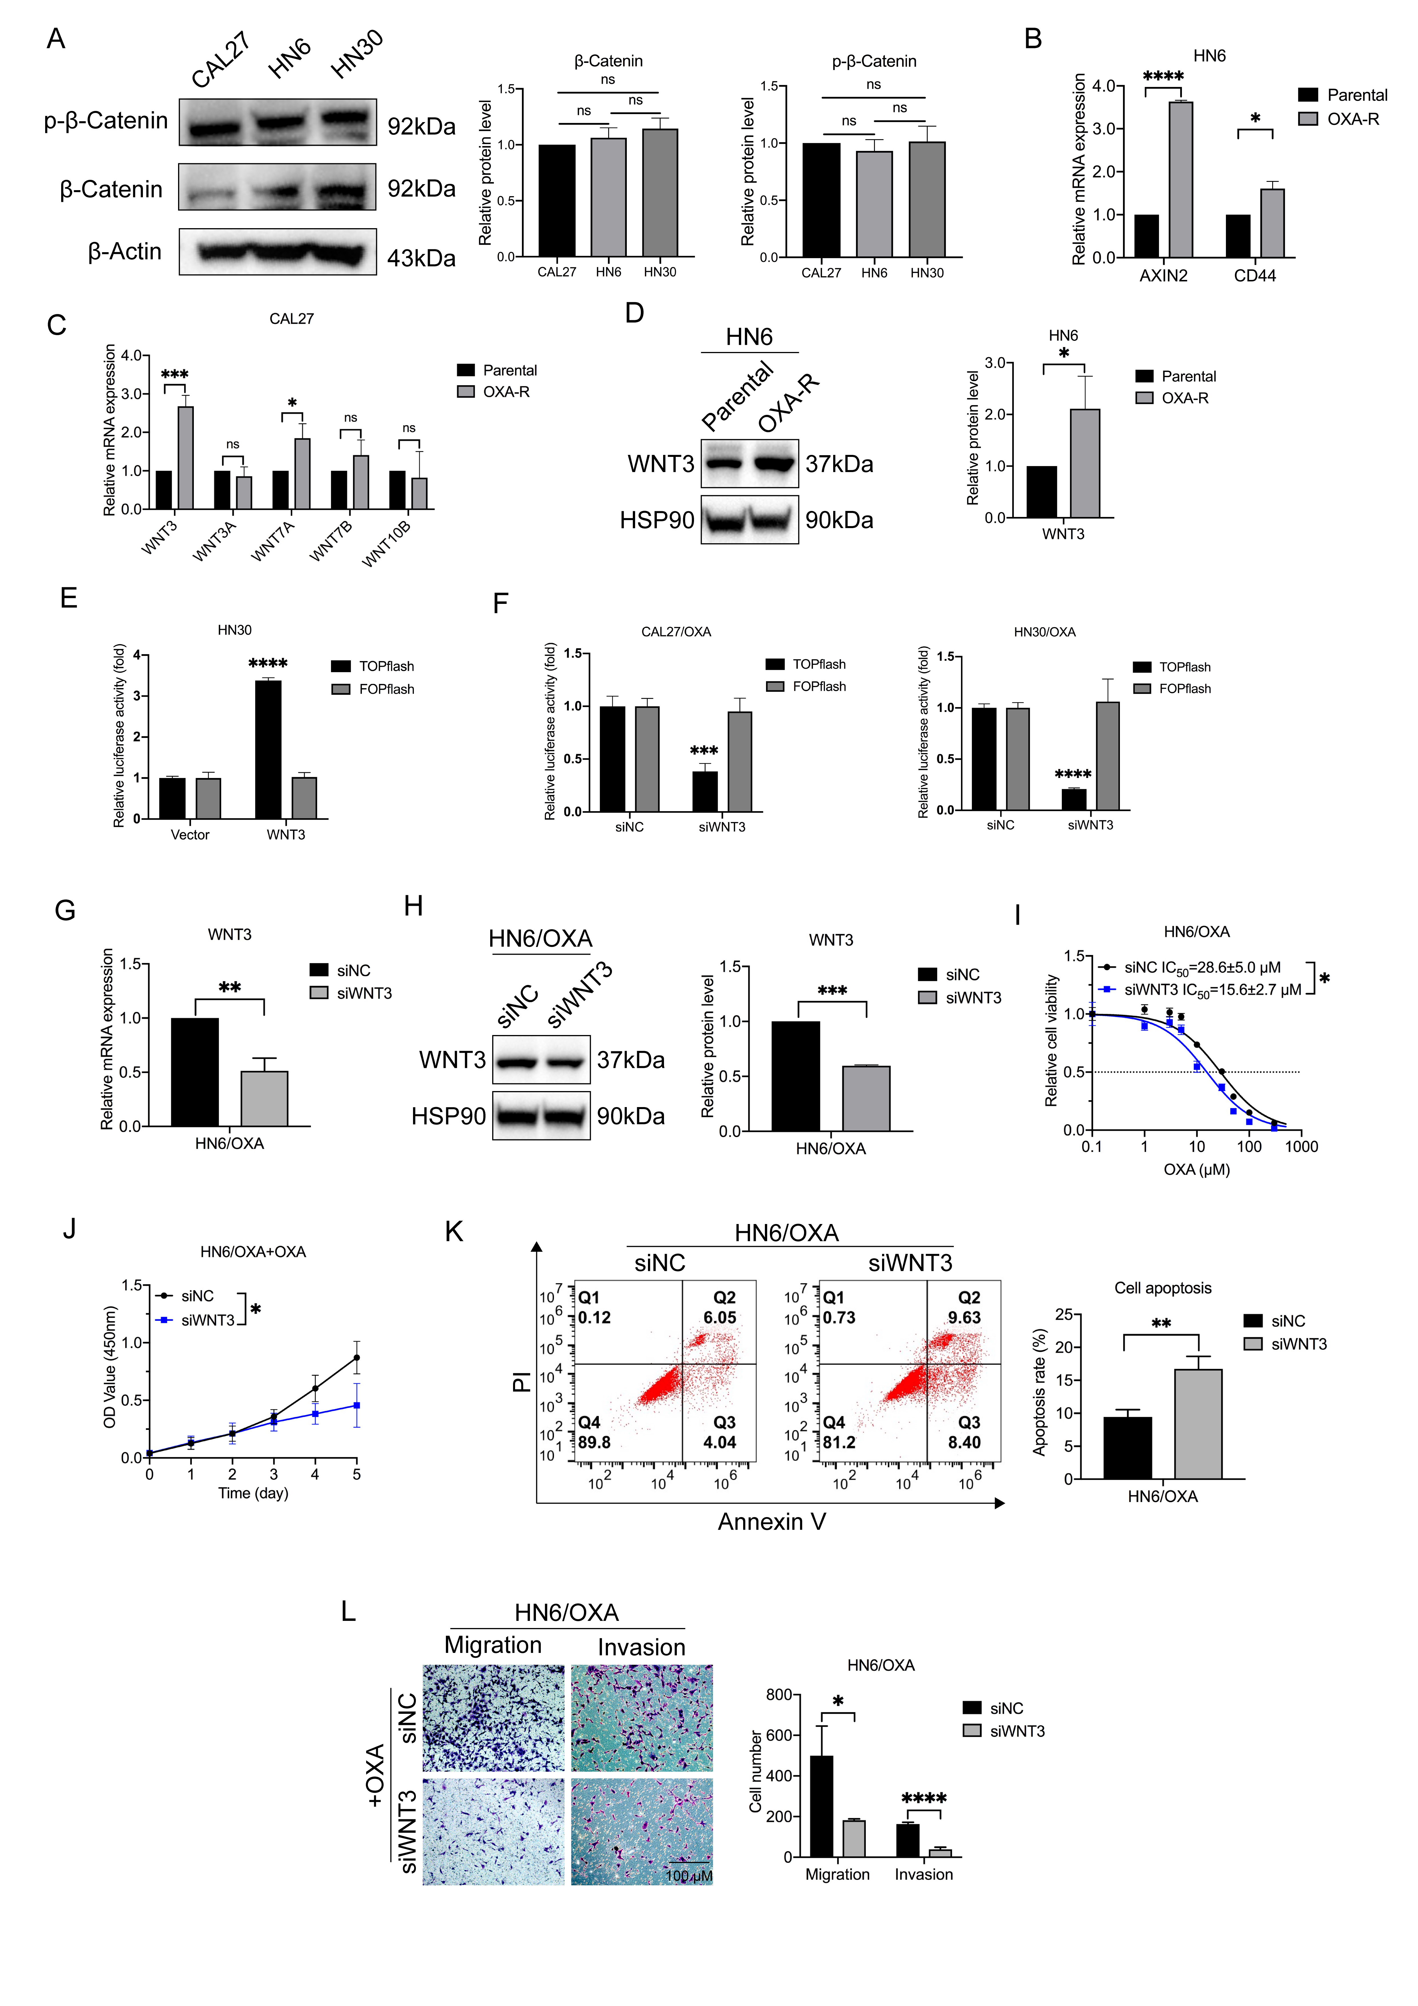
Fig. S 3 Knockdown of WNT3 inhibited chemoresistance in HN6/OXA cells. (A) Western blotting analyses were used to assess the basal β-catenin in the different cell lines. (B) The expression of WNT target genes were analyzed using RT-qPCR. (C) The expression of WNT ligands in CAL27/OXA and CAL27 cells were analyzed using RT-qPCR. (D) Western blotting analyses were conducted to assess the protein levels of WNT3. (E) Enhanced TOP/FOP activity was observed in the TOP/FOP luciferase reporter assay after WNT3 overexpression in HN30. (F) Knocking down WNT3 in drug-resistant cells resulted in reduced TOP/FOP luciferase activity. (G-H) RT-qPCR (G) and western blotting (H) analyses confirmed the effectiveness of WNT3 knockdown using siRNA interference. (I) Following WNT3 knockdown, there was a decreased IC₅₀ of oxaliplatin in HN6/OXA cells as shown by the CCK8 assay. (J-K) Proliferation (J) and anti-apoptotic effects (K) were inhibited under oxaliplatin exposure in HN6/OXA cells after transfection with siWNT3. (L) Diminished migration and invasion were observed in HN6/OXA cells under oxaliplatin exposure after WNT3 knockdown. Data shown as mean ± SD (n = 3). Statistical significance was denoted as follows: *, P< 0.05; **, P< 0.01; ***, P< 0.001; and ****, P< 0.0001.
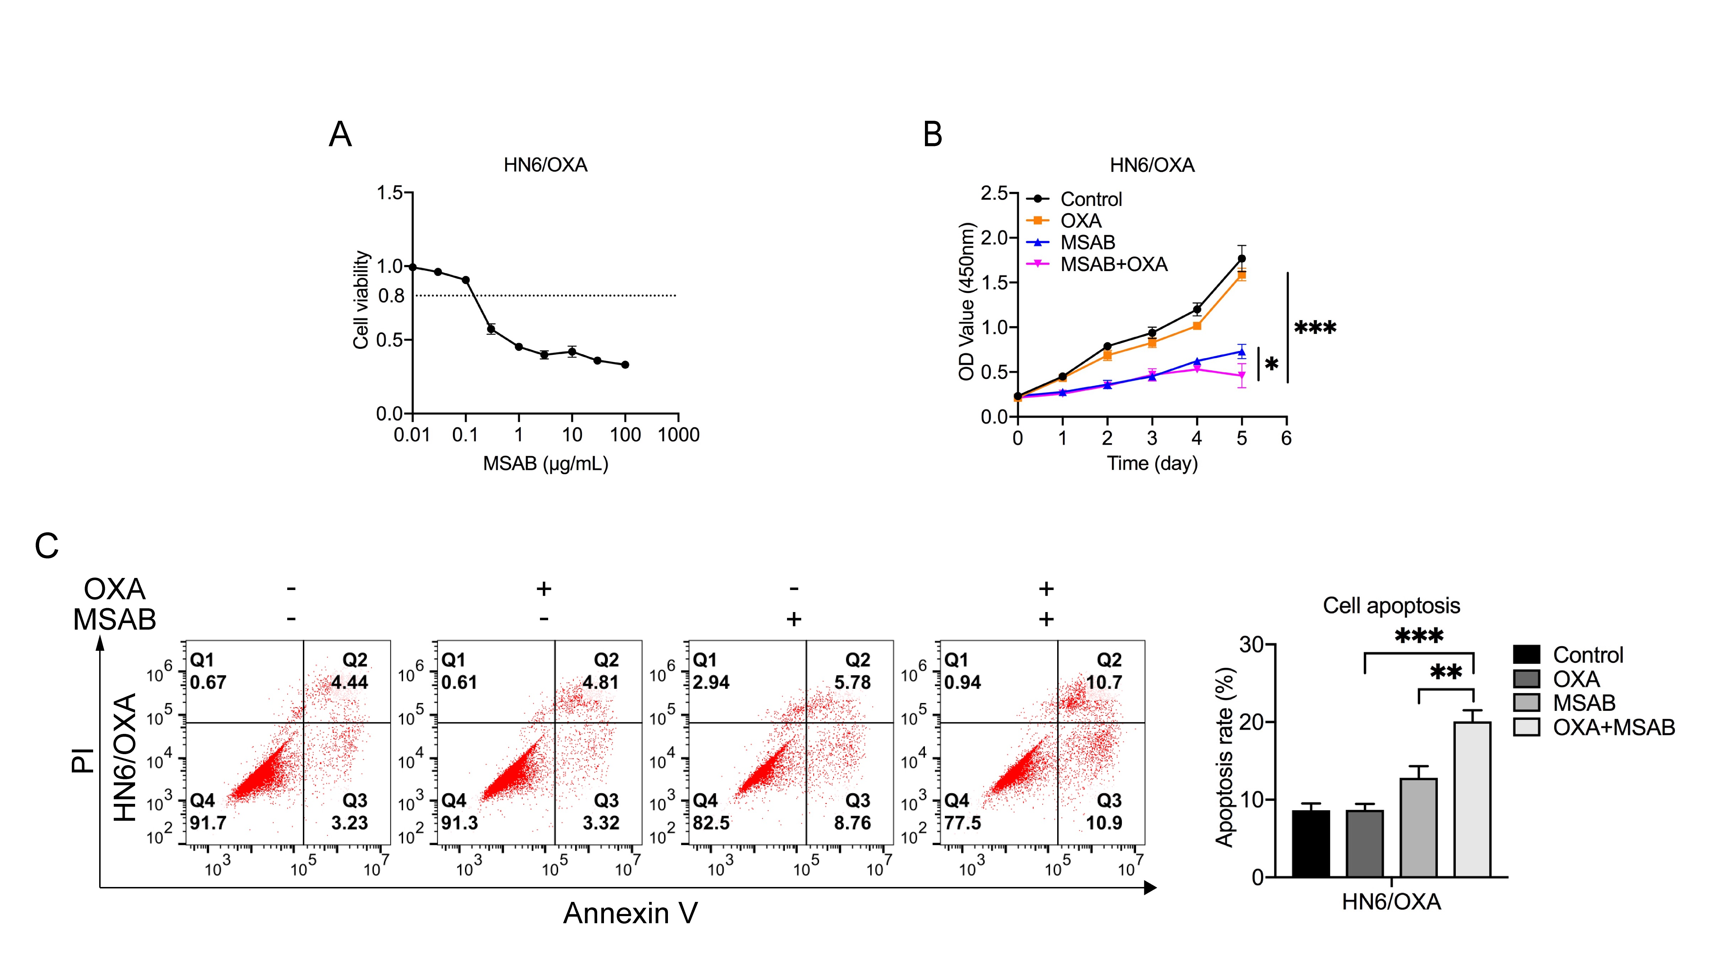
Fig. S 4 The WNT/β-catenin inhibitor MSAB reverses chemoresistance in OSCC OXA-R cells. (A) The cell viabilities of MSAB on HN6/OXA were evaluated. (B-C) Proliferation curves (B) and apoptosis rates (C) of HN6/OXA cells were assessed in the control group, OXA (10 μM) group, MSAB (0.2 μg/mL) group, and OXA (10 μM) combined with MSAB (0.2 μg/mL) group. Data shown as mean ± SD (n = 3). Statistical significance was denoted as follows: *, P< 0.05; **, P< 0.01; ***, P< 0.001; and ****, P< 0.0001.
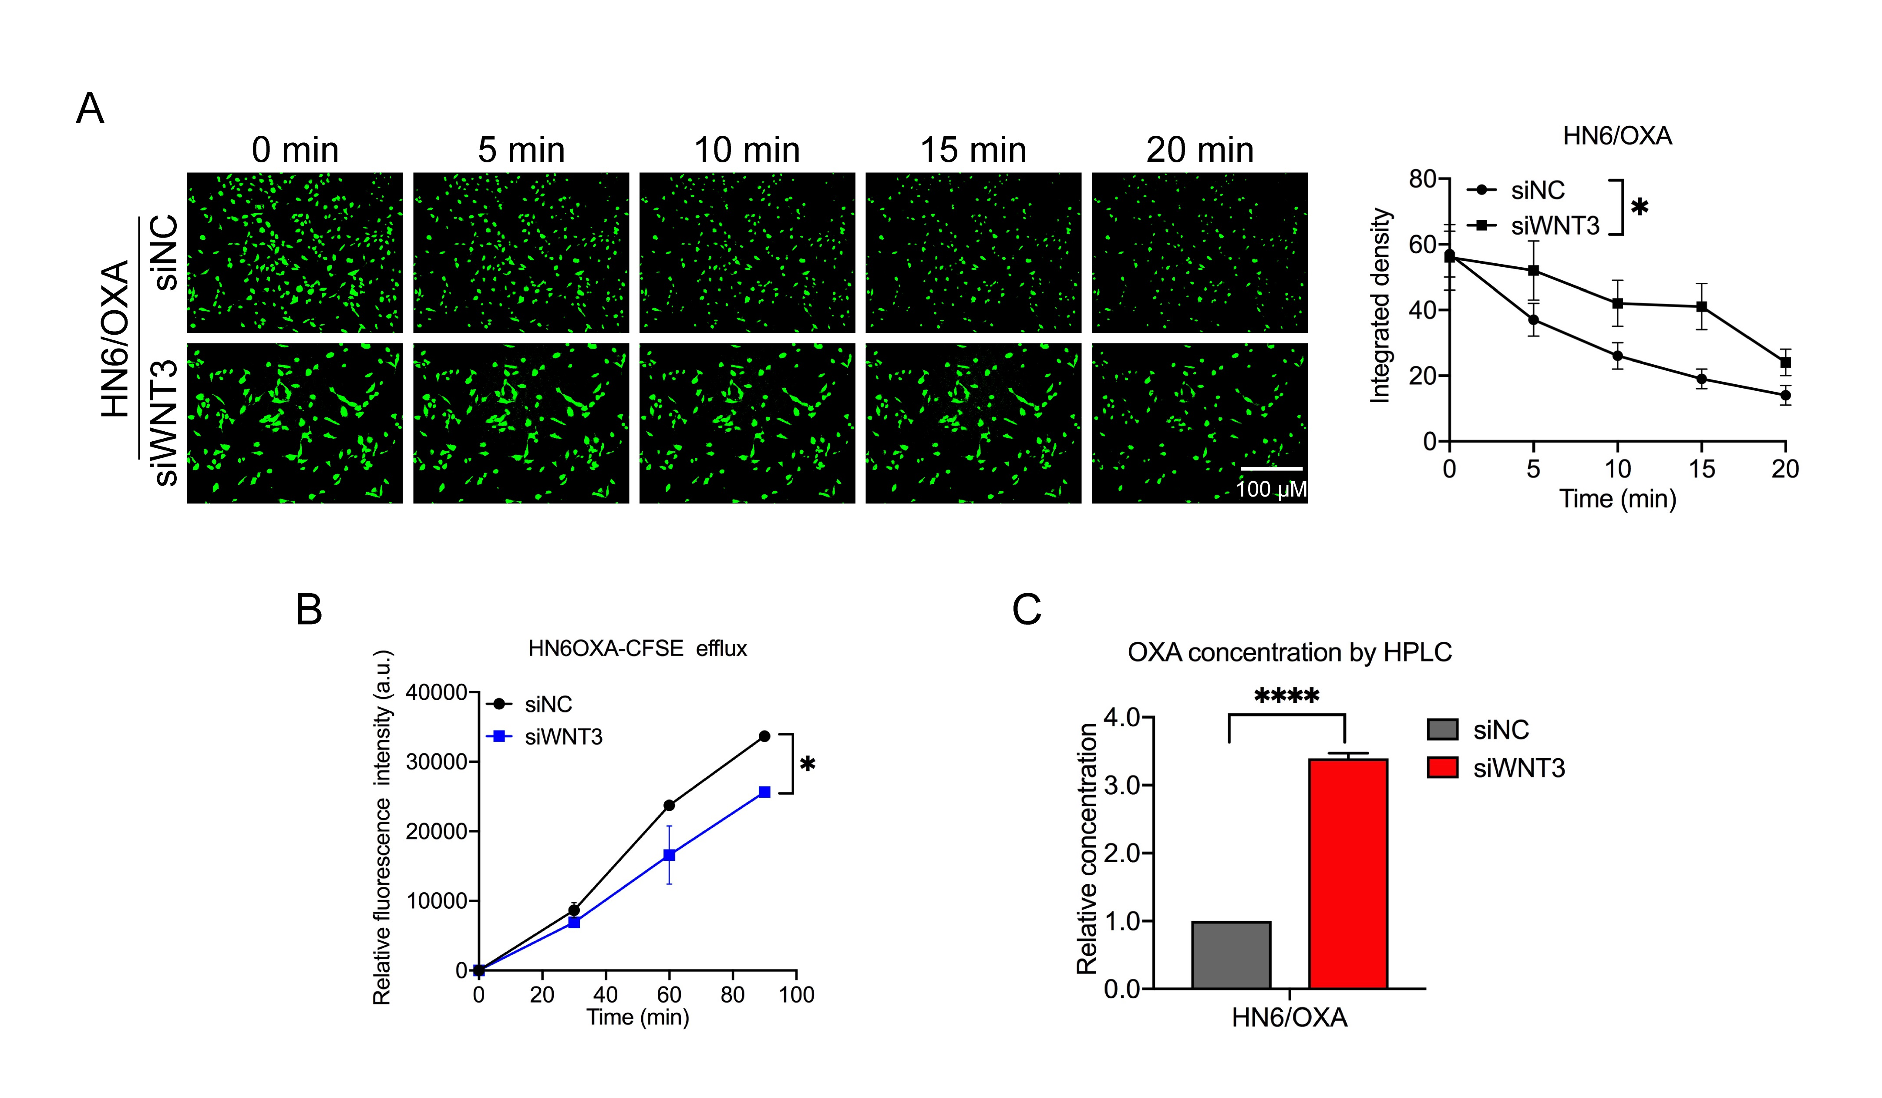
Fig. S 5 WNT3 promoted the efflux of HN6/OXA cells. (A) The CFSE fluorescence efflux assay revealed a weakened efflux ability of HN6/OXA cells after WNT3 knockdown. (B) Decreased fluorescence output of CFSE was observed in HN6/OXA cells following WNT3 knockdown. (C) The relative oxaliplatin content was increased in HN6/OXA cells after WNT3 knockdown, as determined by HPLC analysis. Data shown as mean ± SD (n = 3). Statistical significance was denoted as follows: *, P< 0.05 and ****, P< 0.0001.
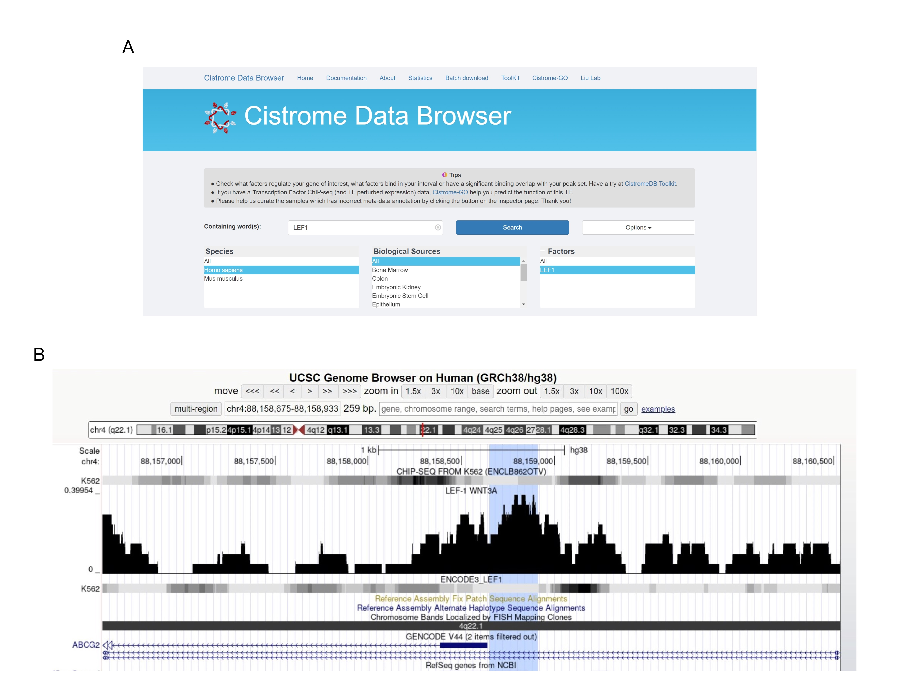
Fig. S 6 The design of ChIP-qPCR primers using (A) Cistrome Data Browser (http://cistrome.org/db/#/) and (B) UCSC Browser (https://genome.ucsc.edu/cgi-bin/hgTracks).

Supplementary tables
Table S 1 Primer sequences for target genes in real-time qPCR.
Gene name (Homo sapiens) | Forward primer (5ʹ→3ʹ) | Reverse primer (5ʹ→3ʹ)
ABCG2 | ACGAACGGATTAACAGGGTCA | CTCCAGACACACCACGGAT
GAPDH | GGTGTGAACCATGAGAAGTATGA | GAGTCCTTCCACGATACCAAAG
ABCA10 | ACCTATGCTCGCTGGTTTGG | TCCAGGTGTGTAATCTGGGC
ABCA13 | TGCCATACCAGCGACCTATT | ATCTCCTGCTCATACACCAACT
ABCB1 | GGGAGCTTAACACCCGACTTA | GCCAAAATCACAAGGGTTAGCTT
ABCB11 | CCTGGTCATCTTGTGCTTCTTC | TCAATGAACCGCCTCTCCTT
ABCB5 | TATGGACGAGATGATGTGACTGA | CGAACTAAGGCACGAGCAAT
ABCE1 | ACTGGAAGTGTTCGCCAGTT | GCCCAAGCAAAGGGCTAAAG
ABCB4 | ATGGCCCTACTTTGTCGTGG | CTGCTTCACTGCATCATCGC
ABCC9 | ACGTATGCTGGAACTGACGG | GGACAATGCAAGCTCCCAGA
WNT3 | TACTCGCTCTTCAAGCCACC | CTTCTCCGTCCTCGTGTTGT
WNT3A | ACAAAGCTACCAGGGAGTCG | TCCCACCAAACTCGATGTCC
WNT7A | CGCAAGCATCATCTGTAACAAG | TGAGCCTTCTCCTATGACGAT
WNT7B | GCTTTGGCGTCCTGTACGTG | AACTGGTACTGGCACTCGTTG
WNT10B | TTGTGCAGTCGGGCTCTAAG | GATGTGCAGACCCTGAAGCG

Table S 2 Information on antibodies used.
Primary antibody | Manufacturer | Reference | Dilution
WNT3 | Abcam, UK | Ab32249 | 1:1000
ABCG2 | Proteintech, China | 27286-1-AP | 1:1000
HSP90 | CST, USA | 4877S | 1:1000
N-Cad | CST, USA | 13116S | 1:1000
VIM | CST, USA | 5741S | 1:1000
GAPDH | Proteintech, China | HRP-60004 | 1:1000
β-catenin (for WB) | CST, USA | 8480S | 1:1000
β-catenin (for immunofluorescence) | BD, USA | 610154 | 1:200
Lamin A/C | CST, USA | 4777S | 1:1000
Flag Tag | Beyotime, China | AF5051 | 1:1000
LEF1 | CST, USA | 76010S | /
Rabbit IgG Isotype Control | Zenbio, China | A00002 | 1:40
Caspase-3 | CST, USA | 9662S | 1:1000
c-Caspase-3 | CST, USA | 9664S | 1:1000
PARP | CST, USA | 9532S | 1:1000
c-PARP | CST, USA | 5625S | 1:1000
α-tubulin | Boster, China | BM1452 | 1:1000
Goat Anti-mouse IgG (H+L) (Alexa Flour® 488 Conjugate) | CST, USA | 4408S | 1:200
HRP Conjugated AffiniPure Goat Anti-rabbit IgG (H+L) | Boster, China | BA1055 | 1:3000
HRP Conjugated AffiniPure Goat Anti-mouse IgG (H+L) | Boster, China | BA1051 | 1:5000

Table S 3 siRNA sequences targeting WNT3 and ABCG2.
Sequences  (Homo sapiens) | Sense (5ʹ→3ʹ) | Antisense (5ʹ→3ʹ)
siNC | UUCUCCGAACGUGUCACGUTT | ACGUGACACGUUCGGAGAATT
siWNT3-homo-646 | GCCAUGAACAAGCACAACATT | UGUUGUGCUUGUUCAUGGCTT
siWNT3-homo-1120 | CAGGAGUGUAUUCGCAUCUTT | AGAUGCGAAUACACUCCUGTT
siABCG2-homo-521 | GGAGGCAAAUCUUCGUUAUTT | AUAACGAAGAUUUGCCUCCTT
siABCG2-homo-1087 | GGCCUUGGGAUACUUUGAATT | UUCAAAGUAUCCCAAGGCCTT

