Supplementary Information
Figure S1. Pearson r correlation plot among number of villages, surveyed population, and active fire alerts across the three zones of the Huascaran Biosphere Reserve (HBR) IN 2007 AND 2017. Not significant values (p < 0.05) are not showed.

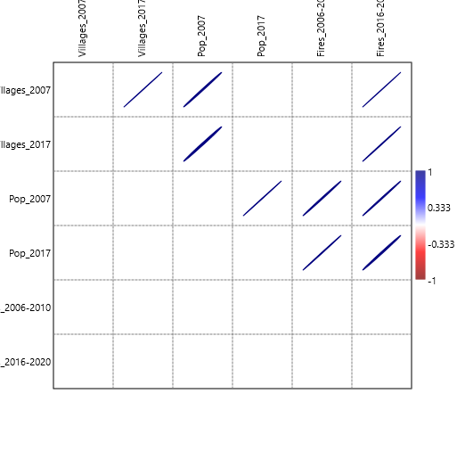
Figure S2. Active fires Data against precipitation shown two distribution patterns (Figure 5d). The first peak associated to xeric conditions (a) and a second associated to dense-populated wetter valleys (b).

