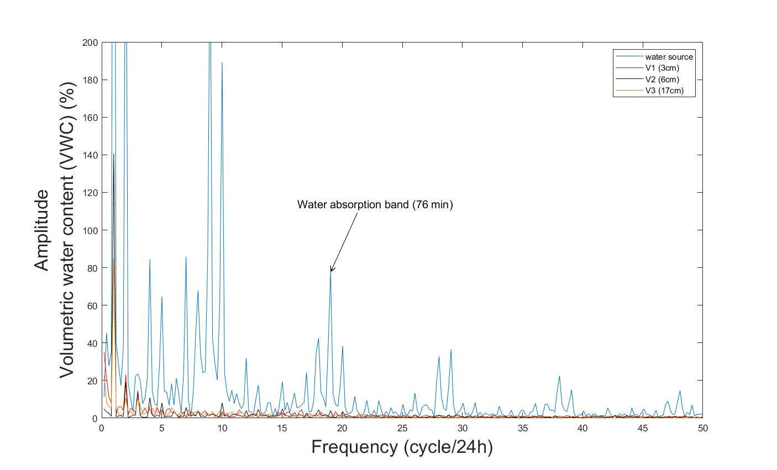
Supplementary Fig.1 The frequency spectrum at the water source, V1, V2, and V3. The peak at 19 cycles/hour was identified as the water absorption band of the plant.

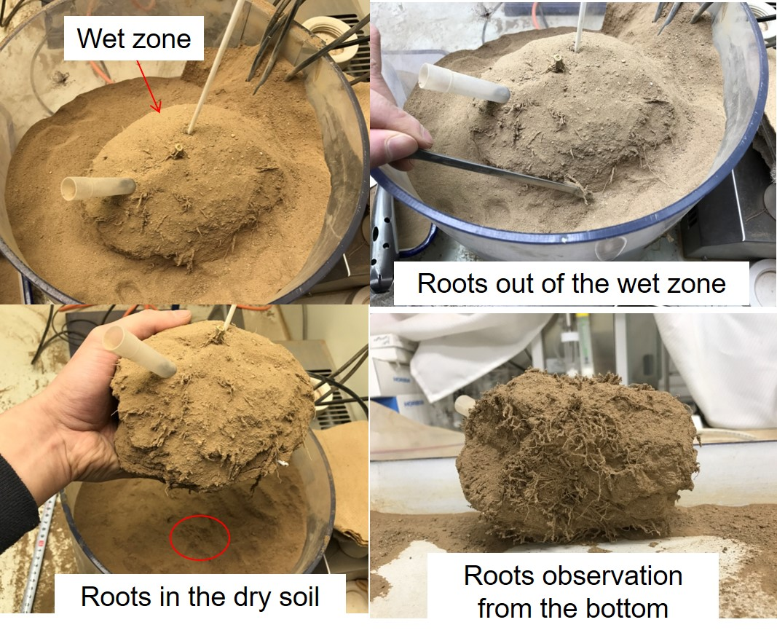
Supplementary Fig.2 Observe root distribution in Pot 2 by taking out the wet zone from the soil at the end of the experiment. Root growth outside the wet zone was observed.

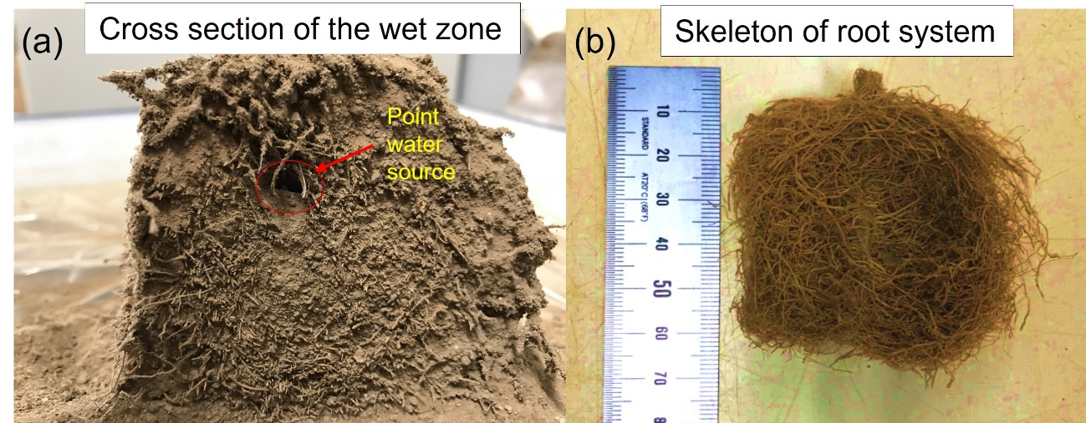
Supplementary Fig.3 Root skeleton at the cross-section of the wet zone. (a) We observed some roots growing towards the inside of the wet zone. The shape looks like a vortex around the point water source. (b) The root system was separated from the soil with the initial shape

