Supplement
Supplement 1. Changes in blood parameters after bleomycin induction and treatment with Box A
**
**
**
***
**
*
*
**
*
**
Figure supplement 1. Results from the blood analysis of the 6 groups of samples (n=6 each). NSS + PC is used to represent the control group (green color). Ble+PC is used to represent the pulmonary fibrosis disease group (red color). Ble+Box A is used to represent the treatment group (blue color). The values represent the means±SDs. *p ≤ 0.05, **p ≤ 0.01, ***p ≤ 0.001 t‐test

Box A protein treatment of bleomycin-induced pulmonary fibrosis in the rats following our experimental protocol revealed that the serum creatinine, serum BUN, and hemoglobin levels in the disease group significantly differed from those in the control groups (Figure supplement 1). The serum creatinine level in the Bleomycin-treated group at both the 6-week and 8-week groups (0.78±0.16 and 1.22±0.64, respectively) was greater than that in the control group at both 6-week and 8-weeks(0.20±0.00 and 0.12±0.04, respectively). The serum creatinine level also increased in rats treated with both Bleomycin and Box A in the 6-week and 8-week groups (1.15±0.75 and 0.95±0.23, respectively). However, the serum creatinine level in the bleomycin-Box A group at 6 weeks was greater than that in the 8-week group. Compared with those in the control group, the serum BUN levels in the groups that received bleomycin and plasmid control increased at both 6 and 8 weeks (50.00±11.35 and 85.67±34.71, respectively) compared with those in the control groups at 6 and 8 weeks (20.00±2.19 and 21.67±2.16, respectively). The group that received bleomycin+Box A for 6 weeks was shown to have higher serum BUN than the group that received bleomycin+PC for 6 weeks (50.00±11.35 vs. 66.33±39.88, respectively). However, the group that received bleomycin+Box A for 8 weeks had lower serum BUN levels than did the group that received bleomycin+PC for 8 weeks (68.17±26.65 vs. 85.67±34.71, respectively). Compared with those of the BLE+PC group, the blood Hb levels of the control NSS+PC group at 6 weeks and 8 weeks (15.73±0.75 and 14.82±0.64, respectively), the BLE+PC group at 6 weeks and 8 weeks (15.28±1.11 and 12.98±1.59, respectively), and the BLE+Box A group at 6 weeks and 8 weeks (13.83±1.03 and 14.03±0.88, respectively) tended to be associated with the changes in the serum creatinine and serum BUN levels. However, the blood results at 8 weeks were improved compared with those at 6 weeks.

Supplement 2. Confirmation that the Box A-producing plasmid entered the cells and produced Box A
A 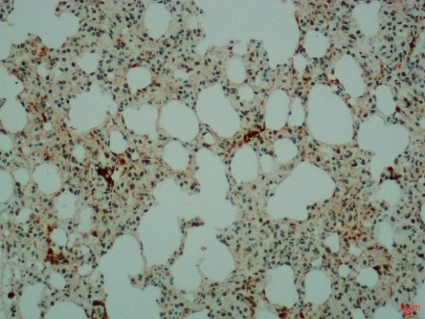 B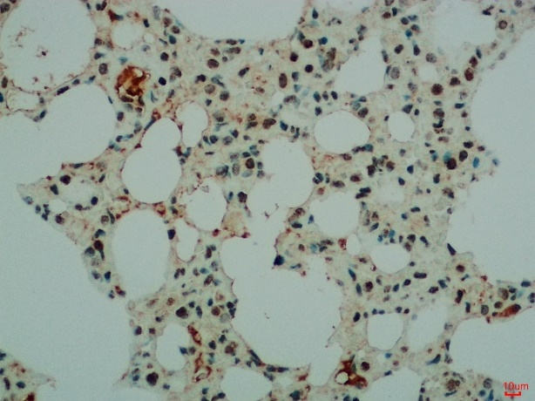
Figure supplement 2. Immunohistochemical staining with an anti-DYKDDDDK tag confirmed that the plasmid had entered the cells and produced Box A. Both images (A, B) show positive staining for the DYKDDDDK tag.
After our Box A protein treatment of the rats with bleomycin-induced pulmonary fibrosis following our experimental protocol, we sacrificed the rats and harvested their lung tissue to stain them with anti-FLAG via immunohistochemical staining and hematoxylin counterstaining. The results (Figure supplement 2) revealed that the pulmonary tissue of the rats was positive for the DYKDDDDK tag, which is attached to Box A in the plasmid and does not occur naturally. This result clearly indicates that the plasmid had entered the cells and produced the Box A protein.

