Supplementary material
Replicas for success - microplastics sampling strategy for low-polluted waterbodies
Barone, M. ^{ab}, Antonsson, E. ^{c}, Blache, M. ^{d}, Buhhalko, N. ^{e}, Mischke, S. ^{d}, Saarni, S. ^{f}, Svipsta, S. ª, Dimante-Deimantovica, I.ª
ª Latvian Institute of Aquatic Ecology, Voleru Street 4, LV-1007, Riga, Latvia
^{b} The Faculty of Natural Sciences and Healthcare, Daugavpils University, Parades Street 1, LV-5401, Daugavpils, Latvia
^{c} Marine and Freshwater Research Institute, Fornubúðum 5, 220 Hafnarfjörður, Iceland
^{d} Institute of Earth Sciences, University of Iceland, Sturlugata 7, 102 Reykjavík, Iceland
^{e} Department of Marine Systems, Tallinn University of Technology, Akadeemia tee 15a, 12618 Tallinn, Estonia
^{f} Department of Geography and Geology, University of Turku, Akatemiankatu 1, 20500 Turku, Finland
corresponding author: Marta Barone, marta.barone@lhei.lv, Voleru Street 4, LV-1007, Riga, Latvia
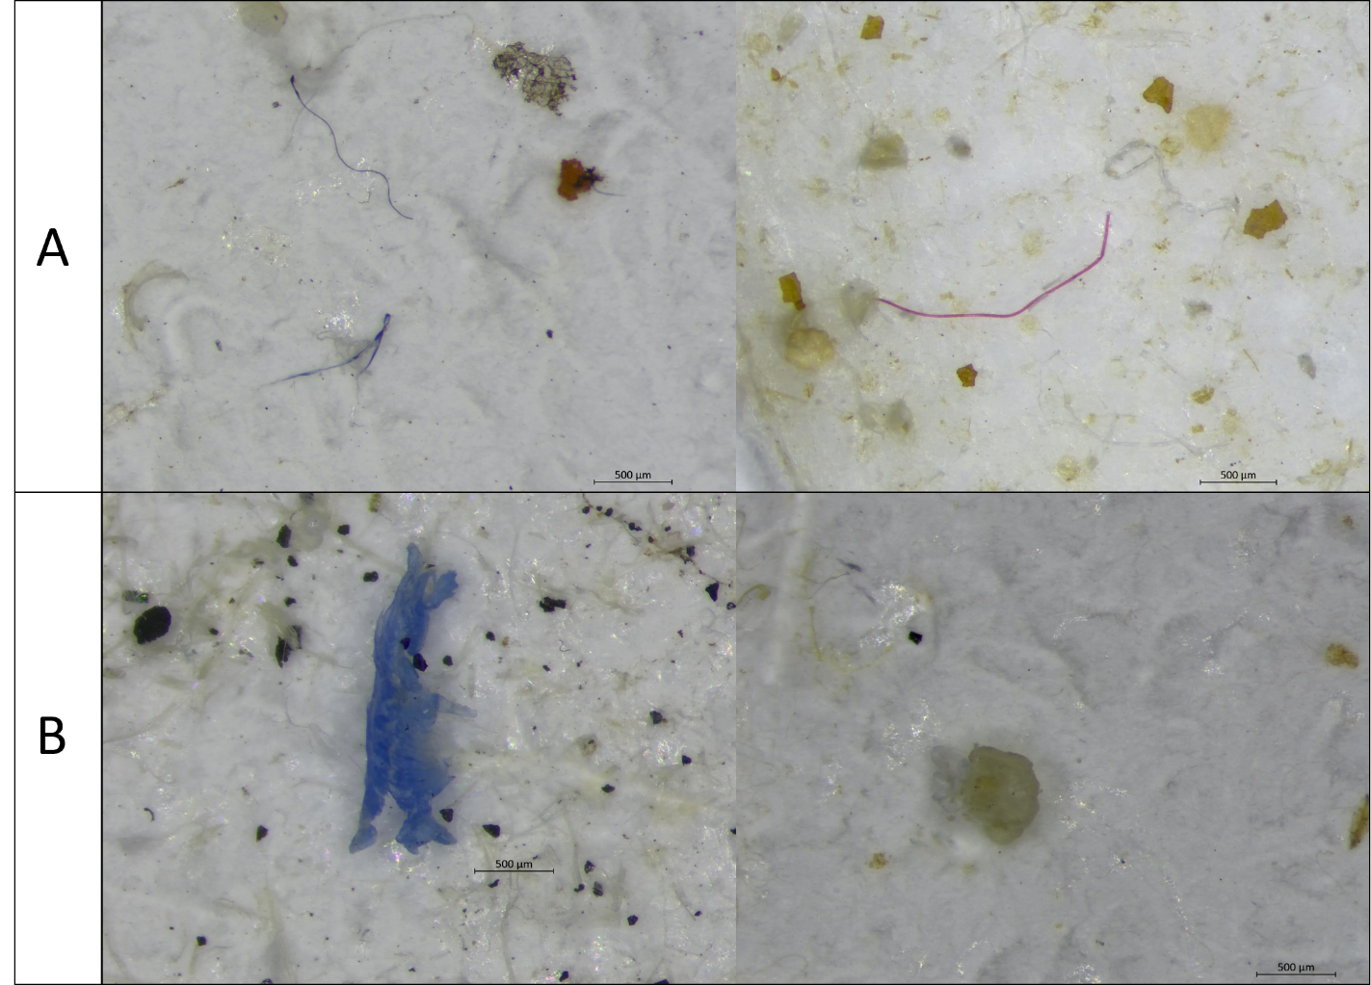
Fig. S1. Examples of main microplastic particles shapes found in the Lake Meðalfellsvatn and Fossvogur Bay: (A) fibers; (B) fragments.
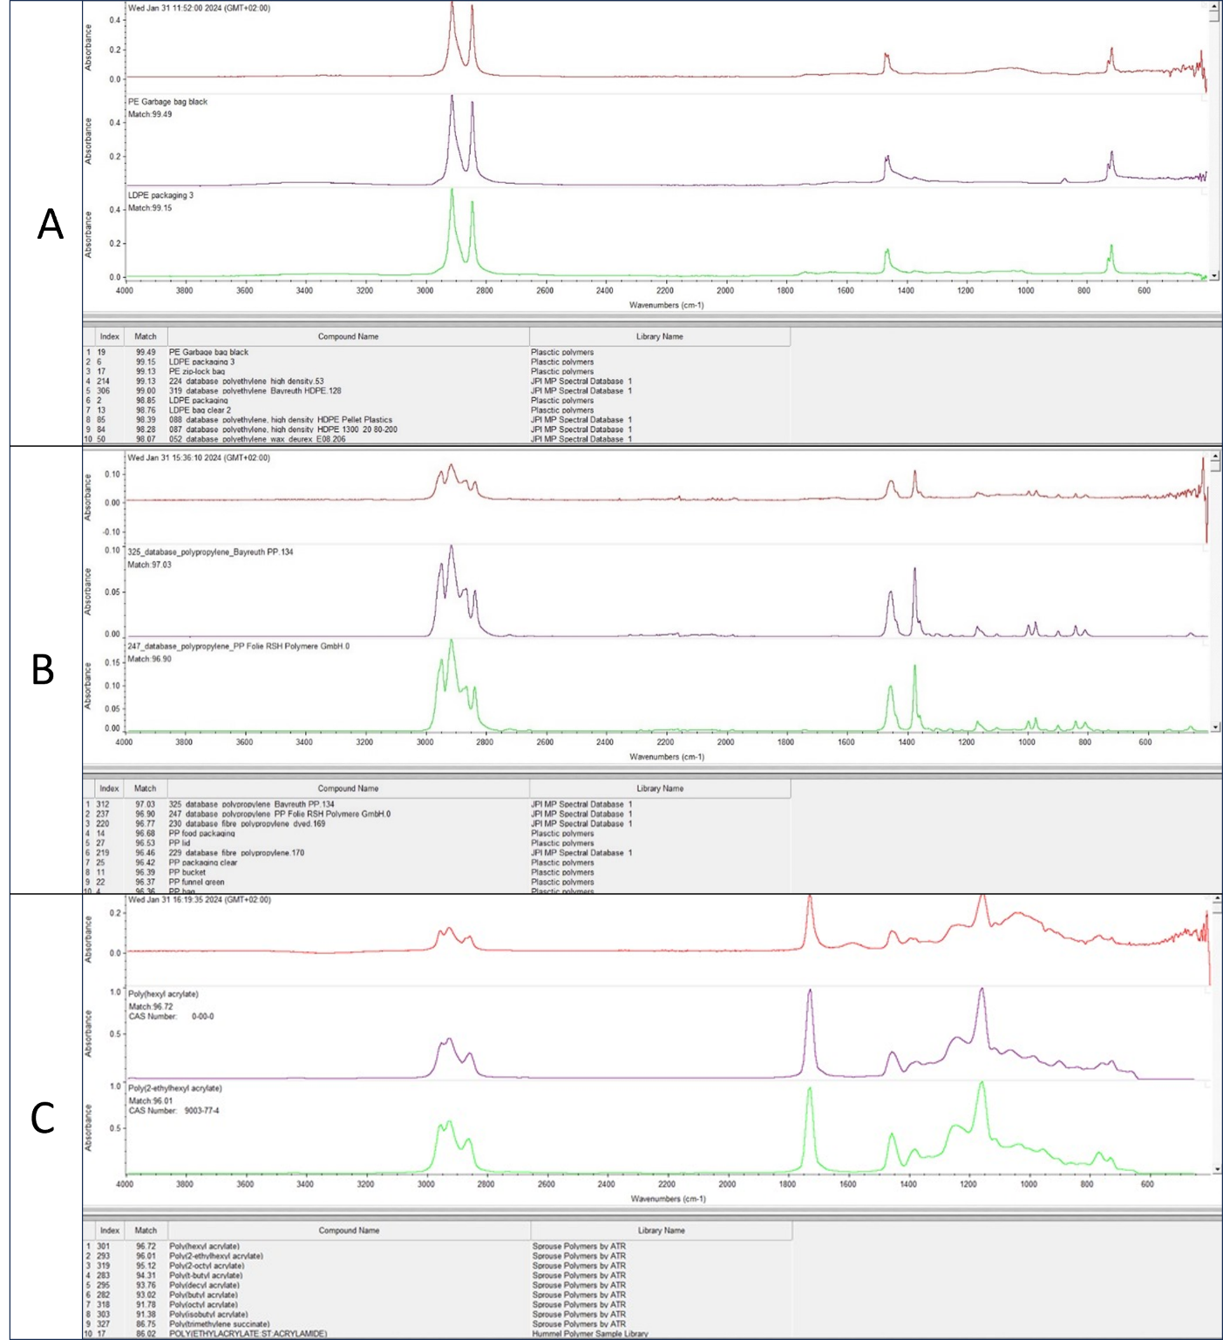
Fig. S2. Examples of spectra of identified polymer types along with spectrum matching scores to the library, found in the Lake Meðalfellsvatn and Fossvogur Bay: (A) polyethylene; (B) polypropylene; (C) acrylate.

