Supplementary information
Photoenhanced Field-Emission Nano-Air-Channel Devices for Terahertz Generation
Feiliang Chen^{1,2*}, Mo Li^{1,2*}, Xiaoxu Li^{1,2}, Lixin Sun^{1,2}, Xiangyang Li^{1,2}, Hao Jiang^{1,2}, Fan Yang^{1,2}, Yang Liu^{1,2}, Gang-Ding Peng³, Jian Zhang^{1,2*}

The transit time of the electrons through the nano-air channel is estimated by Newton's equation of motion. Assuming the initial velocity of electrons emitted from the surface of the photocathode is 0, the acceleration of electrons is about 1.76×10¹⁹ m/s² according to the electric field intensity (1 MV/cm) inside the nano-air channel, then the transit time (τ) can be calculated by Newton's equation of motion,
L=1/2aτ²
The length (L) of the nano-air channel is 50 nm, then τ is estimated to be about 75 fs.
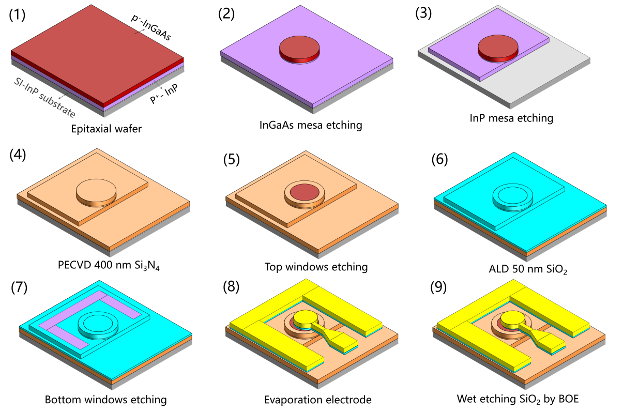
Figure S1. The step-by-step fabrication process flow diagram of the proposed NACDs.
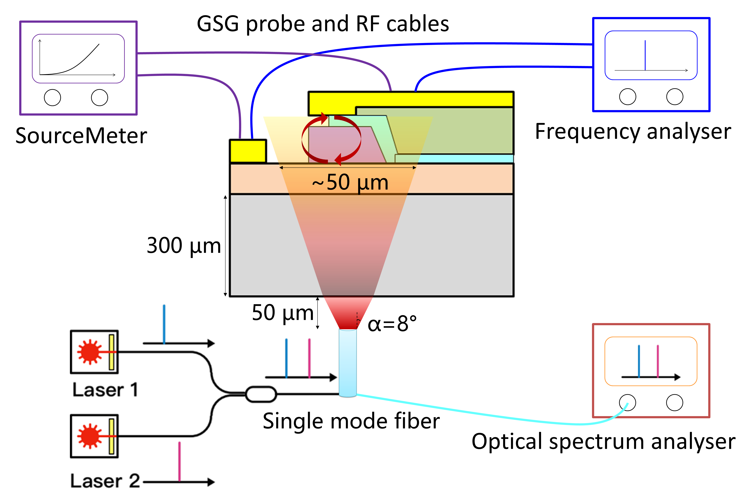
Figure S2. Schematic diagram of the photoresponse characteristics and RF generation measurement setup for the NACDs.
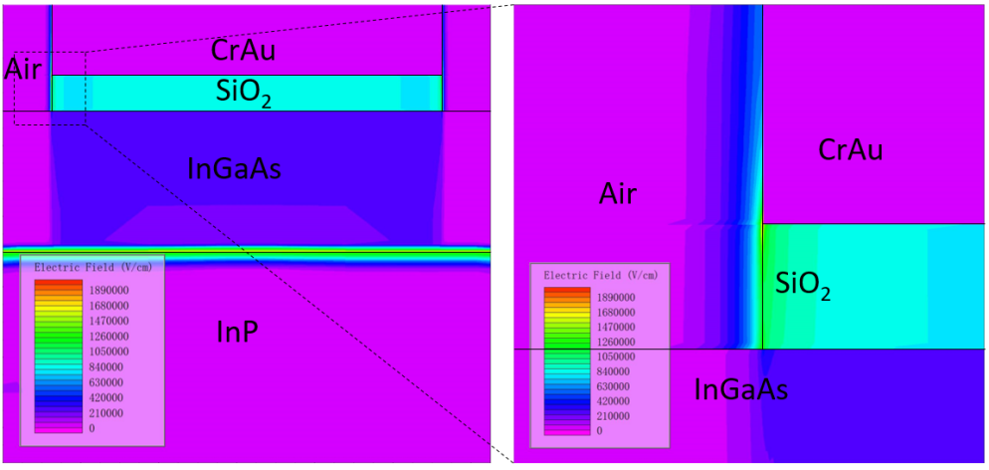
Figure S3. Calculated electric field distribution of the NAPMs with out-of-plane nano-air channel at a bias voltage of 10 V.
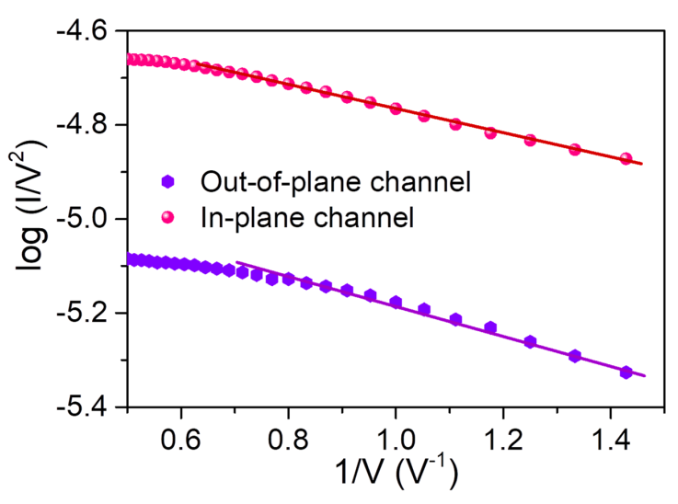
Figure S4. The Fowler–Nordheim plot of the photocurrents for the out-of-plane and in-plane nano-air channels, corresponding to the I-V curves in Fig 2e.
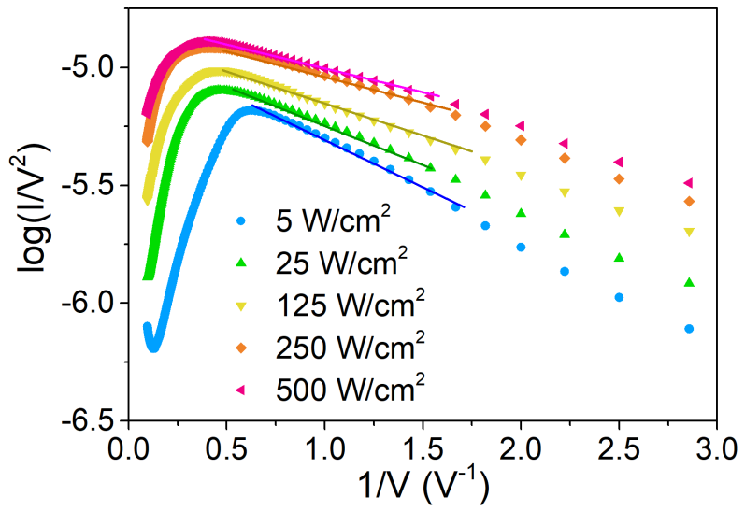
Figure S5. The Fowler–Nordheim plot of the photocurrents at different laser power densities.
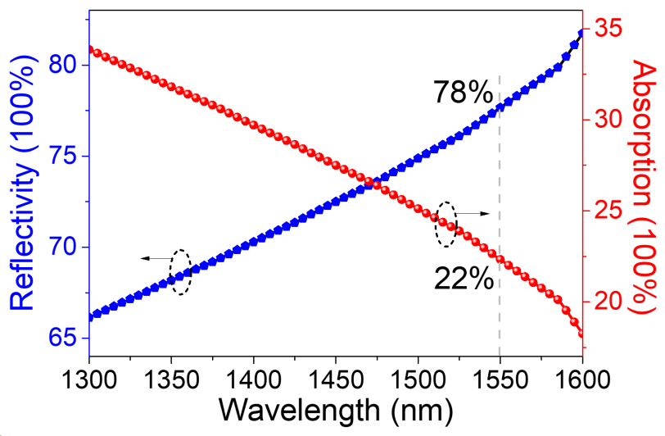
Figure S6. Calculated optical reflectivity and absorption of the NACDs with backside illumination.
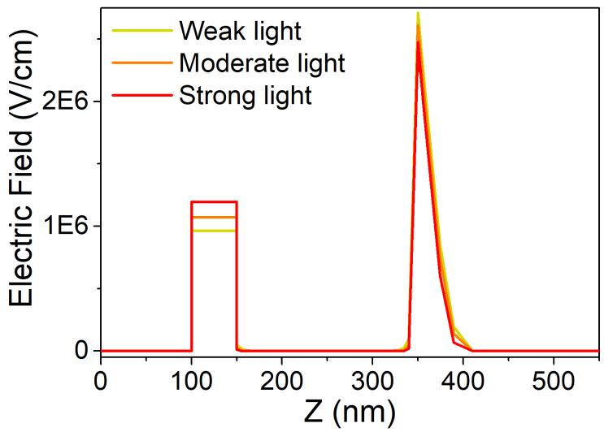
Figure S7. Calculated electric field of the NACDs at different laser power densities.
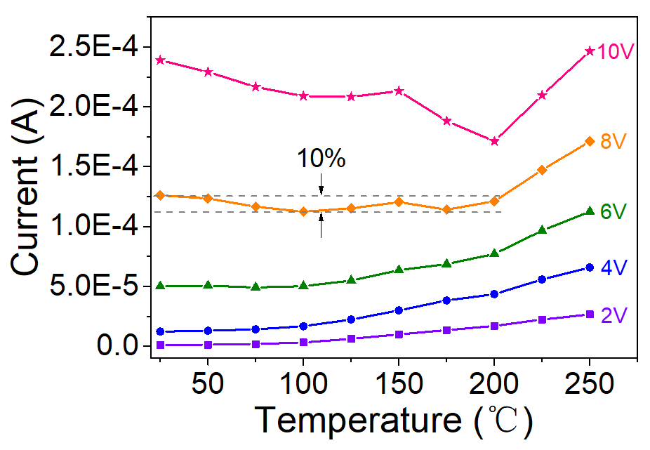
Figure S8. Temperature dependence I-V characteristics of the NACDs at different bias voltages.
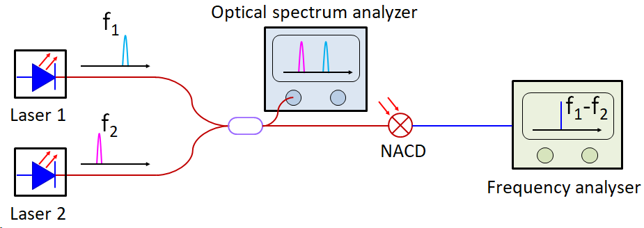
Figure S9. Schematic diagram of the heterodyne photomixing for terahertz generation based on the NACDs.

