Fig.3 B
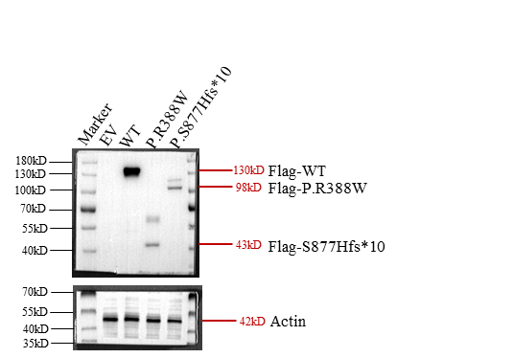
The molecular weight of the target protein is highlighted in red, and the molecular weight of the reference marker is shown in black.

Fig.3 C

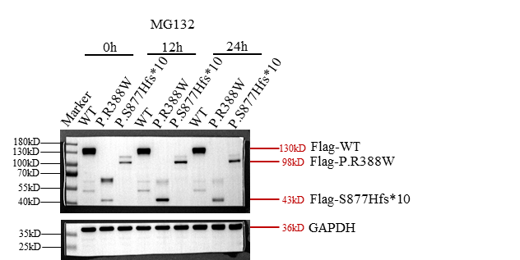
The molecular weight of the target protein is highlighted in red, and the molecular weight of the reference marker is shown in black.

Fig.4 B

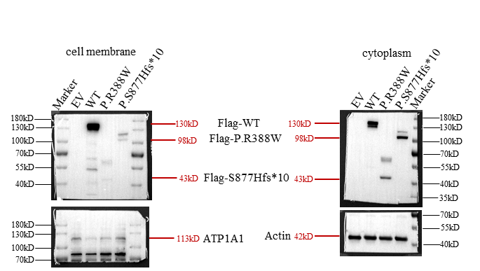
The molecular weight of the target protein is highlighted in red, and the molecular weight of the reference marker is shown in black.

The details regarding the molecular weight marker are as follows: PageRuler™ Prestained Protein Ladder, ranging from 10 to 180 kDa, provided by ThermoFisher.
