Supporting Information

Title
Simulation of Piezoelectric Inkjet Printing Using Fluid Structural Interaction

Authors
Dong Yeol Shin^{1, 2}, Jaebum Jeong¹, Woo Jin Jeong¹, Seok Hwan Jang¹, Sung Wook Kang³, Kyung-Tae Kang² and Jun Young Kim^{1*}
¹ Department of Semiconductor Engineering, Gyeongsang National University, Jinjudae-ro 501 beon-gil, Jinju-si 52828, Republic of Korea
² Autonomous Manufacturing Process R&D Department, Korea Institute of Industrial Technology (KITECH), Sangnok-gu, Ansan-si 15588, Republic of Korea
³ Department of Smart Ocean Mobility Engineering, Changwon National University, 20 Changwondaehak-ro Uichang-gu Changwon-si, Gyeongsangnam-do, 51140, Republic of Korea

*kimjy86@gun.ac.kr (Jun Young Kim)

The figures below are for additional figures mentioned in the manuscript. The figures are numbered with the addition of the letter "S".
Figure S1. MicroFab Technologies' MJ-AT-01-50.

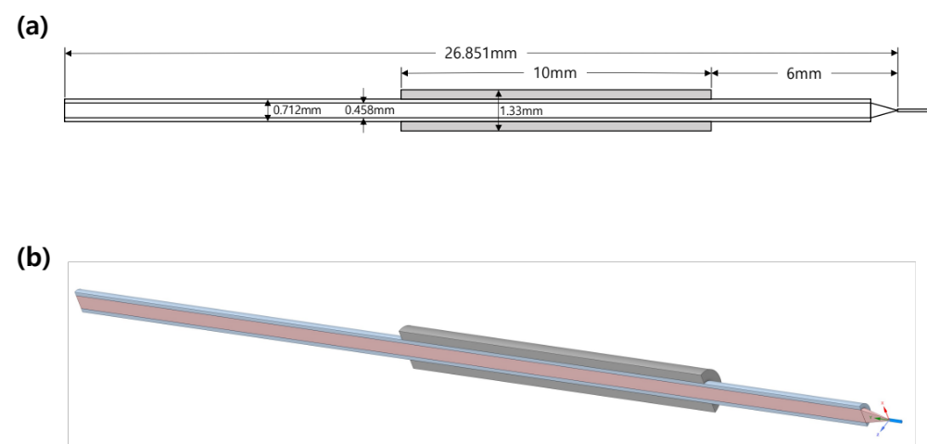
Figure S2. (a) The structure size diagram of piezoelectric inkjet printing head. The gray area is piezoelectric material. (b) The 3-dimension modeling of (a). Red area is channel of fluid, sky blue area is glass, gray area is piezoelectric material and blue area is air.
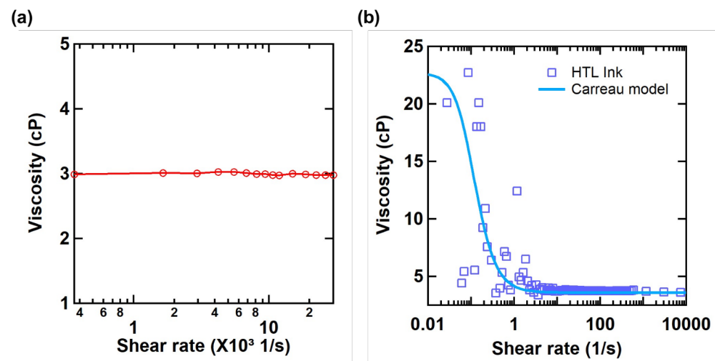
Figure S3. (a) Viscosity of EMB+EBP ink, (b) Viscosity of HTL ink.

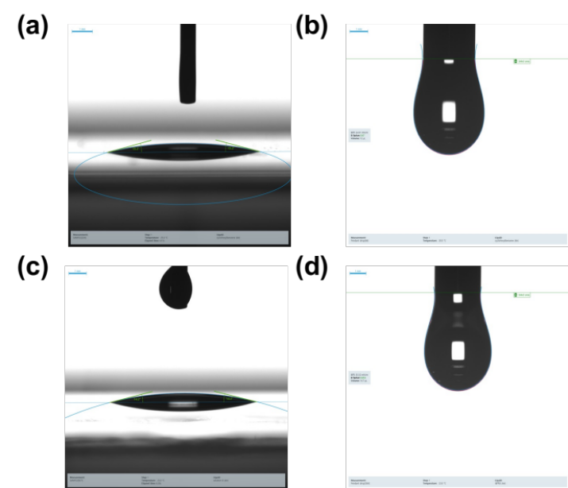
Figure S4. (a) Contact angle of HTL ink, (b) Surface tension of HTL ink, (c) Contact angle of EMB+EBP ink, (d) Surface tension of EMB+EBP ink

The tables below are for additional tables mentioned in the manuscript. The tables are numbered with the addition of the letter "S".

Table S1 Material Properties of BaTiO₃
Property | Symbol | Value | Unit
Density | ρ | 5500 | kg/m³
Piezoelectric constant | d₃₁ | -5.80$×$10⁻¹¹ | m/V
Piezoelectric constant | d₃₃ | 1.49$×$10⁻¹⁰ | m/V
Piezoelectric constant | d₁₅ | 2.42$×$10⁻¹⁰ | m/V
Elastic constant | s^{E}₁₁ | 8.60$×$10⁻¹² | m²/N
Elastic constant | s^{E}₃₃ | 9.10$×$10⁻¹² | m²/N
Elastic constant | s^{E}₁₂ | -2.60$×$10⁻¹² | m²/N
Elastic constant | s^{E}₁₃ | -2.70$×$10⁻¹² | m²/N
Elastic constant | s^{E}₄₄ | 2.22$×$10⁻¹¹ | m²/N
Elastic constant | s^{E}₆₆ | 2.24$×$10⁻¹¹ | m²/N
Relative permittivity | ε₁₁/ε₀ | 1300 | -
Relative permittivity | ε₃₃/ε₀ | 1200 | -

Table S2. Carreau model parameters of HTL ink
Parameter | Value | Unit
$$η_{0}$$ | 22.7 | cP
$$η_{∞}$$ | 3.57 | Pa∙s
$$λ$$ | 10 | sec
$$n$$ | -0.5 | -

Table S3. Properties of HTL ink
Property | Value | Unit
Density | 1119.7 | kg/m³
Surface tension | 24.9 | mN/m
Contact angle | 15.2 | $°$ (degree)

Table S4. Properties of Newtonian ink
Property | Value | Unit
Density | 1178.2 | kg/m³
Surface tension | 35.52 | mN/m
Contact angle | 14.2 | $°$ (degree)

The formula below is for additional formulas mentioned in the manuscript. The formula is numbered with the addition of the letter "S".

 | $$η\left(\dot{γ}\right)=η_{∞}+\left(η_{0}-η_{∞}\right){\left[1+{\left(\dot{γ}λ\right)}^{2}\right]}^{\frac{n-1}{2}}$$ | (S1)

Here $η_{∞}$ is infinite shear viscosity, $η_{0}$ is zero shear viscosity, $λ$ is the time constant, and $n$ is the power law index.

