Table S1. Correlation coefficients of embryo size in the population of Morex/AWCS276 among the four trials and BLUP dataset#
Trait | EL_FH22 | EL_BO22 | EL_FH23 | EL_BO23 | EL_BLUP
EL_FH22 | 1.00
EL_BO22 | 0.98** | 1.00
EL_FH23 | 0.96** | 0.92** | 1.00
EL_BO23 | 0.88** | 0.95** | 0.94** | 1.00
EL_BLUP | 0.85** | 0.91** | 0.81** | 0.82** | 1.00
 | EW_FH22 | KW_BO22 | KW_FH23 | KW_BO23 | EA_BLUP
EW_FH22 | 1.00
EW_BO22 | 0.82** | 1.00
EW_FH23 | 0.76** | 0.71** | 1.00
EW_BO23 | 0.81** | 0.98** | 0.87** | 1.00
EW_BLUP | 0.91** | 0.93** | 0.87** | 0.94** | 1.00
 | EA_FH22 | EA_BO22 | KA_FH23 | KA_BO23 | EA_BLUP
EA_FH22 | 1.00
EA_BO22 | 0.93** | 1.00
EA_FH23 | 0.97** | 0.76** | 1.00
EA_BO23 | 0.92** | 0.98** | 0.81** | 1.00
EA_BLUP | 0.95** | 0.97** | 0.84** | 0.94** | 1.00
#EL embryo, EW embryo width, EA embryo area, FH22, BO22, FH23 and BO23 four independent trials conducted for embryo size, BLUP best linear unbiased prediction, ** significant at P < 0.01
Table S2. Conditional QTL analysis-based determination of relationships between embryo and other agronomic traits
Traits | Chr. | Linkage map interval (cM) | Physical map interval (Mbp) | LeftMarker | RightMarker | LOD | PVE (%)
EL|KL | 7H | 89.8-96.3 | 597.9-615.1 | GBS_MST4580 | GBS_MST4562 | 3.5 | 7.9
EL|KW | 2H | 52.9-59.5 | 529.1-542.6 | GBS_MST828 | GBS_MST1262 | 3.3 | 7.7
 | 4H | 15.8-20.9 | 13.2-23.0 | GBS_MST2470 | GBS_MST2490 | 3.1 | 7.1
 | 7H | 89.8-96.6 | 597.9-615.1 | GBS_MST4580 | GBS_MST4560 | 4.7 | 10.7
EL|KA | 6H | 33.6-38.2 | 274.5-327.2 | GBS_MST4430 | GBS_MST4093 | 3.0 | 6.9
 | 7H | 89.5-96.3 | 597.9-615.1 | GBS_MST4580 | GBS_MST4562 | 3.4 | 7.8
EL|TKW | 2H | 52.9-59.5 | 529.1-542.6 | GBS_MST821 | GBS_MST1262 | 3.2 | 7.4
 | 4H | 12.9-23.3 | 13.2-23.0 | GBS_MST2469 | GBS_MST2490 | 3.1 | 7.2
 | 7H | 91.5-98.8 | 597.9-615.1 | GBS_MST4573 | GBS_MST4554 | 4.7 | 10.5
EW|KL | 2H | 67.4-72.0 | 568.8-586.1 | GBS_MST1320 | GBS_MST1355 | 5.7 | 12.7
 | 4H | 12.9-24.9 | 11.2-25.7 | GBS_MST2469 | GBS_MST2491 | 5.4 | 12.0
 | 7H | 76.9-85.9 | 581.1-593.4 | GBS_MST4621 | GBS_MST4586 | 3.5 | 8.1
EW|KW | 4H | 15.8-19.8 | 13.2-22.7 | GBS_MST2470 | GBS_MST2477 | 6.3 | 14.8
 | 6H | 33.6-38.2 | 274.5-327.2 | GBS_MST4430 | GBS_MST4093 | 3.4 | 7.9
 | 7H | 76.9-85.9 | 581.1-593.4 | GBS_MST4621 | GBS_MST4586 | 4.1 | 9.2
EW|KA | 4H | 15.8-19.8 | 13.2-23.0 | GBS_MST2470 | GBS_MST2477 | 4.2 | 10.1
 | 7H | 76.9-85.9 | 581.1-593.4 | GBS_MST4621 | GBS_MST4586 | 3.3 | 7.5
EW|TKW | 1H | 67.4-72.0 | 493.3-512.4 | GBS_MST625 | GBS_MST648 | 3.0 | 6.9
 | 4H | 15.8-19.8 | 13.2-22.7 | GBS_MST2470 | GBS_MST2477 | 7.2 | 15.9
 | 7H | 76.9-85.9 | 581.1-593.4 | GBS_MST4633 | GBS_MST4586 | 3.1 | 7.1
EA|KL | 4H | 15.8-19.8 | 13.2-22.7 | GBS_MST2470 | GBS_MST2477 | 4.8 | 10.8
 | 7H | 76.9-85.9 | 602.9-613.1 | GBS_MST4621 | GBS_MST4586 | 3.6 | 8.2
EA|KW | 4H | 15.8-19.8 | 13.2-22.7 | GBS_MST2470 | GBS_MST2477 | 5.7 | 13.1
 | 6H | 33.6-38.2 | 274.5-327.2 | GBS_MST4430 | GBS_MST4093 | 3.4 | 7.7
 | 7H | 91.5-94.5 | 602.9-613.1 | GBS_MST4573 | GBS_MST4562 | 5.1 | 11.5
EA|KA | 4H | 15.8-19.8 | 13.2-22.7 | GBS_MST2470 | GBS_MST2477 | 4.3 | 10.6
 | 6H | 33.6-38.2 | 274.5-327.2 | GBS_MST4430 | GBS_MST4093 | 3.6 | 8.3
 | 7H | 91.5-94.5 | 602.9-613.1 | GBS_MST4573 | GBS_MST4562 | 3.5 | 7.9
EA|TKW | 4H | 15.8-19.8 | 13.2-22.7 | GBS_MST2470 | GBS_MST2477 | 6.7 | 14.7
 | 6H | 33.6-38.2 | 274.5-327.2 | GBS_MST4430 | GBS_MST4093 | 2.8 | 6.6
 | 7H | 91.5-94.5 | 602.9-613.1 | GBS_MST4573 | GBS_MST4562 | 4.6 | 10.4
The QTL in bold indicates that the QTL newly detected in conditional QTL analysis, and the remaining QTL without bold indicates that can be detected both in conditional and traditional QTL analysis.

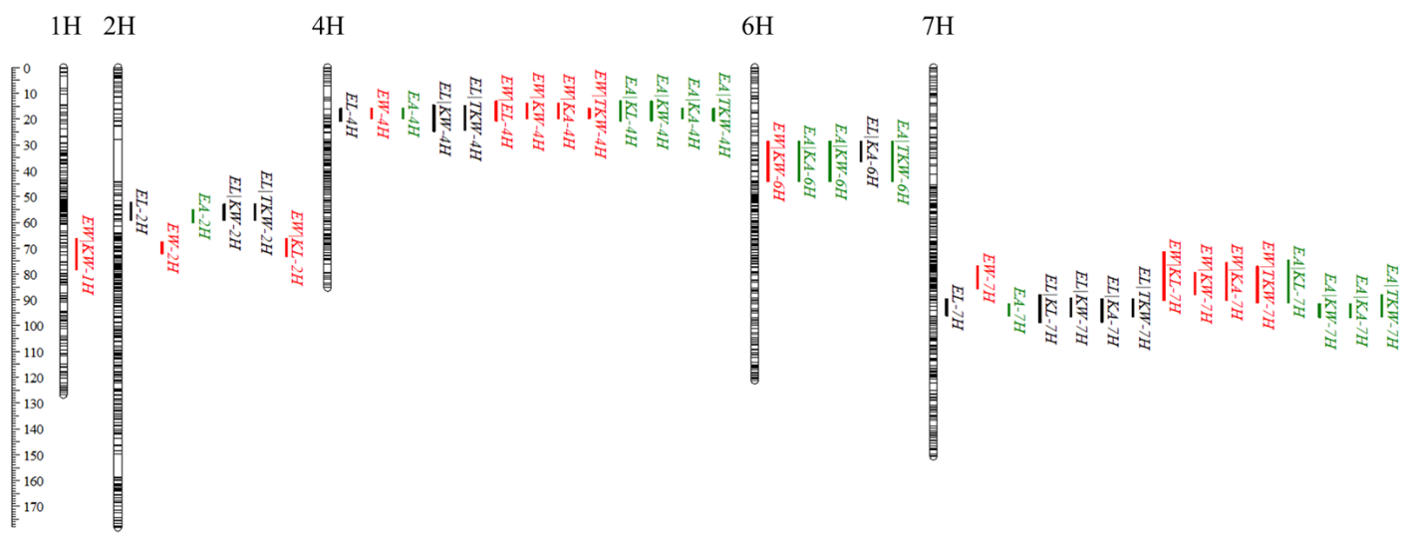
Figure S1. QTL for embryo size identified from both traditional and conditional QTL analysis in the population of Morex/AWCS276 using BLUP datasets. EL embryo length, EW embryo width, EA embryo area, KL kernel length, KW kernel width, KA kernel area, TKW thousand kernel weight.

