Interaction between amorphous and crystalline SiO₂ with ZnO obtained by various methods: implications for rhodamine 6G elimination

Supporting Information

Lucy-Caterine Daza-Gómez¹, Brandon Enrique Vargas Escobar², David Díaz³, Nidia Guadalupe García-Peña⁴, Rocío Redón^{2*}

¹ División de Ingeniería Mecánica e Industrial, Facultad de Ingeniería, Universidad Nacional Autónoma de México, Ciudad Universitaria, Coyoacán, Ciudad de México, 04510, México
² Instituto de Ciencias Aplicadas y Tecnología, Universidad Nacional Autónoma de México, Cd. Universitaria, C.P. 04510, Coyoacán, Ciudad de México, México.
³ Facultad de Química, Universidad Nacional Autónoma de México, Ciudad de México, 04510, México
⁴ Department of Applied Physics, CINVESTAV-IPN, Antigua Carretera a Progreso km 6, A.P. 37, Mérida 97310, México

Rocío Redón: rredon@unam.mx

Figure S1. XRD patterns of ZnO obtained by precipitation and combustion method with and without CTAB. ZnO NPs synthesized without CTAB (—) and with CTAB (—) by precipitation method, and ZnO NPs synthesized with CTAB (—) and without CTAB (—) by combustion method.

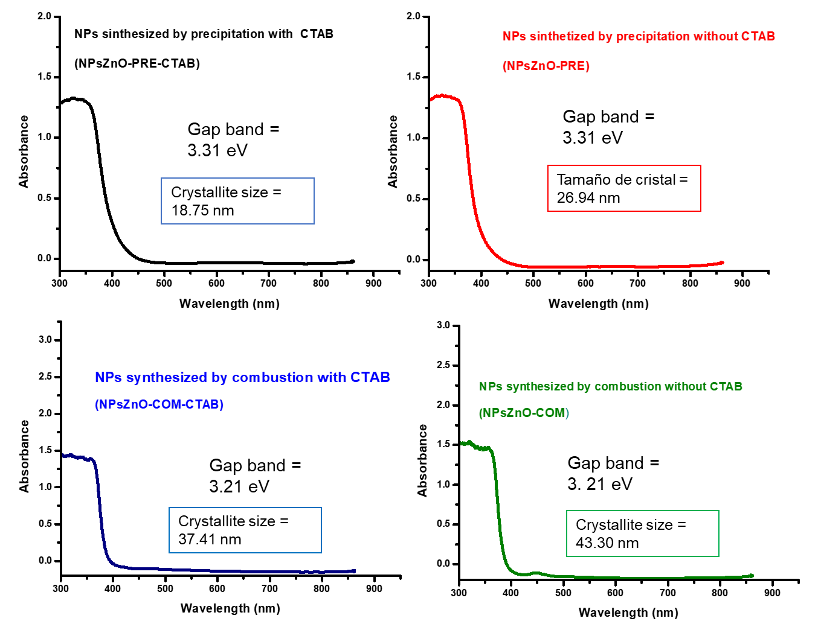
Figure S2. UV-Vis absorption spectra of ZnO NPs.

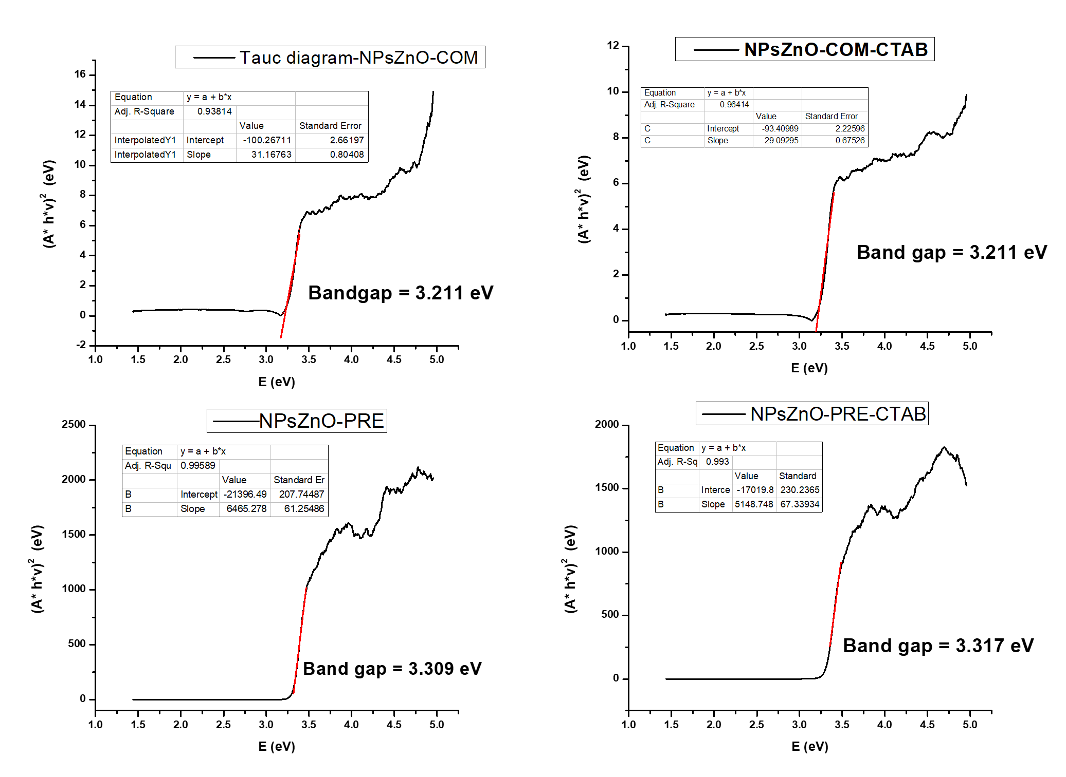
Figure S3. Tauc diagrams of ZnO NPs. NPsZnO-PRE: ZnO NPs synthesized with CTAB and NPsZnO-PRE: ZnO NPs synthesized without CTAB by precipitation method; NPsZnO-COM-CTAB: ZnO NPs synthesized with CTAB and NPsZnO-COM: ZnO NPs synthesized without CTAB by combustion method.

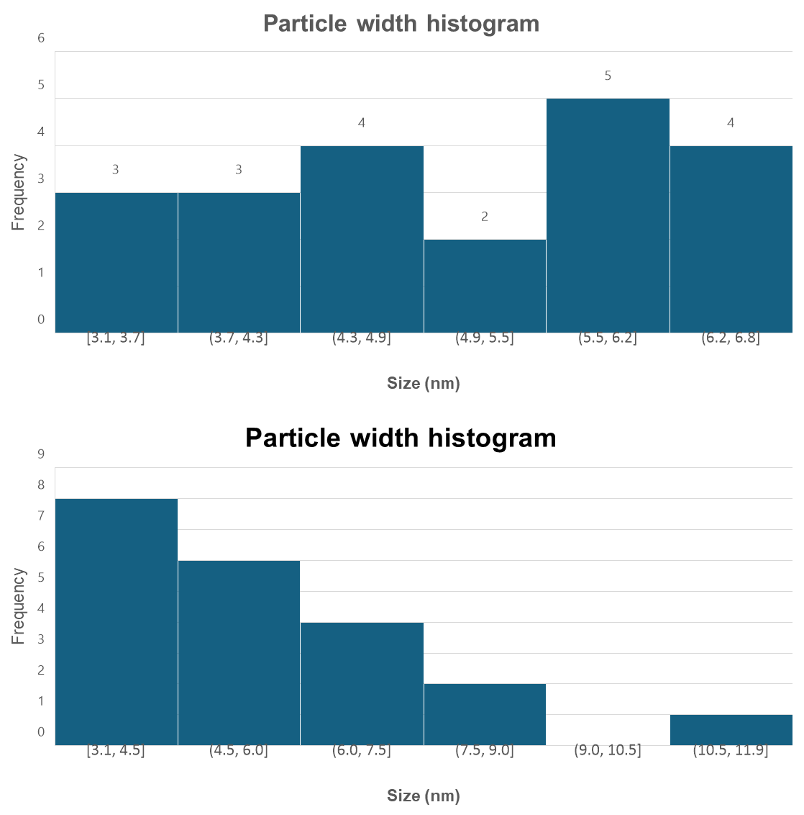
(a)
(b)

Figure S4. Absolute frequency histogram for particle width (a) absolute frequency histogram for particle width and, (b) length for NPs synthesized by precipitation without CTAB supported on amorphous SiO₂ (SiO₂AM/NPsZnO-PRE).

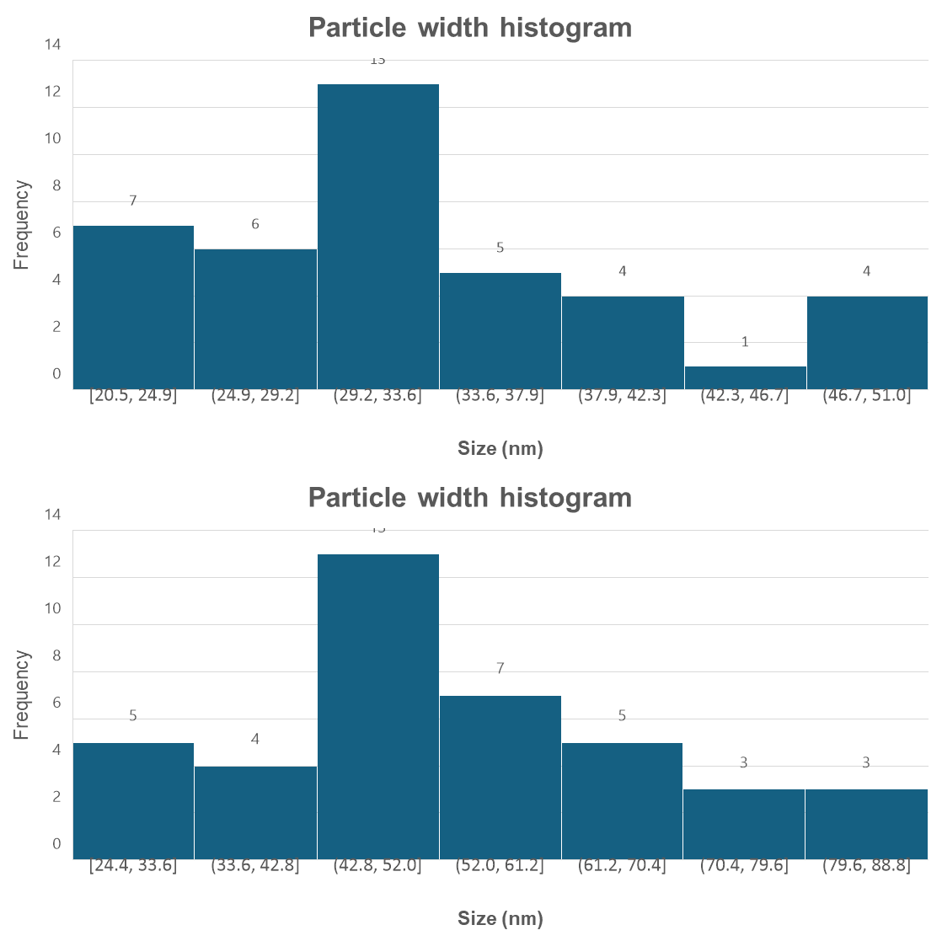
(a)
(b)

Figure S5. Absolute frequency histogram for particle width (a) absolute frequency histogram and, (b) for particle length for NPs synthesized by precipitation without CTAB (NPsZnO-PRE).

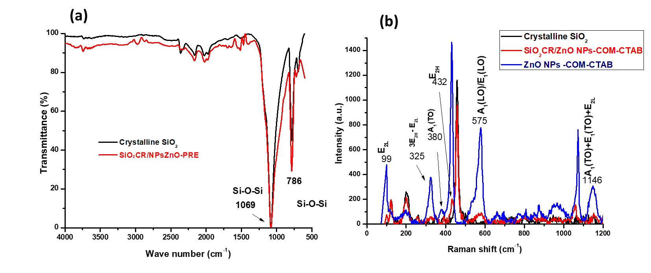
Figure S6. FT-IR spectra ZnO/SiO_{2(crystalline)} sample (a) and Raman spectra of crystalline SiO₂, isolated ZnO NPs and ZnO NPs supported on crystalline SiO₂ obtained by the CTAB combustion method (b).

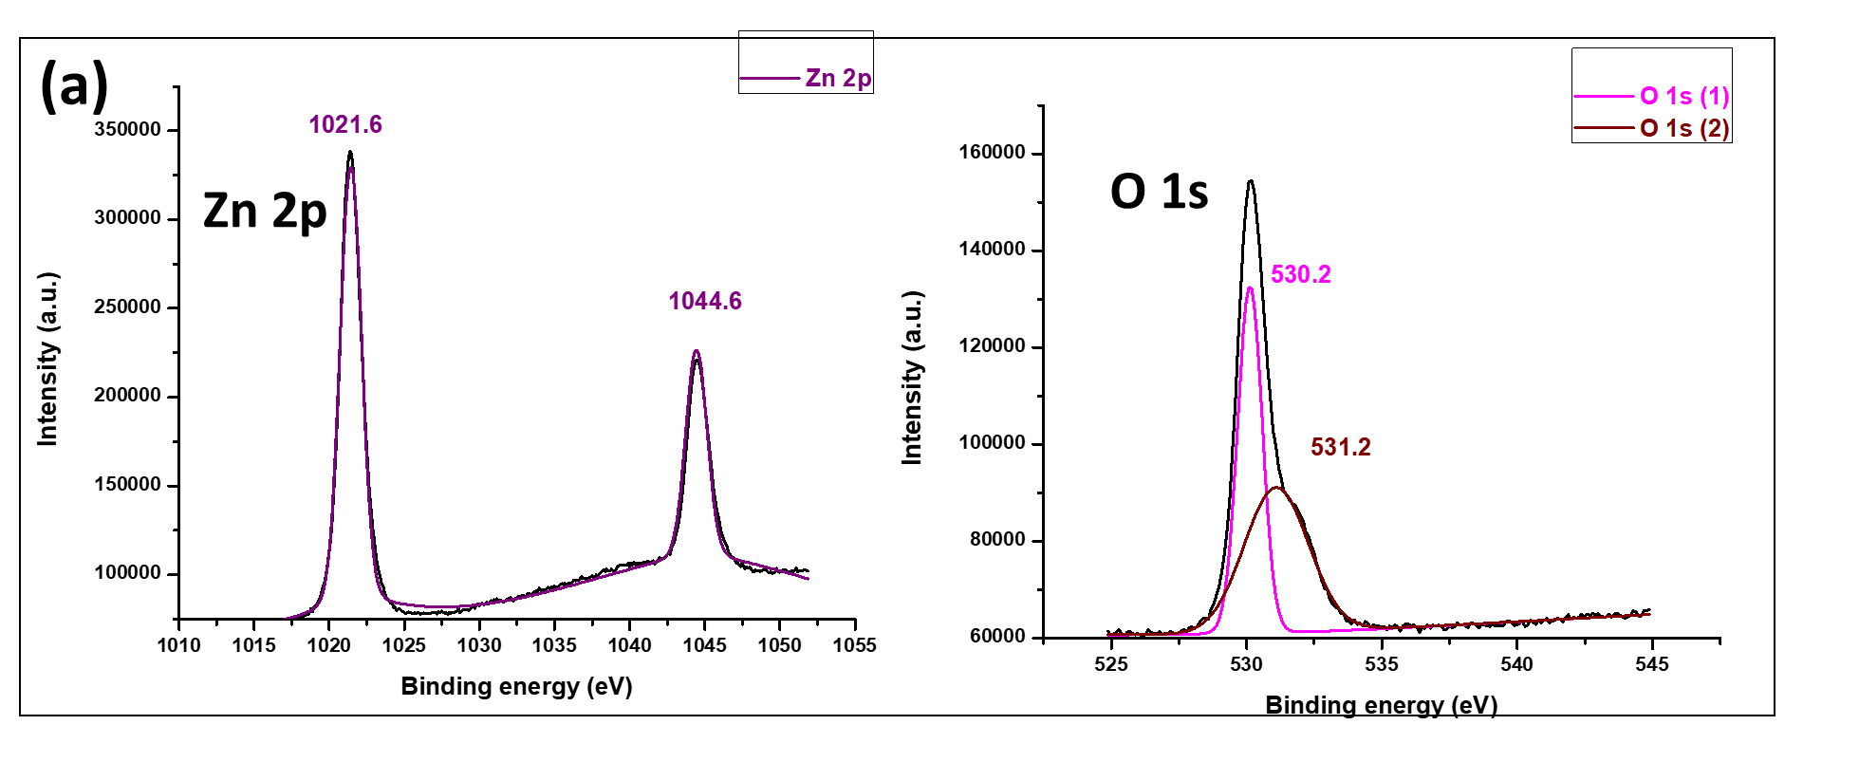

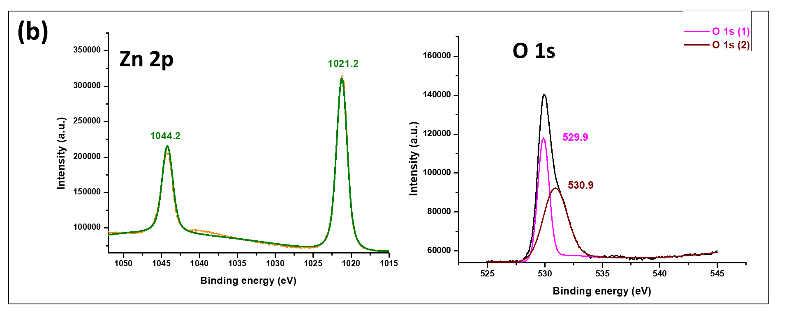

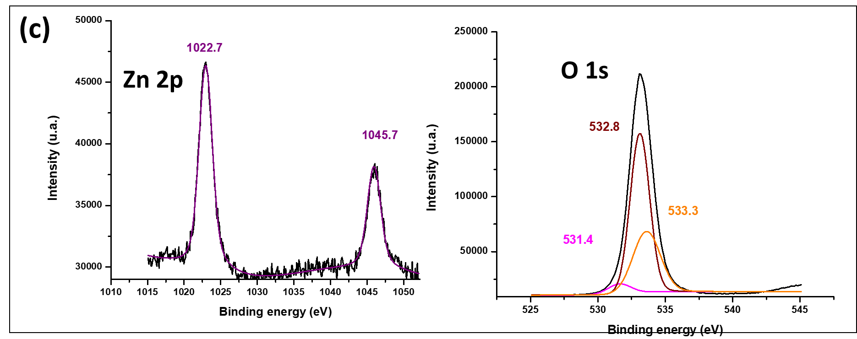

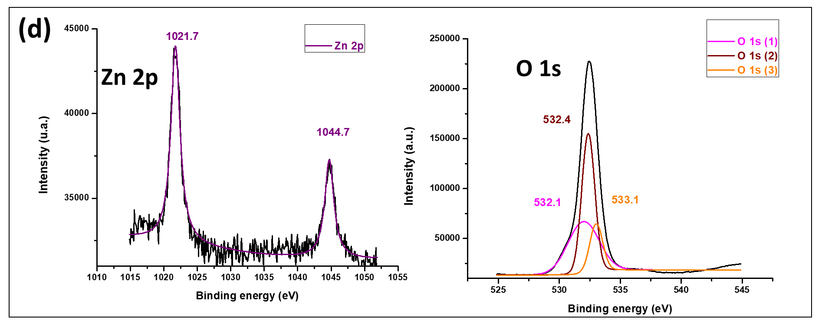

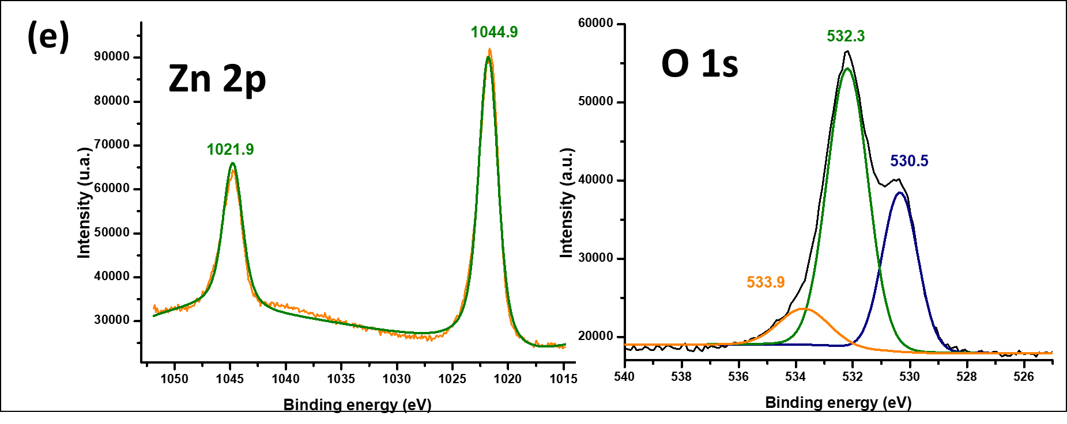

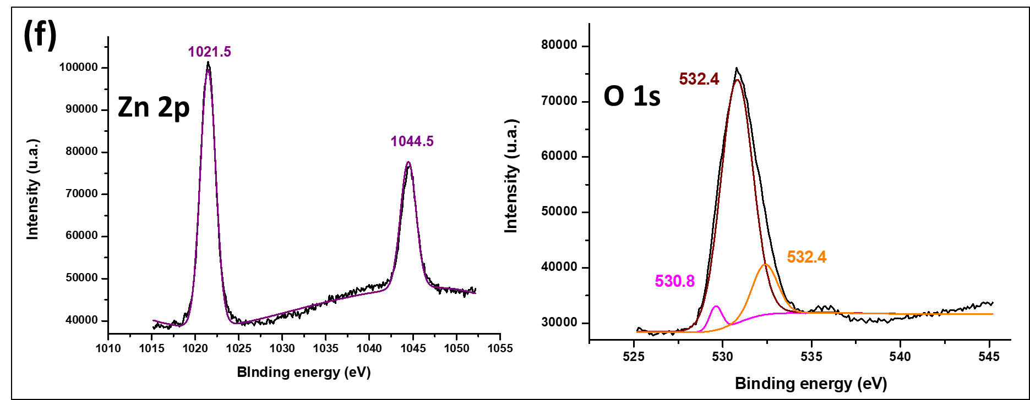

Figure S7. High-resolution XPS spectra of (a) ZnO by combustion method, (b) ZnO by precipitation method, (c) ZnO/SiO₂ (Amorphous) by combustion method, (d) ZnO/SiO₂ (Amorphous) by precipitation method, (e) ZnO/SiO₂ (Crystalline) by combustion method and (f) ZnO/SiO₂ (Crystalline) by precipitation method.

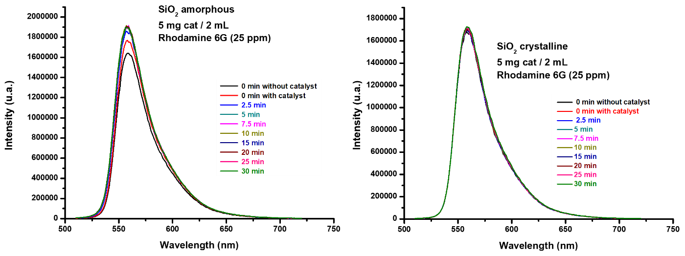
Figure S8. Emission spectra of rhodamine 6G using amorphous and crystalline SiO₂.

