Supplemental Information

Fabrication of Super-Lubricous Polyethylene Glycol Hydrogel Microspheres
Samuel Stealey¹, Ether Dharmesh¹, Maitreyi Bhagat², Abdul Malik Tyagi³, Andrew Schab¹, Mellissa Hong², Damon Osbourn², Yousef Abu-Amer³, Paul A. Jelliss², Silviya Petrova Zustiak^{1,}*
¹ Department of Biomedical Engineering, School of Science and Engineering, Saint Louis University, Saint Louis, MO
² Department of Chemistry, School of Science and Engineering, Saint Louis University, Saint Louis, MO
³ Department of Orthopedic Surgery, Washington University in Saint Louis, Saint Louis, MO

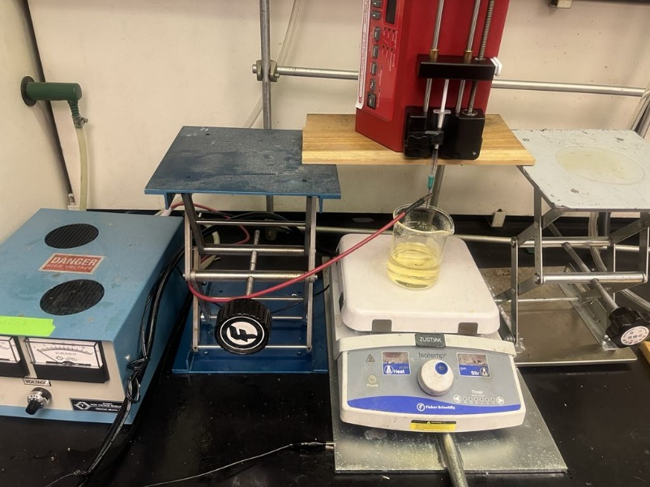
Supplemental Figure S1. Photograph of Electrospraying Setup. PEG is loaded into a syringe with attached blunt tip needle, which is then mounted on a programmable syringe pump. The syringe needle tip is attached via clip to a high voltage generator. The oil collection vessel is mounted on a stir plate on top of a grounded metal sheet. Stirring rate is programmed with stir plate and stir bar within oil collection vessel.

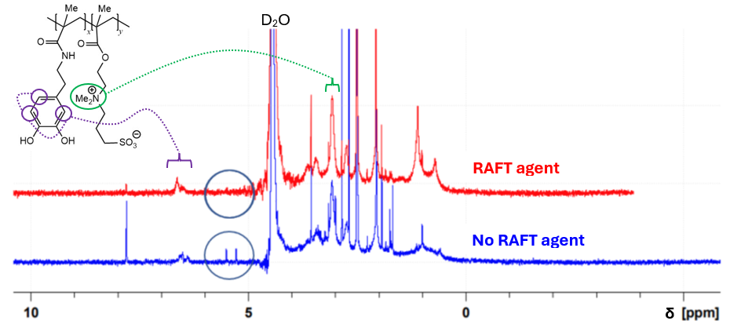
Supplemental Figure S2. 400 MHz NMR spectra of poly(DMA-co-SBMA) in PBS/D₂O. Products recovered by dialysis after polymerization with and without RAFT agent.

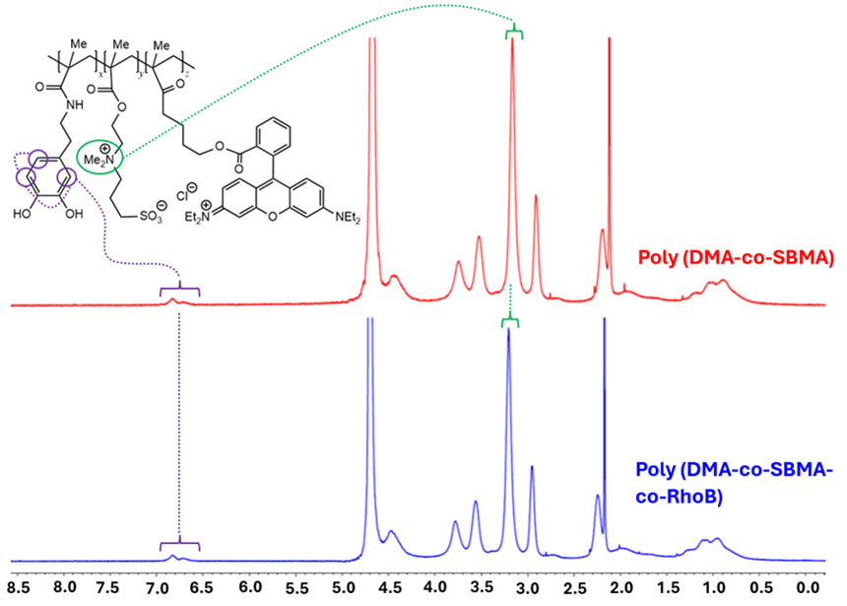
Supplemental Figure S3. 400 MHz NMR spectra of poly(DMA-co-SBMA) and poly(DMA-co-SBMA-co-RhoB) in PBS/D2O.

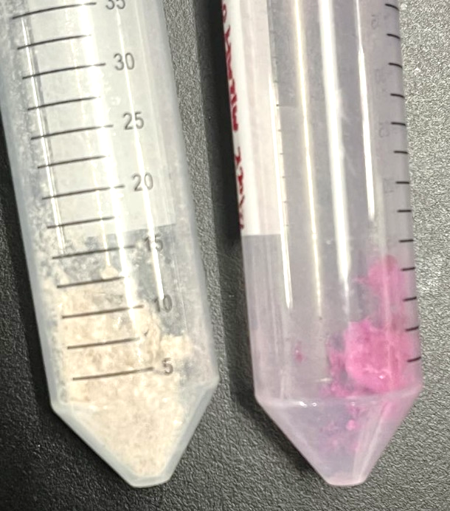
Supplemental Figure S4. Macroscopic photograph of poly(DMA-co-SBMA) (Left) and poly(DMA-co-SBMA-co-RhoB) (Right), with the pinkish color being attributed to the incorporation of RhoB within the copolymer.

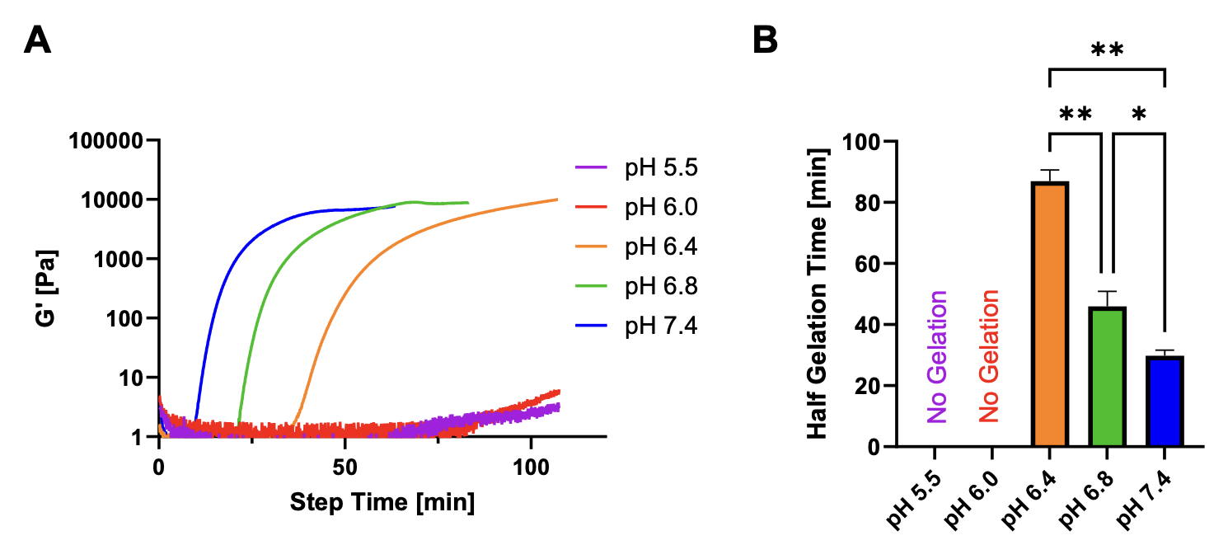
Supplemental Figure S5: Gelation kinetics (A) and calculated half-gelation time (B) of 4-arm PEG-Ac and PEG-diSH at varying pH. Gelation kinetics were measured via rheology, where increase in polymer solution storage modulus, G’, was indicative of gelation. * indicates p < 0.05, while ** indicates p < 0.01 (N = 4).

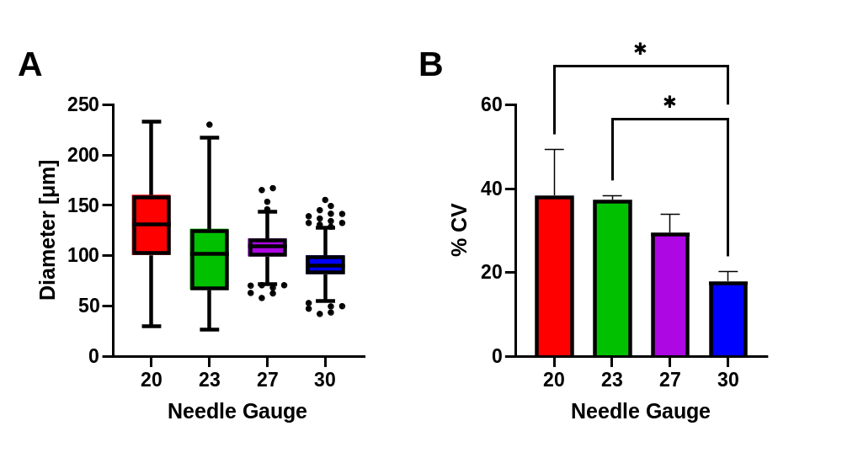
Supplemental Figure S6: A. Distribution of droplet diameters following electrospraying with varying needle diameter. B. Polydispersity of droplet diameters following electrospraying with varying needle diameter. * indicates statistically significant difference (N = 3, p < 0.05).

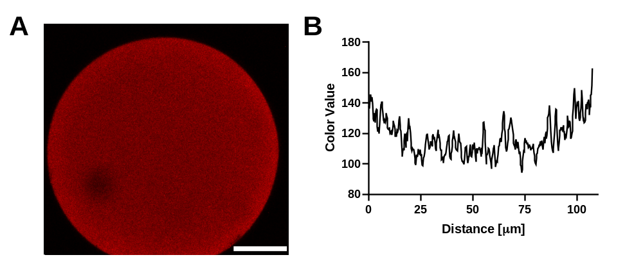
Supplemental Figure S7: A. Confocal slice of poly(DMA-co-SBMA-co-RhoB)-coated PEG microsphere. Scale bar represents 25 µm. B. Quantification of red color value from confocal image, where a color value of 0 represents no fluorescence, and a value of 255 represents the upper end of fluorescence.

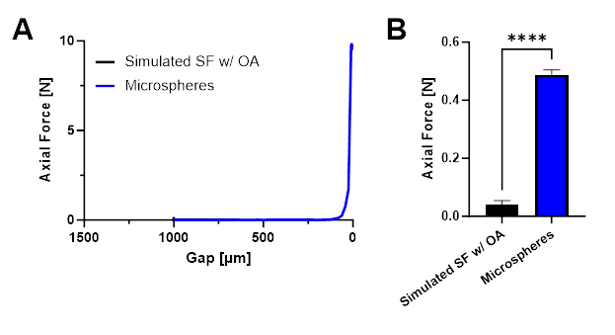
Supplemental Figure S8: A. Validation of rheological compression of hydrogel microspheres, where geometry gap was lowered and axial force recorded. B. Measured axial force at a gap of 10 µm.

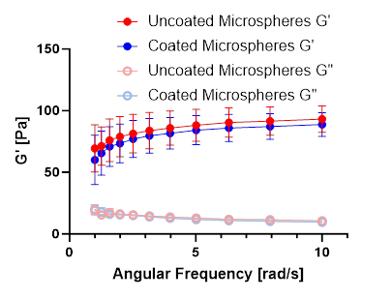
Supplemental Figure S9: Evolution of storage modulus, G’, and loss modulus, G”, as a function of angular frequency.

