Supplementary Information for:
Diversity and ecology of fungi in the sediments and surface water of brackish and salt marshes

Author names: Madeleine A. Thompson¹ (mthompson@seoe.sc.edu), Bruce W. Pfirrmann² (bruce@baruch.sc.edu), William H.J. Strosnider^{1,3} (bill@baruch.sc.edu), James L. Pinckney¹ (pinckney@sc.edu), and Xuefeng Peng ¹ (xpeng@seoe.sce.du)

Author affiliations: 1. School of Earth, Ocean, and Environment, University of South Carolina, Columbia, SC; 2. Baruch Marine Field Laboratory, University of South Carolina, Georgetown, SC 29440 USA; 3. Belle W. Baruch Institute for Marine and Coastal Sciences, University of South Carolina, Columbia, SC.

Authors for correspondence: Madeleine A. Thompson, School of Earth, Ocean, and Environment, University of South Carolina, Columbia, SC, Email: mthompson@seoe.sc.edu; Xuefeng Peng, School of Earth, Ocean, and Environment, University of South Carolina, Columbia, SC, Email: xpeng@seoe.sc.edu

Contents
Supplementary Figures 1 – 14
Supplementary Tables 1 – 9

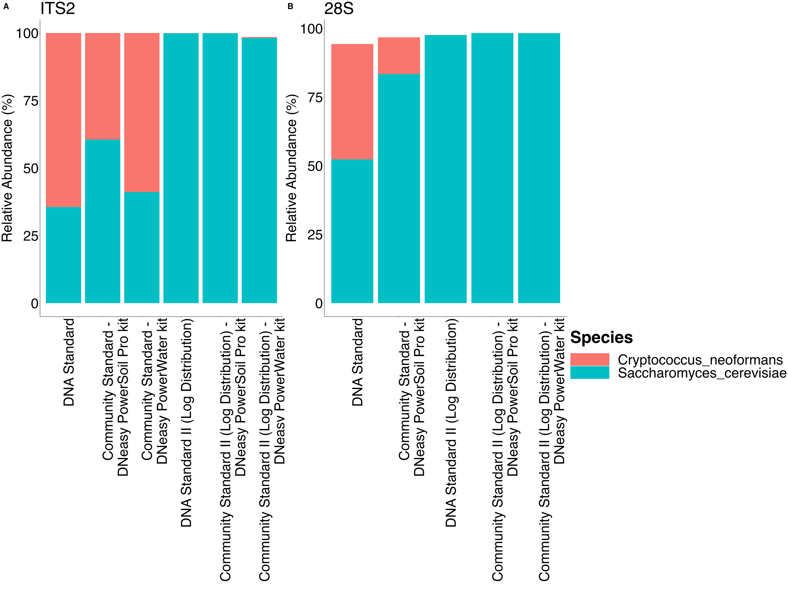
Supplementary Figure S1: The relative abundances of Saccharomyces cerevisiae and Cryptococcus neoformans OTUs were assessed in libraries prepared from ZymoBIOMICS Microbial Community DNA Standards and Microbial Community Standards (cells). For the DNA reference materials, the expected relative abundance of each species is 50%, based on a theoretical composition of 2% Saccharomyces cerevisiae and 2% Cryptococcus neoformans. However, in version II (log distribution) of the standards, the theoretical composition changes to 0.89% Saccharomyces cerevisiae and 0.00089% Cryptococcus neoformans, yielding an expected relative abundance of 99.9% for Saccharomyces cerevisiae and 0.1% for Cryptococcus neoformans. Different extraction kits were used for these microbial community standards. The DNeasy PowerSoil Pro kit was used for DNA extraction from sediment, while the DNeasy PowerWater extraction kit was used for DNA extraction from the Sterivex filters. These extraction methods were applied to the ZymoBIOMICS DNA Standard, ZymoBIOMICS Community (cells) Standard, ZymoBIOMICS DNA Standard II (log distribution), and ZymoBIOMICS Community (cells) Standard II (log distribution), using both A) ITS2 and B) 28S primers.

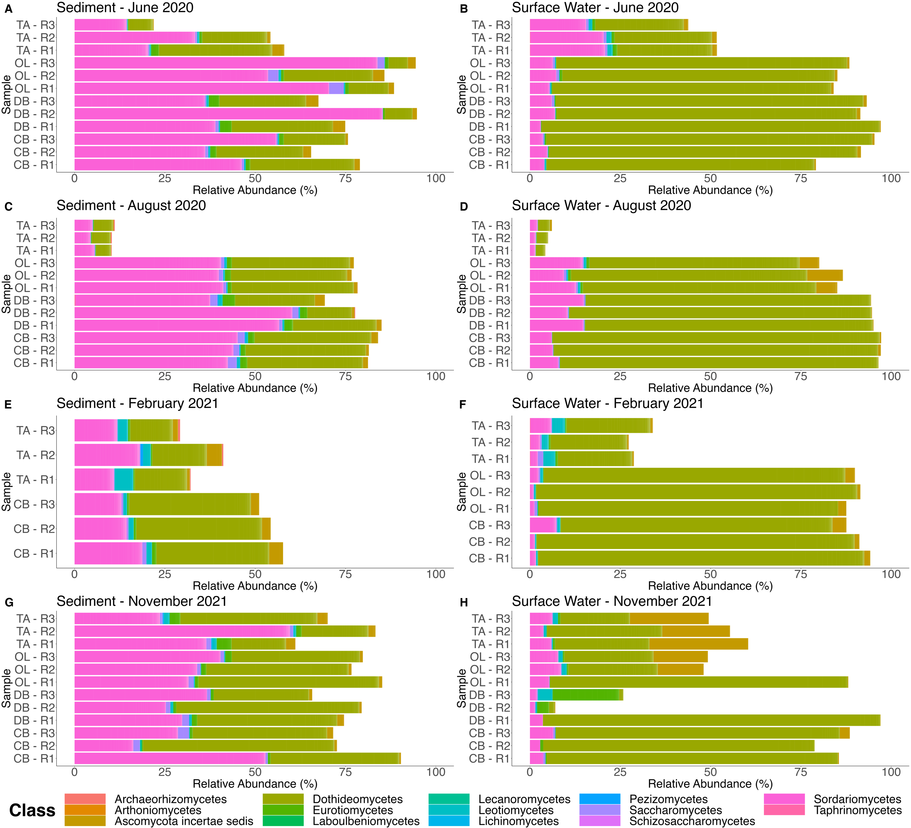

Supplementary Figure S2: The relative abundance of 28S OTUs from Ascomycota at the class level separated by sediment and surface water samples taken in June 2020, August 2020, February 2021, and November 2021 at Thousand Acre (TA), Oyster Landing (OL), Debidue Creek (DB), and Clambank (CB) in North Inlet – Winyah Bay, South Carolina, USA.

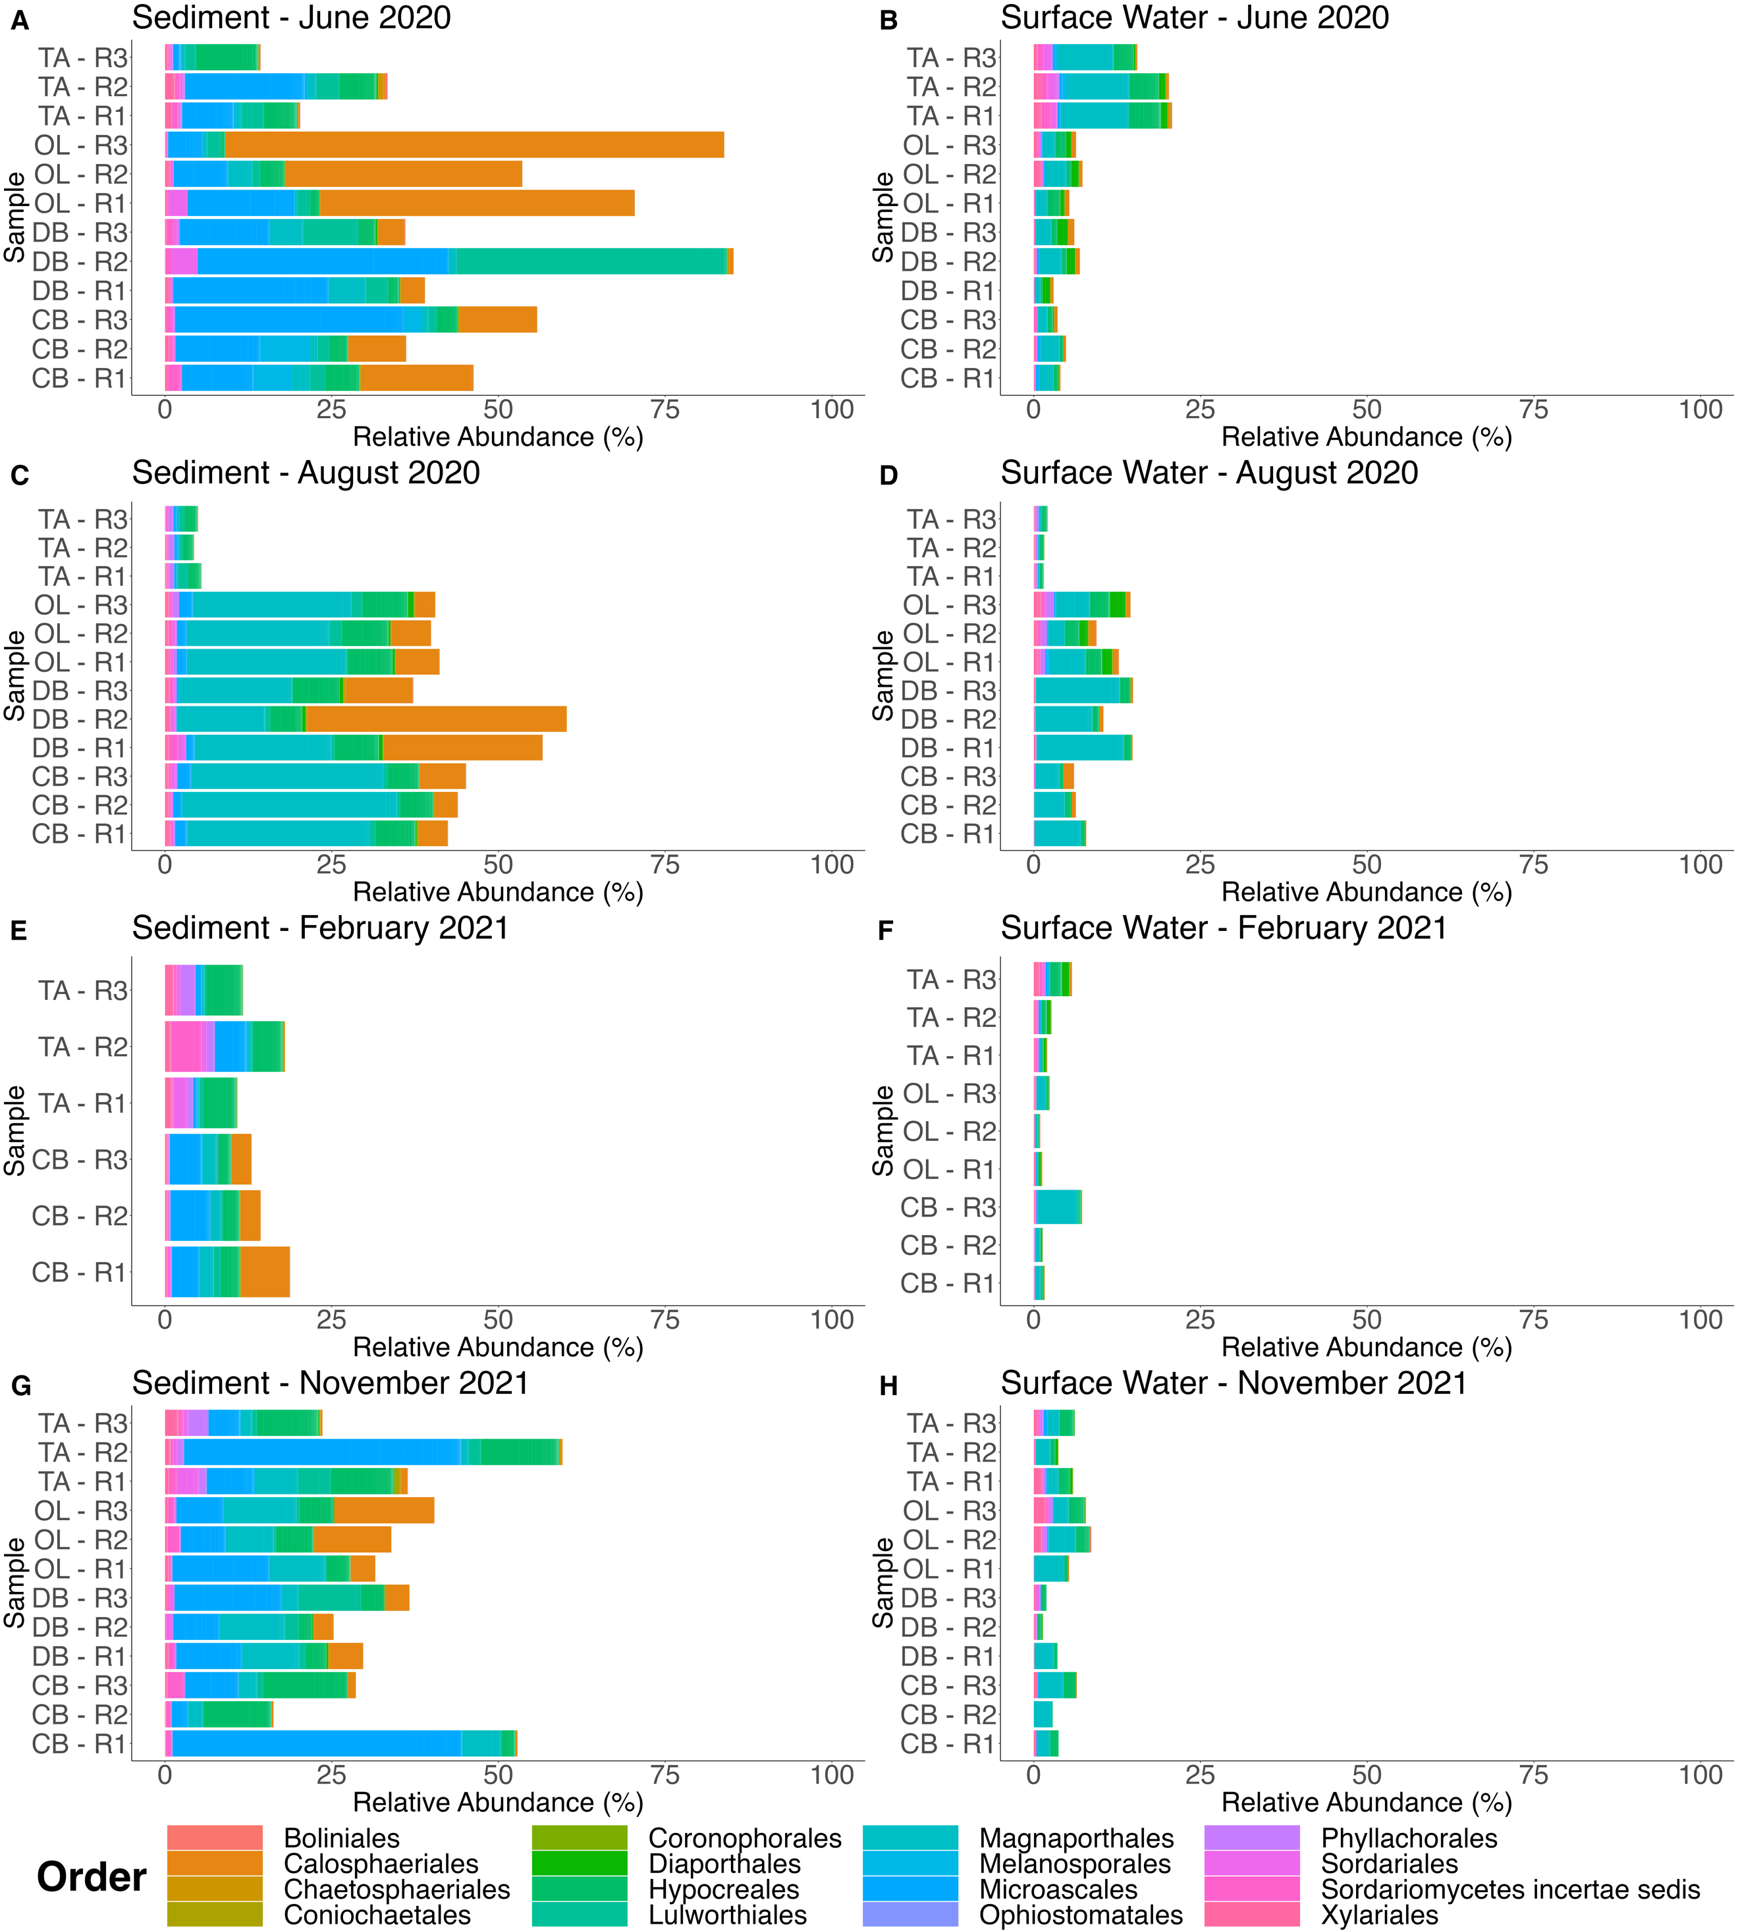

Supplementary Figure S3: The relative abundance of 28S OTUs from Sordariomycetes at the order level separated by sediment and surface water samples taken in June 2020, August 2020, February 2021, and November 2021 at Thousand Acre (TA), Oyster Landing (OL), Debidue Creek (DB), and Clambank (CB) in North Inlet – Winyah Bay, South Carolina, USA.
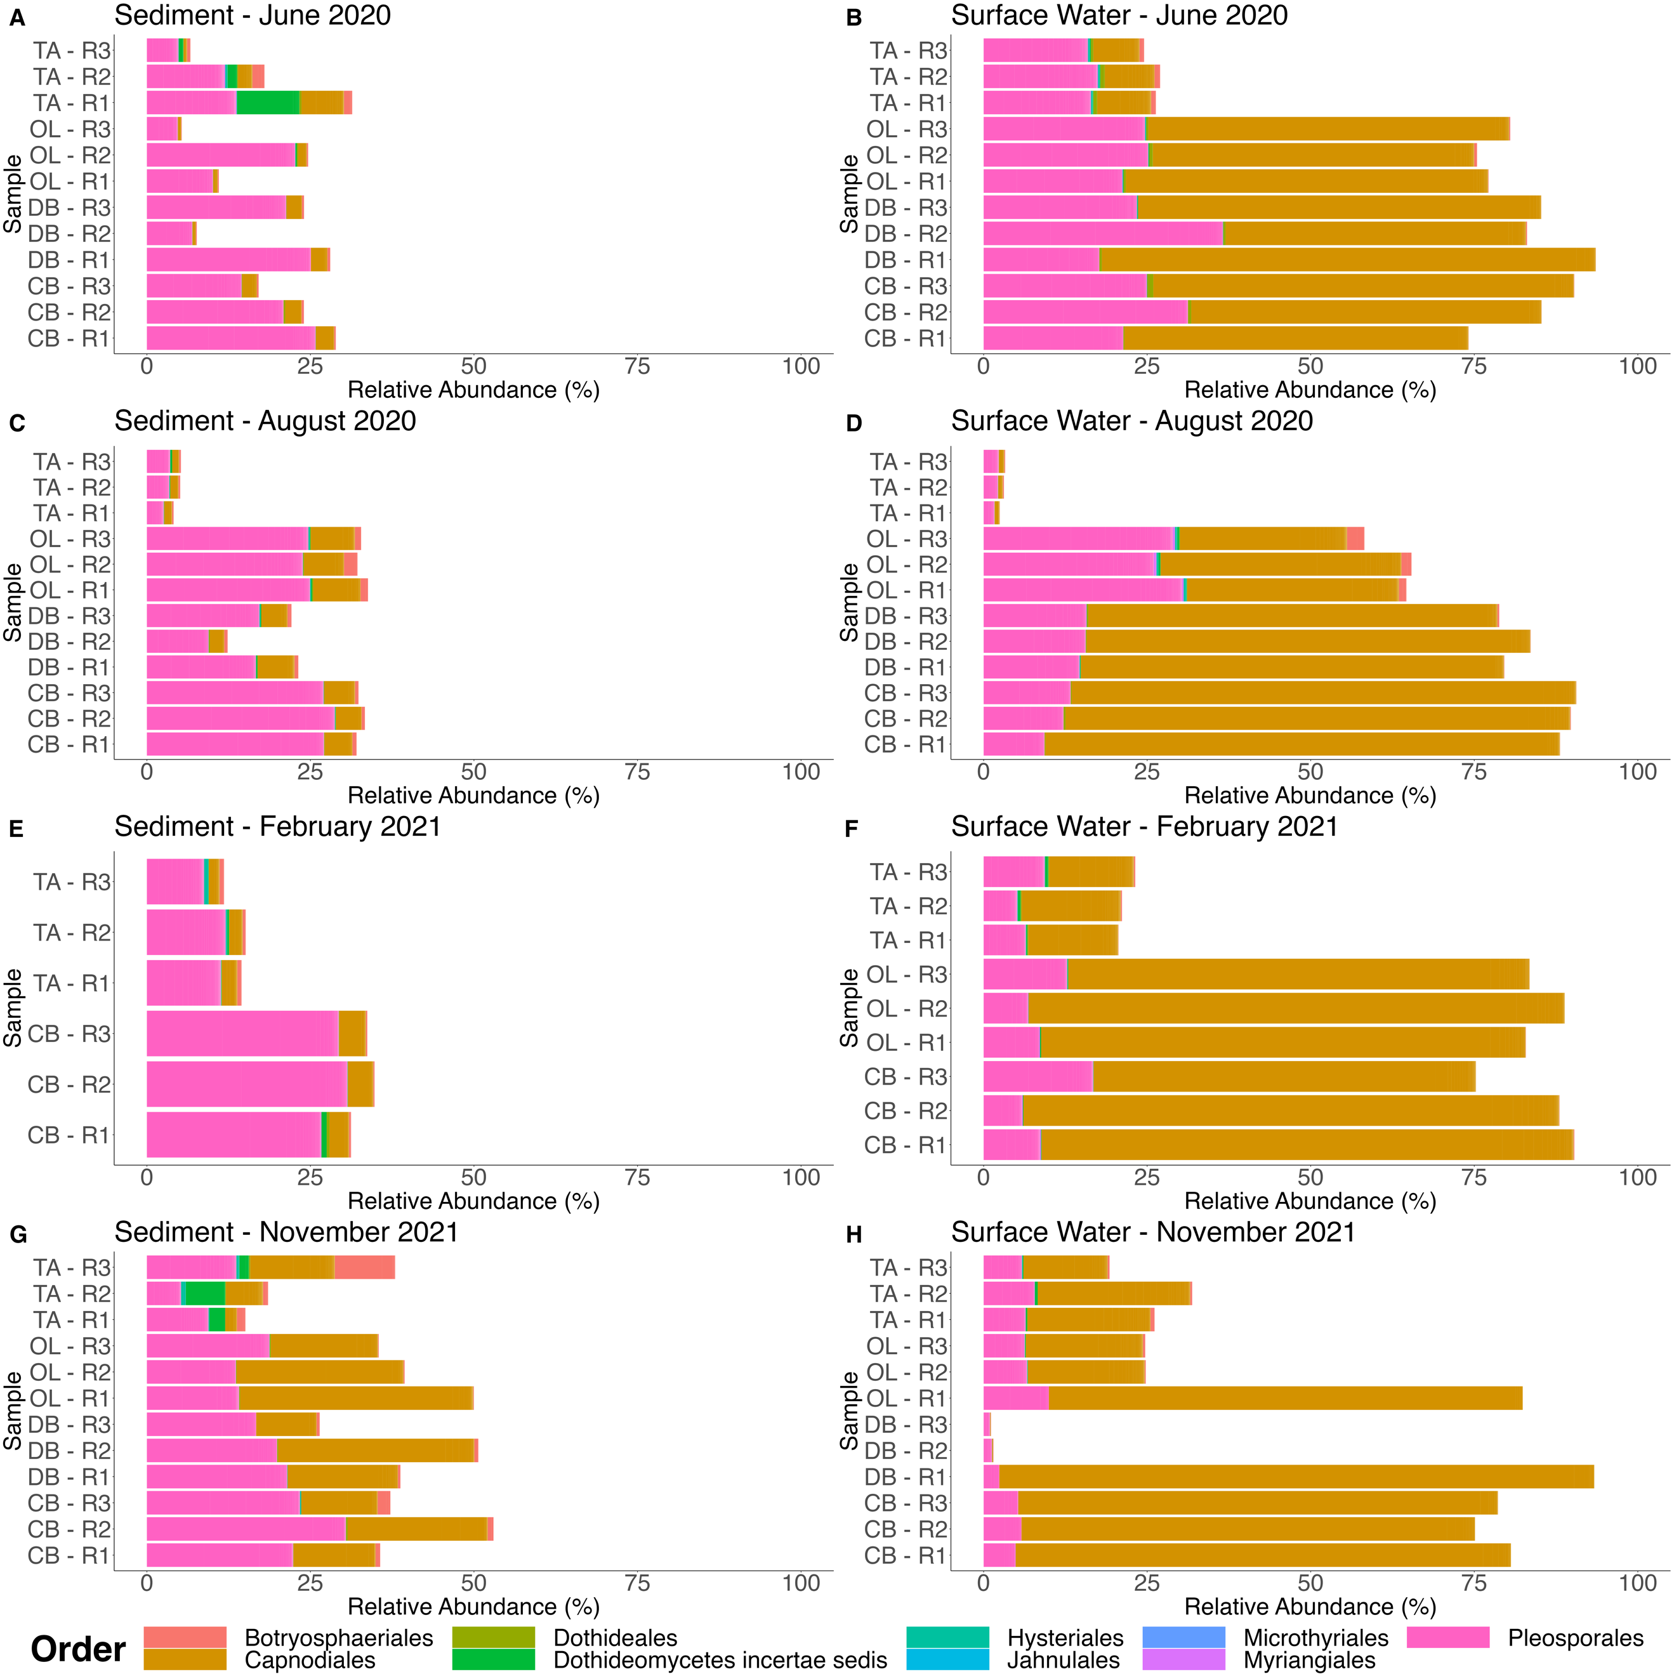

Supplementary Figure S4: The relative abundance of 28S OTUs from Dothideomycetes at the order level separated by sediment and surface water samples taken in June 2020, August 2020, February 2021, and November 2021 at Thousand Acre (TA), Oyster Landing (OL), Debidue Creek (DB), and Clambank (CB) in North Inlet – Winyah Bay, South Carolina, USA.

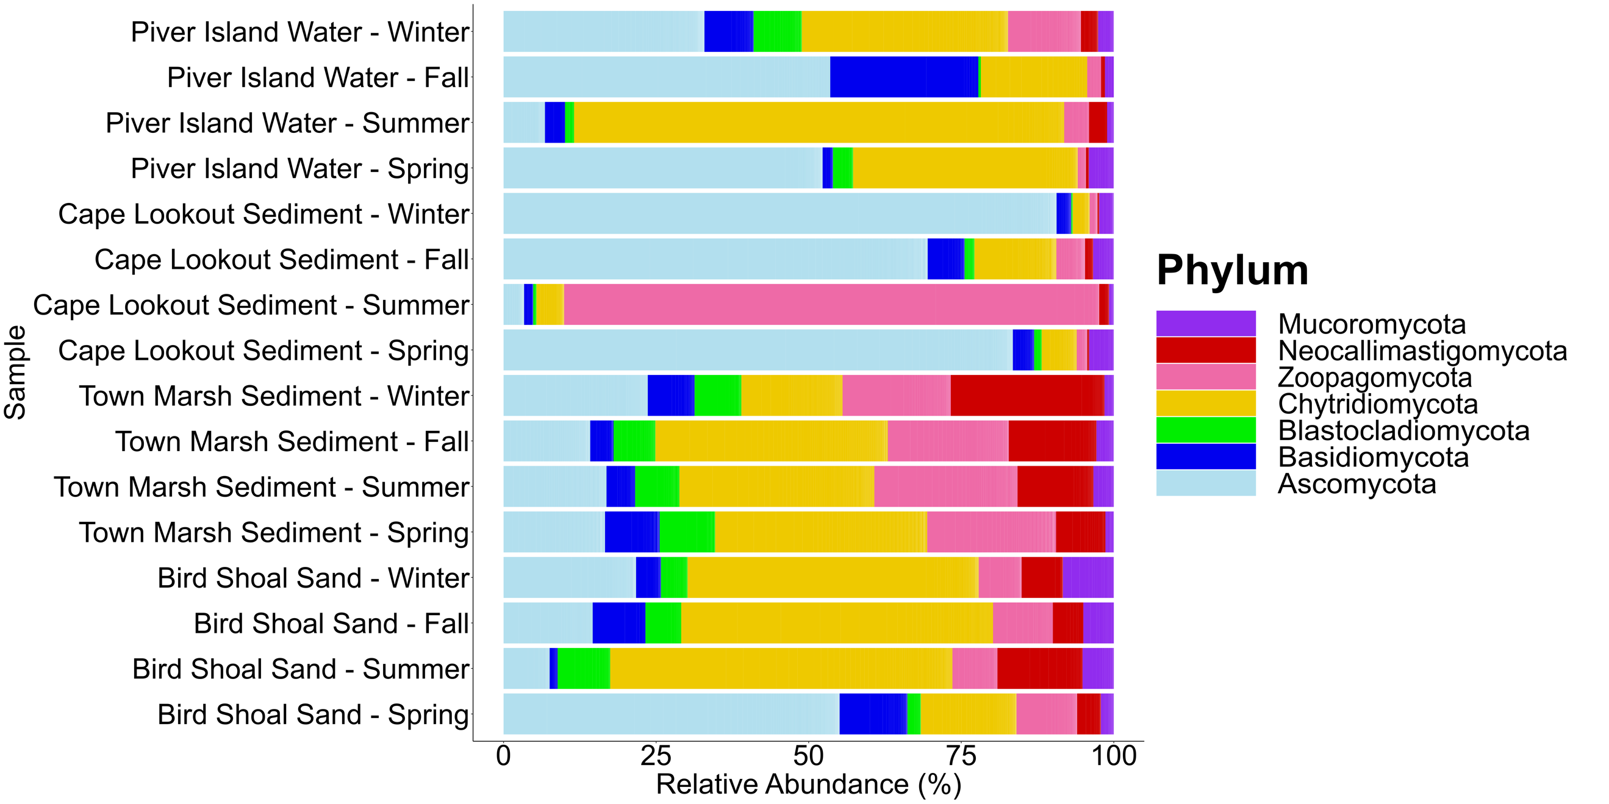

Supplementary Figure S5: The relative abundance of 28S OTUs from from Picard (2017; sequences from the Sequence Read Archive #SRP091681) processed using our 28S analysis pipeline and RDP database. Picard (2017) had found many early diverging fungi in coastal sediments with approximately 10% of fungal OTUs unclassified at the phylum level. Picard (2017) used both BLAST + MEGAN v. 5.8.4 and RDP classifiers to classify their 440 97% fungal OTUs. However, when the sequences from Picard (2017) were processed with our 28S pipeline, the updated RDP 2.14 classifier classified 1020 97% fungal OTUs (Wang & Cole, 2024) with no unclassified fungi at the phylum level and an increase in Zoopagomycota identified (Supplementary Figure S6).

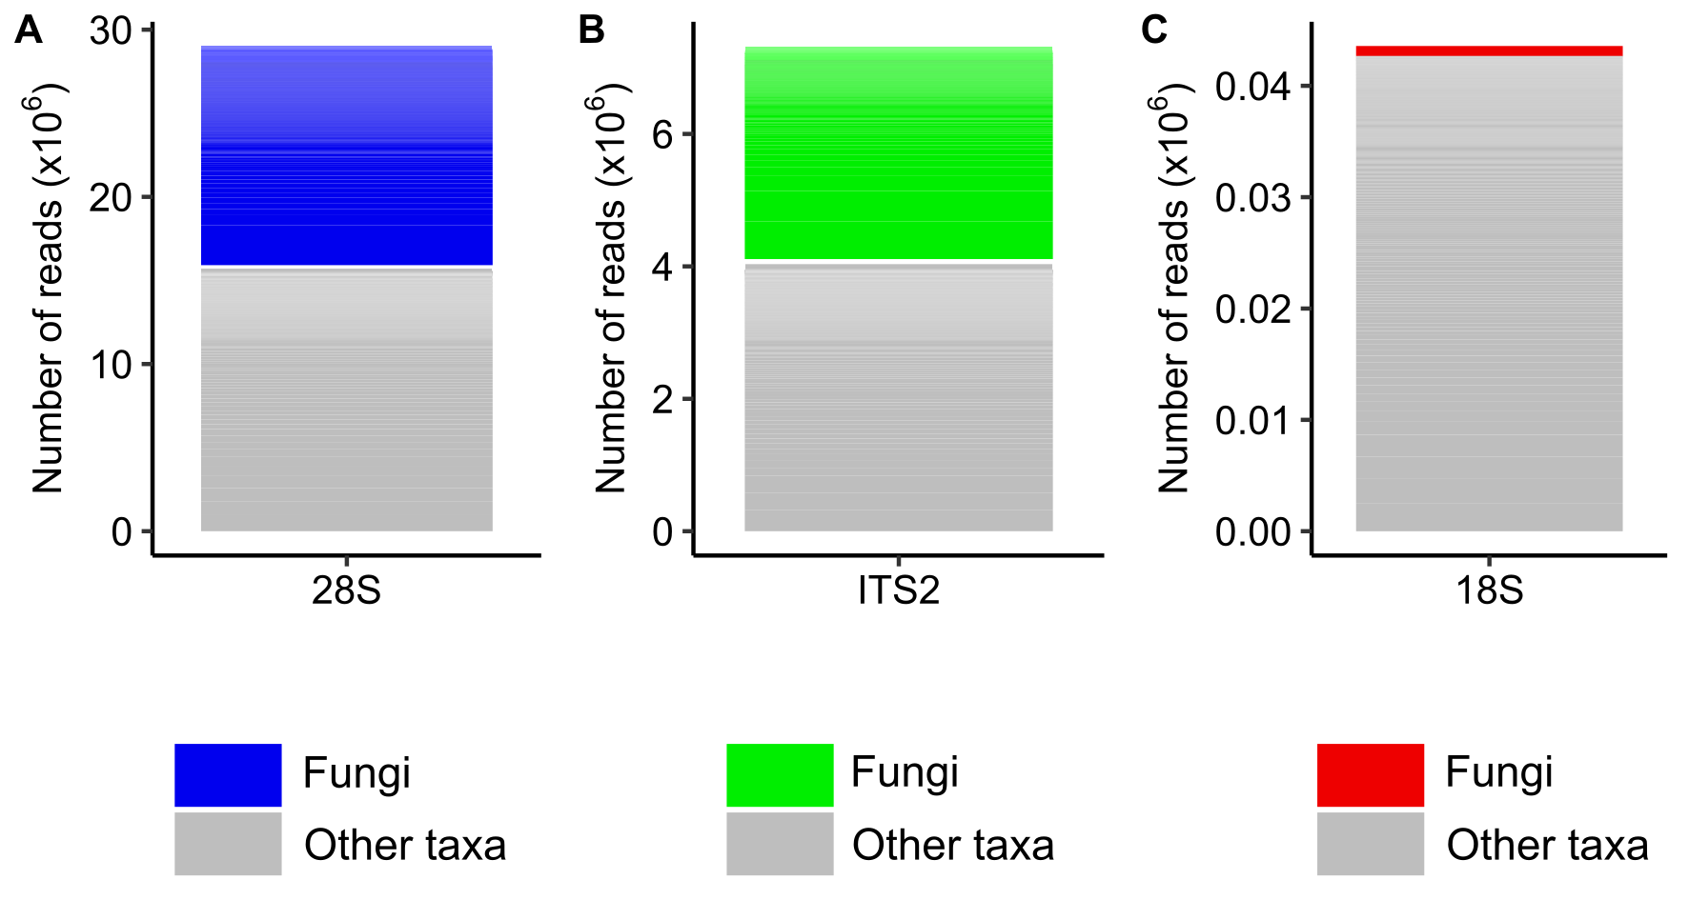

Supplementary Figure S6: The number of reads that were identified as fungi and non-fungal from the A) 28S primer set, B) ITS2 primer set, and C) 18S primer set in all samples collected from North Inlet – Winyah Bay National Estuarine Research Reserve.

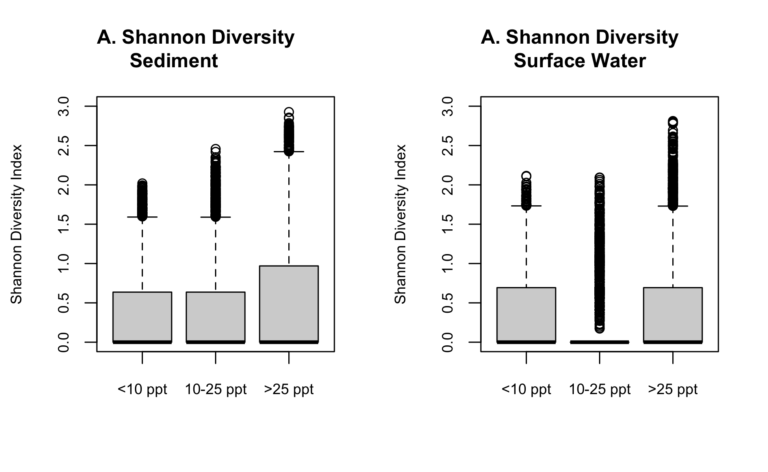
Supplementary Figure S7: Shannon diversity of 28S OTUs in A) the sediment and B) surface water between different salinity ranges (<10 ppt, 10 – 25 ppt, and >25 ppt).

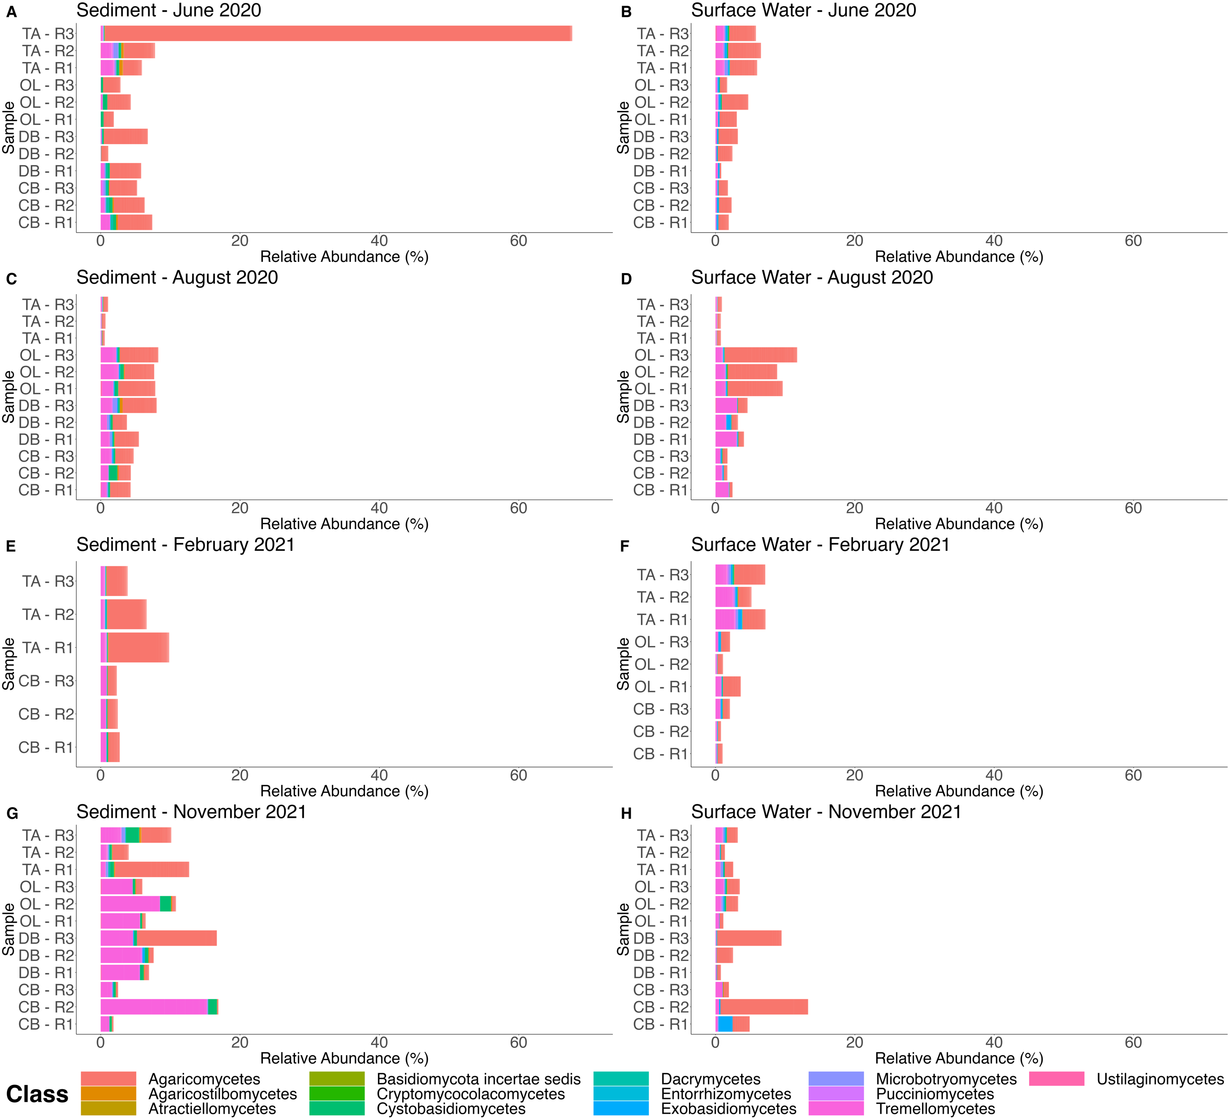

Supplementary Figure S8: The relative abundance of 28S OTUs from Basidiomycota at the class level separated by sediment and surface water samples taken in June 2020, August 2020, February 2021, and November 2021 at Thousand Acre (TA), Oyster Landing (OL), Debidue Creek (DB), and Clambank (CB) in North Inlet – Winyah Bay, South Carolina, USA.

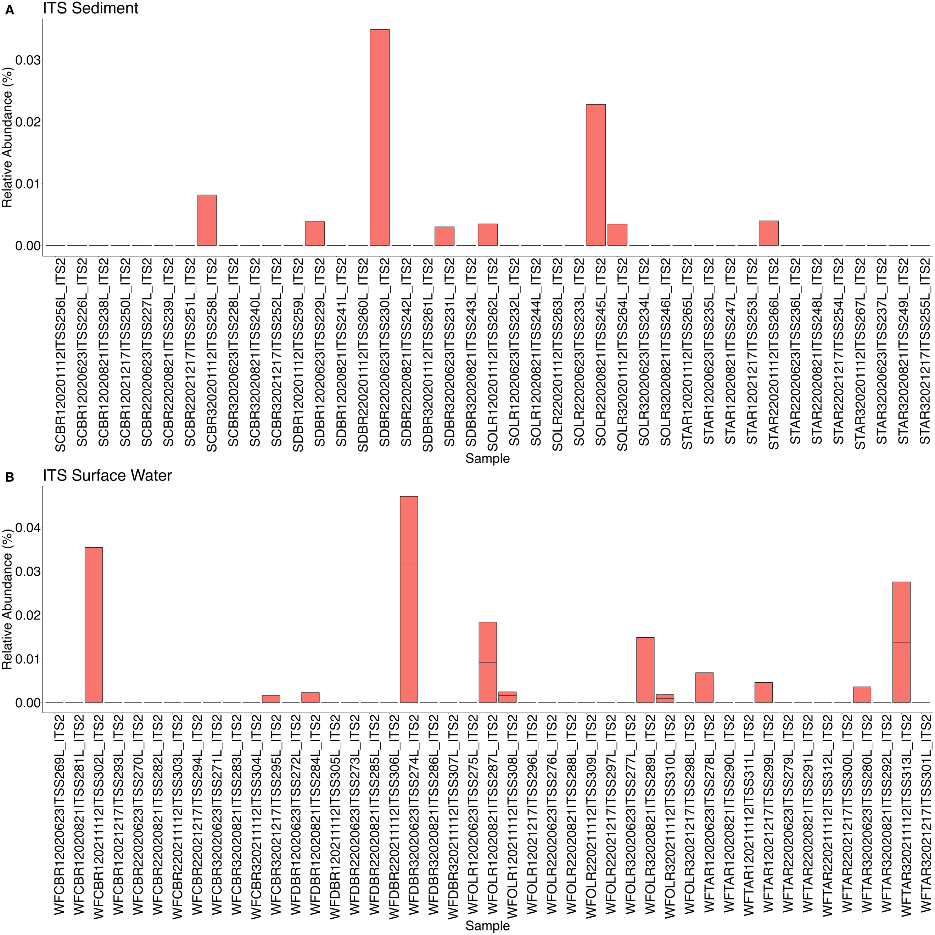

Supplementary Figure S9: The relative abundance of ITS2 OTUs from Malasseziaceae in all samples from A) sediment and B) surface water in North Inlet - Winyah Bay.

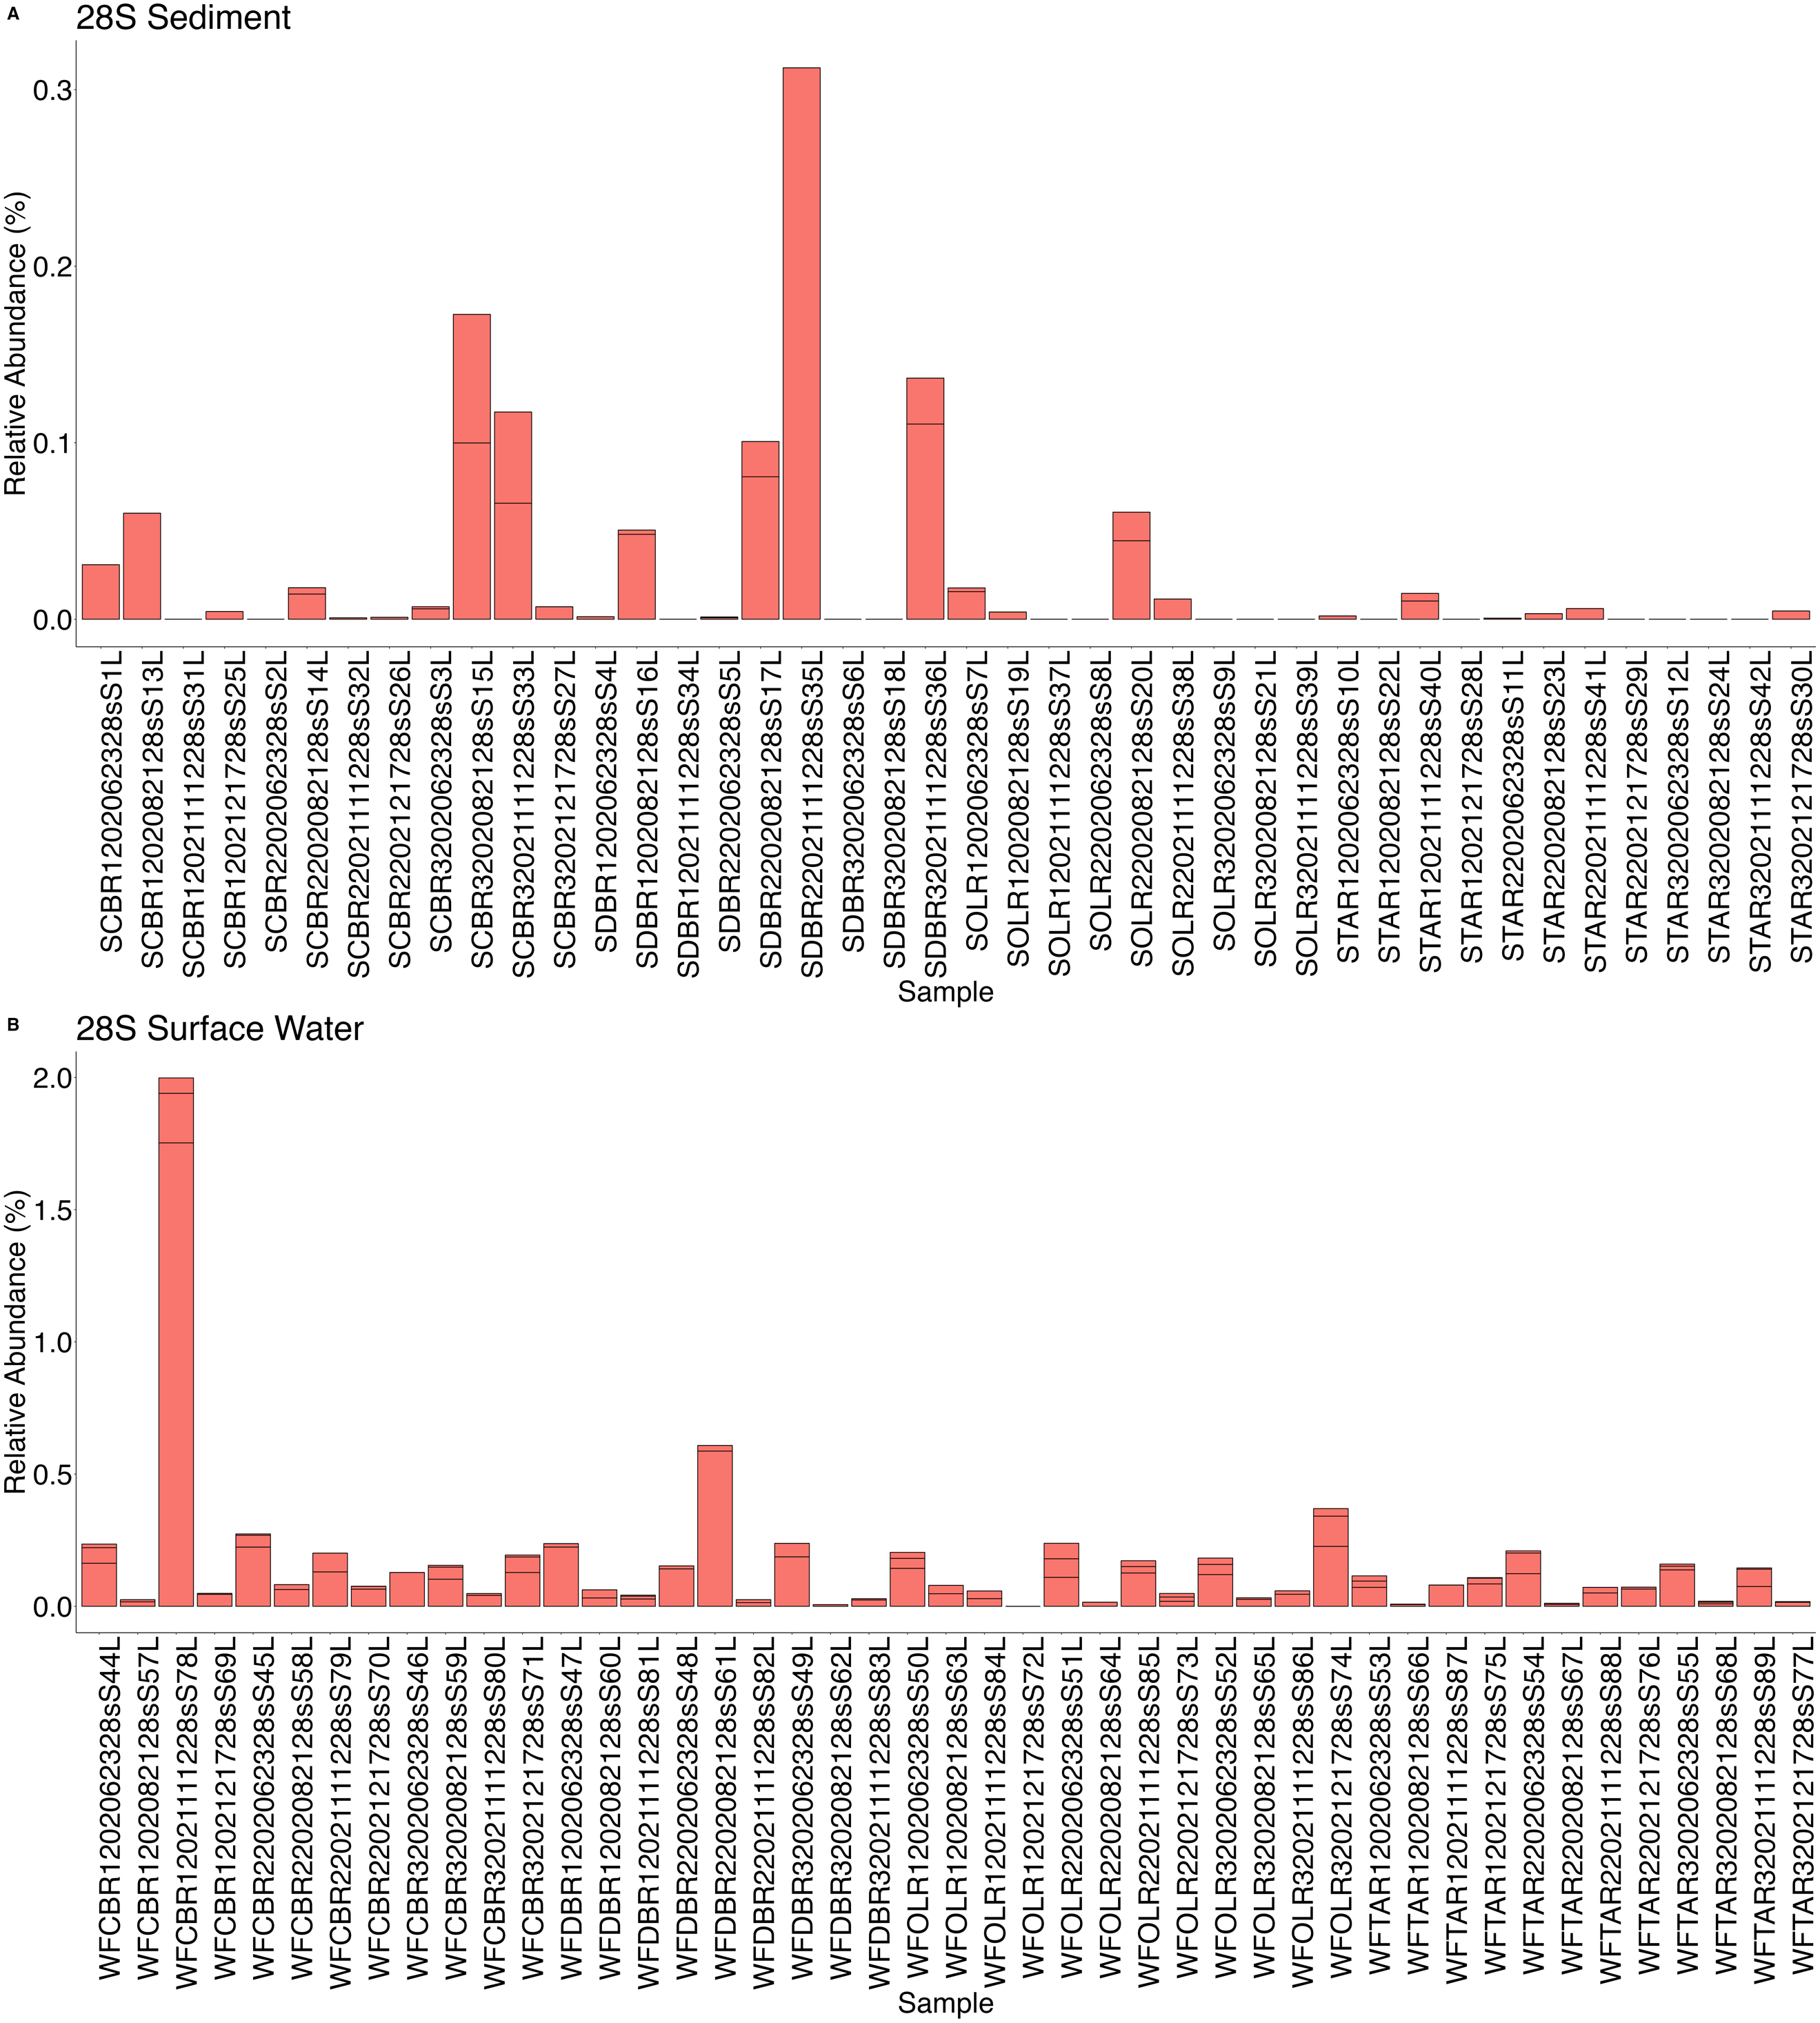

Supplementary Figure S10: The relative abundance of 28S OTUs from Malasseziaceae in all samples from A) sediment and B) surface water in North Inlet - Winyah Bay.
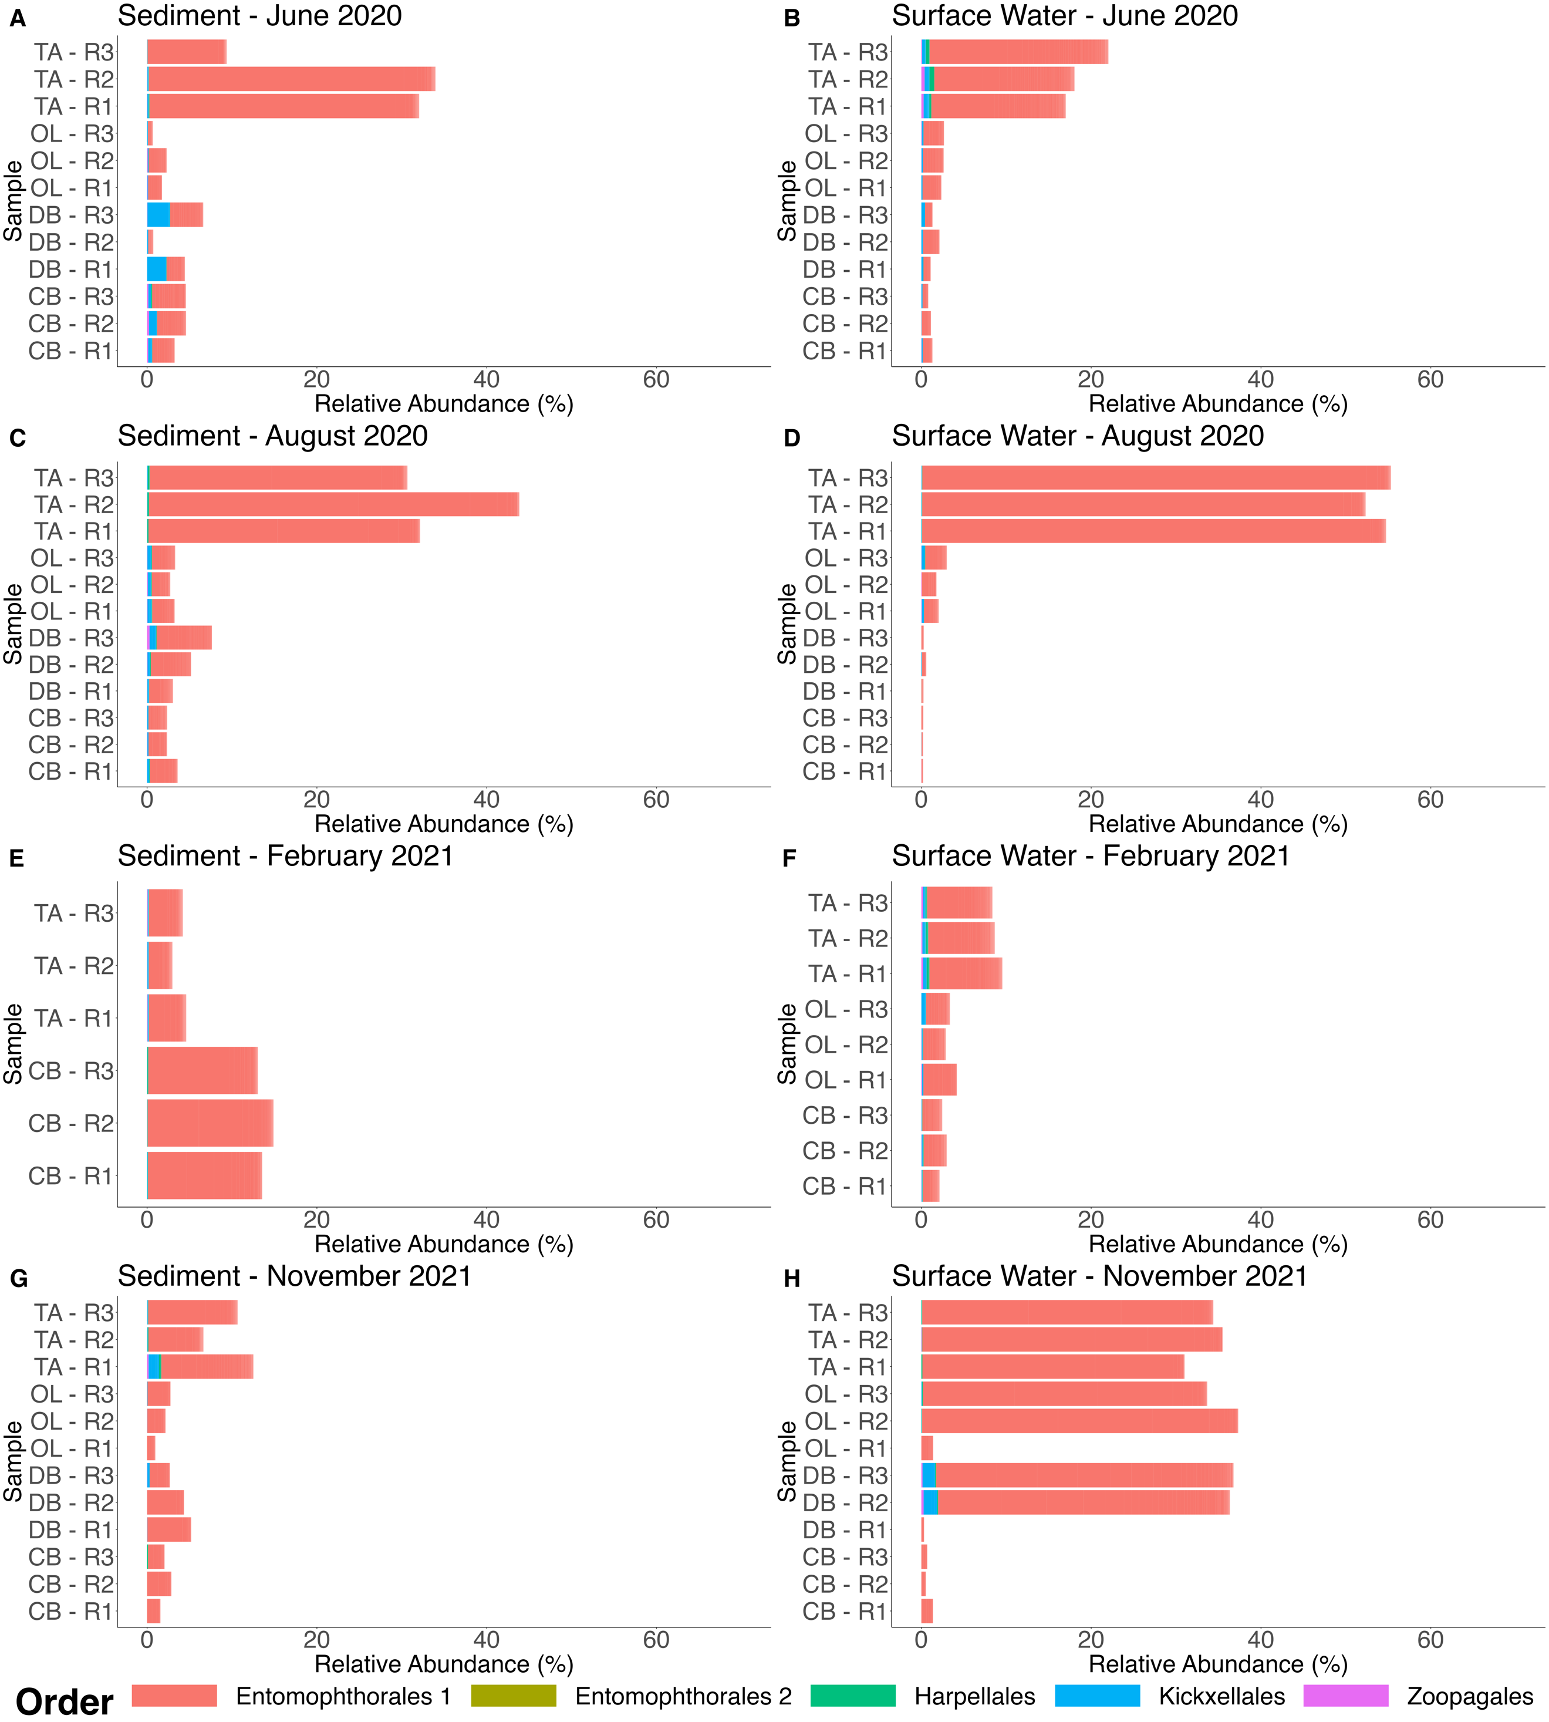

Supplementary Figure S11: The relative abundance of 28S OTUs from Zoopagomycota at the order level separated by sediment and surface water samples taken in June 2020, August 2020, February 2021, and November 2021 at Thousand Acre (TA), Oyster Landing (OL), Debidue Creek (DB), and Clambank (CB) in North Inlet – Winyah Bay, South Carolina, USA.
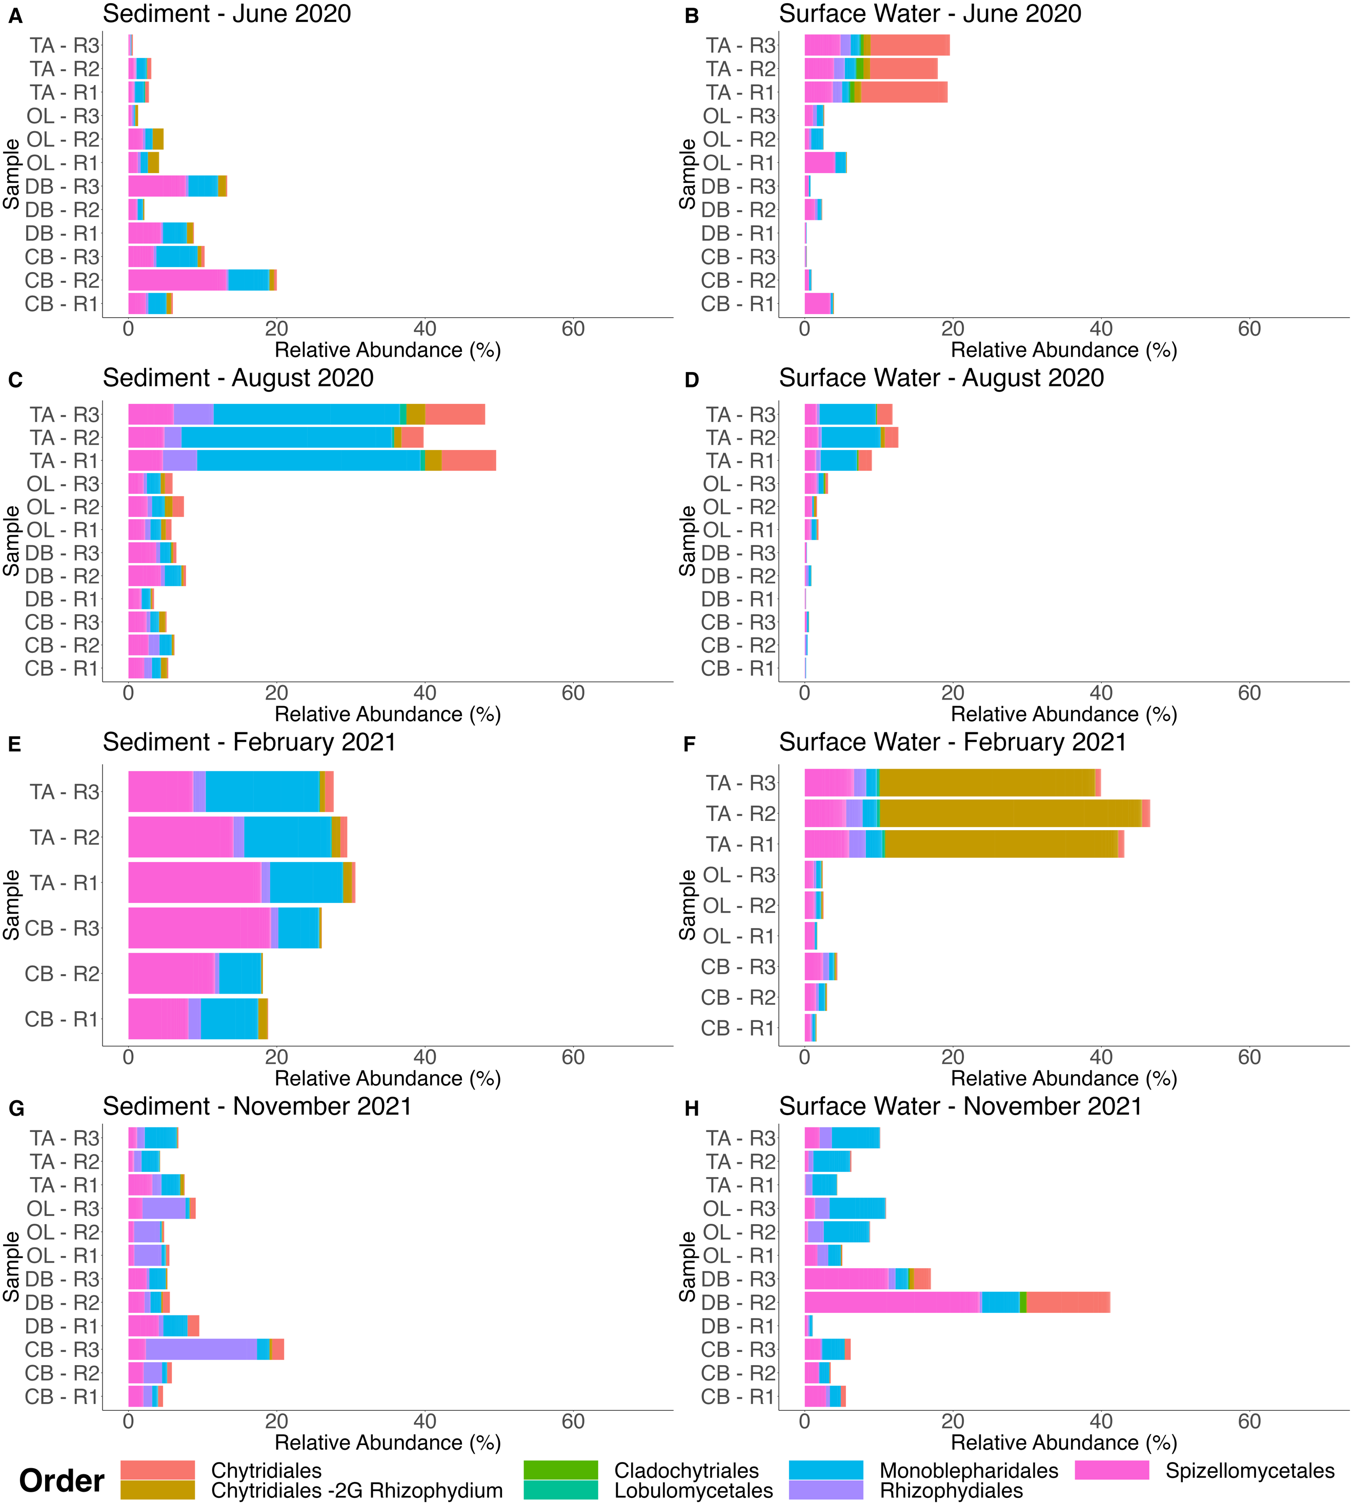
Supplementary Figure S12: The relative abundance of 28S OTUs from Chytridiomycota at the order level separated by sediment and surface water samples taken in June 2020, August 2020, February 2021, and November 2021 at Thousand Acre (TA), Oyster Landing (OL), Debidue Creek (DB), and Clambank (CB) in North Inlet – Winyah Bay, South Carolina, USA. Chytridales -2G Rhizophydium primarily consists of members of the morphogenus Rhizophydium, characterized by a monocentric, epibiotic, inoperculate sporangium, an endobiotic rhizoidal axis that branches, and an epibiotic resting spore. It also includes various other genera, such as Kappamyces, Batrachochytrium (endobiotic species), Entophlyctis (endobiotic species), JEL142 (species with multiple rhizoidal axes), and JEL223 (operculate species) (James et al., 2006, Mycologia).

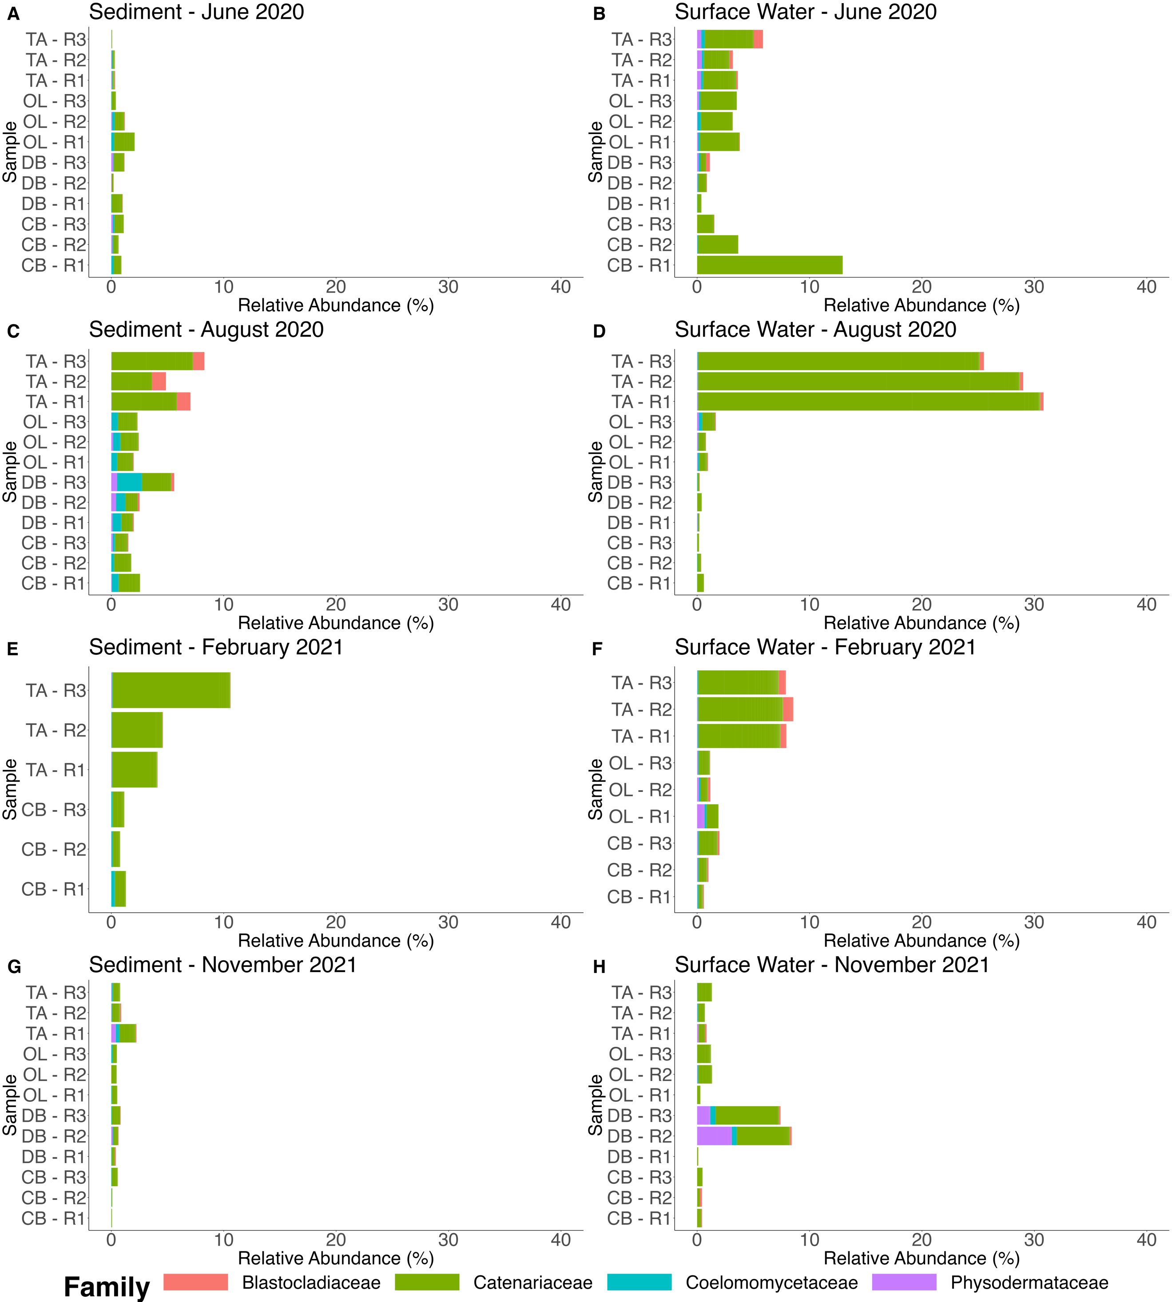

Supplementary Figure S13: The relative abundance of 28S OTUs from Blastocladiomycota at the family level separated by sediment and surface water samples taken in June 2020, August 2020, February 2021, and November 2021 at Thousand Acre (TA), Oyster Landing (OL), Debidue Creek (DB), and Clambank (CB) in North Inlet – Winyah Bay, South Carolina, USA.

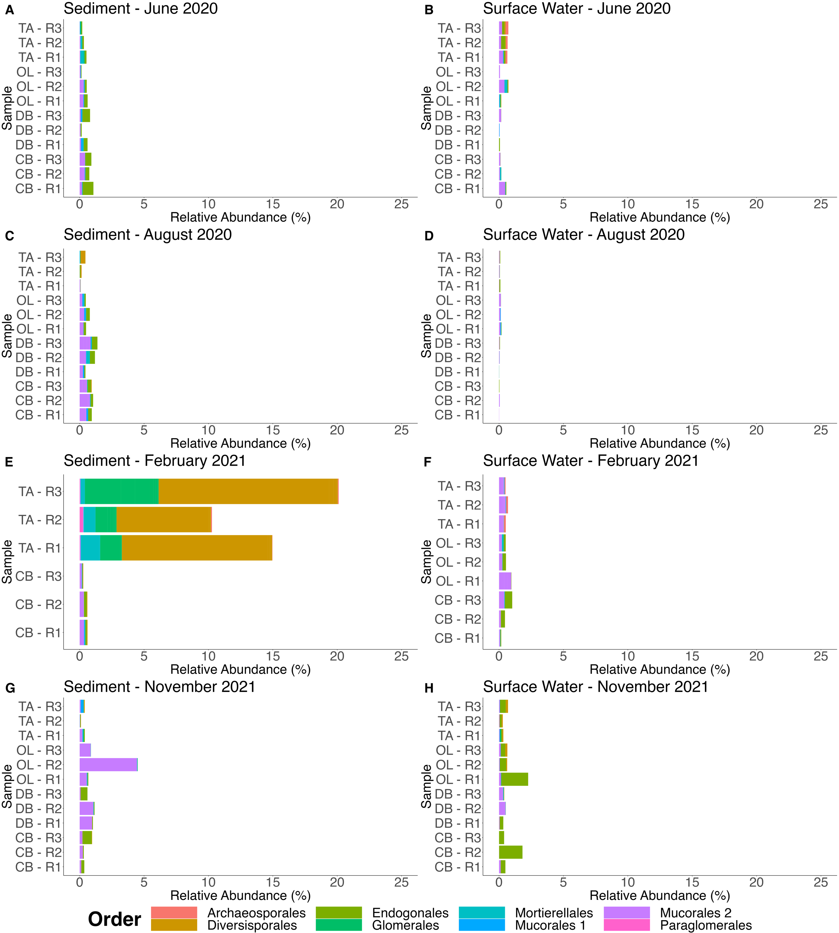

Supplementary Figure S14: The relative abundance of 28S OTUs from Mucoromycota at the order level separated by sediment and surface water samples taken in June 2020, August 2020, February 2021, and November 2021 at Thousand Acre (TA), Oyster Landing (OL), Debidue Creek (DB), and Clambank (CB) in North Inlet – Winyah Bay, South Carolina, USA.

Supplementary Table S1: Forward primers used for ITS2 sequencing (cite Tedersoo et al. 2015 Mycokeys here). The parts in bold font are standard Illumina adapters. The five ITS3tag primers were combined in equimolar as the forward primer.

Primer name for ITS2 | Primer sequence
ITS3tagmix1_adapter | TCGTCGGCAGCGTCAGATGTGTATAAGAGACAGCTAGACTCGTCATCGATGAAGAACGCAG
ITS3tagmix2_adapter | TCGTCGGCAGCGTCAGATGTGTATAAGAGACAGCTAGACTCGTCAACGATGAAGAACGCAG
ITS3tagmix3_adapter | TCGTCGGCAGCGTCAGATGTGTATAAGAGACAGCTAGACTCGTCACCGATGAAGAACGCAG
ITS3tagmix4_adapter | TCGTCGGCAGCGTCAGATGTGTATAAGAGACAGCTAGACTCGTCATCGATGAAGAACGTAG
ITS3tagmix5_adapter | TCGTCGGCAGCGTCAGATGTGTATAAGAGACAGCTAGACTCGTCATCGATGAAGAACGTGG

Supplementary Table S2: Amplicon analysis pipeline statistics of all samples for 18S, ITS2, and 28S primer sets. The 18S reads were merged following the Furhman lab protocol with modifications (described in main text). ITS2 reads were trimmed and merged using ITSxpress which uses Vsearch. 28S reads were merged by USEARCH v11.0.667.

 | 18S | ITS2 | 28S
Total forward and reverse reads sequenced | 6,386,809 | 147,932,265 | 113,838,892
Merged reads | NA | 13,069,369 (8.8%) | 84,007,763 (73.8%)
Mean merged length | NA | 183.9 bp | 228.12 bp
Merged reads passed quality filtering | 590,816 (23.0%) | 10,935,964 (83.7%) | 36,787,733 (43.8%)
Number of OTUs | 3,762 | 18,389 | 8,461
Number of fungal OTUs | 3 (0.07%) | 8,751 (47.5%) | 3,821 (45.2%)
Number reads mapped to eukaryotic OTUs | 4.3x10⁴ | 7.3x10⁶ | 2.9x10⁷
Percent of reads mapped to fungal OTUs | 0.0005% | 26.9% | 45.1%

Supplementary Table S3: Number and percent of 18S reads of fungal OTUs identified by the universal primer set across all samples in North Inlet - Winyah Bay (1,746,250 total 18S reads).

Fungal OTU Taxonomy | Number of reads across all samples | Percent of 18S reads across all samples
Phylum: Ascomycota, Class: Dothideomycetes, Order: Pleosporales, Family: Pleosporaceae | 55 | 0.0031%
Phylum: Ascomycota, Class: Saccharomycetes, Order: Saccharomycetales, Family: Saccharomycetaceae, Genus: Saccharomyces | 274 | 0.016%
Phylum: Basidiomycota, Class: Malasseziomycetes;, Order: Malasseziales, Family: Malasseziaceae; Genus: Malassezia | 571 | 0.033%

Supplementary Table S4: Results of Hutcheson’s t-test used to compare the Shannon diversity, Simpson diversity, and evenness of fungal communities between the ITS2 and 28S primer sets from North Inlet - Winyah Bay.

Sample Type | Alpha-diversity test | p-value
Sediment | Shannon | < 2x10⁻¹⁶
Sediment | Simpson | < 2x10⁻¹⁶
Sediment | Evenness | < 2x10⁻¹⁶
Surface water | Shannon | < 2x10⁻¹⁶
Surface water | Simpson | < 2x10⁻¹⁶
Surface water | Evenness | < 2x10⁻¹⁶

Supplementary Table S5: Average (± standard deviation) relative abundance of each phylum identified by the ITS2 and 28S primer sets from the brackish and salt marsh.

Sample Location | Phylum | ITS2 | 28S
Brackish Marsh | Ascomycota | 60.7±23.8% | 37.6±22.6%
Brackish Marsh | Basidiomycota | 7.4±16.4% | 7.4±13.3%
Brackish Marsh | Blastocladiomycota | 0.0±0.0% | 7.1±8.9%
Brackish Marsh | Chytridiomycota | 4.5±4.4% | 20.5±16.5%
Brackish Marsh | Cryptomycota | 3.1±3.8% | 0.0±0.0%
Brackish Marsh | Mucoromycota | 0.2±0.4% | 2.2±5.2%
Brackish Marsh | Olpidiomycota | 0.0005±0.002% | 0.0±0.0%
Brackish Marsh | Neocallimastigomycota | 0.02±0.05% | 1.1±0.9%
Brackish Marsh | Zoopagomycota | 0.0007±0.003% | 23.8±16.8%
Brackish Marsh | Unclassified Fungi | 24.1± 20.4% | 0.4±0.9%
Salt Marsh | Ascomycota | 89.7±9.6% | 79.9±16.9%
Salt Marsh | Basidiomycota | 3.2±5.1% | 4.8±3.7%
Salt Marsh | Blastocladiomycota | 0.0±0.0% | 1.6±2.1%
Salt Marsh | Chytridiomycota | 0.1±0.1% | 6.4±7.2%
Salt Marsh | Cryptomycota | 0.9±1.3% | 0.0±0.0%
Salt Marsh | Mucoromycota | 0.01±0.04% | 0.6±0.7%
Salt Marsh | Neocallimastigomycota | 0.0004±0.002% | 1.5±1.8%
Salt Marsh | Zoopagomycota | 0.0±0.0% | 5.1±8.6%
Salt Marsh | Unclassified Fungi | 5.9±6.6% | 0.0±0.0%

Supplementary Table S6: Number of 97% OTUs identified as fungal phyla from the ITS2 primer set and 28S primer set.

Phylum | ITS2 | 28S
Ascomycota | 4,569 | 1,434
Basidiomycota | 1,225 | 434
Blastocladiomycota | 0 | 262
Chytridiomycota | 326 | 869
Cryptomycota | 809 | 0
Mucoromycota | 86 | 102
Olpidiomycota | 2 | 0
Neocallimastigomycota | 1 | 141
Zoopagomycota | 1 | 572
Unclassified Fungi | 1,732 | 7
Total | 8,751 | 3,821

Supplementary Table S7: Results of the permutation test for nonmetric multidimensional scaling (NMDS). P-values < 0.01 are highlighted in bold font.

Primer | Parameter | p-value
28S | Salinity | 0.001
28S | Sampling station | 0.001
28S | Sample type | 0.001
28S | Date | 0.299
28S | Temperature | 0.090
28S | Chlorophyll a | 0.037

Supplementary Table S8: Log fold change and p-values between Low Salinity (<10 ppt), Mid Salinity (10 -25 ppt), and High Salinity (>25 ppt) from the top 32 most abundant 28S genera from the differential abundance analysis in order of Figure 7 from top to bottom.

 |  | Log fold change
OTU ID | Genus | Low vs. Mid Salinity | Low vs. High Salinity | High vs. Mid Salinity | p-Value
OTU16701 | Basidiobolus | 8.03 | 7.46 | -0.57 | 1.22x10⁻¹⁰
OTU97 | Basidiobolus | 11.01 | 10.40 | -0.61 | 7.94x10⁻¹⁷
OTU3556 | Basidiobolus | -8.49 | -7.01 | 1.49 | 0.00
OTU9245 | Basidiobolus | -8.43 | -7.98 | 0.45 | 0.00
OTU516 | Basidiobolus | 10.40 | 9.25 | -1.15 | 6.94x10⁻¹⁴
OTU3091 | Catenomyces | 7.91 | 7.67 | -0.24 | 1.28x10⁻¹¹
OTU174346 | Catenomyces | 5.32 | 6.20 | 0.88 | 9.43x10⁻⁹
OTU5715 | Catenomyces | 12.91 | 0.94 | -11.96 | 1.78x10⁻⁷
OTU4973 | Spizellomyces | 8.80 | 3.67 | -5.13 | 1.76x10⁻⁵
OTU1253 | Entophlyctis | 13.90 | 3.34 | -10.57 | 9.95x10⁻⁹
OTU342 | Entophlyctis | 9.92 | 2.94 | -6.98 | 1.42x10⁻⁵
OTU1908 | Olpidium | -1.55 | -7.14 | -5.59 | 3.23x10⁻⁵
OTU4335 | Oedogoniomyces | 9.13 | 8.58 | -0.55 | 9.40x10⁻¹⁴
OTU69188 | Oedogoniomyces | 10.08 | 9.66 | -0.41 | 7.86x10⁻¹⁴
OTU13417 | Oedogoniomyces | 8.96 | 2.33 | -6.63 | 1.23x10⁻⁵
OTU5230 | Diversispora | 14.87 | 1.83 | -13.03 | 1.27x10⁻⁷
OTU4221 | Cryptococcus | 0.02 | -2.07 | -2.09 | 0.02
OTU87 | Datronia | 8.66 | 8.97 | 0.30 | 2.39x10⁻¹⁷
OTU1788 | Rhizopogon | 0.84 | 2.65 | 1.81 | 0.02
OTU2431 | Capnobotryella | -4.56 | -3.68 | 0.88 | 0.02
OTU1139 | Magnaporthe | -2.91 | -4.86 | -1.95 | 0.00
OTU126 | Phaeoacremonium | -6.44 | -4.56 | 1.88 | 0.00
OTU7367 | Aniptodera | -5.78 | 4.94 | 10.72 | 3.78x10⁻¹²
OTU258 | Ceriosporopsis | -4.83 | -7.59 | -2.76 | 0.00
OTU4876 | Nectria | 7.05 | 5.86 | -1.19 | 1.04x10⁻⁸
OTU602 | Lulworthia | -1.50 | 2.24 | 3.74 | 0.00
OTU1414 | Kirschsteiniothelia | 1.60 | 7.40 | 5.80 | 7.93x10⁻⁷
OTU8211 | Pithomyces | 3.04 | 2.03 | -1.01 | 0.02
OTU4816 | Pyrenochaeta | 2.89 | 2.90 | 0.01 | 0.00
OTU41211 | Ophiosphaerella | 1.40 | -0.67 | -2.07 | 0.04
OTU24304 | Mycosphaerella | 3.87 | 2.22 | -1.65 | 0.00
OTU4297 | Ramulispora | 2.45 | -1.22 | -3.67 | 0.01

Supplementary Table S9: Results of Hutcheson’s t-test used to compare the Shannon diversity of 28S fungal communities between salinity ranges (<10 ppt, 10 -25 ppt, and >25 ppt) in the North Inlet - Winyah Bay. P-values < 0.01 are highlighted in bold font.

Sample Type | Salinity Ranges | p-value
Sediment | >25 ppt vs. 10 – 25 ppt | < 2x10⁻¹⁶
Sediment | 10 – 25 ppt vs. <10 ppt | 0.559
Sediment | >25 ppt vs. <10 ppt | < 2x10⁻¹⁶
Surface water | >25 ppt vs. 10 – 25 ppt | < 2x10⁻¹⁶
Surface water | 10 – 25 ppt vs. <10 ppt | < 2x10⁻¹⁶
Surface water | >25 ppt vs. <10 ppt | 0.1833

