 | Table 4: The Electrical Properties of Water-Glucose at 2.45 GHz.
Phantom Parameters |  | 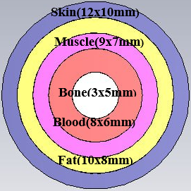 | 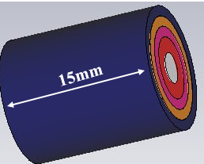 | $$ε_{r}$$ | $$σ$$ | tan δ
Skin |  |  |  | 34.9 | 3.9 | 0.3336
Fat |  |  |  | 4.9 | 0.3 | 0.1871
Muscle |  |  |  | 48.1 | 0.3 | 0.3263
Blood |  |  |  | 52 | 6.9 | 0.3933
Bone |  |  |  | 9.54 | 1.2 | 0.3788

Table 6: Comparison of the Measured SAR Levels for Proposed sensor.
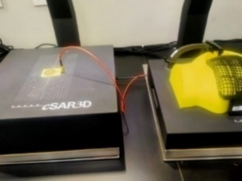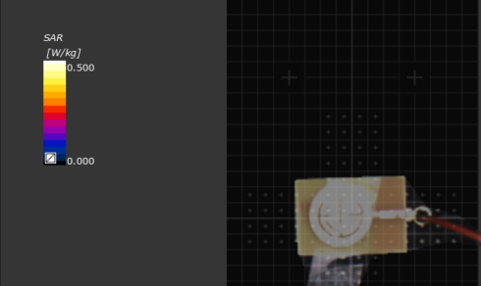
Fre. (GHz) P(dBm) | 1.5 |  | 3 |  | 5.2
 | 1g | 10g | 1g | 10g | 1g | 10g
0 | 0.009 | 0.1 | 0.01 | 0.15 | 0.131 | 0.032
5 | 0.04 | 0.17 | 0.087 | 0.42 | 0.181 | 0.045
10 | 0.131 | 0.057 | 0.273 | 0.131 | 0.231 | 0.068
15 | 0.413 | 0.179 | 0.851 | 0.410 | 0.738 | 0.217
20 | 1.32 | 0.572 | 1.6 | 1.31 | 1.34 | 0.687

