Supplementary File
Comparative Assessment of sEV Biogenesis Regulator Proteins in MSCs and HeLa Cells for Elucidating Novel Therapeutic Strategies
Yashvi Sharmaª, Sujata Mohanty^{a*}
ªStem Cell Facility- DBT Centre of Excellence for Stem Cell Research, All India Institute of Medical Sciences, New Delhi 110029, India

Yashvi Sharma (Y.S.): yashvi2707@gmail.com
Sujata Mohanty (S.M.): drmohantysujata@gmail.com; drmohantysujata@aiims.edu

*Correspondence should be addressed to S.M. drmohantysujata@gmail.com

Supplementary Figures

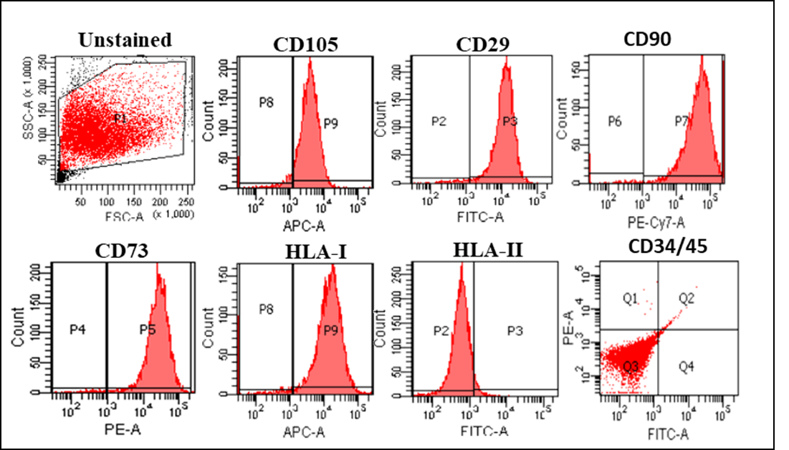
Fig S1. MSCs express surface protein markers as per ISCT guidelines. Flow cytometry based surface marker profile for MSCs depicting positive expression for CD105, CD29, CD90, CD73 and HLA-I, and negative expression for HLA-II, CD34 and CD45
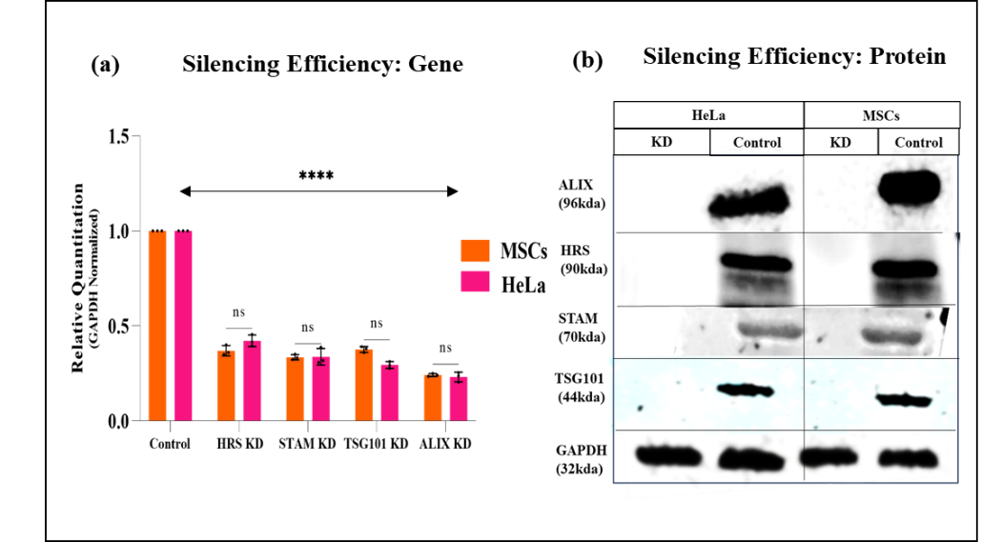
Fig S2. Significant silencing effect was observed for selective biogenesis regulators. (a) qPCR based analysis for silenced genes depicting significantly silenced genes as compared to the respective controls. (b) Western blotting based analysis for corresponding proteins for the silenced genes. Error bars represent Mean ± SD; n=3. *p value <0.05; ** <0.01; ***<001; ****<0.0001
Fi S3. Same biogenesis regulators affect sEV specific markers CD63 differentially in cancer cells and stem cells. (a) Replicates of CD63 (30-60kDA) expression in MSCs and HeLa sEV upon loading with an equal volume (including the representative image in manuscript Fig2 (g)). (h) Densitometry analysis of the CD63⁺ sEV protein bands.

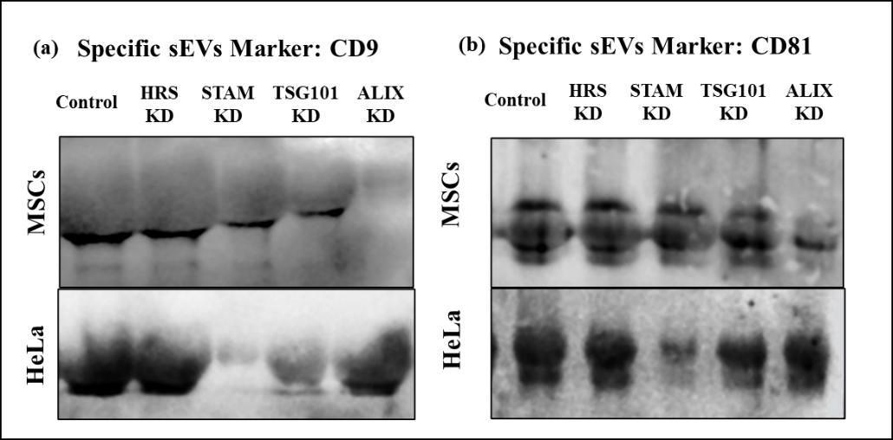
Fig S4. Same biogenesis regulators affect sEV specific markers CD9 and CD81 differentially in cancer cells and stem cells. (a) Representative images of CD9 (22-35 kDA; depending upon glycosylation status) expression in MSCs and HeLa sEV upon loading with an equal volume; (b) Representative images of CD81 (26-32 kDA; depending upon glycosylation status) expression in MSCs and HeLa sEV upon loading with an equal volume.

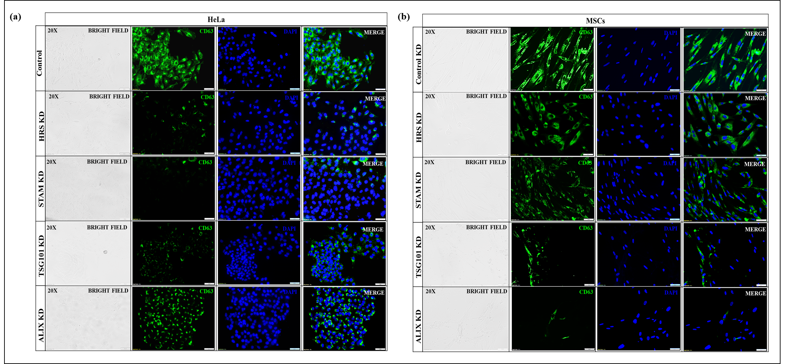
Fig S5. Same biogenesis regulators affect sEV specific marker CD63 differentially in cancer cells and stem cells. (a) Immunofluorescence based analysis in HeLa cells with silenced genes depict reduction in the expression of sEVs specific marker CD63 in the order STAM>HRS>TSG101>ALIX. (b) Immunofluorescence based analysis in MSCs with silenced genes depict reduction in the expression of sEVs specific marker CD63 in the order ALIX>TSG101>STAM>HRS. Magnification 20X; Scale bars: 50µm.

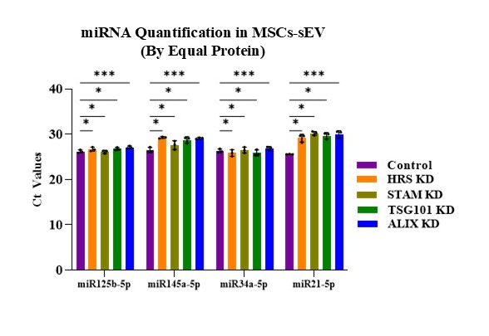
Fig S6. ALIX contributes to the biogenesis and packaging of MSCs-sEV. qPCR-based analysis of the Ct values of selected miRNAs for equal sEV number. The error bars represent mean ± s.d.; n=3. p value *<0.05; ** <0.01; ***<001; ****<0.0001; ns- non significant. KD: Knockdown

Supplementary Tables
Table S1. List of primary antibodies used in the study
S.No. | Protein | Company | Catalogue Number | Dilution used for Western Blotting Analysis
1 | HRS | Affinity Biosciences | AF0316 | 1:1500
2 | STAM | Affinity Biosciences | DF13448 | 1:1500
3 | ALIX | GeneTex | GTX135282 | 1:500
4 | TSG101 | Santa Cruz Biotechnology | SC-7964 | 1:1000
5 | CD63 | ThermoFischer | 10628D | 1:1000
6 | CD9 | Affinity Biosciences | AF5139 | 1:2000
7 | CD81 | Affinity Biosciences | DF2306 | 1:2000
8 | GAPDH | GeneTex | GTX100118 | 1:3000
9 | Calnexin | GeneTex | GTX13504 | 1:3000

Table S2. List of siRNAs used in the study
S.No. | siRNA | Company | Catalogue Number
1 | HRS | Santa Cruz Biotechnology | sc-41232
2 | STAM | Santa Cruz Biotechnology | sc-41043
3 | TSG101 | Santa Cruz Biotechnology | sc-36752
4 | ALIX | Santa Cruz Biotechnology | sc-60149
5 | FITC-Control Non targeting siRNA | Santa Cruz Biotechnology | sc-36869
6 | Scramble siRNA | Santa Cruz Biotechnology | sc-37007

Table S3. List of mRNA primers used in the study
S.No. | Gene | 5’-3’Forward primer | 5’-3’Reverse primer
1 | HRS | CTCCTGTTGGAGACAGATTG | CAGGTACAGGATCTTGTTAC
2 | STAM | GATGAATACTGCTGAGGACT | CTGAGAGCCAATAGCTGGGA
3 | ALIX | CTGACAAAATCAATCGTGCC | CCAAAGACTGCTGTACTGAC
4 | TSG101 | GAGAGCCAGCTCAAGAAAATGG | GGGATTGTTCCAGTGAGGTTC
5 | GAPDH | CAAGGGTCATCCATGACAACTTTG | GTCCACCACCCTGTTGCTGTAG

Table S4. List of miRNA primers used in the study
S.No. | miRNA primer | Catalogue Number
1 | hsa-miR125b-5p | YP00205713
2 | hsa-miR145a-5p | YP00204483
3 | hsa-miR34a-5p | YP00204486
4 | hsa-miR21-5p | YP00204230

Figure wise blot images

