Efficacy of tolvaptan on nephrotic patients with diuretic-resistant edema: a pathological viewpoint
Ryo Matsuura, M.D., Ph.D. ^{1,2}, Yasuhiro Mochida, M.D. ¹, Kunihiro Ishioka, M.D. ¹, Hidekazu Moriya, M.D. ¹, Sumi Hidaka, M.D., Ph.D. ¹, Teruhiko Imamura, M.D., Ph.D., Koichiro Kinugawa, M.D., Ph.D. ³, Takayasu Ohtake, M.D., Ph.D. ¹ and Shuzo Kobayashi M.D., Ph.D. ¹

Table of contents
Supplemental Figure legends 2
Supplemental Figure S1: The scheme of protocol 3
Supplemental Figure S2: An example collecting duct stained with anti-AQP2 antibody. 4
Supplemental Figure S3: Pathological evaluation in control and nephrotic patients. 5
Supplemental Figure S4: Time-dependent course of osmolality and electrolytes in serum and spot urine. 6

Supplemental Figure legends
Supplemental Figure S1: The scheme of protocol
Evaluation of the degree of edema, chest X-ray, echocardiogram, and renal biopsy was performed at the screening phase before TLV administration. Then TLV 7.5mg per day was added on enrolled patients for 14 days. During the trial, other diuretics than TLV were continued with fixed doses. If urine output did not increase or symptoms were not improved for two days after 7.5mg of TLV administration, the dose of TLV could be increased to 15mg as needed. During TLV administration, water intake was not restricted to prevent volume depletion. Body weight, daily urine output, blood pressure and pulse rate were monitored every day. Serum and urine osmolality, serum sodium and creatinine were measured before TLV administration, and at 4hr, 8hr, day2, 3, 5, 8, and 15 after TLV medication.

Supplemental Figure S2: An example collecting duct stained with anti-AQP2 antibody.
Red arrows indicate AQP2-positive cells in collecting duct.

Supplemental Figure S3: Pathological evaluation in control and nephrotic patients.
(a) Glomerular sclerosis index, (b) tubulointerstitial injury and (c) interstitial fibrosis. C, control (N=3); N, nephrotic patients (N=10).

Supplemental Figure S4: Time-dependent course of osmolality and electrolytes in serum and spot urine.
This figure shows time-dependent course of (a) serum and (b) urine osmolality, (c) serum and (d) urine creatinine, (e)serum and (f) urine urea nitrogen (UN), (g) serum and (h) urine sodium, (i) serum and (j) urine potassium, and (k) serum and (l) urine chloride after TLV administration for nephrotic patients. * p<0.05.

Supplemental Figure S1: The scheme of protocol

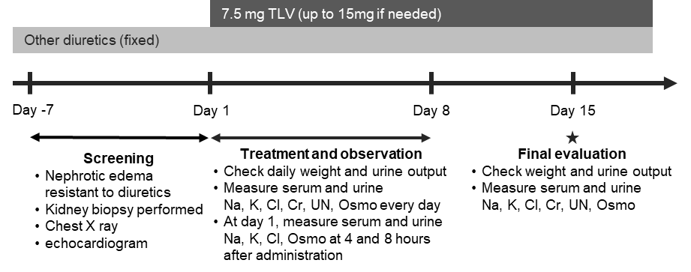

Supplemental Figure S2: An example collecting duct stained with anti-AQP2 antibody.
Red arrows indicate AQP2-positive cells.

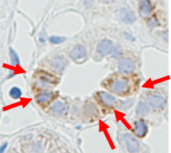

Supplemental Figure S3: Pathological evaluation in control and nephrotic patients.
(a) Glomerular sclerosis index, (b) tubulointerstitial injury and (c) interstitial fibrosis. C, control (N=3); N, nephrotic patients (N=10).

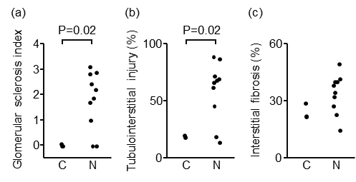

Supplemental Figure S4: Time-dependent course of osmolality and electrolytes in serum and spot urine.
This figure shows time-dependent course of (a) serum and (b) urine osmolality, (c) serum and (d) urine creatinine, (e)serum and (f) urine urea nitrogen (UN), (g) serum and (h) urine sodium, (i) serum and (j) urine potassium, and (k) serum and (l) urine chloride after TLV administration for nephrotic patients. * p<0.05.

(a) Serum osmolality (mOSM/kg) | (b) Urine osmolality (mOSM/kg)
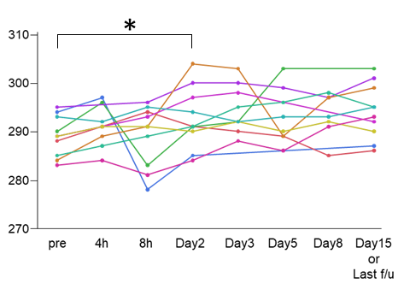 | 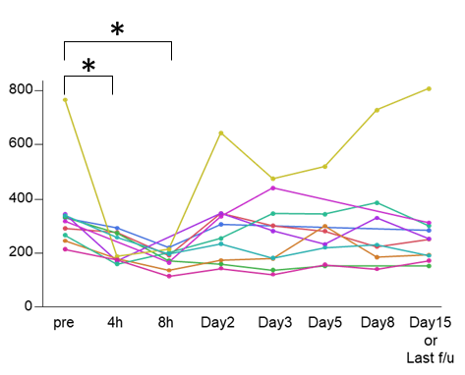
(c) Serum creatinine (mg/dL) | (d) Urine creatinine (mg/dL)
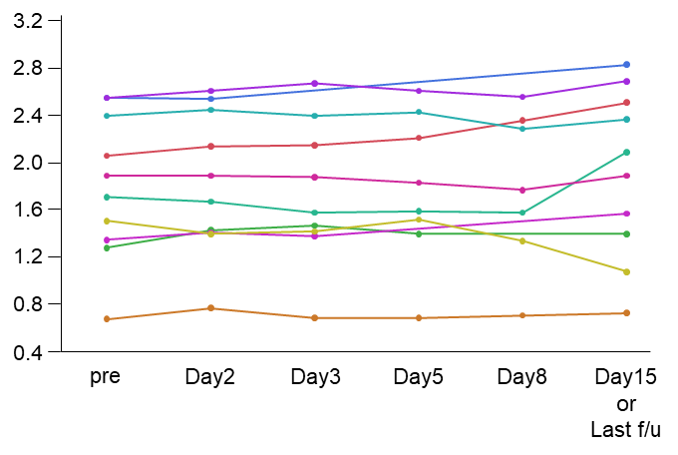 | 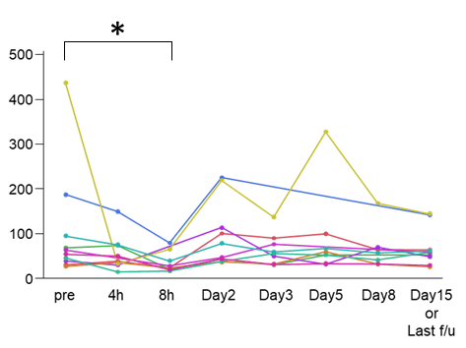
(e) Serum UN (mg/dL) | (f) Urine UN (mg/dL)
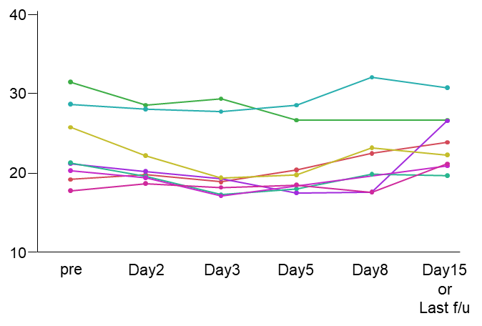 | 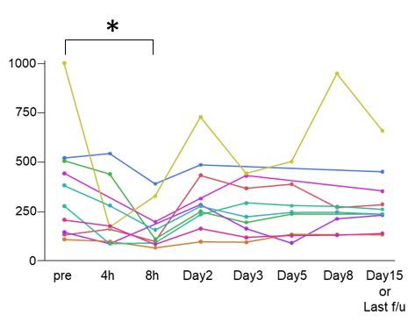
(g) Serum Na (mEq/L) | (h) Urine Na (mEq/L)
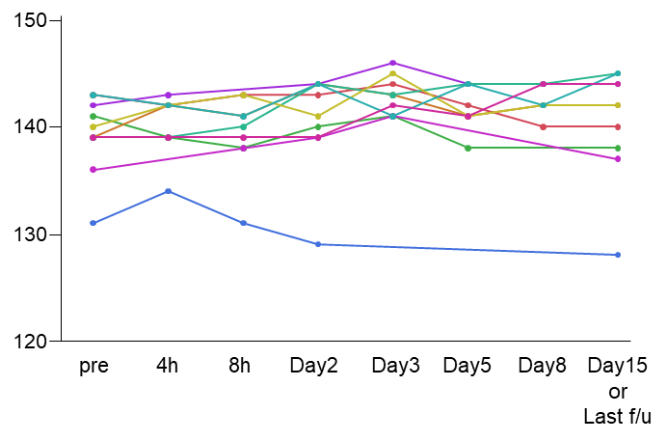 | 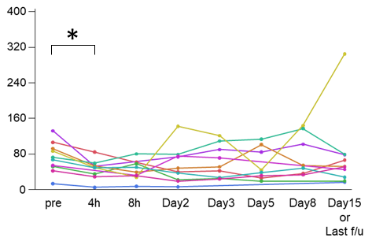
(i) Serum K (mEq/L) | (j) Urine K (mEq/L)
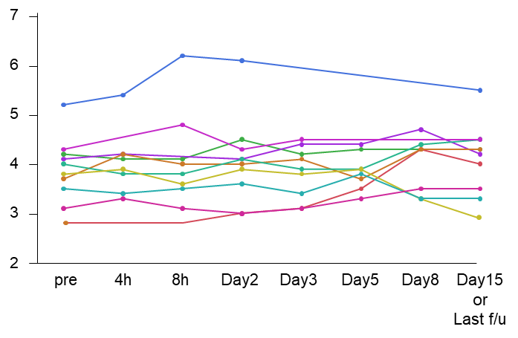 | 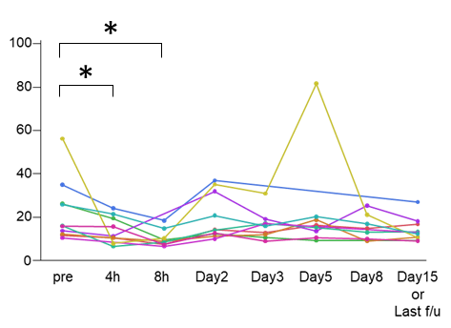
(k) Serum Cl (mEq/L) | (l) Urine Cl (mEq/L)
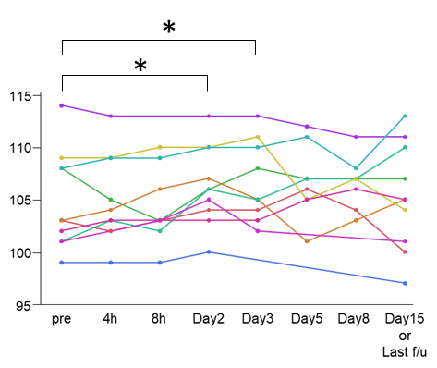 | 